Introduction to Elementalism:

A Self-Guided Home Study Program

By
Lesley Teitelbaum, Ph.D. © 2019

Tampa Bay Emotional Wellness Seminars and Services, LLC

Copyright Notice – DO NOT COPY. Copying and sharing any portion of these pages is prohibited, and subject to civil and criminal liabilities by law.

Course Contact Information: Instructor Office Hours:

Lesley Teitelbaum Lesley.teitelbaum@gmail.com Wednesday 2 – 4 pm EST
except while traveling

Module #4 – The Element of Water

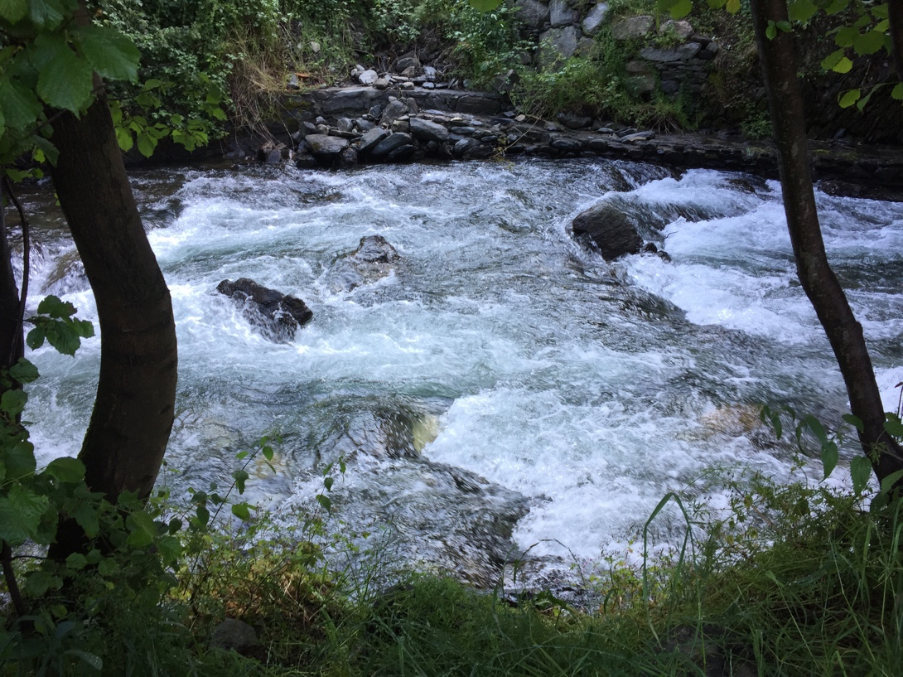

Our decisions and actions elicit consequences from others and the world around us. The more well thought out our actions are in response to our life situations the greater the potential for positive outcomes, for us, as well as for others. In this module you will be working on exploring higher level behavioral responses to the events in your life that present you with challenges.

In this program, the element of fire is associated with creativity, inspiration, and courage. Below please find examples of higher level and lower level behavioral expressions associated with the element of fire.

Examples of Higher Level Behavioral Expressions of the Element of Water

Higher levels of emotional intelligence (ability to be aware of one’s emotions, emotions of others, inability to manage emotional balance, and ability to develop positive and productive relationships with others)
Ability to create emotional balance and regulate one’s own emotions
Ability to create opportunities to nurture oneself and others
Ability to compassionate toward oneself and others – ability to empathize and feel the feelings of another dispassionately – being able to imagine and understand the unique needs of another - and wanting to help that person in a way that does not compromise one’s own wellbeing
Thoughtful of self and others
Ability to perceive life events and circumstances as opportunities to change, grow, and learn.
Ability to focus upon and express positive emotions
Observations of others rather than comparison to others can result in appreciating and accepting differences of others
Tendency to respond (taking time – using mental faculties and connection to inner self to create a response that achieves the highest and most positive outcome) to emotionally charged events

Examples of Lower Level Behavioral Expressions of the Element of Water

Low levels of emotional intelligence (inability to be aware of one’s emotions, emotions of others, inability to manage emotional balance, and difficulty developing positive and productive relationships with others)
Being emotionally overwhelmed / experiencing meltdowns
Inability to regulate emotions – emotionally unstable - labile
Inability to create opportunities to nurture self or others emotionally
Tendency to be sympathetic – ability to sympathize and feel the feelings of another – feeling sorry for that person – feeling pity for them – and wanting to help that person by taking away their challenge and rescuing them – unintentionally putting oneself at risk - or unintentionally compromising the wellbeing of another by taking away the opportunity for that person to use their own resources and develop new skills
Focused primarily on emotions of self – tendency toward feeling sorry for oneself in certain situations - self pity
Victim consciousness – perceiving oneself to be a helpless victim of life events and circumstances –
Inability to focus upon and express positive emotions
Comparison to others is emotional and personal and can result in jealousy, self pity, or hostility
Tendency to react (highly emotional response that typically has a negative outcome) to emotionally charged events

Overview of Water Element Module Activities

- The first step involves self-awareness and description of a particular event that created emotional unbalance or upset for you. Maybe a time where you found your emotions swinging out of balance, overreacting to emotionally provocative situations in your life, feeling overwhelmed or having emotional outbursts, experiencing and focusing on negative emotions.

- The second step involves observing the situation from multiple points of view.

- The third step involves connecting with your inner self through the use of contemplation and meditation to generate ideas for new approaches to confronting your life event or interaction.

- The fourth and final step involves taking actions based upon the results of your contemplation and meditation and practicing new responses to your life events and challenges that takes you to higher levels of behavioral expressions of the element of water.

This whole process is designed to help you increase your self-awareness, and by connecting with your inner self – explore and discover ways to shift from lower level reactions to higher level behavioral responses to life events. Every decision leads to an action that is associated with a particular consequence. Using higher level behavioral responses can lead to more positive and productive outcomes to challenging life events and interactions and greater levels of emotional wellbeing.

You have ONE WEEK to complete all four activities for Module 4 (i.e., description; observation; connection to inner self; action / review). They are to be completed sequentially, in numerical order. Failure to submit homework in a timely manner will result in the instructor not including that module in your final report. If you have any questions about the material or directions, please feel free to send them along via electronic mail (email) to instructor’s address: Lesley.teitelbaum@gmail.com.

Office hours are on Wednesday afternoon 2 – 4 pm. If you do not receive an answer to a question by 10 pm Wednesday evening, please resend your question and please note you did not receive any answer. Please confine your questions to course related content only. Please remember that the instructor does not provide any advice regarding your personal situations and relationships and the instructor does not evaluate the status of your mental health or offer any recommendations regarding mental health treatment.

All homework activities (i.e., description, observation, connection to inner self, and action) are to be submitted to instructor electronically one week from being received. Please have a physical or electronic journal, notebook, or notepad available where you can keep the results of your work for each of the activities safe.

HOMEWORK ACTIVITIES FOR MODULE 4 – Water Element

Please do these activities I – IV in order. Please feel free to record your answers to the Homework Activities in the Homework Workbook provided, or you may respond using an electronic word document that you can email.

- Description Activities.

Describe a time when you found yourself feeling emotionally unbalanced, overwhelmed, focused on negative thoughts and feelings or having temper tantrums or emotional outbursts. A time when you may have felt sorry for yourself – or a time when you were having difficulty with your relationships with others.

(Select only one to write about for the HW submission, however, feel free to explore as many as you wish over time.)

- Describe the situation from your point of view – it can be as long or as short of a description as you wish.

- Describe your thoughts about the situation – any sayings that you have that you use to describe the situation, yourself, or others.

- Describe any related feelings.

- Describe any related worries, concerns, fears, or beliefs you have about the situation.

- Observation Activities.

- Describe the situation / event / memory from the point of view of another person who is close to that event.

- Describe the situation / event / memory from the point of view of another person who is distant to that event.

- Connection to Your Inner Self Activities.

- Spend some quiet time alone. Create a space and time where you and others are safe. Make arrangements in advance so you will be uninterrupted and have time just to be, and relax for at least 10 minutes. Give yourself permission to day dream, to shift your mental focus away from your daily activities, and to use your imagination to contemplate ideas of how you can move beyond what is to what can be – take time to allow yourself to be inspired, to imagine other ways you can respond to the situation that would help you maintain your emotional balance and serve the greater good of all involved. Consider how you might use the higher level behavioral expressions of the element of water to approach the situation you described in the first activity.

Questions you may wish to ponder:

- What activities can you do that would increase your ability to feel more emotionally balanced?
- What ways can you revise your thinking process to help you to focus and express positive thoughts, and being more compassionate to yourself and others?
- What ways can you nurture yourself and restructure your daily habits, routines, and lifestyle that may help you to cope with, resolve, or change the situation?
- What ways can you shift your focus of attention to create new attitudes and feelings about the situation and enjoy some of the higher expressions of the element of water?

Please record the results of your contemplation in a journal, or somewhere safe, where you will be able to view them again for your work in the next section.

- Spend some time reviewing the thoughts and ideas that occurred to you during the previous activity of contemplation. Use the guided meditation (less than 10 minutes) provided to connect to your inner self to relax, and explore ideas of behaviors that may help you move to the higher levels of the element of water.

You may use the recording once in the week, or up to once each day. There is no correct number of times to use the recording. Each time you use the meditation, you may have a different experience. Remember that each person’s meditative experience varies, so please do not worry or think you are in any way getting it wrong if you do not perceive anything during the meditation. Trust that your experience is unique and that participating in the meditative experience is helpful for reducing the activation of your sympathetic nervous system and can help you feel more calm, more mentally clear, more inspired, and more emotionally balanced.

Please record the results of your meditation in a journal, or somewhere safe, where you will be able to view them again for your work in the next section.

Note: Complete part A and B on different days.

- Take Action / Review Outcome of that Action.

- Based upon your work in contemplation / meditation activities, what are some actions you can take that will help you move into the higher expressions of the element of water?

- Experiment by trying out some of the higher behavioral expressions of the element of water.

- What were the outcomes of those actions for yourself and others? Please note the outcomes of your actions, did they assist you in any way? Did they help you move toward increasing your ability to express the higher levels of the element of water? help you cope with the situation? help you increase your wellbeing? accept the situation? help you to resolve or change the situation?

--------------------------

*** IMPORTANT NOTE: Please remember if at any time in the course you feel that your emotions are stirred, or out of balance in a manner that concerns you, or those who are closest to you, or if at any time you feel in danger of harming yourself, or another, please seek out professional mental health treatment, emergency psychiatric services, or crisis oriented mental health services. Please remember to contact information for local mental health services available.

