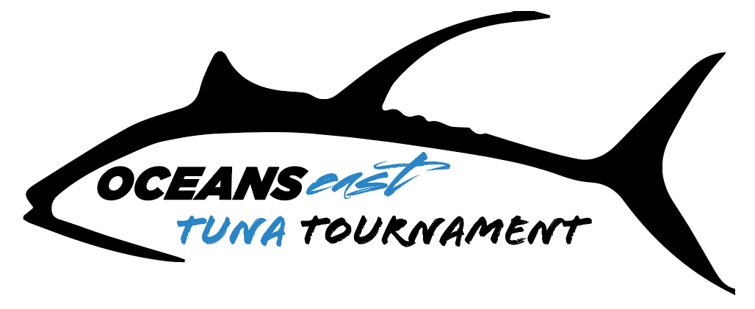
Rules and Regulations

- All anglers must abide by all State and Federal laws.

- Registration — Will be held at Oceans East - Nags Head or Oceans East – Virginia Beach from May 7, 2021 until 5:00 PM on May 20, 2021. All boats must be registered with the Tournament committee and all entry fees paid to qualify for prizes and trophies. Any substitute must be registered with the Tournament Director prior to ﬁshing and will be permissible only if original boat becomes disabled. Captain’s Meeting will be held through a Zoom meeting on May 20, 2021 at 7:00 PM. Zoom invitation will be sent to Captain’s email.

- Fishing Days —There will be three ﬁshing days. Fishing hours are from 7:00 AM to 2:30 PM daily. No lines or teasers in the water prior to 7:00 AM or after 2:30 PM. Any ﬁsh hooked prior to 2:30 PM may be played until caught.

- Ofﬁcial Clock —Time starts the ﬁrst day of the tournament. Ofﬁcial tournament time will be continuous GPS time. In case of tie in weight, time of weigh in will determine the winner.

- Chunking (chumming), use of live bait, and green sticks are not permitted. There is no limit to the number of lines in the water or anglers - anglers may pass the rod. The use of electric reels is prohibited on hook baits.

- Culling of fish is prohibited. Disposing of a dead fish in efforts to replace it with a larger one is strictly prohibited. No boat may keep more than 18 tunas per a boat, all eligible tuna species included. Once a boat has 18 dead tunas in the boat your day is deemed over and must return back to the dock.

- Boundaries — All ﬁsh must be hooked within tournament boundaries which 65 nm from Oregon Inlet sea buoy. Fish can then be played outside boundaries until caught or released.

- Points System – All Tunas will receive one (1) point per pound. Any tuna weighing less than 10 pounds will not be eligible for points. Dolphin points do not count toward any tuna division. There is no billﬁsh division.

- Weighing Fish — Any ﬁsh weighed must be entered on the scorecard by the Tournament Weighmaster. If anyone wants to have a ﬁsh reweighed, it must be done while ﬁsh is still hanging. All ﬁsh that have been mutilated will be disqualiﬁed. Mutilation shall be deﬁned as damage which would impair the ﬁghting ability of the ﬁsh. The decision of the weighmaster will be ﬁnal. Weigh stations will close at 7:00 PM each day of the Tournament. Fish may be driven in by vehicle to the weigh station.

There will be 3 official weigh stations:
Pirates Cove Marina, Oregon Inlet Fishing Center, OBX marina

- Scoring —All tuna will receive one (1) point per pound. Teams may weigh no more than three tuna per day. Top boat honors will be determined by adding together the weights of the team's heaviest three Tunas from each day of ﬁshing. Dolphin will also receive one (1) point per pound; heaviest single ﬁsh of each species will determine the winner in that category. Bluefin, Blackfin, Big Eye, and Yellowfin are eligible species.

- Tie Breaker – Winner will be determined by weight. Weighed ﬁsh will be recorded in fractions of a pound. If two or more entries are of the same weight. The ﬁsh with the earliest weigh-in time will determine the winner.

- Polygraph Testing – Crew members, Captain and Mate of money winning boats and individual trophy winners may be subject to polygraph testing before receiving any money and/or trophies. Polygraph test for winners will be completed at a designated time and location. By virtue of signing the entry form, participants agree to the ﬁnal decision of the polygraph test. Refusal to submit to the polygraph test will be automatic grounds for disqualiﬁcation from the Tournament and any winnings.

- Protests - must be submitted in writing to the Tournament Director by 7:00 PM on Sunday night. Protests must be submitted in writing with a deposit of $100 which will be refunded if the protest is upheld. The Rules Committee at their discretion may use polygraph testing to reach a decision. By virtue, or signing the entry form all participants agree to the ﬁnal decision of the Rules Committee.

- Cancellation Policy - If weather and /or other conditions exist that require that the tournament be cancelled, refunds will be paid less tournament expenses. The decision to cancel the tournament will be made by the Tournament Director. One day of ﬁshing by at least 10% of the ﬁeld constitutes a tournament.

- Prize money - Checks will be made payable to the entrant or authorized agent of the winning boat as designated on the ofﬁcial entry form. Social Security Number or Taxpayer ID must be listed on the entry form. Checks will be mailed within 30 days of tournament event.

- Anglers -There is no limit to the number of eligible anglers per boat. Captain and Mates are eligible anglers.

- Tournament Expenses - In an effort to offset tournament expenses, Oceans East Tuna Tournament will retain up to $100 of the Entry Fee and 15% of Calcuttas will be donated to the Oceans East Fisherman’s Fund.

- BY SIGNING THE ENTRY FORM AND PAYING THE ENTRY FEE, MY TEAM AND I ACKNOWLEDGE THAT WE HAVE READ THE RULES AND FORUM SELECTION/INDEMNIFICATION AND ARE BOUND BY THE SAME.

- Forum Selection/Indemniﬁcation - All participants, owners of vessels and pro hoc owners of vessels, consent and agree that the federal and state courts for Dare County, North Carolina, shall serve as the sole venue for all litigation and disputes, including, but not limited to, Pirate's Cove Yacht club & Marina, Oceans East, Inc, Oceans East OBX. LLC, and Oceans East Tournaments, Inc., rulings, property damage, personal injury, and contract disputes arising out of a person or vessel's participation in the Oceans East Tuna Tournament. If a participant does not secure the signature of the vessel's owner and / or pro hoc owner for this agreement, the participant(s) agrees to indemnify the Pirate's Cove Yacht club & Marina, Oceans East, Inc, Oceans East OBX. LLC, and Oceans East Tournaments, Inc. against all claims brought by the owner and or pro hoc owners of the vessel(s). Any participant whose action causes Pirate's Cove Yacht club & Marina, Oceans East, Inc, Oceans East OBX. LLC, and Oceans East Tournaments, Inc., its officers, directors, sponsors, owners and employees, to occur legal expenses, shall indemnify, hold harmless and reimburse said persons or entities from such costs. The rules and release shall also be binding on my heirs, executors, administrator or assignees.

