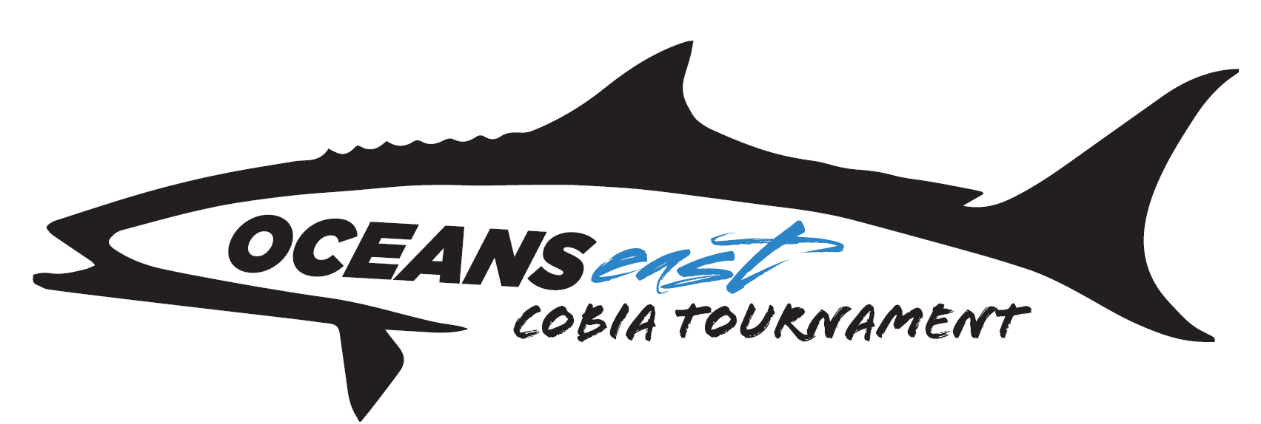

**Oceans East Cobia Tournament Structure**

**Base Entry Dates** ~

**May 21st**: (300.00) **May 22nd**: (300.00) **May 23rd: ______** (300.00)

*Overall Tournament Payouts~ 50/30/20 spit* ~ *Two fish Stringer*

Trophies will be awarded to the top 3 boats

**Calcutta’s (Optional)**

**Big Fish Daily ~** *Each day pays to 2 places ~70/30 split*

**May 21st**: (200.00) **May 22nd**: (200.00) **May 23rd**: ________ (200.00)

**Stringer 1 Daily ~** *Each Day pays to 2 places ~ 70/30 split*

**May 21st**: (200.00) **May 22nd**: (200.00) **May 23rd**: ________ (200.00)

**Stringer 2 Daily ~** *Each Day pays to 2 places ~ 70/30 split*

**May 21st**: (200.00) **May 22nd**: (200.00) **May 23rd**: ________ (200.00)

**Jr. Angler Division**

~ Single largest Cobia caught overall by a Jr. angler will receive a prize package worth $250.

**Female Angler Division**

~ Single largest Cobia caught overall by a female angler will receive a prize package worth $250.