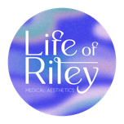
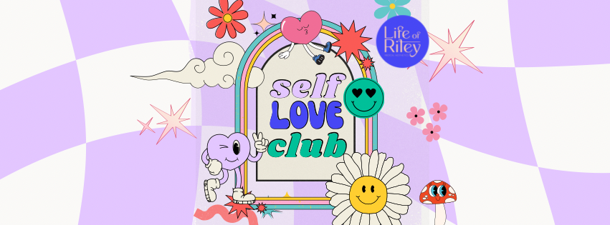
Terms and Conditions for Life of Riley Medical Aesthetics Clinic Membership Scheme
Life of Riley’s ‘Self Love Club’
Welcome to Life of Riley Medical Aesthetics’ Membership Scheme. By subscribing to membership, you agree to the following terms and conditions. Please read them carefully to understand your rights and obligations under this agreement.
Commencement and Duration: The Membership Scheme contract commences on the date of your first payment and continues indefinitely until terminated by either party. The minimum term is twelve months. After the initial twelve months, the contract will automatically continue on a monthly rolling basis until you choose to cancel, providing one month's notice.
Payments: Membership fees are due monthly and will be automatically charged on the 1st of each calendar month. You must ensure sufficient funds are available to cover the monthly fee.
Membership Changes: You may upgrade your membership at any time. Downgrading membership benefits is only permitted at the start of a new membership year. Membership services are exclusively available at Life of Riley Medical Aesthetics clinic locations.
Treatment Funds: Members must maintain sufficient funds in their account for chosen treatments. If the account balance is insufficient, the remaining balance must be paid on the day of treatment or in advance, with membership level discounts applied.
Appointment Cancellation: A minimum of two working days’ notice is required to cancel or reschedule appointments. Failure to comply will result in a £50 cancellation fee, which must be settled before future bookings.
Membership Pause: (At clinic discretion only). Membership can be paused for a minimum of one month and a maximum of nine months under certain conditions (e.g., temporary relocation, extended illness). Payments and benefits are suspended during the pause period. Conditions apply for pausing and resuming your membership.
Termination and Cancellation/Cancellation Policy: Memberships cannot be paused (unless agreed at the clinics discretion). But it may be cancelled at any time, with a 30-day written notice via email to anna@lor-medicalaesthetics.co.uk. Any treatments or products received at a discounted rate within this time must be paid back in full upon cancellation.
Money-Back Guarantee: As per the Consumer Contracts (Information, Cancellation and Additional Charges) Regulations 2013, you are entitled to cancel your contract and receive a full refund of any fees paid within 14 days of completing your agreement application form. However, as per regulation 36 of Consumer Contracts (Information, Cancellation and Additional Charges) Regulations 2013, if you select to commence your treatment immediately, you agree that if you subsequently cancel your agreement within 14 days, you will pay the balance of the treatment or package, less an amount for the payments you have already paid commencing from the first day after joining.
Non-transferability: Membership is personal and non-transferable. It cannot be shared or transferred to another individual.
Payment Issues: If a payment is unpaid by the due date, treatment may be suspended until full payment is made. Members are responsible for any fees incurred due to insufficient funds or changes in bank details not communicated to Life of Riley Medical Aesthetics Ltd.
Changes to Membership Plan: Life of Riley Medical Aesthetics Ltd reserves the right to modify membership plans, privileges, and pricing with one month’s notice.
Compliance and Changes: Life of Riley Medical Aesthetics Ltd may revise these terms and conditions to comply with applicable laws or to reflect changes to the Membership Scheme. Members will be notified of significant changes.
Discounts and Promotions: Membership discounts cannot be combined with other clinic promotions or offers.
By joining Life of Riley Medical Aesthetics’ Membership Scheme, you acknowledge and agree to these terms and conditions.
I thank you for choosing Life of Riley Medical Aesthetics and I look forward to providing you with exceptional care and exclusive benefits through the Membership Scheme.

