Monthly Information Package

February 2021

Columns & Features

your newborn and their social security number 2

workers in your home and social security 4

get Your Social Security Benefit Statement (SSA-1099 / SSA-1042S) 5

making the most of america saves week 7

MY SOCIAL SECURITY, it’s NOT JUST FOR RETIREES 9

Produced at U.S. taxpayer expense.

Social Security Column

# your newborn and their social security number

By Lizna Odhwani

Social Security Public Affairs Specialist in Virginia



Getting your newborn a Social Security number is important for their future. If your child is born in a hospital, the easiest way to apply for a Social Security number is right at the hospital.

When you give information for your child’s birth certificate at the hospital, you’ll be asked whether you want to apply for a Social Security number for your child. If you say “yes,” you will be asked to provide both parents’ Social Security numbers, if you can. Even if you don’t know both parents’ Social Security numbers, you can still apply for a number for your child.

There are many reasons why your child should have a Social Security number. You need a Social Security number to claim your child as a dependent on your income tax return. Your child may also need a number if you plan to do the following for your child:

* Open a bank account.
* Buy savings bonds.
* Get medical coverage.
* Apply for government services.

You can find more information by reading *Social Security Numbers for Children* at www.ssa.gov/pubs/EN-05-10023.pdf.

Please share this information with people who are expecting a child. Applying for a Social Security number at the hospital will save them time and let them focus on the new member of their family.

# # #

Social Security Column

# workers in your home and social security

By Lizna Odhwani

Social Security Public Affairs Specialist in Virginia

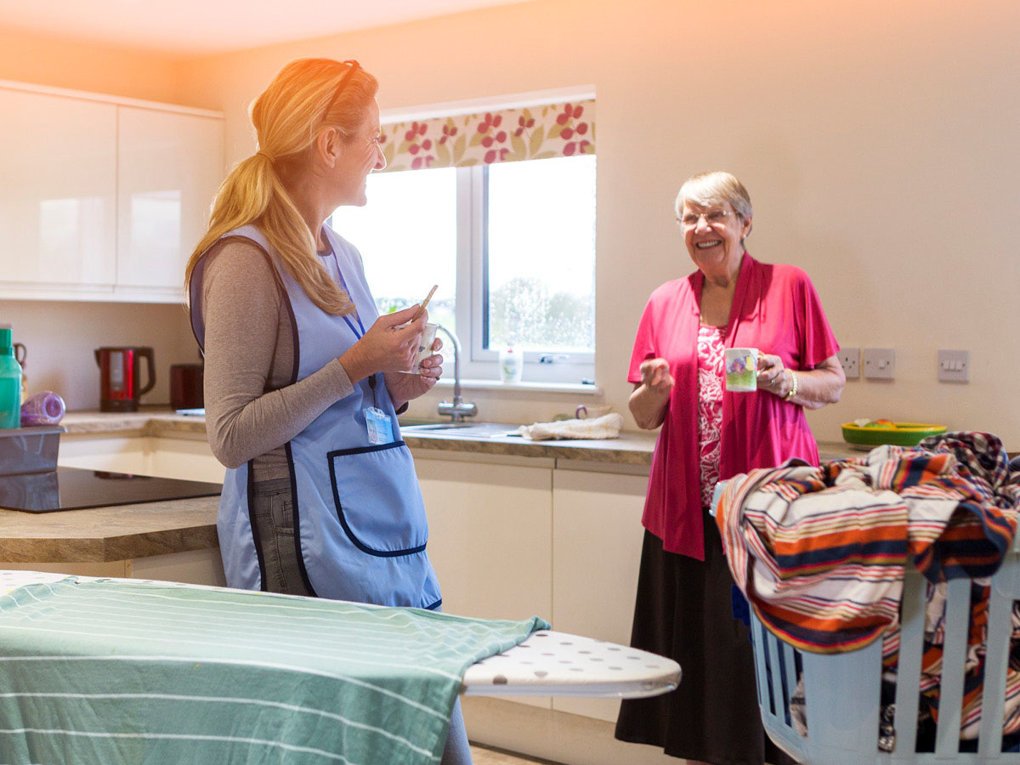

Do you plan to pay a cleaning person, cook, gardener, babysitter, or other household worker at least $2,300 in 2021? This amount includes any cash you pay for your household employee’s transportation, meals, and housing. If you will pay at least $2,300 to one person, you have some additional financial responsibilities.

When you pay at least $2,300 in wages to a household worker, you must do all of the following:

* Deduct Social Security and Medicare taxes from those wages.
* Pay these taxes to the Internal Revenue Service.
* Report the wages to Social Security.

For every $2,300 in wages, most household employees earn credits toward Social Security benefits and Medicare coverage. Generally, people need 10 years of work to qualify for:

* Retirement benefits (as early as age 62).
* Disability benefits for the worker and the worker’s dependents.
* Survivors benefits for the worker’s family.
* Medicare benefits.

You can learn more about reporting household worker income by reading *Household Workers* at www.ssa.gov/pubs/EN-05-10021.pdf.

# # #

Social Security Column

# get Your Social Security Benefit Statement (SSA-1099 / SSA-1042S)

By Lizna Odhwani

Social Security Public Affairs Specialist in Virginia



Tax season is approaching, and replacing your annual Benefit Statement has never been easier. The Benefit Statement, also known as the SSA-1099 or the SSA-1042S, is a tax form we mail each year in January to people who receive Social Security benefits. It shows the total amount of benefits you received from us in the previous year so you know how much Social Security income to report to the Internal Revenue Service on your tax return.

If you live in the United States and you need a replacement form SSA-1099 or SSA-1042S, simply go online and get an instant, printable replacement form using your personal *my Social Security* account at www.ssa.gov/myaccount. A replacement SSA-1099 or SSA-1042S is available for the previous tax year after February 1.

If you don’t have access to a printer, you can save the document to your computer or email it to yourself. If you don’t have a *my Social Security* account, creating one is very easy to do and usually takes less than 10 minutes.

With a personal *my Social Security* account, you can do much of your business with us online. If you receive benefits or have Medicare, your personal *my Social Security* account is also the best way to:

* Request a replacement Social Security number card (in most states and the District of Columbia).
* Get your benefit verification letter.
* Check your benefit and payment information.
* Change your address and phone number.
* Change your direct deposit information.
* Request a replacement Medicare card.
* Report your wages if you work and receive Social Security disability insurance or Supplemental Security Income benefits.

If you’re a non-citizen who lives outside of the United States and you received or repaid Social Security benefits last year, we will send you form SSA-1042S in the mail. The forms SSA-1099 and SSA-1042S are not available for people who receive Supplemental Security Income benefits.

Visit www.ssa.gov to find more about our online services.

*# # #*

Social Security Column

# making the most of america saves week

By Lizna Odhwani

Social Security Public Affairs Specialist in Virginia



This year, America Saves Week runs from February 22 – 26. The week is an opportunity for organizations to promote good financial habits. It’s also a great time for people to assess their own saving status, as planning and saving are key to a successful retirement.

Each day of the week will focus on a different aspect of saving:

* Monday – Save Automatically
* Tuesday – Save for the Unexpected
* Wednesday – Save to Retire
* Thursday – Save by Reducing Debt
* Friday – Save as a Family

It’s never too early to start planning for your retirement. Set a goal, make a plan, and save automatically. People with a plan are twice as likely to save successfully. Pledge to save for America Saves Week at www.americasavesweek.org.

We have many tools to help you with your goals as you save for retirement. You can access our online information and resources at www.ssa.gov/benefits/retirement.

It’s never too late for you and your loved ones to begin saving. Younger workers may think they have time to put off saving for their future, but the sooner they begin, the more their money can grow. Visit our website for young workers at www.ssa.gov/people/earlycareer for resources that can help you secure today and tomorrow.

# # #

Social Security Column

# my social security, It’s not just for retirees

By Lizna Odhwani

Social Security Public Affairs Specialist in Virginia

  
  
You don’t have to be retired or even close to retirement to benefit from a personal *my Social Security* account. Calling or visiting a local Social Security office probably is rarely necessary once you have one. You can do much of your business with us online.

With your personal *my* *Social Security* account, you can:

* Request a replacement Social Security card (in most states and the District of Columbia).
* Estimate your future benefits to compare different dates or ages to begin receiving benefits.
* Check the status of your Social Security application when you do decide to apply.
* Review your work history.

If you already receive benefits, you can also:

* Request a replacement Social Security card (in most states and the District of Columbia).
* Get a benefit verification or proof of income letter.
* Set up or change your direct deposit.
* Change your address.
* Request a replacement Medicare card.
* Get a Social Security 1099 form (SSA-1099).
* Opt out of receiving certain notices by mail and receive them in the secure Message Center.

Please help us spread the word. Let your family and friends know that they can create a *my Social Security* account today at www.ssa.gov/myaccount.

# # #