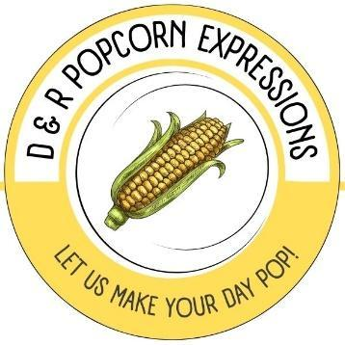

LET’S TALK ABOUT YOUR FUNDRAISER!

We would like to start by thanking you for potentially giving us the opportunity to help you raise money for your business/organization.

We are pleased to be able to offer naturally flavored popcorn as a way to help our community succeed or improve through fundraising.

Flavors Available:
- Cinnamon Swirl
- Hot Pepper
- Kettle Corn
- Theater (Butter)

Cost per bag:
Large (9” x 12”) $6.00

Fundraising amount per bag you will receive (30%):
Large $1.80

FUNDRAISING PROCESS:

- Contact us so we can provide an order form for pre-orders that will be delivered on a specified date of your choosing.
- We will discuss a cut-off date for the pre-orders and also schedule a delivery date.
(Please note that the cut-off date must be at least 2 WEEKS prior to the delivery date).
- We will pick up the order form on the cut-off date and collect the money for the orders.
- We pre-sort, label and bag the orders per customer.
- DELIVERY DAY – you will receive a check for your fundraising amount, and you simply pass out the pre-labeled bags to the customers! 🎈

If you are interested in us helping you make your fundraiser a success, please feel free to call us at
234-817-7677 or you may email us at dandrpopcorn@gmail.com.

You may also visit our website: www.dandrpopcorn.com

We look forward to working with you!
THANK YOU! 😊

