Bus Safety Solutions
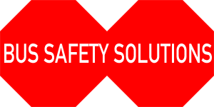
Installation Manual
Extended Stop Arm v. 4.0
AIR System
Thomas Built Buses


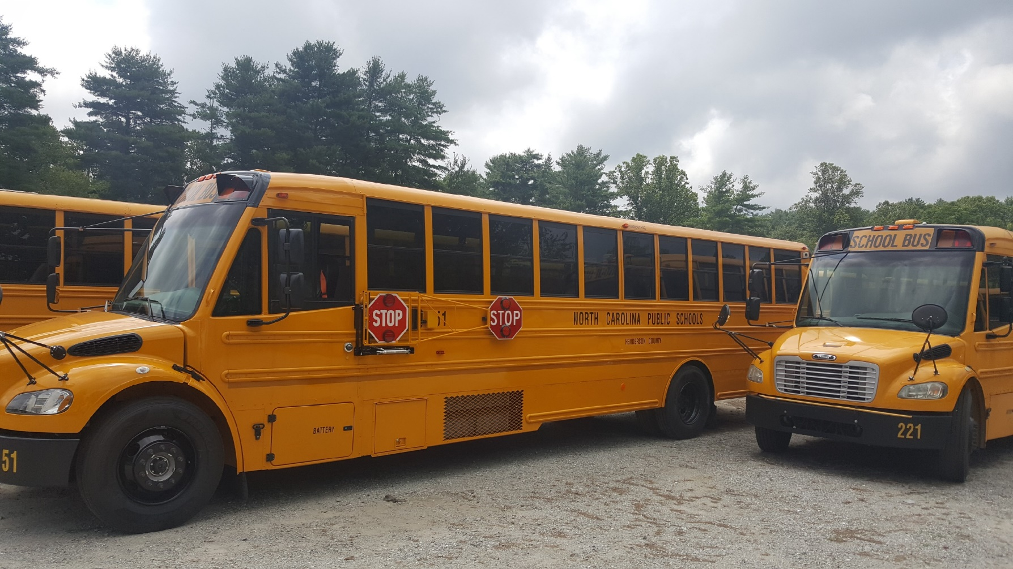

Contents:
- Tools Needed
- Removal of Specialty Stop Arm
- Connect to Power Source
- Install Hinge Frame
- Connect Air Hose
- Install Air Solenoid and Cylinder Assembly
- Install Control Box and Board
- Run Wiring and Electrical Connections
- Install Frame & Signs
- Install Bumper
- Button Up
Tools and Supplies Needed

- Safety Glasses
- Work Cart
- Magnetic dish
- Tape measure
- Small Level
- Impact Driver
- Drill Motor
- Assorted nut drivers
- #2 Philips Bit, #3 Philips Bit
- 7/8” Conduit Hole bit
- Assorted drill bit set
- 9/64” steel bit
- 3/16” steel bit
- ¼” steel bit
- 9/32” steel bit
- 5/16” steel bit
- Hammer (14 oz)
- Hammer (2 lb)
- Vice Grip – Small & Large
- Utility Knife
- Needle Nose Plyers
- Cold Chisel
- #2 Philips head screwdriver
- #3 Phillips head screwdriver
- Flathead screwdriver
- 2 - ½” Wrenches
- 2 – 5/8” Wrenches
- 2 – 7/8” Wrenches
- 1/8” Allen Wrench
- Socket Set
- 1/2” NPT Steel Pipe (7/8” diameter) 8” Long
- Electrical Wire Crimping Tool
- Electrical Wire Stripping Tool
- Electrical Multi-Meter
- Clear Exterior Silicone
- School Bus Yellow Exterior Silicone
- Nutsert (insert nut or rivet nut) tool
- Air hose cutter
- Screw extractor (Easy Out)
- Teflon pipe thread sealant
- 13mm or adjustable wrench
- Fish tape

- Revised: 8-15-2019

Removal of Specialty Stop Arm
- Remove the flat cover plate with four screws and set aside for later.
- Remove the left angled plate and discard.
- Disconnect spring, then disconnect retraction cable from hinge plate by removing cotter key and clevis pin. Discard.
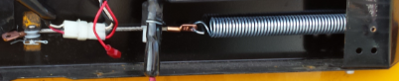
- Disconnect all nuts to the bladder and save a couple nuts.
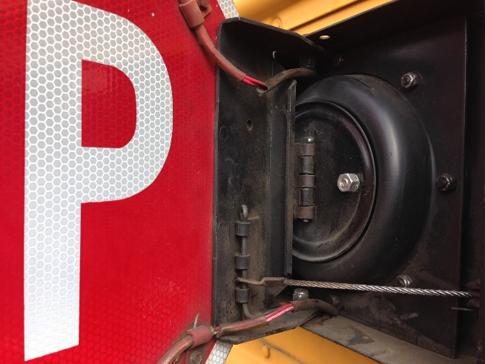
- Undo any cable clamps holding down the stop sign wiring and pull wiring out through hinge plate to hang loose.
- Disconnect sign from hinge using 7/16” wrench or nut driver, remove sign and set aside to remount later.
- Disconnect old hinge using 7/16” wrench and 3/8” wrench or nut driver.
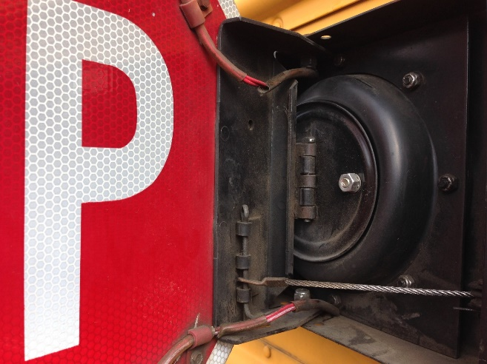
- Remove hinge and bladder assembly and discard.
- Many of these parts marked as “discard” can be re-used in your parts inventory.
Connect to Power Source
- The Extended Stop Arm requires a 12-Volt power source. This can be found under the switch panel in a Thomas C2.
- On a Thomas C2, the rib under the window should be removed. Carefully drill a hole into the wiring compartment under the switch panel. Install a grommet in the hole. Run a 16-gage wire into the bus compartment through a wire mold, and flexible wiring loom. Run the wire into the Specialty box. Replace the rib.
- DO NOT replace the rib yet if the bus has a second stop arm towards the rear of the bus. See “Connect Air Hose” section (pg. 5) below before proceeding with installing hinge frame.
- Connect the wire to an accessory block and insert a 15-amp fuse
- If the block is not present or functioning, connect to the solenoid and use an in-line 15-amp fuse.
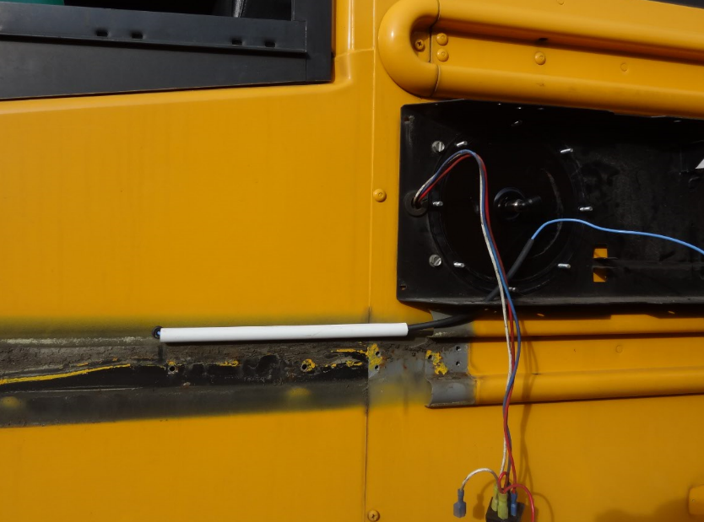
- On a Freightliner FS65, run the power wire through the same hole that the Specialty light wires are located. This will typically require using a stiff wire or fish tape to help fish the power wire through the siding and behind the rib of the bus.
- Connect the wire to an open ignition tab or solenoid using a 15-amp in-line fuse. Make sure the power source is not linked to a Noise Suppressor switch, or the system will not function with the switch active.
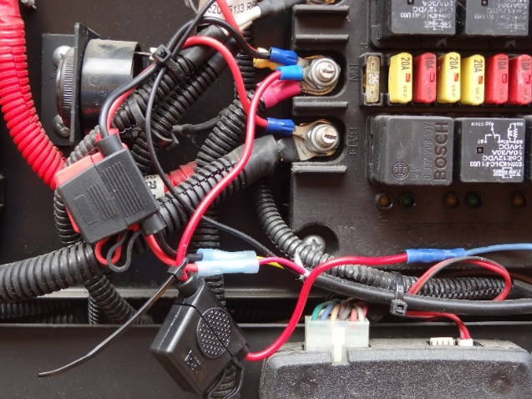
Install Hinge Frame
- PRIOR TO INSTALL, MAKE SURE NO SCREWS WILL PENETRATE A CABLE WITHIN THE BUS! On a Thomas C2, be sure that the multiplex wire harness behind the driver’s seat will not be penetrated. If screws are going into the rib behind the seat, pull the multiplex out beforehand. Cap any screws that go into the rib to ensure the multiplex will not be damaged. Alternatively, move vertical support to the left a few inches.
- Install Vertical Support Bar, must be vertical, use yellow bus siding panels as guide. Pre-drill with 9/64” drill bit.
- Use 1” x #12 self-tapping stainless steel screws or 1-1/4” x #12 if necessary.
- On a Freightliner FS65, the Vertical Support Bar can be attached at the same point as the Specialty Box. Remove the #14 screws at the left edge of the Specialty box and attach the vertical support bar underneath. If any rivets or screws interfere with a tight fit against the side of the bus, remove them. Replace the screws, or (preferably) use longer (at least 1”) #14 screws if the original screws are shorter than 1”.
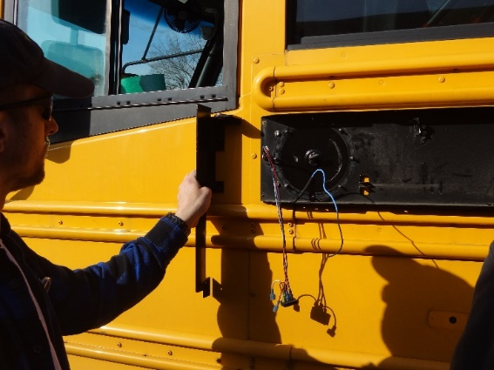
- The topmost attachment should be marked, drilled to 9/32”, and a Nutsert used to securely anchor the vertical bracket. Carefully follow Nutsert tool instructions. On a Freightliner FS65, mark the Nutsert point underneath where the top left tab will rest, drill the 9/32” Nutsert hole in the bus, and drill a 3/16” hole in the tab to fit the Nutsert bolt.
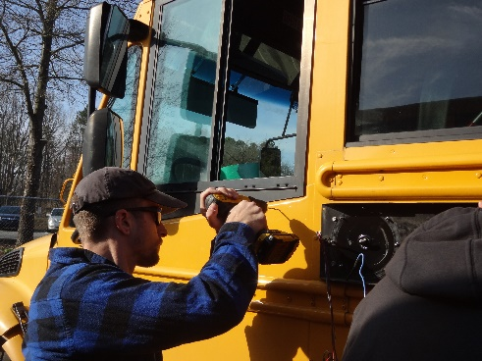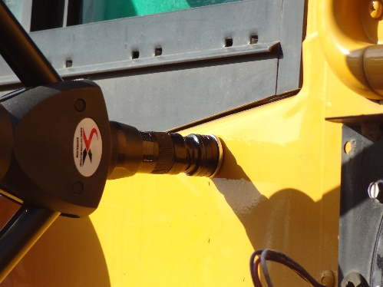
- Once the vertical support bar is attached with Nutsert bolt and self-tapping screws, attach the hinge plate.
- Remove the top collar and nylon washer.
- Push the ½”hinge shaft through the top bearing, add nylon washer and shaft collar with pre-drilled hole.
- Insert cotter key and tighten shaft collar with red Loctite using an Allen wrench.
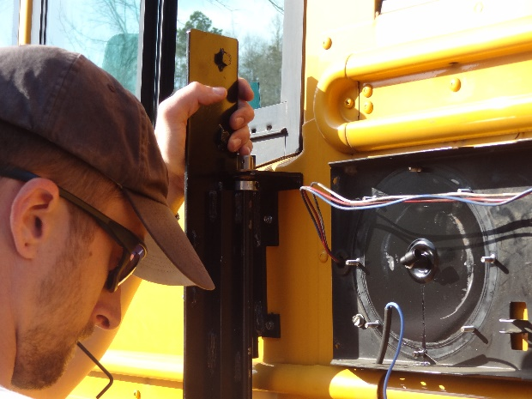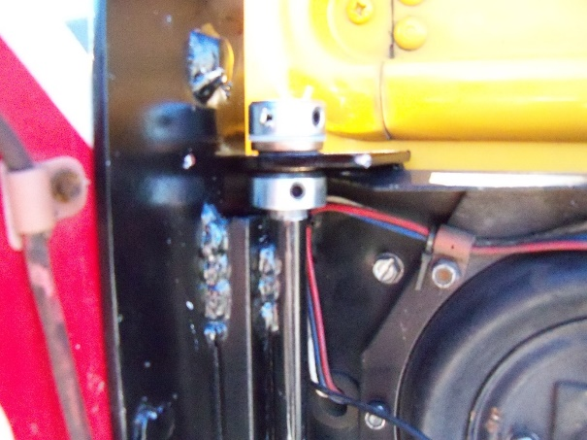

Connect the Lower Support Bar
- Remove any rivets or screws that may be behind the bar.
- You may have to move any lights or cameras that may be mounted in the way of the bar.
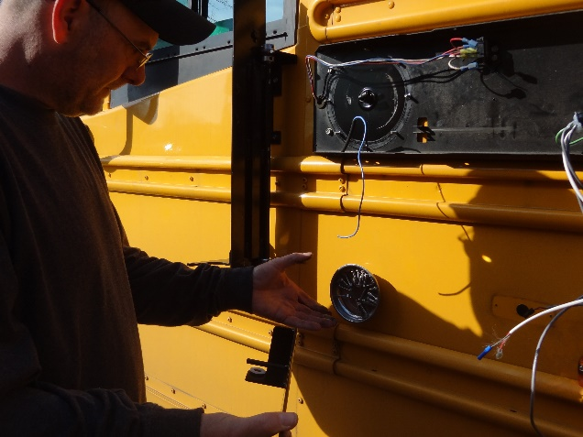
- Install lower support bar with a shaft collar and nylon washer underneath (resting between the shaft collar and brass bushing). Press up slightly to make lower shaft collar hold some of the support before tightening. The bottom of the hinge shaft must be flush with the bottom of the brass bushing.
- Install 2 of the 1” x #12 self-tapping screws in the middle area of the lower support, and then test hinge to make sure it is swinging freely. Lower support must be parallel to bus ribs and tight to Vertical Support Bar at left side, forming a 90-degree angle.
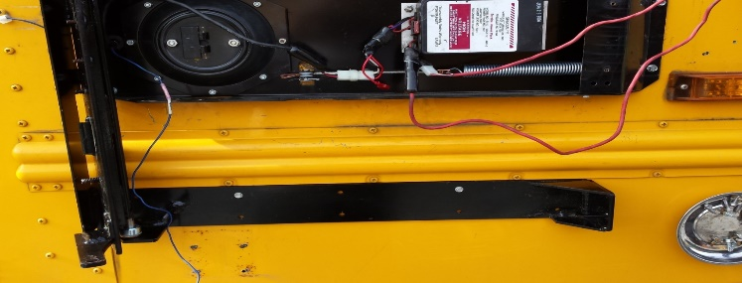
- Attach the bar to the bus using #12 x 1” self-tap screws.
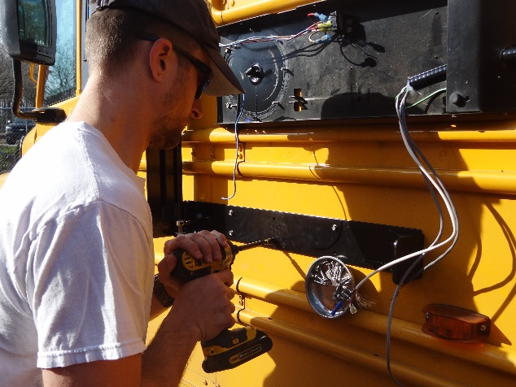
- Tighten the bottom shaft collar with Allen wrench
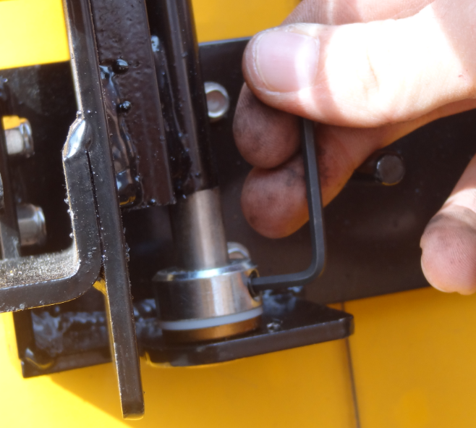
- The Vertical Support Bar has 2 pre-drilled holes at the bottom left corner. Using one of these holes as a guide, drill a ¼” hole in Lower Support to attach to Vertical Support Bar and install ¼” x ¾” bolt and nut with nylon insert lock nuts. Make sure that the vertical piece does not protrude beyond the lower brace or it will interfere with the operation of the arm.
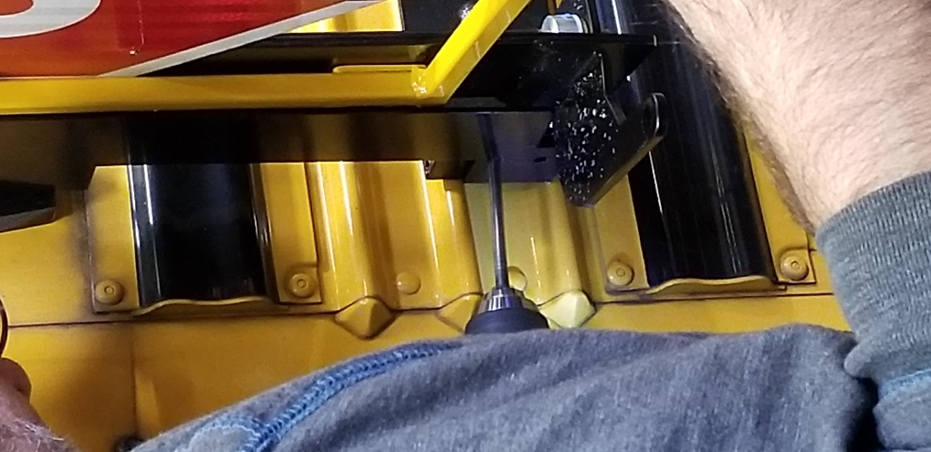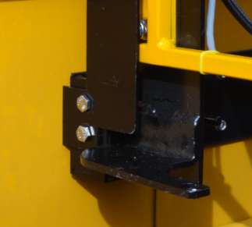
Connect Air Hose
- Locate an external supply for the air. In most cases this will be at the entry point to the bellows. There must be enough screw left to attach a steel elbow. A screw extractor can be used to expose more threading. Usually 2 – 3 threads is enough to connect the elbow securely. Apply pipe thread sealant and secure elbow with a 13mm wrench.
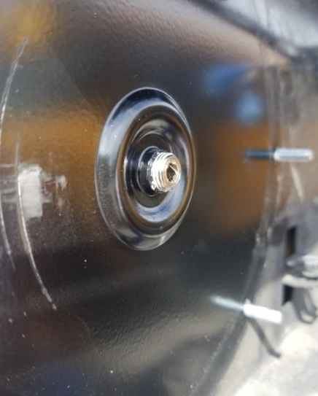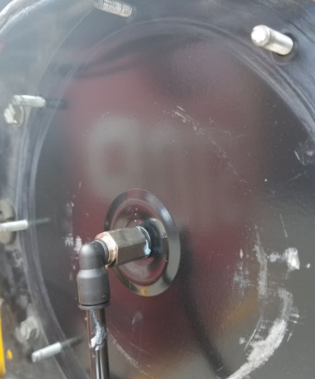
- If there are any issues with the bellows entry point, take the Specialty box off the bus and check the connection in the back. If need be, remove the piece and feed the air hose from the bus straight through the hole. Use a tube-to-tube ¼” elbow instead of the steel elbow.
- On older FS65s, tubing can often be run straight through the entry pipe.
- If the bus has a second rear stop arm, you must run a separate air line. To prevent leaks, remove three screws from the Specialty box so it swings freely, cut the air line behind the box, and cap it off. Replace the Specialty box.
- If the bus has a second rear stop arm, drill another 5/16” hole in the side of the bus, into the switch panel inside. Run the new air line through the hole and feed underneath the switch panel and down to the air supply behind the floor panel.
- 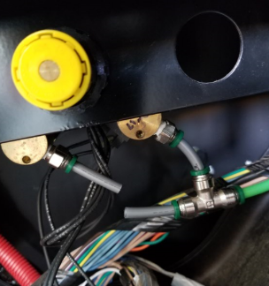
- Locate the air control and supply line. For one stop arm, remove the line to the bellows from the back of the regulator and bypass the regulator and solenoid completely. Tie this line—or your brand new one, if two stop arms—directly into the supply line with a ¼” tube-to-tube connector. Use either a straight coupling or a tee (3-point) connector, whichever is needed. Make doubly sure to tie into the supply line before any solenoids/regulators; the Extended Stop Arm needs constant, full pressure to function properly when running.
If the bus has a second rear stop arm, replace the rib on the side of the bus and proceed with installing the hinge frame (pg. 5).
Install Air Solenoid and Cylinder Assembly
- The air system solenoid, hoses, and cylinder have been pre-assembled and tested in our shop. You will not have to adjust any fittings for tightness or spray test with fluid for leaks.
- The air solenoid is mounted on a bracket. Position the bracket so that the solenoid, hoses, and cables fit comfortably in the box. It can usually be mounted on one of the diaphragm mount bolts using one of the nuts saved from earlier.
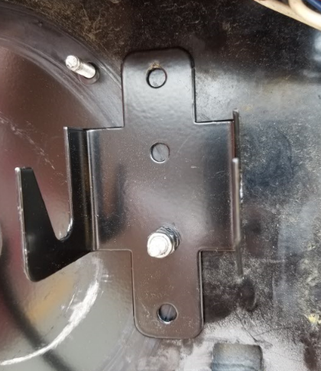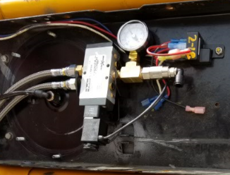
- Using a 7/16” bolt and nut, loosely connect the back piece of the cylinder to the mount on the right side of the lower support. Do not tighten yet.
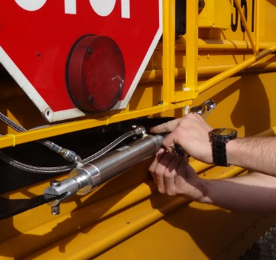
- Connect the air hose from the elbow to the solenoid.
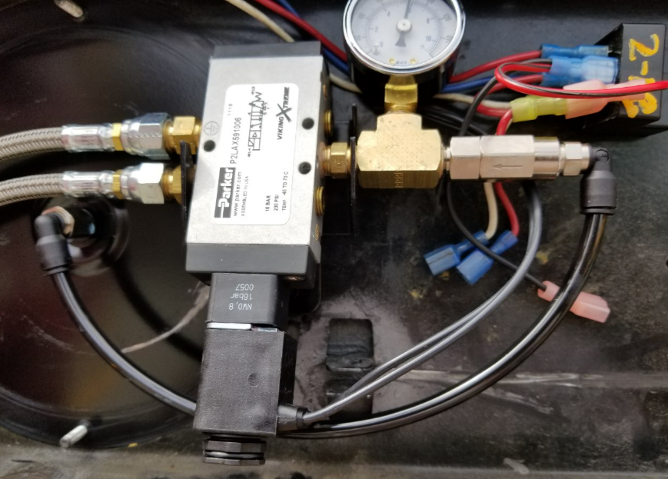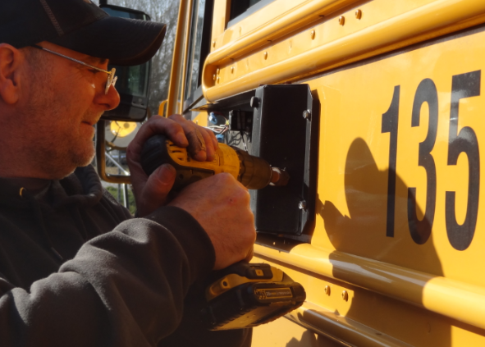

Install Control Box and Board
- Drill a 7/8” entry hole into the lower right side of the Specialty box. Position the hole so that the wiring harness and box will fit parallel to the Specialty box. Use a ½” steel pipe (7/8” OD) to bend the hole parallel—push the pipe toward the bus. This ensures a good fit for the plastic box; too much torque can bend it out and compromise the watertight seal with the lid.
- Run the wiring harness and cables through the hole and attach the control box to the bus using four #12 x 1” screws.
- If the control box covers any numbers, new decals will need to be applied.
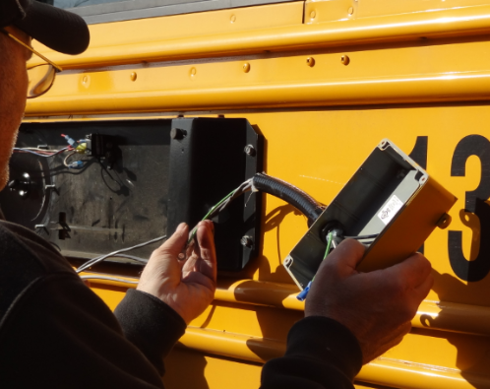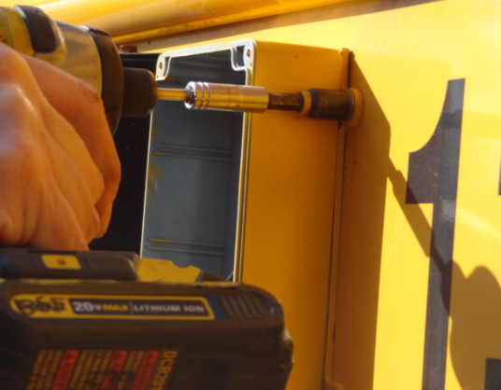
- Connect the Mini-USB connector for the lights to the board, then attach the control board to the box using the double-sided tape pre-applied to the back of the electronic board. The board will typically be positioned in the box at a slight angle.
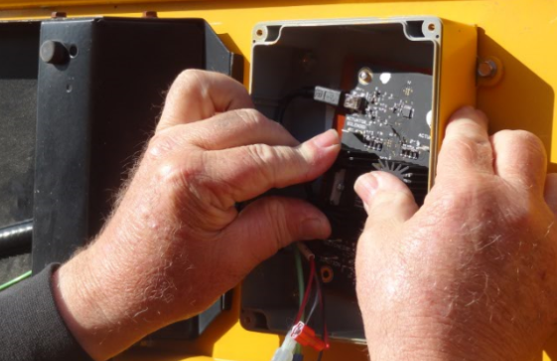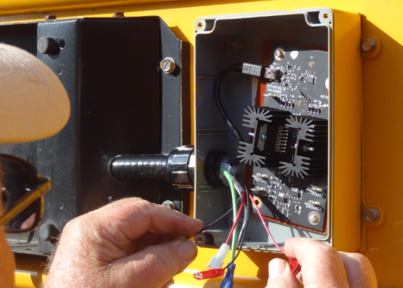
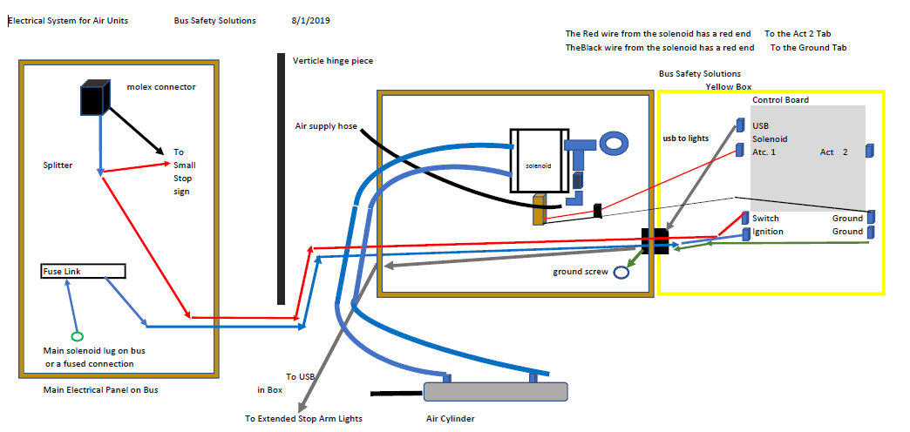
Connect the remaining wiring.
- The thin red solenoid wire attaches to SOLENOID terminal.
- The thin black solenoid wire attaches to GROUND1 terminal.
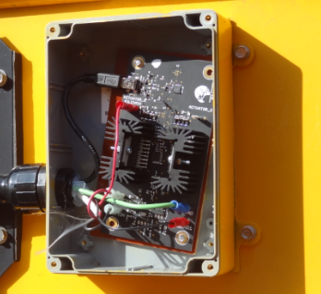
- The Green Ground wire connects to the GROUND terminal
- The thick black wire attaches to the IGNITION terminal

- The thick red wire attaches to the SWITCHED terminal

Run Wiring and Electrical Connections
- On an FS65, connect a high-voltage splitter to the topmost connection—the one with the black cable leading back inside the bus, not to the sign lights.
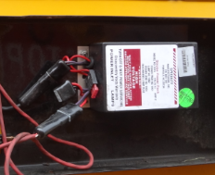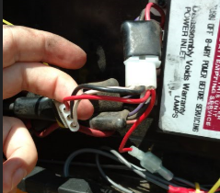

- On a C2, plug a standard splitter into the connection between the relay and the red wire from the sign lights.
- Plug the red switch line with a female end into the splitter.

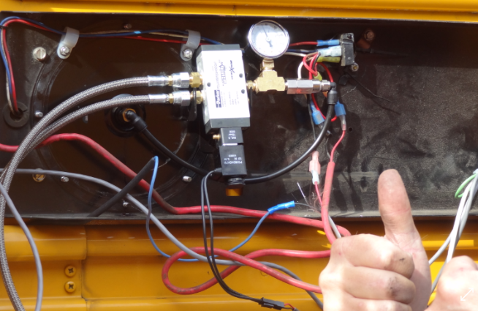
- Connect the Molex connector to the air Solenoid module.
- Connect the black power line to the 12-Volt source using the attached butt connector.
- Attach the green ground connector using a self-tapping screw into the Specialty box bus siding.

Install Frame & Signs
- Attach original sign to the hinge plate using 4 original ¼” locknuts.
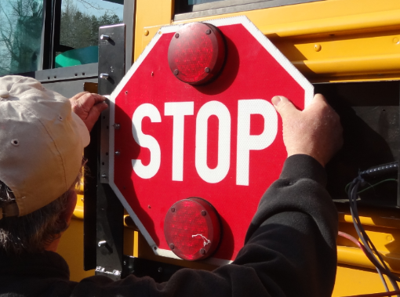
- Reconnect sign lights normally with a high-voltage box. With a C2 relay, reconnect the black wire to the usual place (should be a white wire coming from the relay) and the red to the switch splitter.
- Attach steel frame to the vertical frame using three 3/8” locknuts found on hinge plate.
- Fit tabs on frame to opposite sides of original stop sign.
- Tighten with 9/16” nut driver.
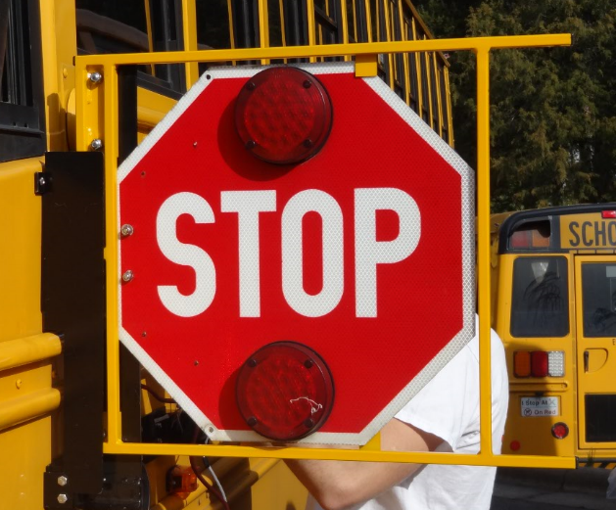
- Attach Extended Stop Arm to steel frame.
- Align using steel ¼” round studs, once aligned, hold with vice grip, or an additional set of hands.
- Secure using two 5/16” nylon bolts and 2 nylon nuts.

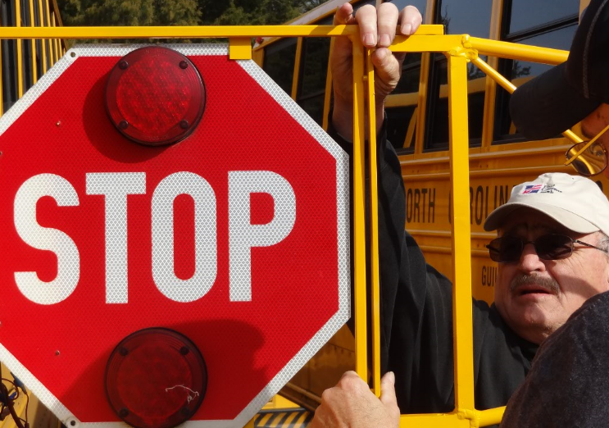

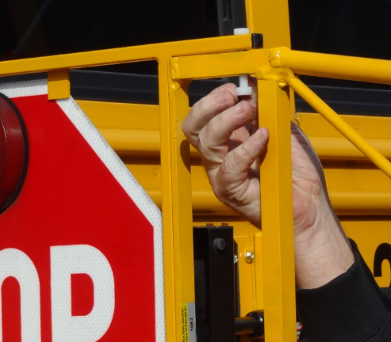
- Tighten nylon nuts to snug with a wrench. Do not overtighten.
- Connect electrical harness to extended stop arm using harsh environment ATM connector
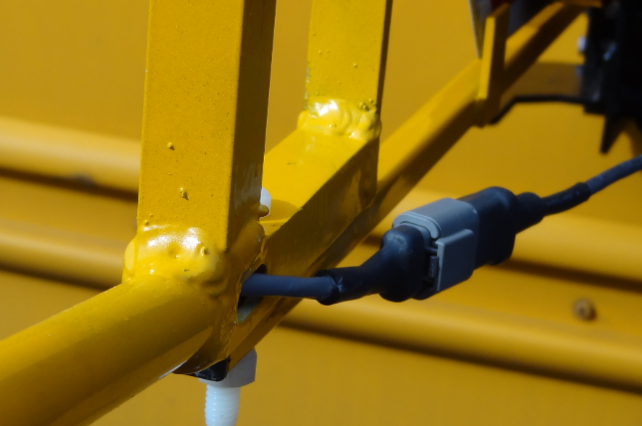

- Attach electrical harness to bottom of steel frame using 3 yellow zip ties
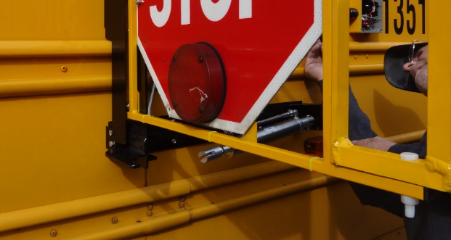
Install Bumper
- Position rubber bumper vertically at the point of the bar connecting sign to frame.
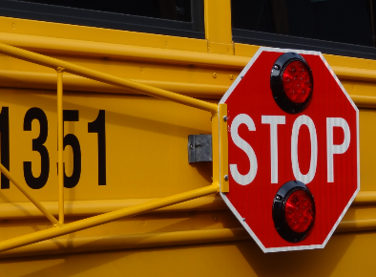
- Attach with 2 stainless steel sheet metal screws. One on either side of bumper.
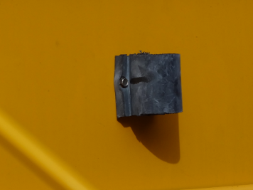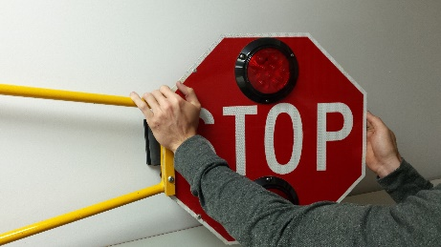
- Adjust sign by bending it slightly away from bus to ensure lights do not hit the bus when closing.

Button Up
- Use black zip-ties to secure all cabling and hoses.
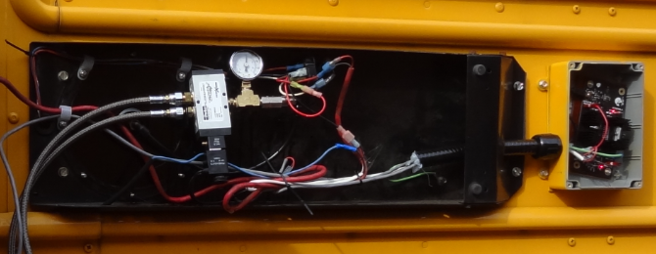
- Close up Specialty box front plate using original screws.
- Attach new left cover plate using 1” x #12 self-tapping screws.
- Ensure that electrical wires and air tubes are protected by rubber grommets.
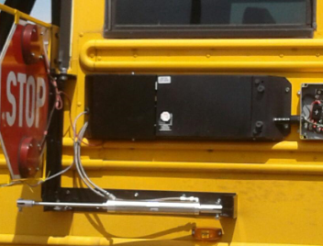
- Close arm and secure cylinder nose piece to hinge with a 7/16” clevis pin and 1/8” x ¾” cotter key.
- Adjust cylinder tail piece to ensure a reasonably tight fit against the bumper and tighten 7/16” bolt and nut.
- Run through installation checklist to ensure that all items are complete.
- Ensure that bus driver is aware and trained on using their new Extended Stop Arm.

From your Friends at Bus Safety Solutions
Please Call 336-671-0838
If you have any problems with the installation

