Bus Safety Solutions

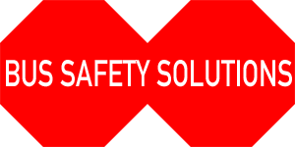

Installation Manual

Extended Stop Arm v. 4.0

Electric Actuator System

**Blue Bird**



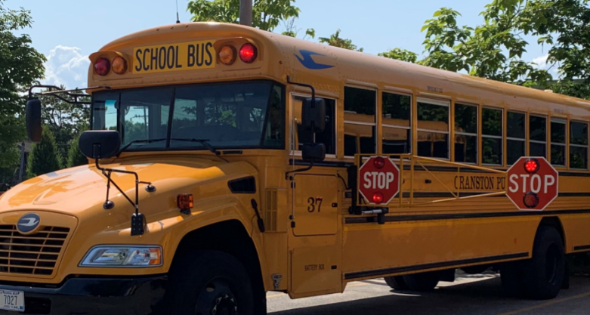

**Contents:**

* Tools Needed
* Removal of Specialty Stop Arm
* Run Electrical Power Connection
* Install Hinge Frame
* Install Control Box and Board
* Run Electrical Connections
* Install Frames & Signs
* Install Bumper
* Button Up

**Tools and Supplies Needed**

* Safety Glasses
* Work Cart
* Magnetic dish
* Tape measure
* Small Level
* Impact Driver
* Drill Motor
* Assorted nut drivers
* #2 Philips Bit, #3 Philips Bit
* Assorted drill bit set
* 7/8” Conduit Hole bit
* 9/64” Steel bit
* ¼” Steel Bit
* 5/16” Steel Bit
* Hammer (14 oz)
* Hammer (2 lb)
* Vice Grip – Small & Large
* Utility Knife
* Needle Nose Plyers
* Cold Chisel
* #2 Philips head screwdriver
* #3 Phillips head screwdriver
* Flathead screwdriver
* 2 - ½” Wrenches
* 2 – 5/8” Wrenches
* 2 – 7/8” Wrenches
* 1/8” Allen Wrench
* Socket Set
* 1/2” NPT Steel Pipe (7/8” diameter) 8” Long
* Electrical Wire Crimping Tool
* Electrical Wire Stripping Tool
* Electrical Multi-Meter
* Clear Exterior Silicone
* School Bus Yellow Exterior Silicone
* Nutsert tool

Revised: 8-22-2019

**Removal of Electric Specialty Stop Arm**

* Carefully remove the entire existing Electric Specialty stop arm.
* The original sign and wiring harness will be re-used with the Extended Stop Arm.
* Save all parts – some for re-use later, others as replacement in your inventory.
* Many of these parts marked as “discard” can be re-used in your parts inventory.

**Install Hinge Frame**

* PRIOR TO INSTALL, MAKE SURE NO SCREWS WILL PENETRATE A CABLE WITHIN THE BUS!
* Install Vertical Support Bar, must be vertical, use yellow bus siding panels as guide. Pre-drill with 9/64” drill bit as needed.

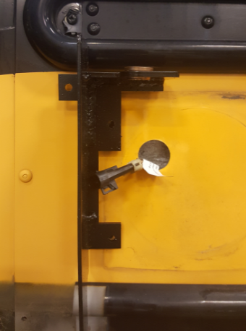

* Use ¾” x 12 self-tapping stainless steel screws or 1-1/4” x 12 if necessary. With some bus models the Vertical Support Bar can be attached at the same point as the Specialty Box. Be sure no rivets or screws interfere with a tight fit against the side of the bus, if so remove them.
* The top left attachment should be marked, drilled, and a Nutsert used to securely anchor the vertical bracket. Carefully follow Nutsert tool instructions.

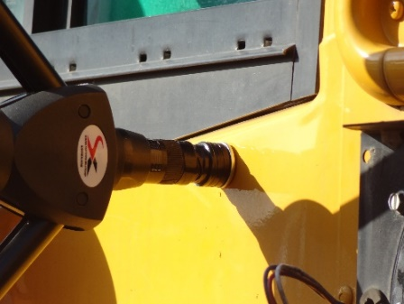

* Once the vertical support bar is attached with Nutsert bolt and sheet metal screws, attach the hinge plate.

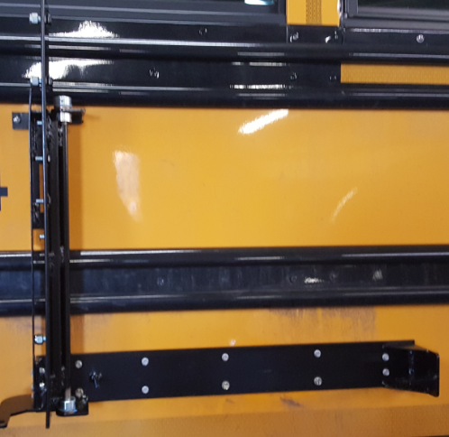

* Remove the top collar and nylon washer.
* Push the hinge pin through the top bearing, add nylon washer and shaft collar with pre-drilled hole.
* Insert cotter key and tighten shaft collar with red Locktite using an Allen wrench.

**Connect the Lower Support Bar**

* This bar should be attached below the rib, and at a 90-degree angle to the vertical frame.
* Remove any rivets or screws that may be behind the bar.
* You may have to move any blinkers or cameras that may be mounted in the way of the bar.
* Install lower support bar with a shaft collar and nylon washer. Press up slightly to make lower shaft collar hold some of the support before tightening. Install 2 of the 1” x 12 self-tapping screws in the middle area of the lower support, and then test hinge to make sure it is swinging freely. Lower support must be parallel to bus ribs and tight to Vertical Support Bar at left side.
* Attach the bar to the bus using #12 x 1” sheet metal screws and rivets.
* Bottom shaft collar should rest on nylon washer
* Tighten the bottom shaft collar with Allen wrench

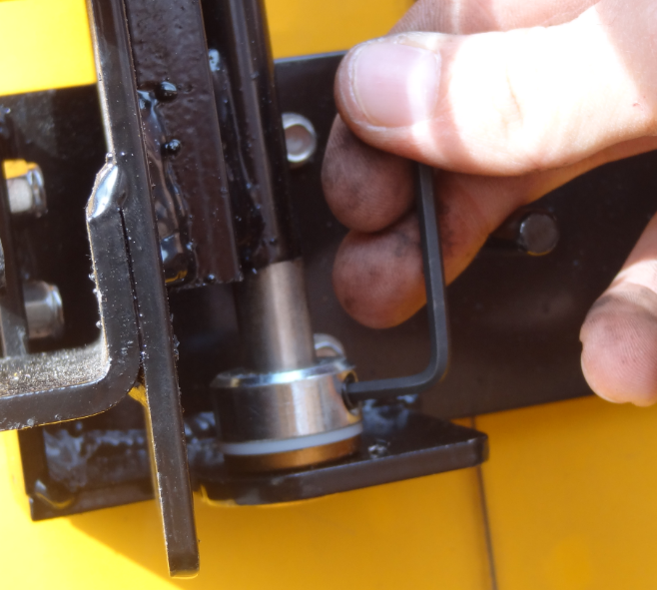

* The Vertical Support Bar has 2 pre-drilled holes at the bottom left corner. Using one of these holes as a guide, drill a ¼” hole in Lower Support to attach to Vertical Support Bar and install ¼” x ¾” bolt and nut with nylon insert lock nuts. Make sure that the vertical piece does not protrude beyond the lower brace or it will interfere with the operation of the arm.

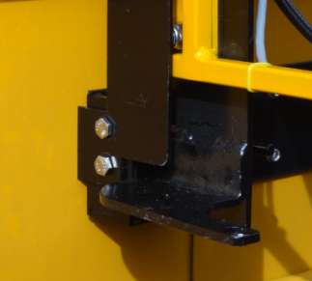

**Install Control Box and Board**

* Run the wiring harness and cables through the hole and attach control box to the bus using 4 screws.
* If the control box covers any numbers, new decals will need to be applied.

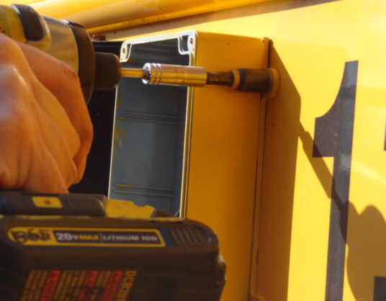

* FIRST, connect the Min-USB connector for the lights to the board, then attach the control board to the box using the double-sided tape pre-applied to the back of the electronic board. The board will typically be positioned in the box at an angle.

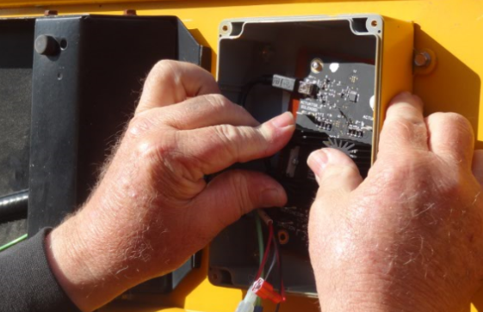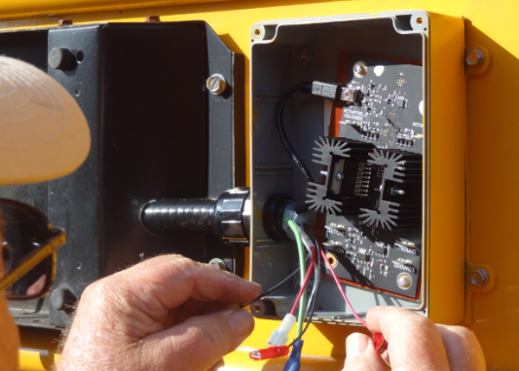

**Connect the remaining wiring**.

* The Green Ground wire connects to the GROUND terminal
* The thick red wire attaches to the SWITCHED terminal
* The thick black wire attaches to the IGNITION terminal

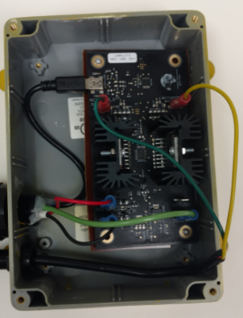

* When attaching the two wires from the actuator, the green wire goes to ACTUATOR_1
* The Yellow wire goes to ACTUATOR_2
* Screw on the cover plate using the provided screws.

**Run Electrical Power Connection**

* The Extended Stop Arm requires a 12-Volt power source. This can be found in the electrical panel in a Blue Bird.
* On the Blue Birdequipped with an electric arm, run the power wire through the same hole that the Specialty light wires are located. This will typically require using a stiff wire to help fish the power wire through the siding and behind the rib of the bus.
* Connect the wire to an accessory block and insert a 15-amp fuse
* If the block is not present or functioning, connect to the solenoid and use an in-line 15-amp fuse.

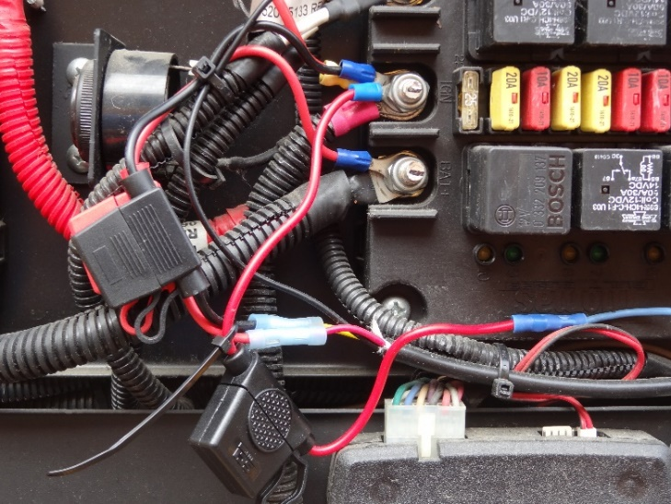

R**un Electrical Connections**

* Connect a splitter (supplied) to the blue switch wire for the Specialty lights.
* Connect the black power line to the 12-Volt source using a butt connector.
* Attach the green ground connector using a self-tapping screw into the bus siding.

**Install Frames & Signs**

* Attach original sign to the hinge plate using 4 original ¼” nylon nuts

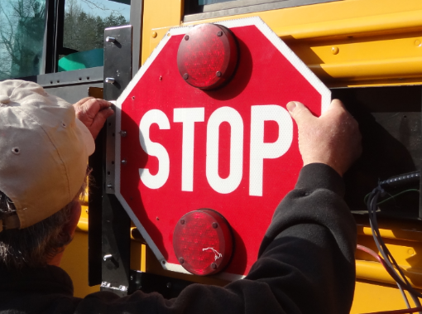

* Attach steel frame to the vertical frame using 3 3/8”nylon insert nuts found on hinge plate.
* Tighten with 9/16” nut driver.
* Alternate tabs on frame to either side of original stop sign.

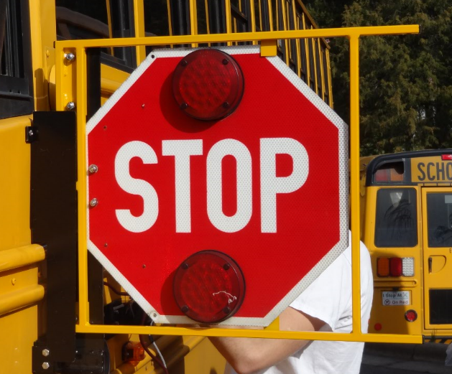

* Attach Extended Stop Arm to steel frame.
* Align using steel ¼” round studs, once aligned, hold with vice grip, or an additional set of hands.
* Secure using 2 5/16” nylon bolts an 2 nylon nuts

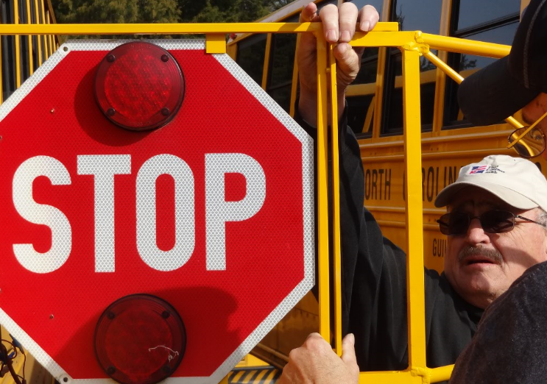

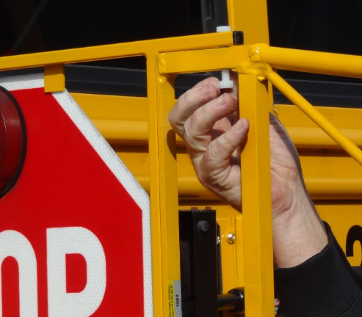

* Tighten nylon nuts to snug with a wrench. Do not overtighten.
* Connect electrical harness to extended stop arm using harsh environment ATM connector

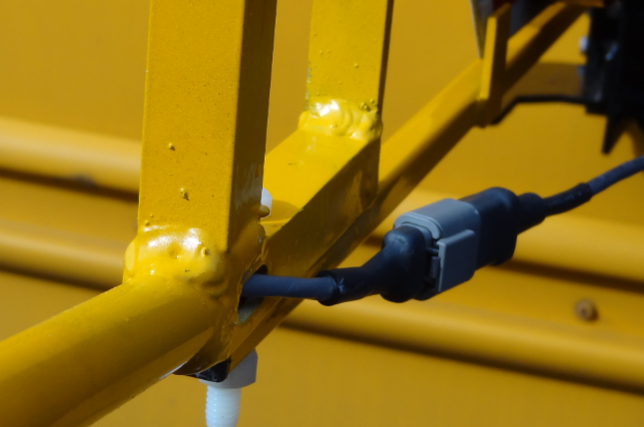

* Attach electrical harness to bottom of steel frame using 3 yellow zip ties

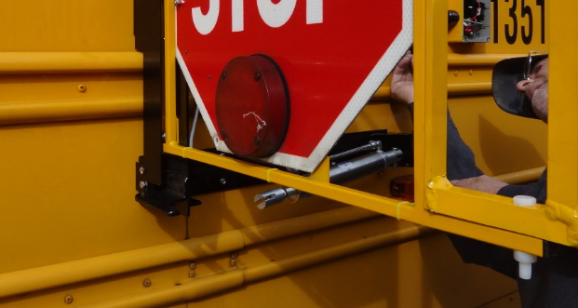

**Install Bumper**

* Position rubber bumper vertically at the point of the bar connecting sign to frame.
* 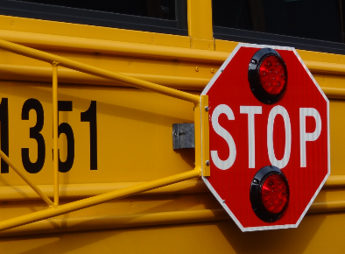 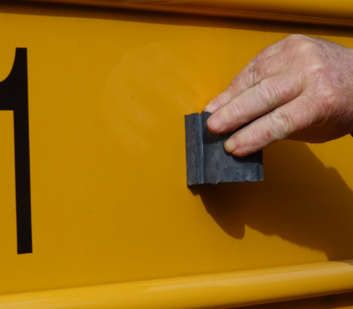
* Attach with 2 stainless steel sheet metal screws. One on either side of bumper.
* Adjust sign by bending it slightly away from bus to ensure lights do not hit the bus when closing.

**Attach Electric Actuator**

* Connect front actuator to steel hinge frame using clevis pin.
* Connect rear of actuator using 7/16” bolt, nylon washer and nut
* Nose piece may be unscrewed to adjust the tension of the actuator – adjust in closed position.

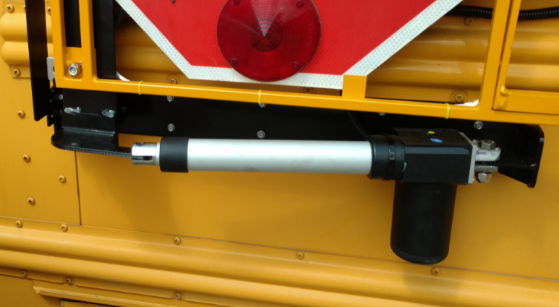

* Tighten bolt once you confirm arm is working well.
* Secure clevis pin with cotter key

**Button Up**

* Run through installation checklist to ensure that all items are complete.
* Ensure that bus driver is aware and trained on using their new Extended Stop Arm.
* Place driver placard on dash
* Return Registration Card to Bus Safety for Warranty Purposes

From your Friends at Bus Safety Solutions

**Please Call**

if you have any problems with the installation 336-671-0838