ROYER COOPER COHEN BRAUNFELD

Who We Are
Full-Service Law Firm: Serving clients globally from offices in the Greater Philadelphia region, New York, and Nashville
Client-Focused Solutions: Practical, business-minded legal solutions to entrepreneurs, growth companies, investors, individuals, and families
Anchored by Experience: Founded in 2012, now 70+ lawyers strong, including former business owners, GCs, and operational leaders – bringing real-world perspective to complex matters
Aligned Interests: Promoting a collaborative, results-driven relationship

Core Practices

- Business Restructuring & Bankruptcy
- Corporate & Business
- Employee Benefits & Executive Compensation

- Employment Law
- Family Law
- Intellectual Property
- Litigation

- Nonprofit & Tax-Exempt
- Private Client Services
- Real Estate
- Tax

Sampling of Industries

Business Services

Consumer Goods and Services

Education

Emerging Company & Venture Capital

Energy

Financial Services

Gaming

Hospitality

Industrial

Insurance

Life Sciences

Manufacturing and Distribution

Mid-Cap and Middle Market

Private Equity

Public Companies

Real Estate

Retail

Software and IT

Sports, Entertainment, and Media

Transportation and Logistics

Waste Management

Recognitions
Chambers USA | Legal 500 Elite | Best Lawyers & Best Law Firms in America | Legally Israel 100 Super Lawyers | World Trademark Review 1000 | World Intellectual Property Review
Pennsylvania Law 100
Recognized as the Fastest Growing Law Firm by Percentage of Attorneys
RCCB LOCATIONS

Philadelphia
Three Logan Square
1717 Arch Street
Suite 4700
Philadelphia, PA 19103

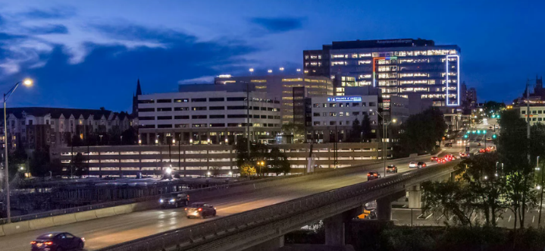
Conshohocken
101 West Elm Street
Suite 400
Conshohocken, PA 19428


New York
1120 Avenue of the Americas
4th Floor
New York, NY 10036


Nashville
1316 Adams Street
Suite 220
Nashville, TN 37208ite 220
Nashville, TN 37208

