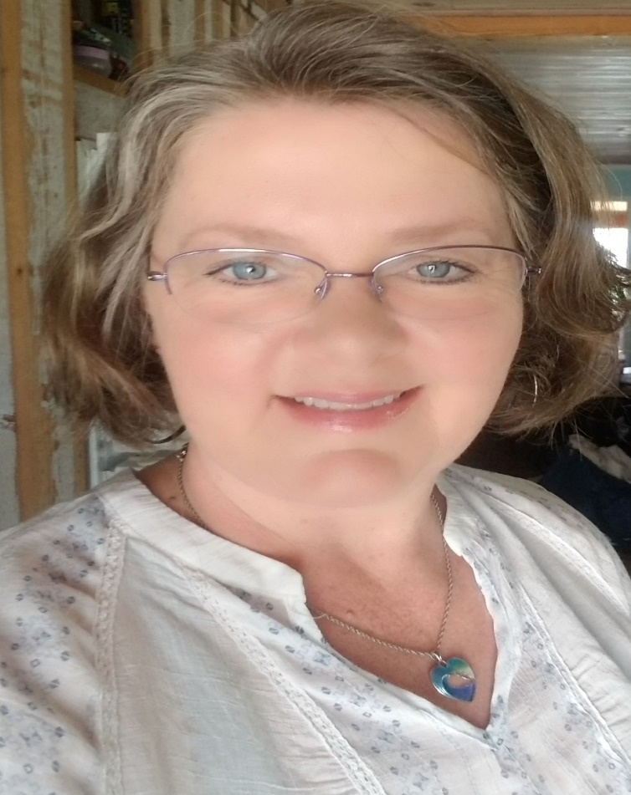

About
S.G. Boudreaux began writing clean fantasy, fiction, and time-travel in 2017. She felt people needed a clean choice option when reading these genres. Her love of the genres began with Star Wars when she was young, and her inspiration for clean writing stems from other authors such as C.S Lewis, and J.R.R. Tolkien.

Available for
Digital or in person interviews-within a reasonable driving distance. Approximately 3 hours - one way
Also available for speaking engagements for women's events, or school lectures

Previous Interviews, Topics for Speaking, and FAQs
Please look under the More Tab/Book Trailers and Interviews, for recordings of previous interviews.

Topics on which I can speak
- Allowing God to use you in your current situation.
- Overcoming obstacles and fears
- Raising Children with special needs
- Creating complete worlds for your fiction/fantasy novel
- Coming up with names for your characters and creatures
- Telling a captivating story
- How to Indie publish
- Upcycling items into something new

FAQs for me?
- How does Christian or faith-based fiction work?
- Why did you start writing fantasy?
- Why did you Indie publish instead of going traditional?
- How do you create your worlds?
- Where did you find your inspiration for your first book series?
- Are you a Planner or Pantster?
- Why did you start using books to create art?

