November 4, 2018
31.st Sunday in Ordinary Time
First Reading. Dt. 6:2-6
Second Reading. Heb. 7:23-28
Gospel. Mk 12:28b-34

Love is the fulfillment of the law

The question posed in today’s Gospel requires Jesus to interpret the Law of Moses. The Mosaic Law consists of the Ten Commandments and many additional commandments, numbering into the hundreds. For a devout Jew, adherence to the Mosaic Law is an expression of faithfulness to God’s covenant with Israel. The ranking of these commandments was regularly debated among the teachers of the Law.

Jesus was not the only Jewish religious teacher to connect these two commandments, love of God and love of neighbor. Both of these commandments were central elements of the religious tradition that Jesus learned from his Jewish community. Indeed, these commandments continue to be central aspects of contemporary Jewish religious understanding.

Jesus’ response to his questioners proposed an integral connection between these two aspects of the Jewish Law. Love of God finds its expression in our love for our neighbor. Many believe, however, that this connection was heard in a new and fresh way when spoken by Jesus.

The scribe who questions Jesus in today’s Gospel engages in a positive dialogue with Jesus. He agrees with Jesus’ teaching that the commandments to love God and love neighbor stand above the commandment to offer worship and sacrifice in the Temple.

With this dialogue, Jesus appears to close the debate with the Jewish authorities. Mark reports that no one dared to question Jesus further.

Today: Feast of St. Charles Borromeo

In a letter of 1892 to the first Scalabrinian Missionaries the founder, John Baptist Scalabrini chose for them their patron saint: "One day, after praying to the Lord in this regard and beseeching light from the Holy Spirit, the figure of the great St. Charles came into my mind more radiant and gentler than ever.

The more we study, read, know and hear about what Borromeo did, the more we are led to believe that the most probable key to his extraordinary stature lies in his function as shepherd, which he exercised with his eyes on the one and only Good Shepherd, Jesus Christ, so that he perhaps came closer than anyone else has done to the image described in Chapter 10 of St. John's Gospel.
He organized the whole care of souls with new structures which survived almost down to our own days, establishing very close relations between faithful and bishop and between faithful and priest as a cornerstone. Both bishop and priest had to know the baptized, helping them, nourishing them with sound doctrine, freeing them from ignorance, correcting them in their errors, punishing them for abuses if necessary, and assisting them if they needed it.

Living alongside the people - hence the obligation of residence for parish priests and bishops and the example he set in this regard - became a primary commitment for St. Charles, allowing him to obtain a deep knowledge of the virtues and vices, needs and capacities of his people. He then issued a series of practical dispositions on the basis of this knowledge, ranging from exhortations to orders .... And before acting with ordinances and corrections, he would act by setting a good example. He always walked before his flock and was always the first to do what he asked, following Christ's example of "doing and teaching" (Acts 1:1). And Christ and his gospel became the reference point for St. Charles' every action and every ordinance ..."
Masses for the Week
November 3, 2018 – November 10
Saturday, November 3
6:00 p.m. (English)
+Robert Covarubias by Beth Covarubias
+Aquiana Brown
For the good health of Nestor Deasis
Sunday, November 4
9:30 a.m. (English/Spanish)
People of the Parish
11:00 a.m. (Italian)
+Bernardo Foschetti by Foschetti and Gallidoro Families
+Socorro Capra by Children and Grand children
For the deceased members of San Trifone Society
6:00 p.m. (English)
People of the parish
Monday, November 5
6:00 p.m. No Mass
Tuesday, November 6
6:00 p.m. +Ennio Capra by Clelia & Michelena
Wednesday, November 7
6:00 p.m. +Ennio Capra by Filomena Capra
Thursday, November 8
6:00 p.m. +Ennio Capra by Antonio & Nelda Capra
Friday, November 9
6:00 p.m. People of the parish
Saturday, November 10
6:00 p.m. People of the parish

Did you know we have Vespers at 5:45 p.m. Tuesday – Friday
Adoration: Thursdays 6:30 p.m.- 7:30 p.m.

Dates to Remember
November 4, Feast of San Trifone
11:00am mass followed by procession.
Dinner and dancing 1:00
Contact Mike Foschetti: 323-257-0302
November 7, St. Anthony Meeting
6:30 p.m. Contact Robert Masters (818)5219224
November 11, All parish brunch
After 11:00 a.m. mass. All are welcome.
All proceeds benefit St. Peter.
November 17, Sacred Heart kick off of the Holiday season. After evening mass. Please contact Ada Iezza (626) 359-4301, Mary Lou Santillo-Jones (818) 632-4437 or Maria D’Egidio (562) 947-2819
November 18, Small feast of Costantinopoli contact Joe Deligio: (626) 261-9848
November 19, Preparation of Thanksgiving baskets 6:30 p.m. at Casa Italiana
November 20, Liturgy, basket distribution and Thanksgiving fiesta. 10:00a.m. Casa Italiana
Visit St. Peter's website: http://stpeteritalianchurchla.org

SCALABRINI OUTREACH PROGRA M
THANKSGIVING BASKETS AND FIESTA
Thanksgiving celebration: We invite you to share in God’s goodness and blessings by helping us prepare 400 baskets for economically vulnerable families.
We need non-expired canned goods of any kind, turkeys and donations.
Preparation: Monday, November 19th at 6:30 p.m. Basket distribution, Liturgy & meal: Tuesday November 20th at 10:00 a.m.
Other ways you can donate time:
Food pantry: 2nd Friday of the month, 4:00 p.m.
Hygiene kit preparation: 2nd Tuesday of the month, 2:30 p.m.
Homeless outreach: 4th Saturday of the month. 8:00 a.m.
Food preparation twice a month during the week. Contact office for days.
ADULT CONFIRMATION CLASSES WILL BEGIN WEDNESDAY JANUARY 16, 2019

St. Peter’s will offer a seven week Adult Confirmation Preparation process during the Lenten Season. The course is open to persons who have reached their 18th birthday, have been baptized in the Catholic church, have not yet received the Sacrament of Confirmation.
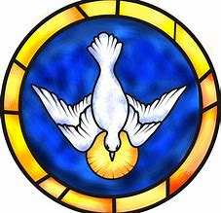
Interested parties must pre-register and provide a copy of your baptismal certificate.
Contact Fr. Louis Piran, c.s. to register
323-225-8119

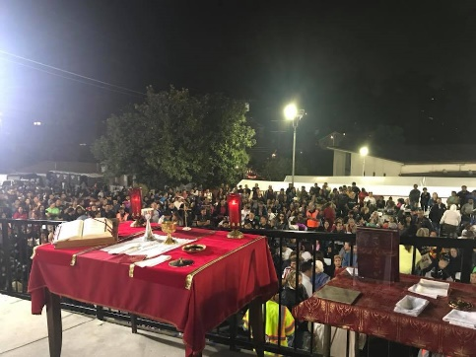
Thank you to all who volunteered and participated in the annual Feast of St. Jude last Sunday.
The celebration was shared by approximately 1,500 people.

Last week's offerings
Offerte Della Settimana Scorsa
Last week's Offering: $1,047.00
**Offerta settimanale necessaria per far fronte alle spese ordinarie
Weekly offering needed to meet basic expenses
- $2,950.00-

