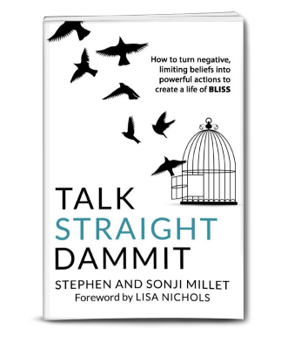

TALK STRAIGHT DAMMIT:
How to turn negative limiting beliefs into powerful actions to create a life of BLISS
By Stephen and Sonji Millet
(with foreward by Lisa Nichols)

Guidance to Get of Your Own Way by Transforming Your Inner and Outer Dialogues
Presented by a Dynamic Husband and Wife Team

Stephen and Sonji Millet have been through the wars—dysfunctional childhoods, multiple marriages, job displacement and dissatisfaction, the challenges of co-parenting, depression, relationship friction—but individually and together they overcame ALL of it by commanding themselves to TALK STRAIGHT DAMMIT!

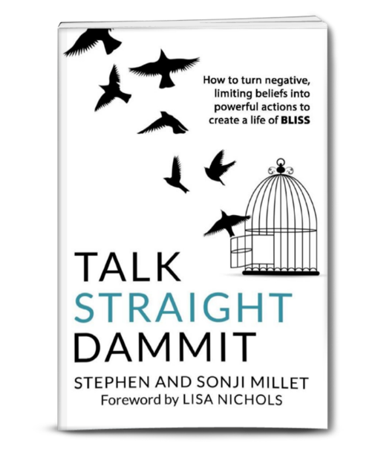
That’s talking straight to their negative, disempowering, blaming inner voice, and transforming that clarity into their greatest asset—and talking straight to everyone else in their lives, whether that was co-workers, bosses, family members, spouses, children, friends or lovers.

Today, they have created a life of BLISS, which they define as the freedom to love and be loved in abundance, with complete forgiveness and without judgment. BLISS also derives from their concepts of BOLD, LEVERAGE, INSPIRED, SELF and START NOW—the steps that lead to that freedom and joy.

Their book, TALK STRAIGHT DAMMIT: How to turn negative limiting beliefs into powerful actions to create a life of BLISS, with a foreward by Lisa Nichols, provides a compassionate, but no-nonsense approach to stepping into one’s truth and power.

Stephen and Sonji bring two unique perspectives to personal growth that is in short supply and which may resonate with many...their African American cultural experience and that of marriage and relationship partners together offering their tested and successful approach as a team from both the male and female aspects.

Together and individually, Stephen and Sonji, have used themselves as laboratories to find the solutions to turning obstacles into opportunities. In the book, they each recount stories of lessons learned, fresh paths forged, and the ways they overcame whatever they individually faced to come out with new understandings. It is woven into a tight and concise, easy-to-read, step-by-step methodology employing talking straight as a road to BLISS.

Today, they offer a process that is transforming lives. Finding each other 10 years ago proved the catalyst both needed to follow their hearts in serving others who are suffering, in pain, struggling with low self-worth, stuck in relationships with abusers or emotionally absent partners, or falling short of their professional or financial success. And they are especially adept as helping couples navigate the landscape of communication, appreciation, and expectations. There is, in fact, a very frank chapter in their book on TALKING STRAIGHT DAMMIT about sex between loving couples.

As transformational speakers and life coaches, their diverse backgrounds uniquely qualify them to provide creative solutions to solving life’s problems.

Stephen Millet was raised by a mother diagnosed with severe mental illness and an absentee father. Over the course of his life, Stephen has overcome many obstacles including dropping out of high school, being rejected by the army, three divorces with high child support and alimony, depression, bankruptcy, foreclosure, being a single father and recovering from the financial and physical impacts of four significant surgeries. Through self-reflection, determination and his love for his three daughters, he learned to TALK STRAIGHT to himself, opening the door for Sonji, the love of his life to walk in.

Sonji spent her entire childhood years in one city living with her two loving parents and two brothers, After her first marriage ended, Sonji successfully balanced being a single mother, completing her master’s degree, volunteering in her community and church, and traveling around the world for work.

Together they now raise a blended family of five children, and commit their lives to inspiring and educating others.

TALK STRAIGHT DAMMIT: How to turn negative limiting beliefs into powerful actions to create a life of BLISS , priced at $14.99,is available from Amazon.com. It is also available on Kindle for 7.99

To learn more and contact The Millets, go to: www.myblisstopia.com

# # #
Praise for TALK STRAIGHT DAMMIT
“What I love about TALK STRAIGHT DAMMIT is that it allows you to identify, create and navigate a powerful conversation, not only about yourself, but about your family, your career, your relationships, your spirituality and your money. This book unapologetically says, who you are is so valuable that you can only give yourself the straightest clearest, most powerful conversation about the man or woman you are becoming.

“I love the definition they offer for BLISS! ...TALK STRAIGHT DAMMIT teaches you how not to visit BLISS, but to reside and take out real estate there. No longer look through the window at other people enjoying their lives and enjoying their experiences, but now have it yourself.” – Lisa Nichols, international bestselling author and celebrated motivational speaker who inspired millions through her seminars and her role as a featured teacher in The Secret.

- Title: TALK STRAIGHT DAMMIT: How to turn negative limiting beliefs into powerful actions to create a life of BLISS
- Authors: Stephen and Sonji Millet
- Paperback: 144 pages
- Publisher: Dreamstarters Publishing
- Language: English
- ISBN-10: 1794116710
- ISBN-13: 978-1794116719

Stephen and Sonji Millet
Biographies

Stephen A. Millet

Stephen A. Millet is a transformational speaker and life coach who helps you to go beyond your physical, mental and financial limitations. He is often affectionately referred to as The BLISS Doctor. Stephen teaches how to turn your negative limiting beliefs into positive powerful actions, your obstacles into opportunity, your tragedies into triumphs and create life-affirming relationships that you want, desire and deserve.

With 30 years of experience speaking in the private and professional sectors, he is an author, a licensed ordained minister, a professional technical instructor and a stand-up comedian. Stephen was raised by a mother diagnosed with severe mental illness and an absentee father. Before he was 18 years old, Stephen had moved 10 times across five different states accumulating five step-parents and nine siblings. Over the course of his life, Stephen has overcome many obstacles including dropping out of high school, being rejected by the army, three divorces with high child support and alimony, depression, bankruptcy, foreclosure, being a single father and recovering from the financial and physical impacts of four significant surgeries. Any of these unfortunate life events could have caused him to give up on life. But, instead, he chose Talking Straight as his way to rise.

Today, Stephen and Sonji have been married 11 blissful, honeymoon years and counting. Together, they have raised their blended family of five children. They find their bliss by taking regular vacations, involving skiing, golfing, scuba diving and spa visits in exotic places around the world.

He is sought after for his personal coaching abilities and motivational techniques and is currently writing his autobiography. Stephen lives the principles he teaches. He will make you laugh, cry and think about the possibilities while you transform your life. If you feel insignificant, powerless, stuck, overwhelmed, stagnant or unhappy with your current situation, he can help you shift your paradigm. His clients are happier, healthier, experience life-affirming relationships and live more fulfilled and productive lives at home and at work. Stephen is frequently asked to appear at speaking, coaching or training events.

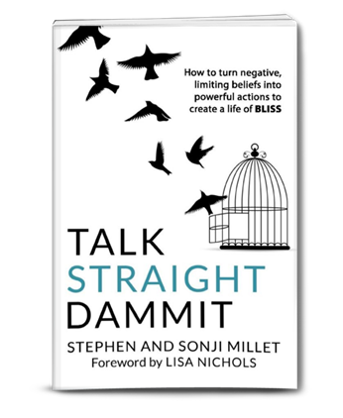

Stephen and Sonji Millet
Biographies

Sonji Millet

Sonji Millet is a transformational speaker and inner voice coach who helps you to go beyond your physical, mental and financial limitations. She is often affectionately referred to as Mrs. BLISS. Sonji teaches how to turn negative limiting beliefs into powerful actions, obstacles into opportunities and tragedies into triumphs which creates life affirming relationships that you want, desire and deserve.

Sonji earned two bachelor’s degrees in five years; one in chemistry and the other in chemical engineering. For the past 25 years, she has worked as a Safety, Health and Environmental professional, and travels around the world teaching people to work safely, so that they can enjoy their life without injury.

It took Sonji more than 10 years to find true love with Stephen, after her first marriage ended. Sonji has successfully balanced being a single mother, completing her master’s degree, volunteering in her community and church, traveling around the world for work and finding her soul mate. Today, Stephen and Sonji have been married 10 blissful, honeymoon years and counting. Together, they have raised their blended family of five children. They find their bliss by taking regular vacations, involving skiing, golfing, scuba diving and spa visits in exotic places around the world.

She is sought after for her personal coaching abilities and motivational techniques and is committed to sharing their life changing principles and proven strategies to help people TALK STRAIGHT DAMMIT to improve their relationships and create a life full of abundance and BLISS. She makes you laugh, cry and think about the possibilities while you transform your life.

If you feel insignificant, powerless, stuck, overwhelmed, stagnant or unhappy with your current situation, she can help you shift your paradigm. Her clients are happier, healthier, experience life affirming relationships and live more fulfilled and productive lives at home and at work. Sonji is frequently asked to appear at speaking, coaching or training events.

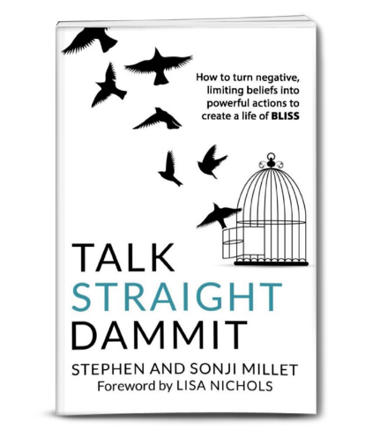

On Air Introduction

Did you know that every 13 seconds someone gets divorced in America and that 3 out 4 divorced people will remarry? Our guests today have added to those statistics by remarrying a total of 5 times between them. Sonji is Stephen’s 4th wife, which he affectionately refers to her as number last. They both describe their current relationship as still being on their honeymoon, 11 blissful years.

Stephen and Sonji Millet are transformational speakers and relationship bliss coaches. Their diverse backgrounds uniquely qualify them to provide creative solutions to relationship problems. They have helped their clients solve such problems as lack of intimacy, how to communicate what you really want and desire, and how to talk about money without fighting.

Today, they will provide tips on how to re-ignite your passion to create life-affirming relationships. In their bestselling book, TALK STRAIGHT DAMMIT, Stephen and Sonji, share their stories and processes on how to create a life of BLISS.

This dynamic couple have been through many of life’s dysfunctions. Stephen Millet was raised by a mother diagnosed with severe mental illness and an absentee father. He moved 10 times before he was 18 across 5 different states and accumulating 5 step-parents and 9 siblings. Over the course of his life, Stephen has overcome many obstacles including dropping out of high school, being rejected by the army, paying high child support and alimony, experiencing depression, bankruptcy, foreclosure, being a single father and recovering from the financial and physical impacts of four significant surgeries. Through self-reflection, determination and his love for his three daughters, he learned to TALK STRAIGHT to himself, opening the door for Sonji, the love of his life to walk in.

In contrast to Stephen, Sonji spent her entire childhood years in one city living with her two loving parents and two brothers. After her first marriage ended, for the next ten years, Sonji successfully balanced being a single mother of two, completing her master’s degree, volunteering in her community and church, and traveling around the world for work. She was about to give up on ever finding true love when Stephen found her online and taught her how to ignite her bliss.

Together, they have committed their lives to inspiring people to transform their personal relationships by showing people how to TALK STRAIGHT DAMMIT! Please join me in welcoming Stephen and Sonji Millet.

Questions for Stephen and Sonji Millet

- Tell us a little bit about Stephen and Sonji.
- Why did you write this book?
- How did you come up with the name Talk Straight Dammit?
- There are a lot of self-help books out there--what set yours apart?
- Your subtitle for the book is “How to turn negative limiting beliefs into powerful actions to create a life of Bliss”. How do you recognize that you have negative limiting beliefs?
- What is it about your life that makes you uniquely qualified to help others?
- Sonji, how did you meet Stephen?
- Stephen, you grew up with a mother suffering from severe mental illness? How does that affect you today?
- What is your book about?
- What do you want your reader to get out of this book?
- Stephen, you have been married 4 times, some may say you are terrible at relationships. How do you respond?
- What does it mean to be “100% responsible?”
- Some people say it is too hard to be positive when you are surrounded by so many negative people. What would you recommend?
- Chapter 2 is called “Who Told You That?”-- why do we have to question what we are told?
- You have an interesting twist on “love the one you’re with” in chapter 6. Can you explain this more?
- Sonji, you share a lot of personal stories in this book. Why do you feel the need to be so transparent?
- What is your favorite chapter or story in the book?
- What did you learn about yourselves while writing this book?
- Where can my audience get a copy of your book?
- Where can I find out more about your movement to Talk Straight Dammit?

Learn More

Book

- TALK STRAIGHT DAMMIT: How to turn negative limiting beliefs into powerful actions to
create a life of BLISS by Stephen and Sonji Millet
- Priced at $14.95 on Amazon.com and 7.99 on Kindle

Website

To learn more about coaching or courses offered by Stephen and Sonji, visit
- www.myblisstopia.com

Speaking

To inquire about Stephen, Sonji or both of them speaking at your event, contact:
- 414.305.1597
- Stephen@MilletEnterprises.com
- Sonji@myblisstopia.com

Social Media

- Facebook: www.facebook.com/myblisstopia/
- Facebook: www.facebook.com/stephen.millet.5
- Facebook: www.facebookcom/sonji.millet
- Twitter: https://twitter.com/theblissdoctor
- LinkedIN: https://www.linkedin.com/in/sonji-millet-14a26810/
- LinkedIN: https://www.linkedin.com/in/stephen-millet-9481119/
- YouTube: https://www.youtube.com/channel/UCiISMKh-aPdP6QGLDhitSCw
- Instagram: https://www.instagram.com/samilletmillet/?hl=en

