## OFFERING SUMMARY

ALL INFORMATION IS CONFIDENTIAL

**AMERICAN DINER WITH FULL BAR AND LARGE PATIO IN HOLLYWOOD**

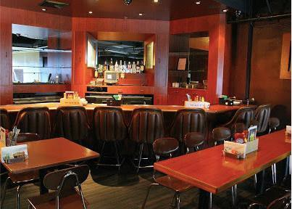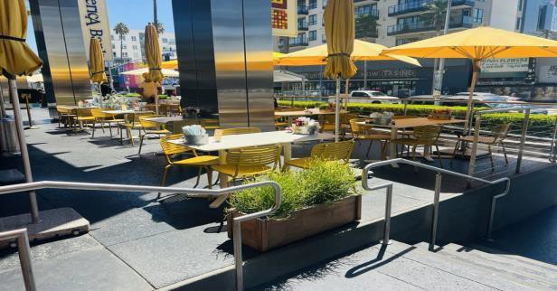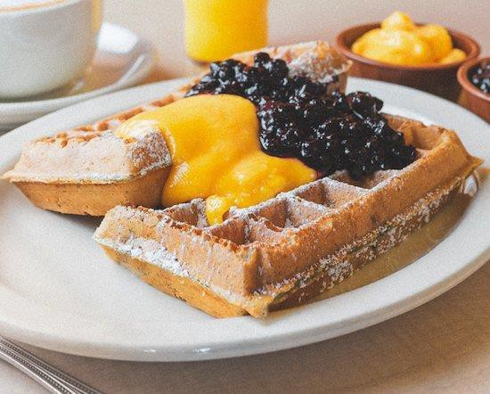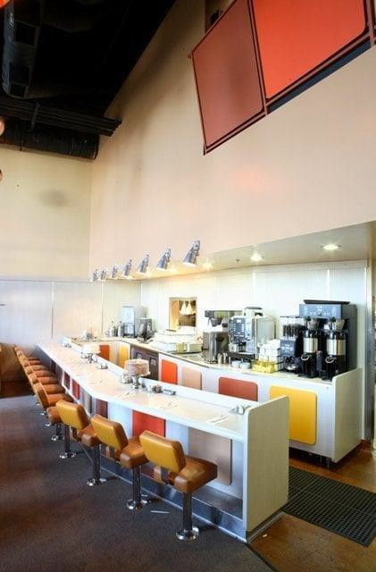

Listing #24011ST-HOW

Proudly offered by

## PACIFIC RESTAURANT BROKERS

17612 Beach Blvd Suite 7A Huntington Beach, Ca 92647

(949)424-6065

Email: [Admin@PacificRB.com](mailto:Admin@PacificRB.com) [www.PacificRestaurantBrokers.com](http://www.pacificrestaurantbrokers.com/)

ALL INFORMATION IS CONFIDENTIAL

This document contains information that is considered to be confidential information to the Seller, and Pacific Restaurant Brokers (PRB). By receiving this document you agree that any unauthorized duplication, distribution or use without express written consent of PRB is strictly

prohibited. You agree not to contact any member of Seller’s team or staff, or landlord, directly without prior arrangement, PRB and will direct all negotiations, offers of purchase, letters of intent or other communications through PRB

# DESCRIPTION:

**Overview:** Pancake House Café is a successful and cash flow positive breakfast and lunch establishment located in a bustling area of Los Angeles. Renowned for its delectable pancakes and diverse menu, the café has quickly gained a reputation as a favorite dining spot. The addition of a full bar and a beautifully designed patio enhances its appeal, offering a unique dining experience that caters to a variety of tastes and preferences.

**Location:** Conveniently situated in a high-traffic neighborhood of Los Angeles, Pancake House Café benefits from excellent visibility and accessibility. Its charming patio provides a picturesque and inviting outdoor space, making it a standout feature and a key attraction for patrons looking to enjoy their meals al fresco.

**Concept:** Pancake House Café specializes in an array of breakfast and lunch options, with a particular focus on its signature pancakes. The menu includes a variety of pancake flavors, toppings, and accompaniments, alongside gourmet coffee and fresh, seasonal dishes. The café also features a full bar, offering a selection of craft cocktails, fine wines, and local beers, adding a sophisticated touch to the dining experience.

**Financial Performance:** The café is financially robust and cash flow positive, reflecting strong operational efficiency and consistent profitability. The introduction of the full bar has contributed significantly to revenue growth, enhancing the café's overall financial performance. Effective cost management and a loyal customer base have ensured a healthy profit margin and a solid return on investment.

**Patio Experience:** The Pancake House Café boasts a beautifully designed patio that provides an inviting and relaxing outdoor dining experience. The patio is thoughtfully landscaped and furnished to create a comfortable and enjoyable environment for guests. This space is a key asset, attracting customers who appreciate the combination of good food, pleasant surroundings, and the option to enjoy beverages from the full bar in an open-air setting.

**Customer Experience:** The café is celebrated for its exceptional customer service and friendly atmosphere. The staff is trained to provide attentive and personalized service, ensuring that every guest has a memorable dining experience. The full bar complements the menu, offering a range of beverage options that enhance the overall dining experience, whether for a casual brunch or an evening out.

**Market Position:** Pancake House Café has carved out a prominent position in the Los Angeles breakfast and lunch market, distinguished by its high-quality offerings, distinctive pancake creations, and comprehensive bar menu. The café's unique combination of a beautiful patio and full bar has set it apart from competitors, making it a top choice for both daytime meals and evening socializing.

**Future Growth:** With its solid financial performance and strong market presence, Pancake House Café is well-positioned for future growth. Plans include expanding the menu to introduce new and innovative dishes, enhancing community engagement efforts, and exploring additional revenue opportunities to further solidify its market position and profitability.

In summary, Pancake House Café is a thriving and cash flow positive business that combines a focus on delicious pancakes, a diverse menu, a full-service bar, and a stunning patio. Its commitment to quality, exceptional service, and a distinctive dining experience has established it as a beloved establishment in Los Angeles.

## This restaurant has been featured on Food Network’s “The Best Thing I Ever Ate, as well as LA Travel Guide and CW Network’s “Food Bites”.

|  |  |  |  |
| --- | --- | --- | --- |
| LEASE | | BUILDING INFO. | |
| Monthly Rent: | $18,200 | Square ft: | 3766 |
| Expiration: | 2026 | Patron capacity: | 111 |
| Options: | Buyer to qualify | Patio: | Yes 1265 SF |
| Deposit: | Buyer to qualify | Hours of Operation: | 7 to 3 p.m. |

|  |  |  |  |
| --- | --- | --- | --- |
| OPERATIONS |  | FINANCIALS | |
| Years established: | 2008 | Monthly sales: | $195K |
| No. of employees | 30+ | Monthly cash flow: | $25k+ |
| Monthly payroll: | $74K | Annual Sales: | $2.4m avg |
| Absentee run: | yes | Annual Revenue: | $300k+ (approx.) |

**2025 MONTHLY FINANCIAL ANALYSIS (Projection)**

Sales: $195k Rent: $18,2K Payroll: $74k C.O.G.:52.8K

Misc: $25k (Uncontrollable of utilities, credit card processing, maintenance etc.) Net Potential income: $25k monthly or $300k+ a year

**PRICE: Call for pricing.** Submit offers to [Steve@PacificRB.com](mailto:%20Steve@PacificRB.com) with Proof of Funds, or call (949) 427-0414