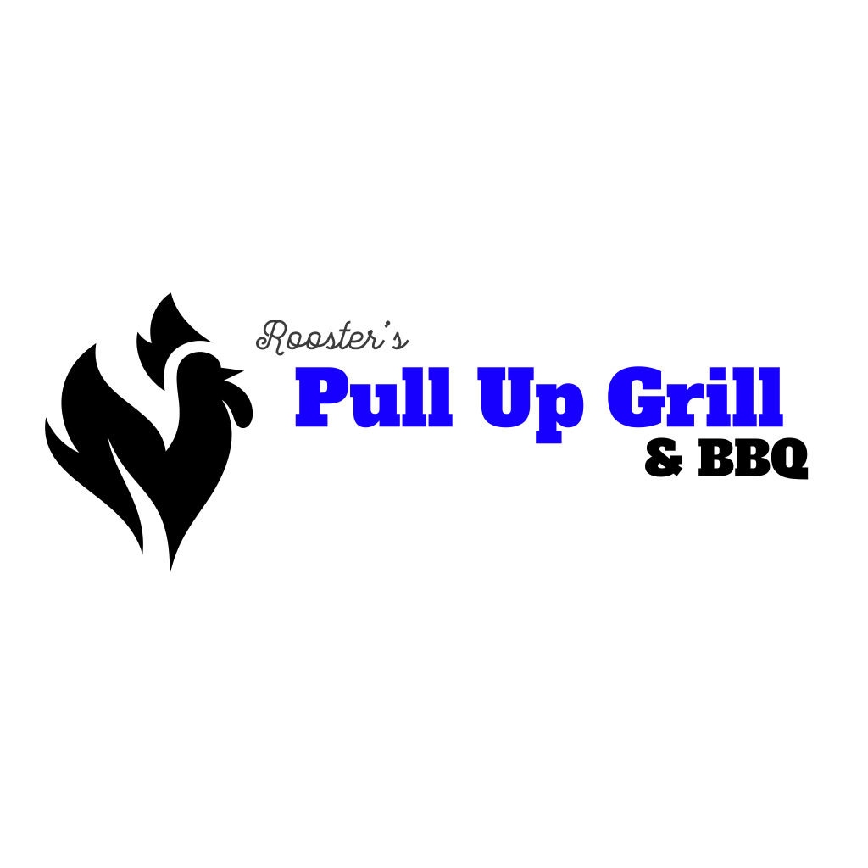

Contact Kenny Owens

Call (317) 840-0391 or

Email: [orders@pullupgrill.com](mailto:orders@pullupgrill.com)

A 48 hour notice is required.

\**prices are subject to change*\*

CATERING MENU

*Name: _____________________ Phone: ___________________ Email: _______________________*

*Event Date: ___________________ Event Time: ____________________# Guests: ______________*

*Circle one: * Corporate * Casual * Family * Wedding * Retirement * Sports * Celebration * Office*

*Event Details: _____________________________________________________________________*

*Select 1 of the following options:* ***Pick Up*** *_____ (Free)* ***Delivery*** *_____ $30 inside 465. Delivery charge quote for locations outside 465.* ***On Site Cater Service*** *_____ + $2 per person + 18% gratuity.*

Small Pan Qty Total Large Pan Qty Total Final Total

Peach Cobbler $49.00 (16) _____ $________ $________

Carrot Cake $49.00 (12) _____ $________ $________

Fresh Greens $40.00 _____ $________ $79.00 _____ $________ $________

Mac & Cheese $40.00 _____ $________ $79.00 _____ $________ $________

Cole Slaw $35.00 _____ $________ $69.00 _____ $________ $________

Baked Beans $35.00 _____ $________ $69.00 _____ $________ $________

Green Beans $35.00 _____ $________ $69.00 _____ $________ $________

Potato Salad $35.00 _____ $________ $69.00 _____ $________ $________

Rib Tips $13 per LB # LBS _____ $________

Pulled Pork $14 per LB # LBS _____ $________

Pulled Chicken $14 per LB # LBS _____ $________

Smoked Turkey Ribs $8 per Rib # Ribs _____ $14 per LB # LBS _____ $________

Beef Brisket $17 per LB # LBS _____ $________

Baby Back Ribs $25 per Slab # Slabs _____ $________

Half Chickens $7 per Half Chicken # Half Chickens _____ $________

Pull Up Wing Platter $19.99 approx. 20 wings # Platters _____ $________

Pull Up Party Wing Platter $44.99 approx. 50 wings # Party Platters _____ $________

Buns $50 each # Buns _____ $________

Drinks $2.00 each # Drinks _____ $________

Pull Up BBQ Sauce Mighty Mild $5 per bottle # Bottles _____ $________

Sweetie Sweet $5 per bottle # Bottles _____ $________ House Hot $5 per bottle # Bottles _____ $________

House Mix (Hot & Sweet) $5 per bottle # Bottles _____ $________

** 2 of each Sauce included (8 total) for all bulk orders over 10 LBS. **

Thank you for planning your special event with Pull Up Grill & BBQ! **Final Total $________**