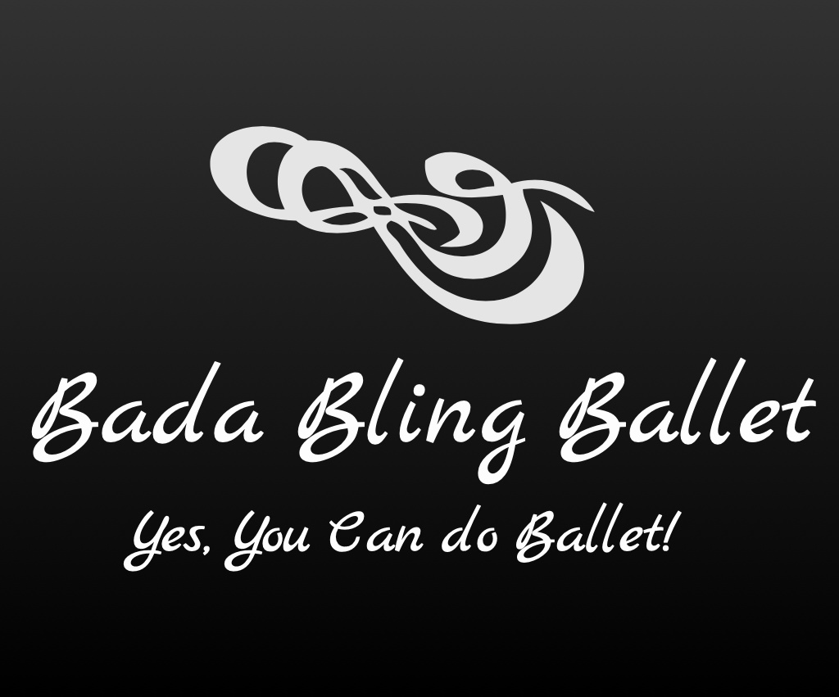

Virtual Adult Class Through Zoom

Bling Razzles (Mon 4:45-5:45p)

Starting 10/5/20

Adult Tone/Stretch

Have an awesome workout learning toning and stretching exercises/techniques inspired by Ballet (on the mat and standing/moving) but helps balance/improve your back strength while also toning the body and working on creating more flexibility for any adult age!! You won’t believe how much you are working and having fun and gaining flexibility!

