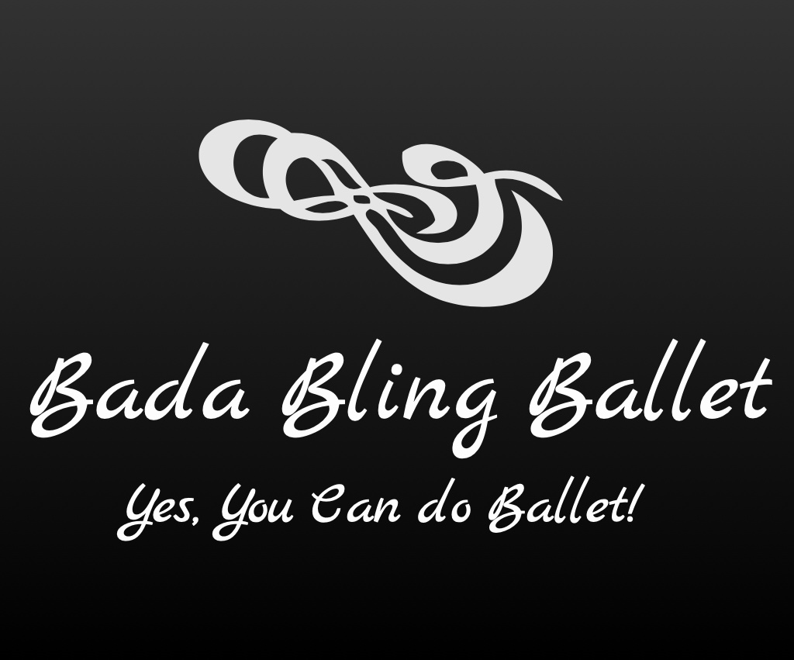

2020-2021 Classes

Adults:

Bling Shimmers (Mon/Wed 7:00-8:00p)
Adult Ballet Classes for Beginners/Intermediates

This class is tailored for Adults who are beginners or who have taken Ballet in the past. Instruction can be given to accommodate either beginners or intermediates.
______________________________________________________________

Bling Glitzies (Monday 4:45-5:45p)
Adult Barre Class

A challenging class that combines Ballet with everyday exercises.
________________________________________________________

Bling Razzles (Mon 11:00-12:00p)

Adult Tone/Stretch

Have an awesome workout learning toning and stretching exercises/techniques inspired by Ballet (on the mat and standing/moving) but helps balance/improve your back strength while also toning the body and working on creating more flexibility for any adult age!! You won’t believe how much you are working and having fun!

_________________________________________________________

Bling Bedazzlers (Thurs 9:30-10:30a)
Senior Adult Movement Class
This age appropriate class improves balance and strengthens muscles while meeting other Seniors and having fun at the same time with some Ballet movement!

