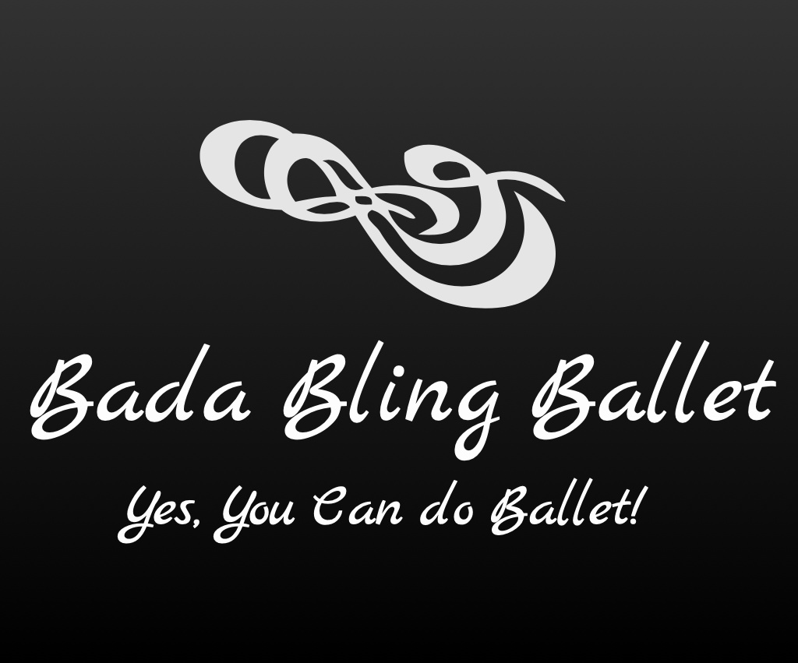

2021-2022 Classes

Adults:

Bling Shimmers (Mon/Wed 7:00-8:00p)
Adult Ballet Classes for Beginners/Intermediates

This class is tailored for Adults who are beginners or who have taken Ballet in the past. Instruction can be given to accommodate either beginners or intermediates. This is an adult ballet class teaching technique in a fun way so adults will learn and quickly feel their body toning and getting stronger.
______________________________________________________________

Bling Glitzies (Monday 5:30-6:30p)
Adult Fun Stretch/Tone Class (New Year; New You!)

A challenging class teaching safe and gentle stretching and learning how to use the core (stomach muscles) to achieve balance/strength through enjoyable but very effective exercises. It helps improve your back strength while also toning the body and working on creating more flexibility for any adult age!! You won’t believe how much you are working and having fun!

________________________________________________________

Bling Razzles (Tuesday 7:00-8:00a)

Adult Barre Wake Up

Have an awesome early workout for the day by having fun at the barre and using the space in the studio to take your mind off of autopilot and work your muscles through ballet inspired movements without ever becoming a ballerina!! All are welcome! You will feel your muscles wake up! You won’t believe how much you are toning and lengthening your muscles, feeling and seeing improvement in such a short time!

_________________________________________________________

