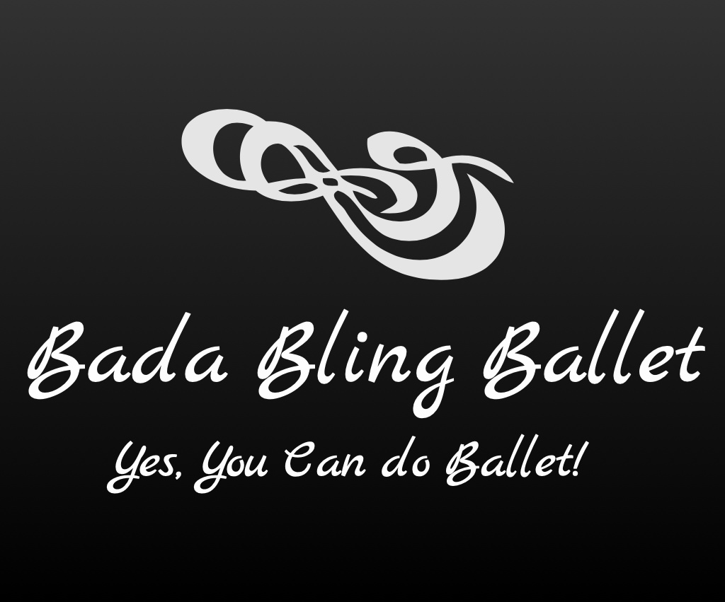

2021-2022 Classes

Children:

Bling Twinkles (Tues. 4:45-5:30p / Wed. 1:30-2:15p)
Ballet Classes for 4 to 5 yr olds

Introduction to Ballet through rhythm, movement and song. Teaches little ones to understand about space around them, socialization, creativity and very basic Ballet positions and steps utilizing age appropriate music.
________________________________________________________

Bling Cuties (Wed. 4:45-5:30p)
Ballet Classes for 6 to 7 yr olds

Continues the introduction of Ballet and also teaches more fundamentals such as the positions, arm movements, age/music appropriate Ballet and steps and how these steps can be used to create
a dance.
________________________________________________________

Bling Sparkles (Tues. 5:45-6:45p)

Ballet Classes for 8-12 yr olds

This class teaches the foundation/fundamentals of Ballet with more advanced steps. It is still taught in a fun and educational environment with age appropriate music.

__________________________________________________________________

