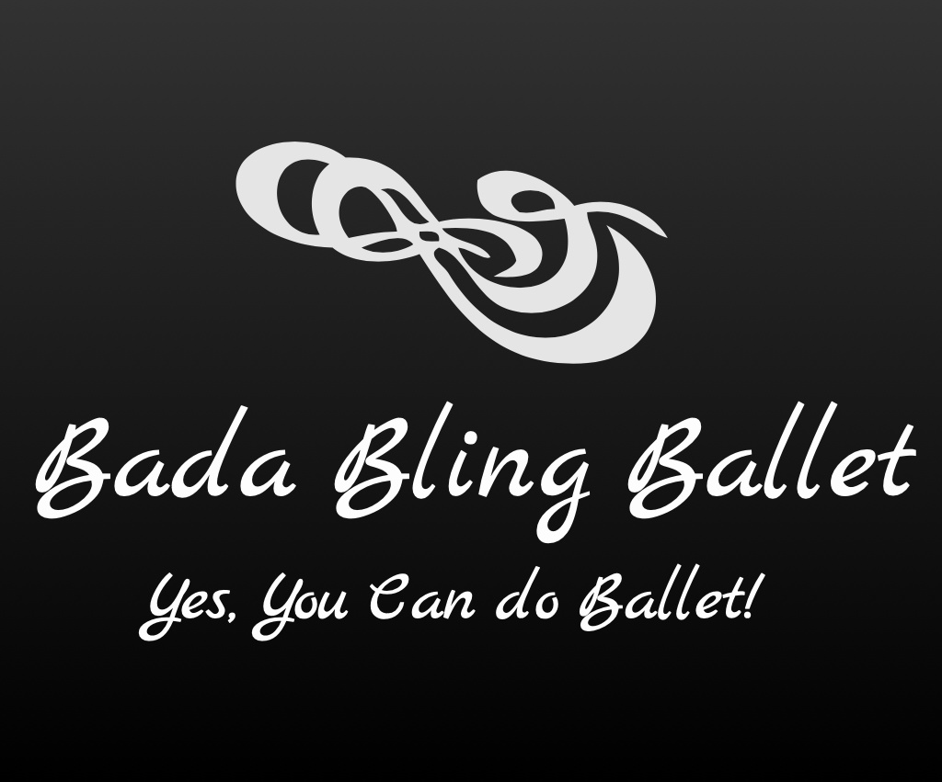

2023-2024 Classes

Adults:

Bling Shimmers Beginners (Monday 7:00-8:00p)

Introduction to Ballet teaching adults all the Ballet positions utilizing the Barre/across the floor to learn balance, strength, and more through fun and engaging steps and music. Must have 4 people for this class.
________________________________________________________

Bling AM Shimmers Beginners (Tues. 10:00-11:00a)

Introduction to Ballet teaching adults all the Ballet positions utilizing the Barre/across the floor to learn balance, strength, and more through fun and engaging steps and music. Must have 4 people for this class.
________________________________________________________

Bling Shimmers Interm./Advanced (Wed. 7:00-8:00p)

Intermediate/Advanced Ballet continuing to work on balance, strength and learning more advanced combinations/movement at the Barre and in the center of the floor through fun and engaging steps/music.
________________________________________________________

