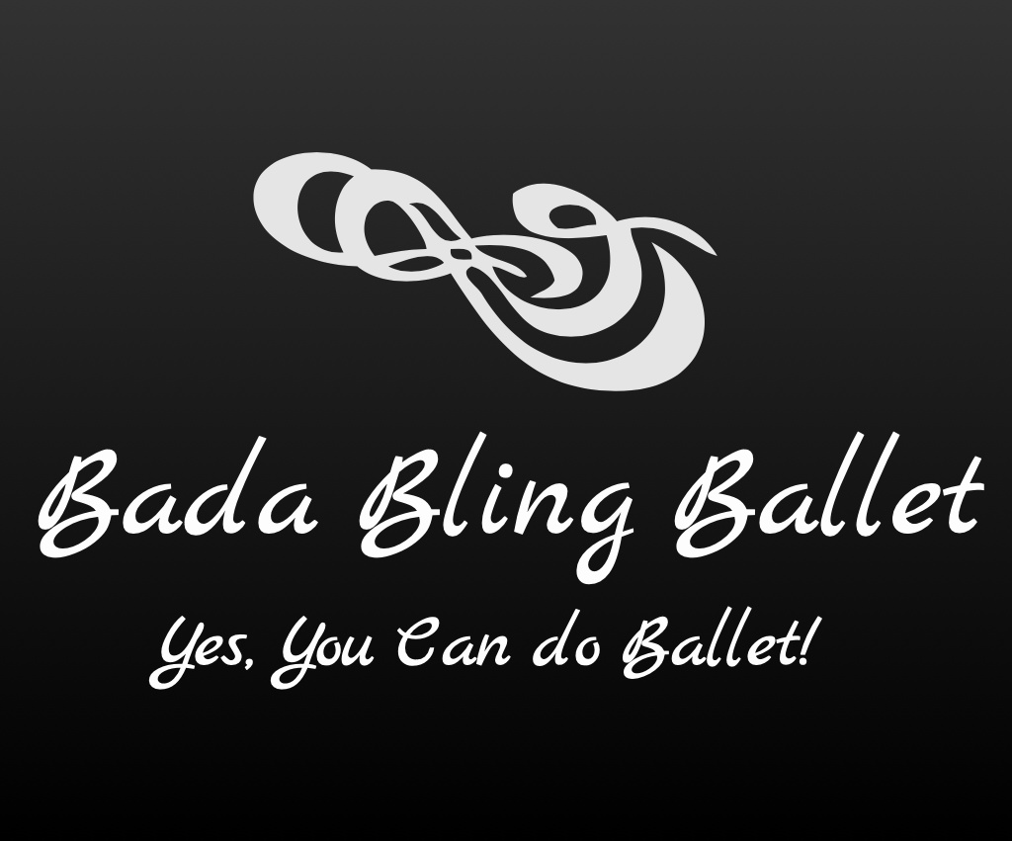

2023-2024 Classes

Children:

Bling Twinkles (Tues. 4:45-5:30p)
Ballet Classes for 6 to 7 yr olds

Introduction to Ballet through rhythm, movement and song. Teaches them continuing socialization, creativity and basic Ballet positions and steps utilizing age-appropriate music and how steps create a dance.
________________________________________________________

Bling Cuties (Wed. 4:45-5:45p)
Ballet Classes for 8 to 9 yr olds

Continues the introduction of Ballet and teaches more fundamentals such as the positions, arm movements, and more intermediate steps, jumps, turns, etc. with age-appropriate music. This age group learns also how these steps can be used to create a dance.
________________________________________________________

Bling Sparkles (Tues. 5:50-6:50p)

Ballet Classes for 10 yr olds and older

This class teaches the foundation/fundamentals of Ballet with more advanced steps (more input is asked from this age group). It is still taught in a fun and educational environment with age-appropriate music.

__________________________________________________________________

