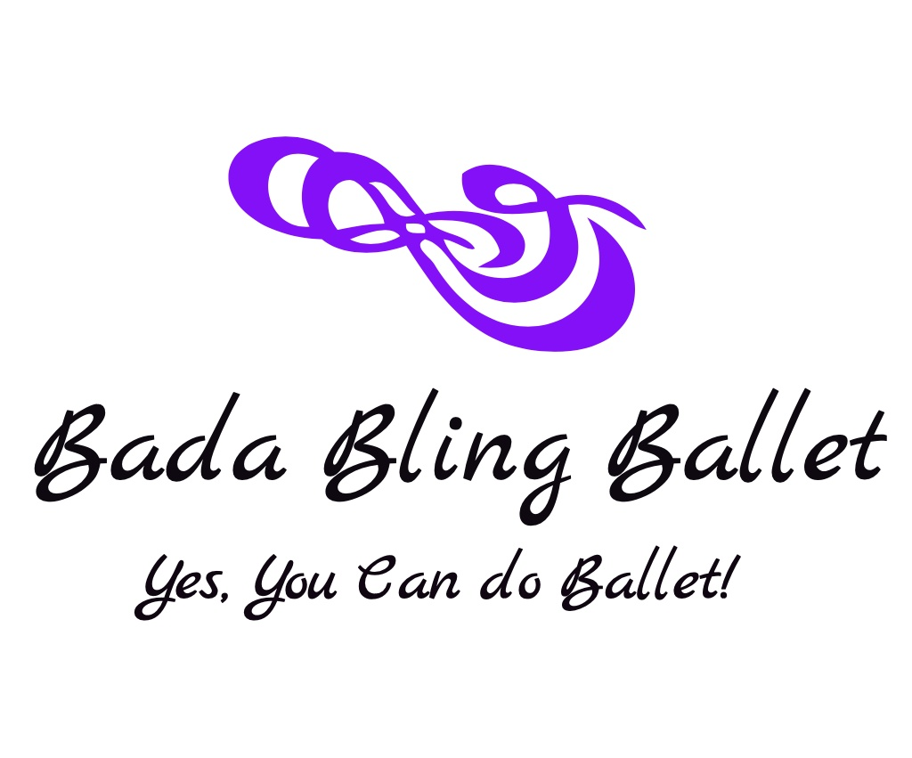

Pricing

Children’s Classes – Ages 4-17 yrs old:

$17/class/student or $14/class/student, Pay 3 months in advance ($36 savings)

2 Siblings in class - $124/month/2 children (2nd child 10% off)

Once/Year Registration Fee: $20/child or $30/family

Adult Classes:

Adult Ballet:

$15/class/student or $12/class/student, Pay 3 months in Advance ($36 savings)

Adult Barre, Adult Jazz, Adult Movement:

4 Class Pass Punch Card - $60 (no makeup classes, only pay for the classes you take; your 1st class is on us so the total for the next 3 classes is $45)

**You’re 1st class is Always on us!!

