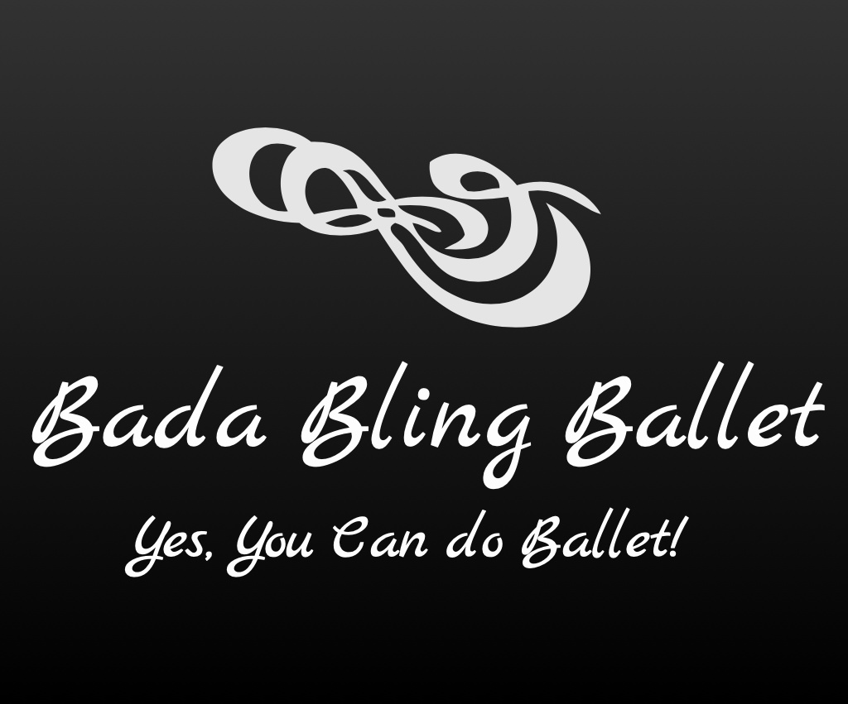

2019-2020 Fall Classes

Adults:

Bling Shimmers (Mon/Wed 6:45-7:45p)
Adult Ballet Classes for Beginners/Intermediates

This class is tailored for Adults who are beginners or who have taken Ballet in the past. Instruction can be given to accommodate either beginners or intermediates.
______________________________________________________________

Bling Glitzies (Thurs. 4:45-5:45p)
Adult Barre Class

A challenging class that combines Ballet with everyday exercises.
________________________________________________________

Bling Razzles (Mon 11:00-12:00p)

Adult Jazz for Beginners/Intermediates

Have fun learning fun steps each week to piece the puzzle together to learn a full dance! Jazz is patterned after the Bob Fosse/Jerome Robbins type of Theatrical/Broadway dance. Meet new people while learning a fun dance to increase cardio/balance and have overall fun!!

_________________________________________________________

Bling Bedazzlers (Thurs 9:30-10:30a)
Senior Adult Movement Class

This age appropriate class improves balance and strengthens muscles while meeting other Seniors and having fun at the same time with some Ballet movement!

