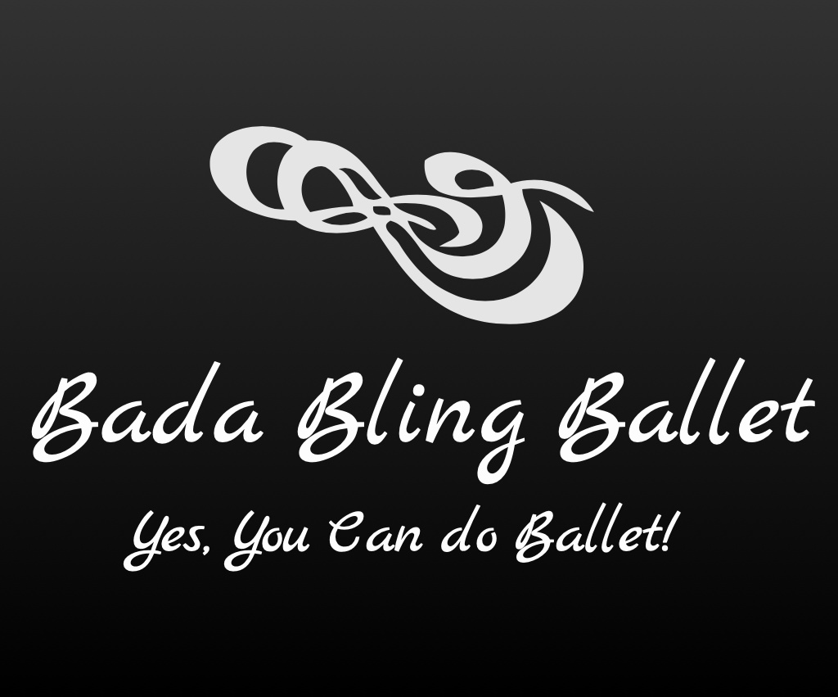

2019-2020 Fall Classes for Children:

*Be a Bling Sparkles Princess (Tues. 1:30-2:15p)

Bling Twinkles (Wed. 1:30-2:15p)
Ballet Classes for 4 to 5 yr olds

*Read an age appropriate Princess story, learn age/music appropriate dance steps and play a game!

Introduction to Ballet through rhythm, movement and song. Teaches little ones to understand about space around them, socialization, creativity and very basic Ballet steps.
________________________________________________________

Bling Cuties (Tues. 4:30-5:15p / Wed. 4:45-5:30p)
Ballet Classes for 6 to 7 yr olds

Continues the introduction of Ballet and also teaches more fundamentals such as the positions, arm movements, age/music appropriate Ballet steps and how these steps can be used to create
a dance.
________________________________________________________

Bling Sparklers (Tues. 6:30-7:30p)

Ballet Classes for 8-12 yr olds

This class teaches the foundation/fundamentals of Ballet with more advanced steps. It is still taught in a fun and educational environment.

__________________________________________________________________

**A High School Class can be added if there is enough interest

