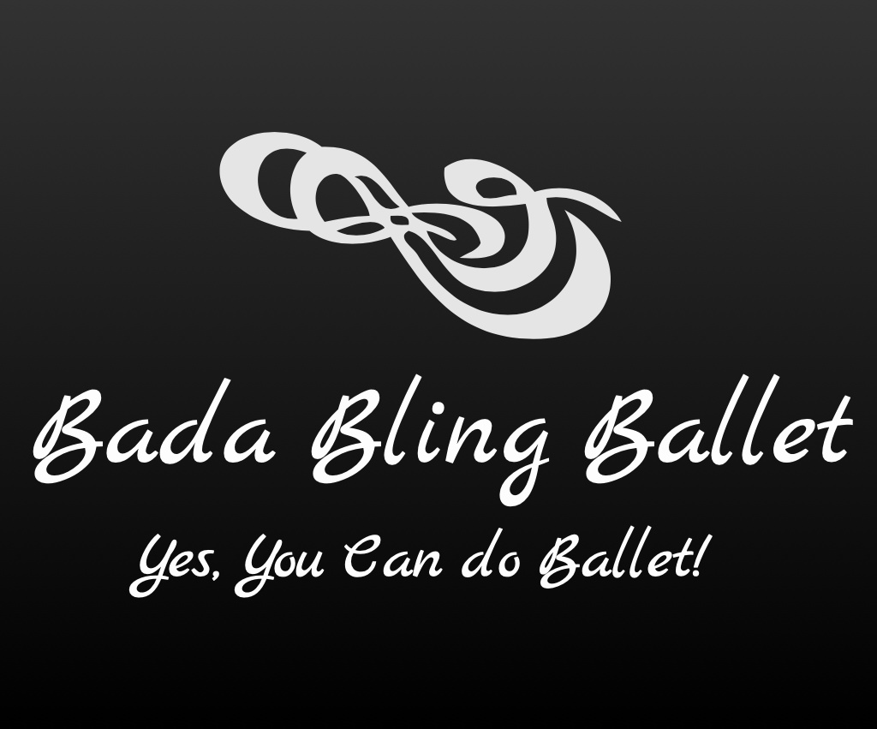

2020-2021 Classes

Children:

Bling Twinkles (Tues. 4:45-5:30p)
Ballet Classes for 4 to 5 yr olds

Introduction to Ballet through rhythm, movement and song. Teaches little ones to understand about space around them, socialization, creativity and very basic Ballet positions an steps.
________________________________________________________

Bling Cuties (Wed. 4:45-5:30p)
Ballet Classes for 6 to 7 yr olds

Continues the introduction of Ballet and also teaches more fundamentals such as the positions, arm movements, age/music appropriate Ballet steps and how these steps can be used to create
a dance.
________________________________________________________

Bling Sparkles (Tues. 5:45-6:45p)

Ballet Classes for 8-12 yr olds

This class teaches the foundation/fundamentals of Ballet with more advanced steps. It is still taught in a fun and educational environment.

__________________________________________________________________

