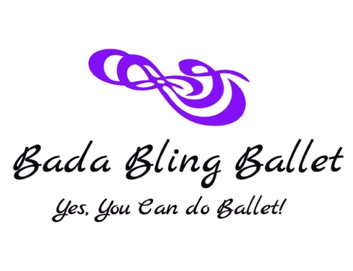
Bada Bling Ballet Princess Camp 2021 Information

Dates:
June 7th-10th
June 21st-24th
July 12th-15th
August 9th-12th

Time: 9:30a-12:00p (a healthy snack will be provided!)

Where: Bada Bling Ballet Studio

Cost: $116/Student/Camp week

**Sign up and bring a friend by 2/26/21 and receive
$10 off for each child!

Space is Limited in Class so Enroll Early

(May have to be done virtual depending on Covid-19 regulations at the time, so stay tuned!)

