GET YOUR SUMMER PRINCESS TIARA ON!

IT’S NOT TOO EARLY TO REGISTER 5 - 8 YR OLDS

FOR THE **SUMMER PRINCESS CAMP** - SPACE IS LIMITED!

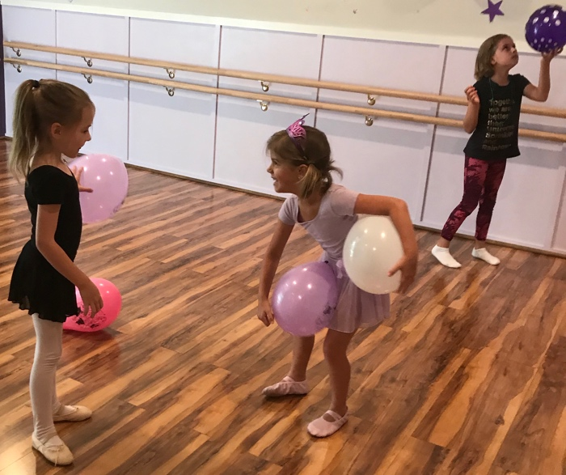

JUNE 15TH-18TH / JULY 6TH-9TH / AUGUST 10TH-13TH

SUMMER BLING PRINCESS FUN!

This is not a dance class; meet new friends, have fun being creative doing crafts, games and more!

Learn about a different Princess each day for 4 days!

-------------------------------------------------------

***Sign up with a friend, and both will receive $20 off the regular price of $115***

***YOU MUST REGISTER BY 3/23/20 TO GET THE DISCOUNT!***

Don’t Wait!! – Email: [info@badablingballet.com](mailto:info@badablingballet.com) or Call/Text 919-63-5738 for Details