Solution
Let's move the ring suspended from the loop on the right to the loop on the left. Pull the center loop down, and slide the ring on the right under the center loop and into the central area.
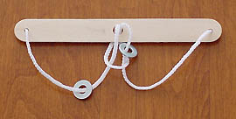
Pull the two strings marked with the arrows toward you ...
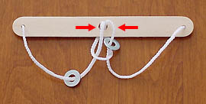
... until a double loop comes up through the center hole.
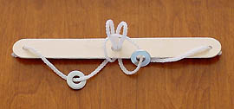
Move the ring to the same position on the other side by passing it through the double loop.
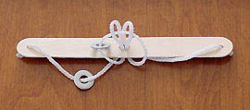
Now reverse the first two steps. Pull the double loop back down through the center hole, ...
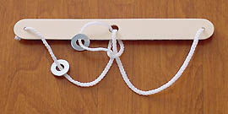
... then slide the ring under the center loop and onto the loop on the left.
