Puzzle Solution

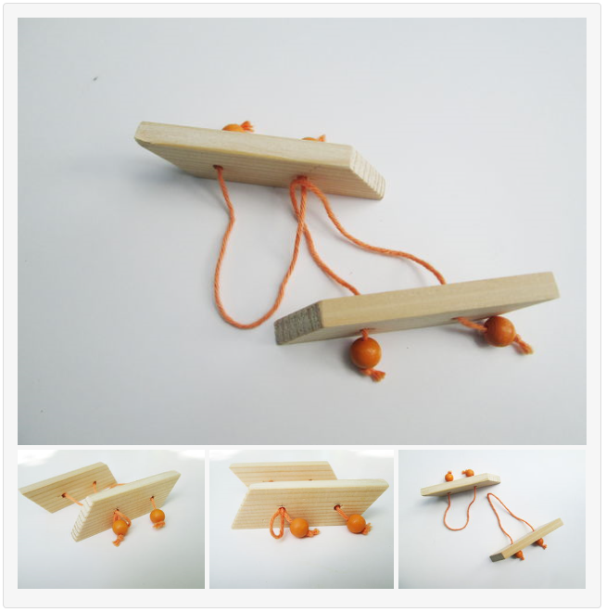

1. Take one of the loops and thread it through one of the holes of the other wood piece. (picture 1)
2. Once the end of the loop is on the other side of the wood, you can pull the bead through the loop. (picture 2+3)
3. Now you’re basically done. The only thing left to do is pulling the loop back through the hole. (picture 4)

Congratulations, you successfully separated the two pieces!