Family Historian’s Corner:
After 2017 Traynham Reunion, Kathe Traynham announced she is stepping down from her role as Traynham Historian. She is venturing into retirement with her husband. We want to wish them best in their new future.
During a visit with Deanie & Louis in 2016, I began a new adventure as volunteer photographer. As a willing help, I arrived early to help support setting up tables and assisting guests whenever possible. Finding my element in research of my own French Acadian-South Louisiana geneaology, I was able to collaborate with Becky Henderson, Deanie May Fincher, and Sylvia Williams Johnson to pool our research efforts. After request from Elaine Traynham Zimney and Becky Traynham Henderson I accepted to call for Volunteer Traynham Family Historian.
In early 2018, I set out on a mission to create a visual display. My goal was to allow younger family members to visually see their ancestral tree with hope’s they would begin to show greater interest in continuing the traditions of Traynham families remembering those who have sacrificed to allow descendants paths to cross. Culmination became a 5 tri-board display of progenitor 9 children of matriarchs David Traynham & KerenHappuch Vaughn. Each of the 9 children descendants were displayed 3 generations toward early to mid-1900 as a reference point to complement Family books of Becky Traynham Henderson and her researchers.
As a disclaimer, errors in documentation are inevitable and I welcome any one willing to contribute corrections or new resources. Most of my verification resources are derived from census records, death records, marriage records, city or local directories, military records, and varied state registers.
Marlon D. Bourque
mdbourque011762@gmail.com

2016 Traynham Reunion
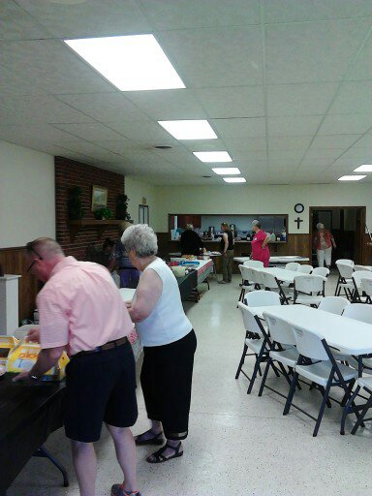
Washington Church Hall
Pelzer SC-August 2016
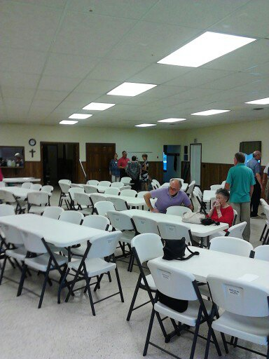
More 2016 Reunion
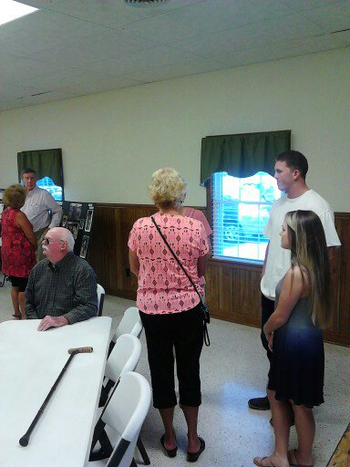
More Traynham-2016
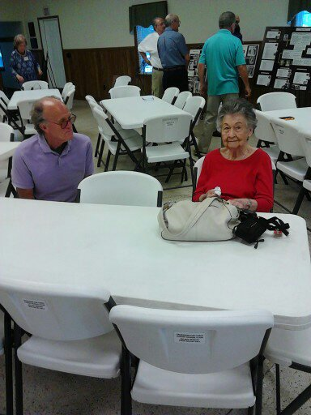
Learn all about Traynham’s
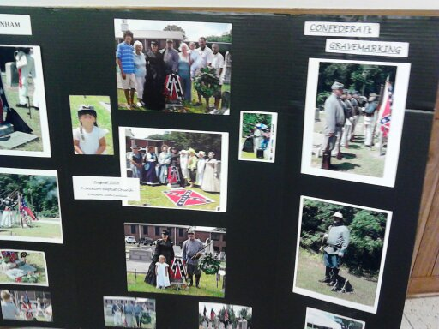
Our strong southern SC roots
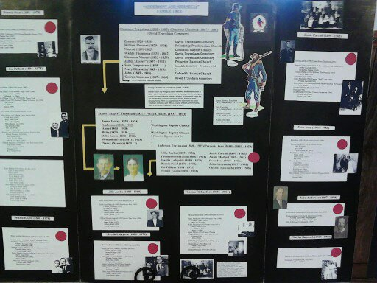
Where do belong?
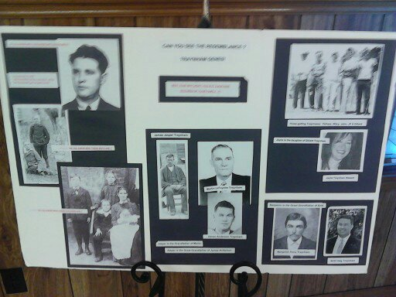
Finding my role models in family?
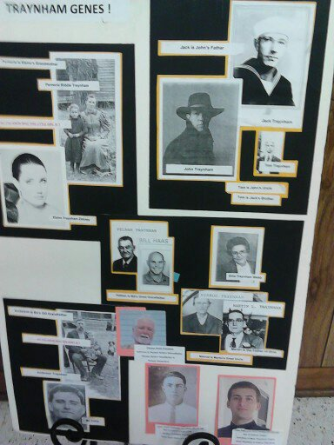
Family of Elaine Traynham Zimney

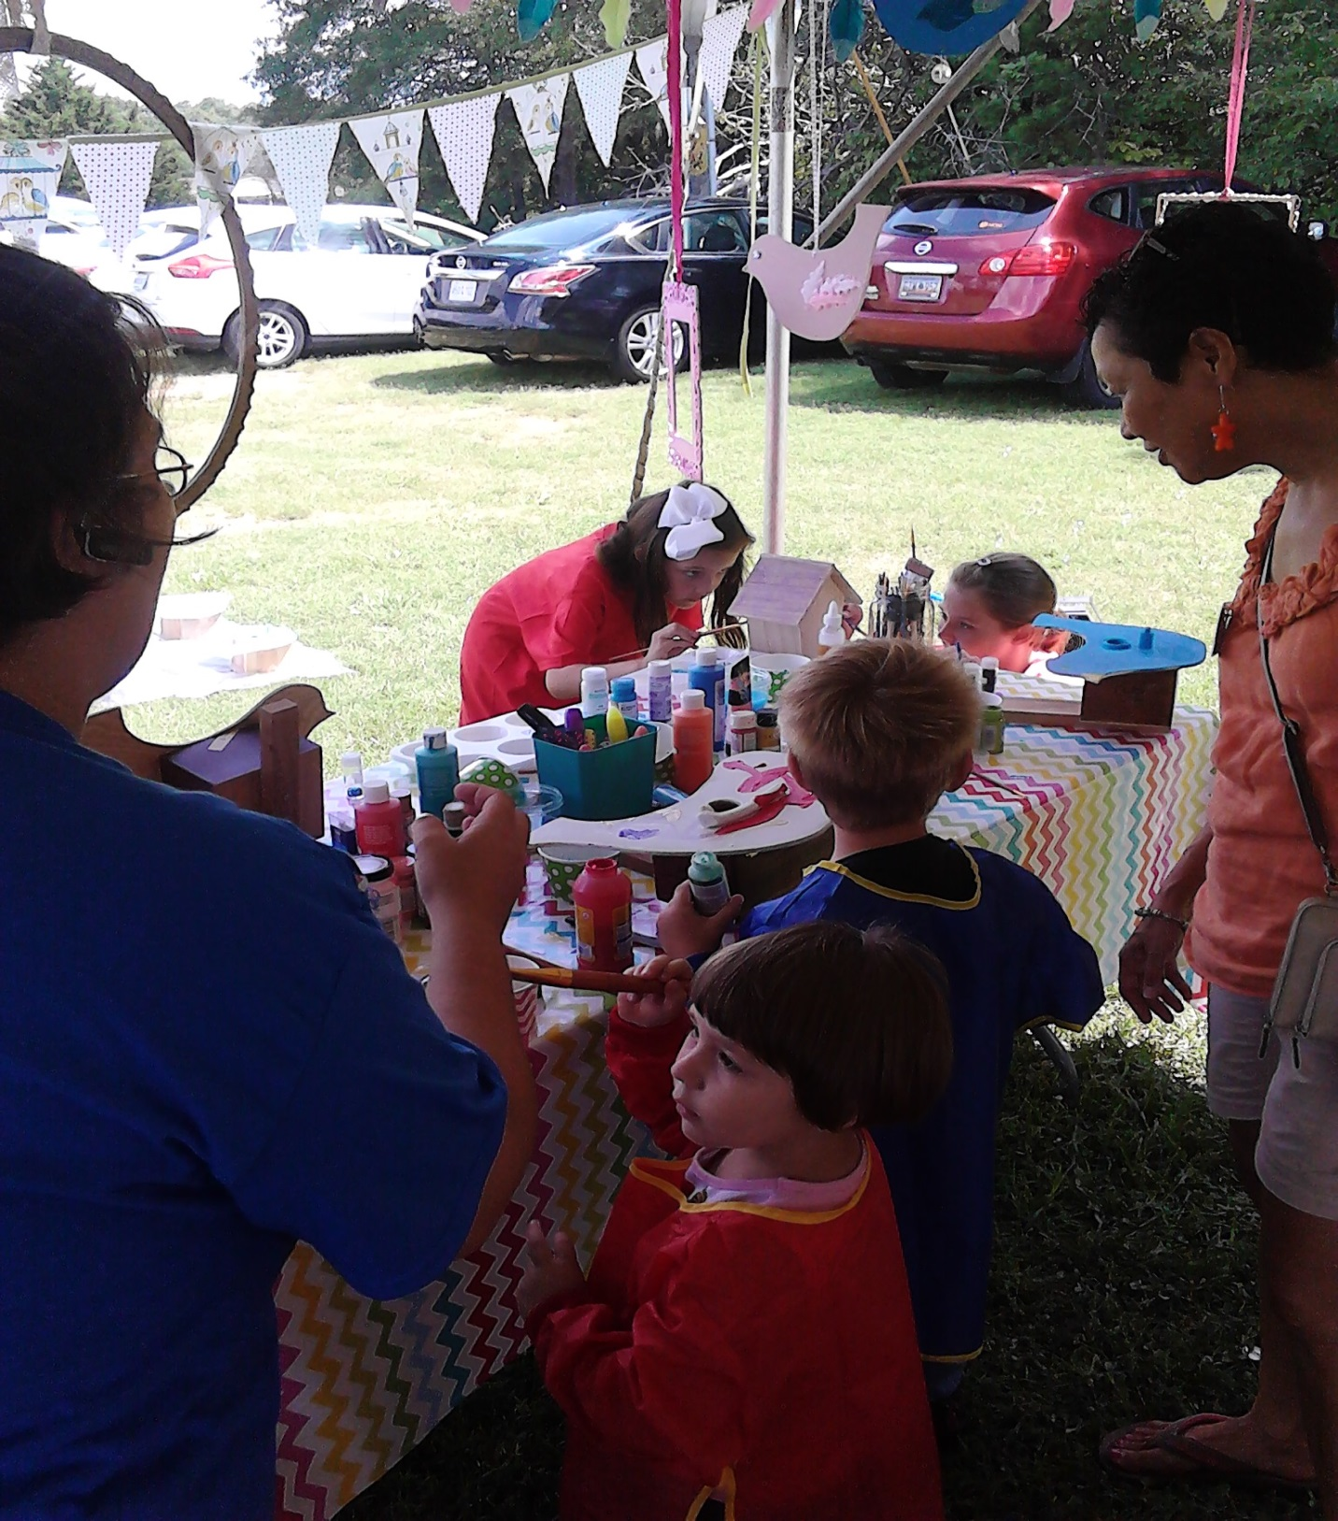
Children’s Activities-2016
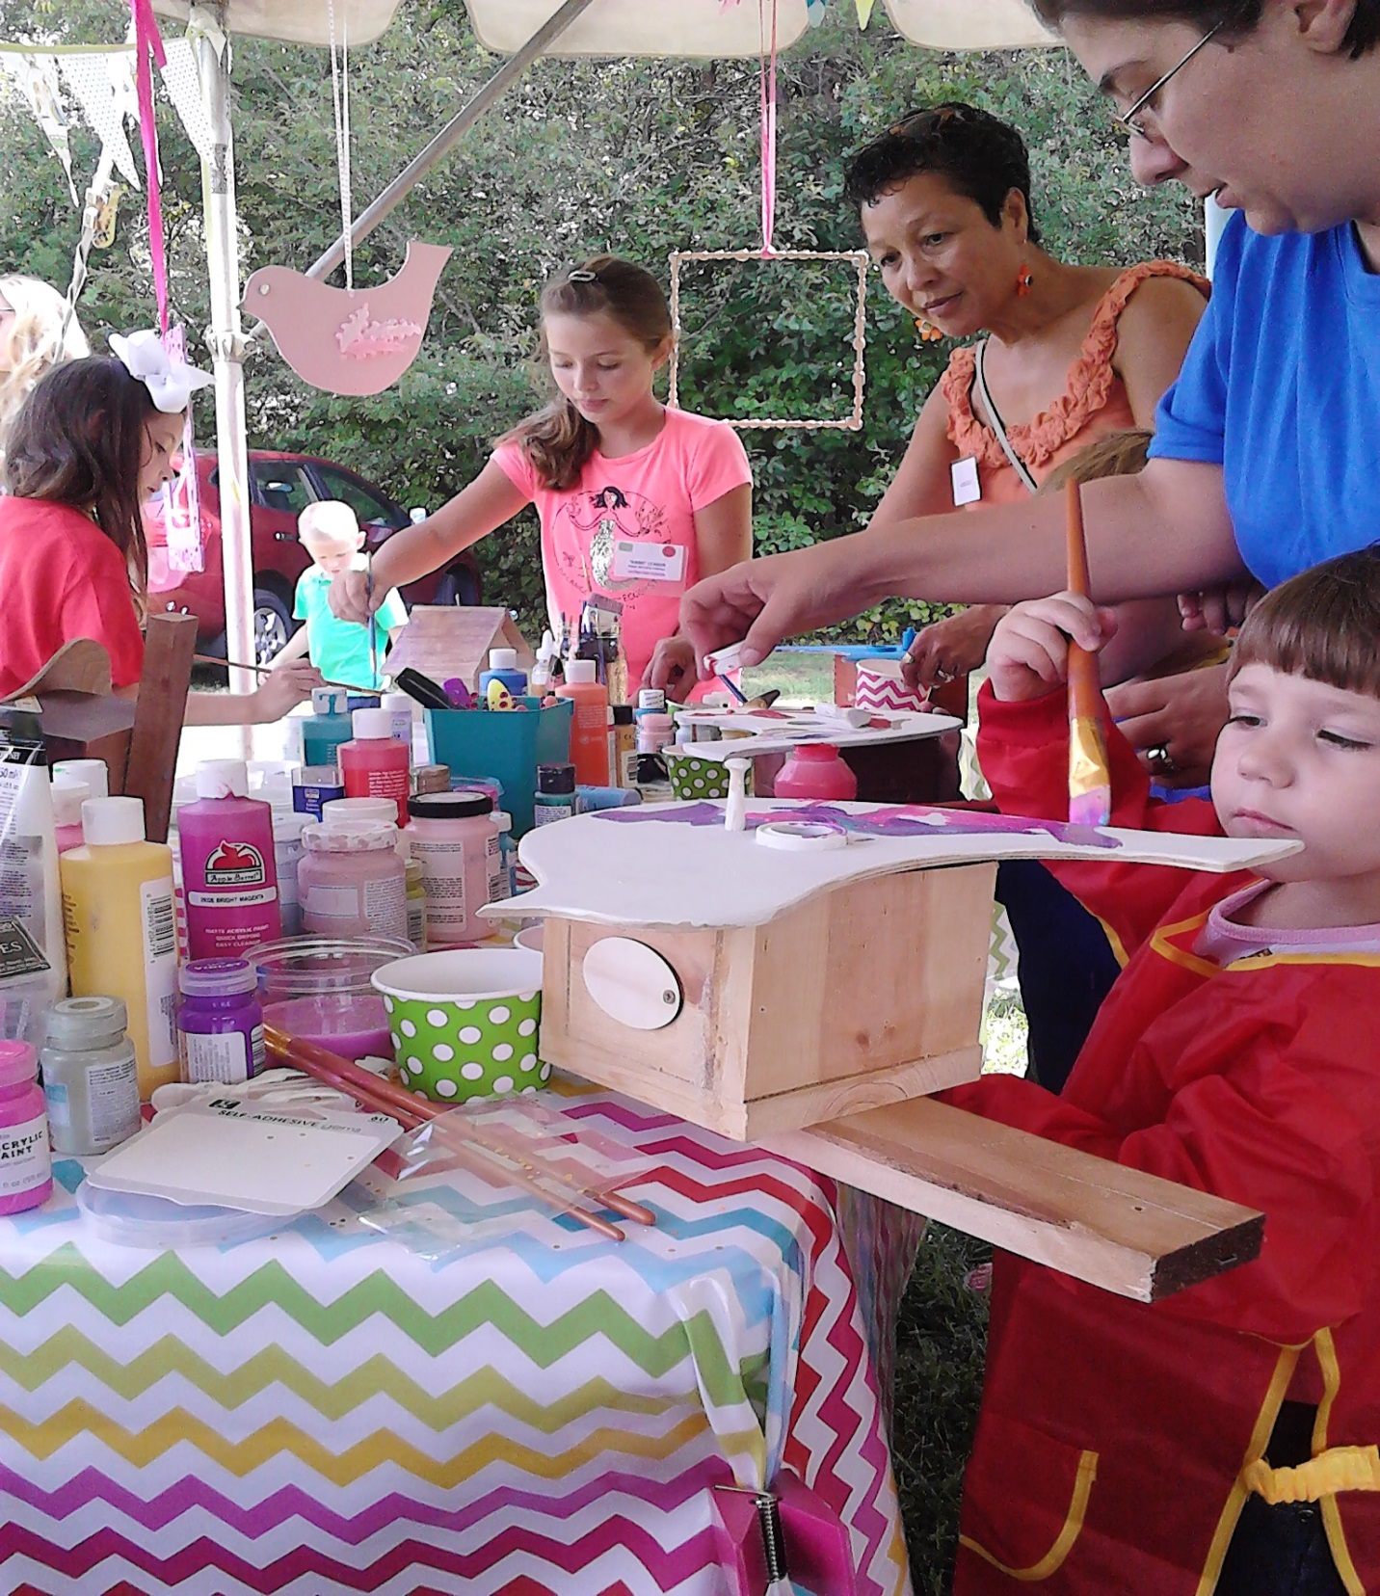
Birdhouse Activity-2016
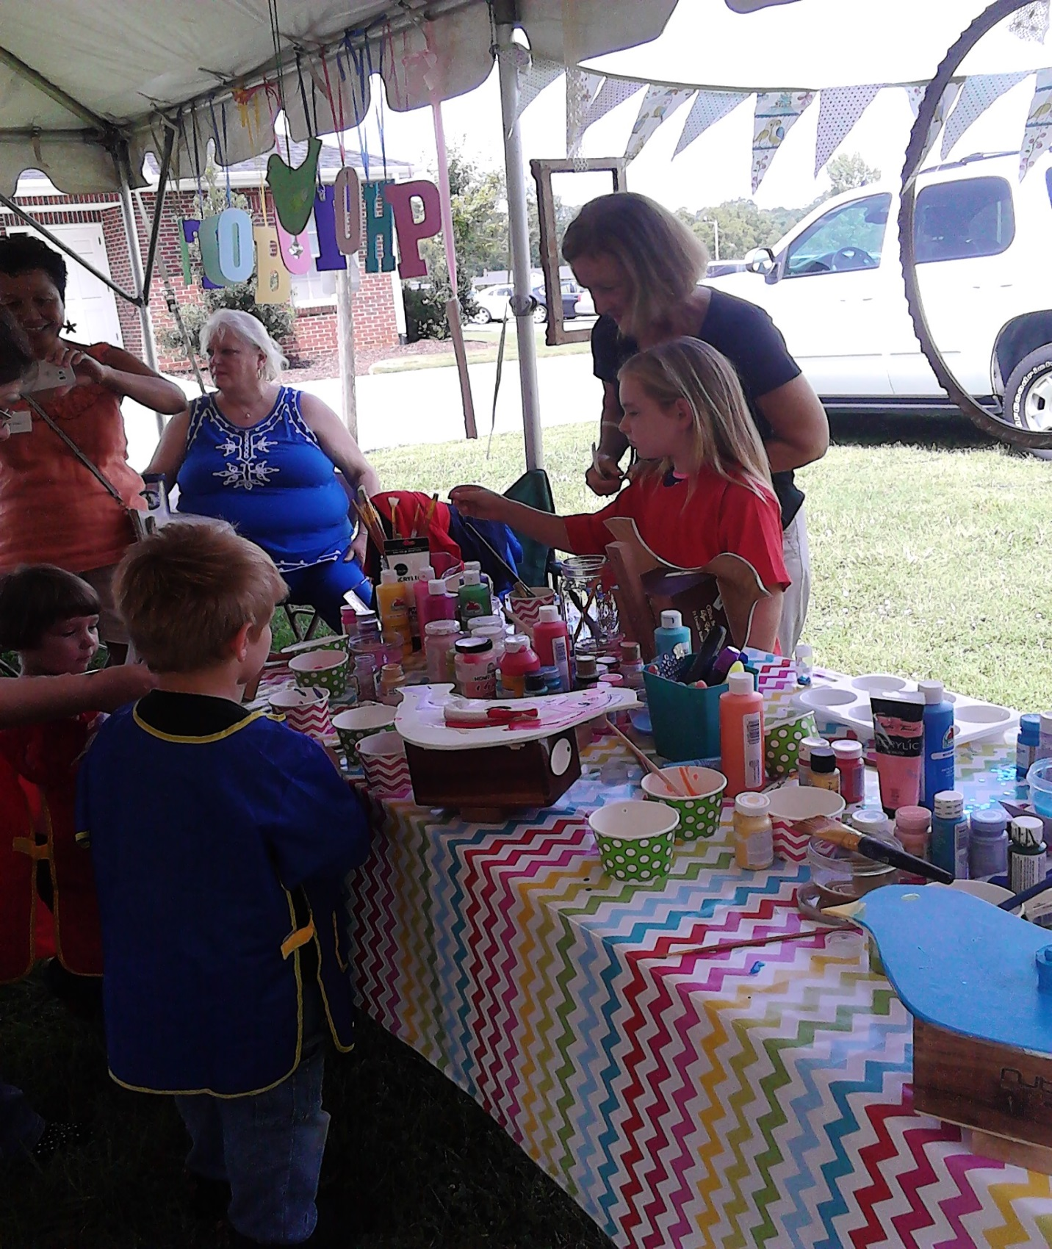
Traynham youth finding artistic niche.
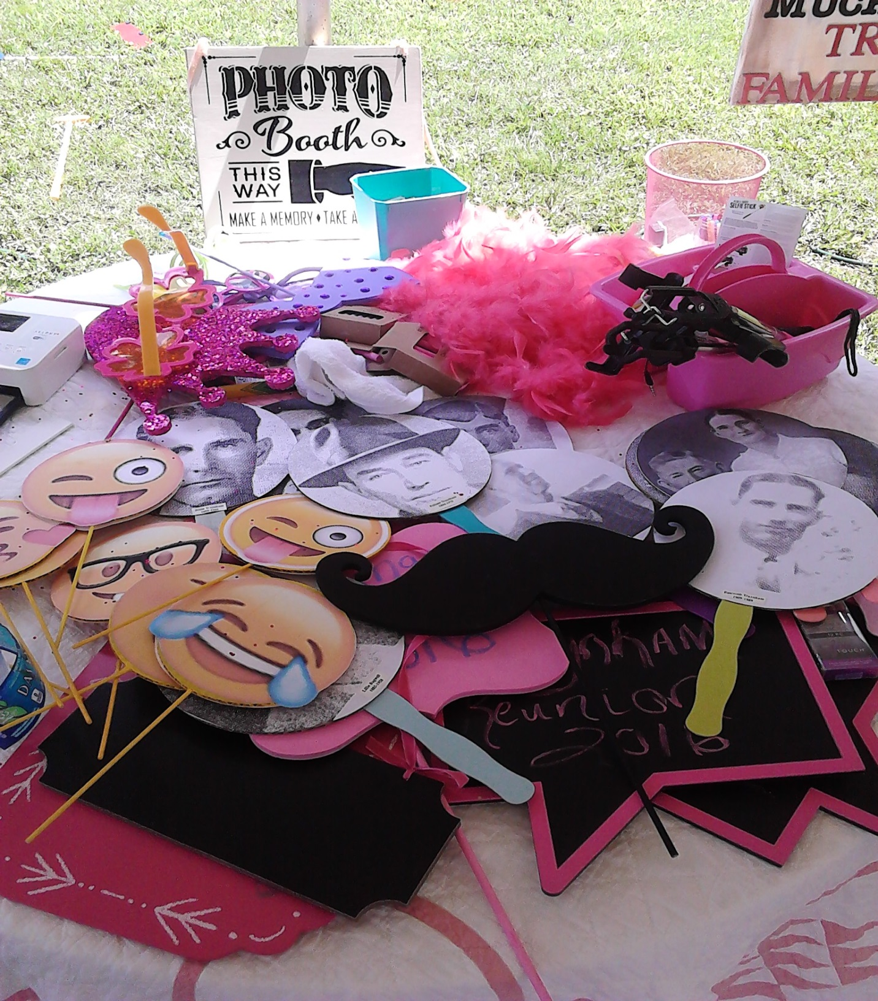
Photo Booth Children’s Activity -2016
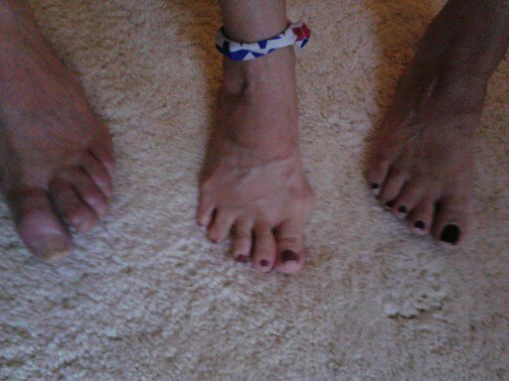
Unusual Traynham Cousins trait
(joined second and third toes)

2017 Traynham Family
Highlight of August 2017 Reunion is the culmination of Stephen Zulli finding his birth mother Darrell Traynham Ruppert. Beginning through correspondence with Becky Henderson and board members Jasper Carroll Traynham, Elaine Traynham Zimney, and other DNA researchers Stephen Zulli search for his birthmother begins around early 2016. August 2016 reunion Stephen attends and meets his Traynham extended family. Stephen discovers a welcoming family eager to assist in his search. Darrell lives in Washington state with daughter Robin Ruppert Goodrich

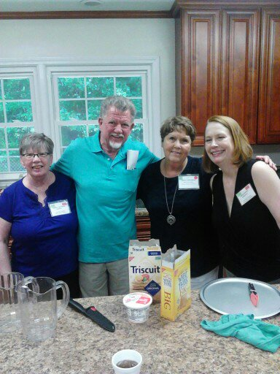
Aug 2017 – Washington Church
(LtoR: Darrell Traynham, Louis Campbell Boyd, Becky Henderson, Darrell’s daughter-

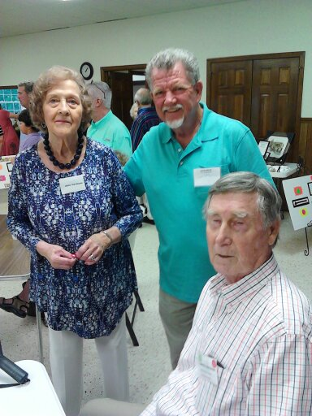
2017 Traynham Reunion
Jamie Lee Stowe (wife of Jasper Carroll Traynham seated) &
Louis Campbell Boyd
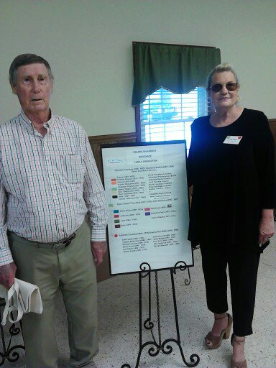
Jasper Carroll Traynham & Elaine Traynham Zimney
2017- Traynham Reunion
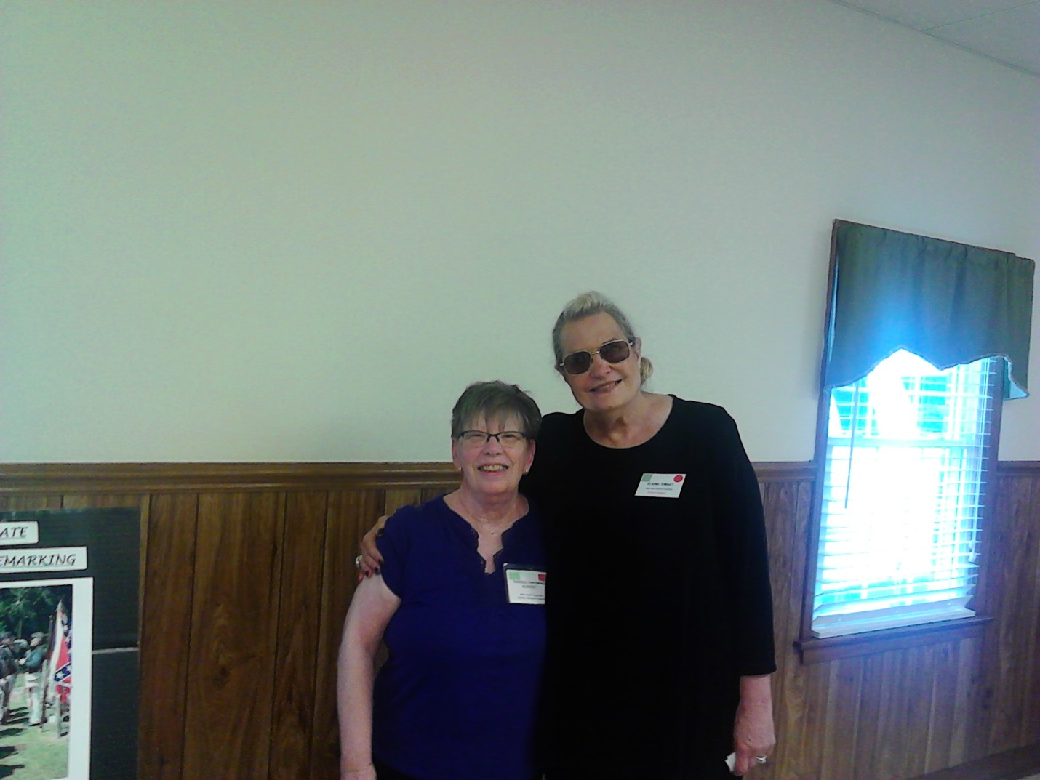
Darrell Traynham Ruppert & Elaine Traynham Zimney
2017- Traynham Reunion
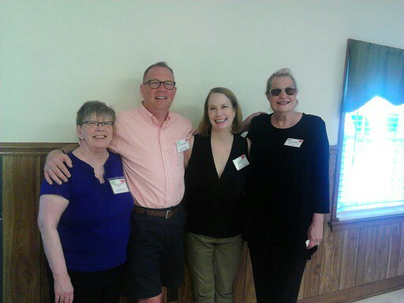
(LtoR: Darrell, Stephen, Robin, & Elaine)-2017
Darrell Traynham Ruppert is birth mother of Stephen Traynham Zulli & Robin Ruppert Goodrich
Elaine Traynham Zimney is acting president of
Traynham Family Reunion
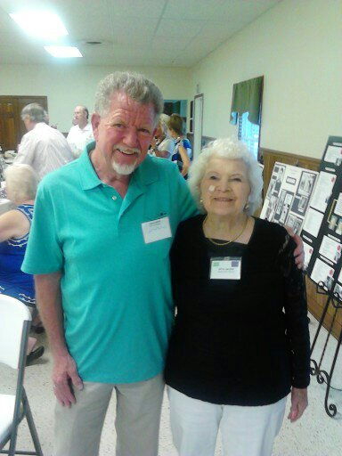
Louis Campbell Boyd & Veta Traynham Crumpton Neves
2017-Traynham Reunion
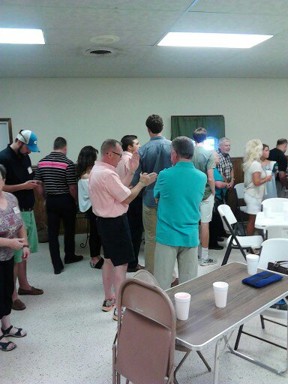
Stephen Traynham Zulli captures Louis Campbell Boyd
attention waiting in lunch line.
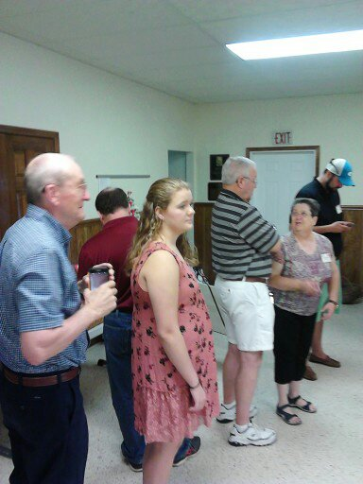
Is it lunch time yet?
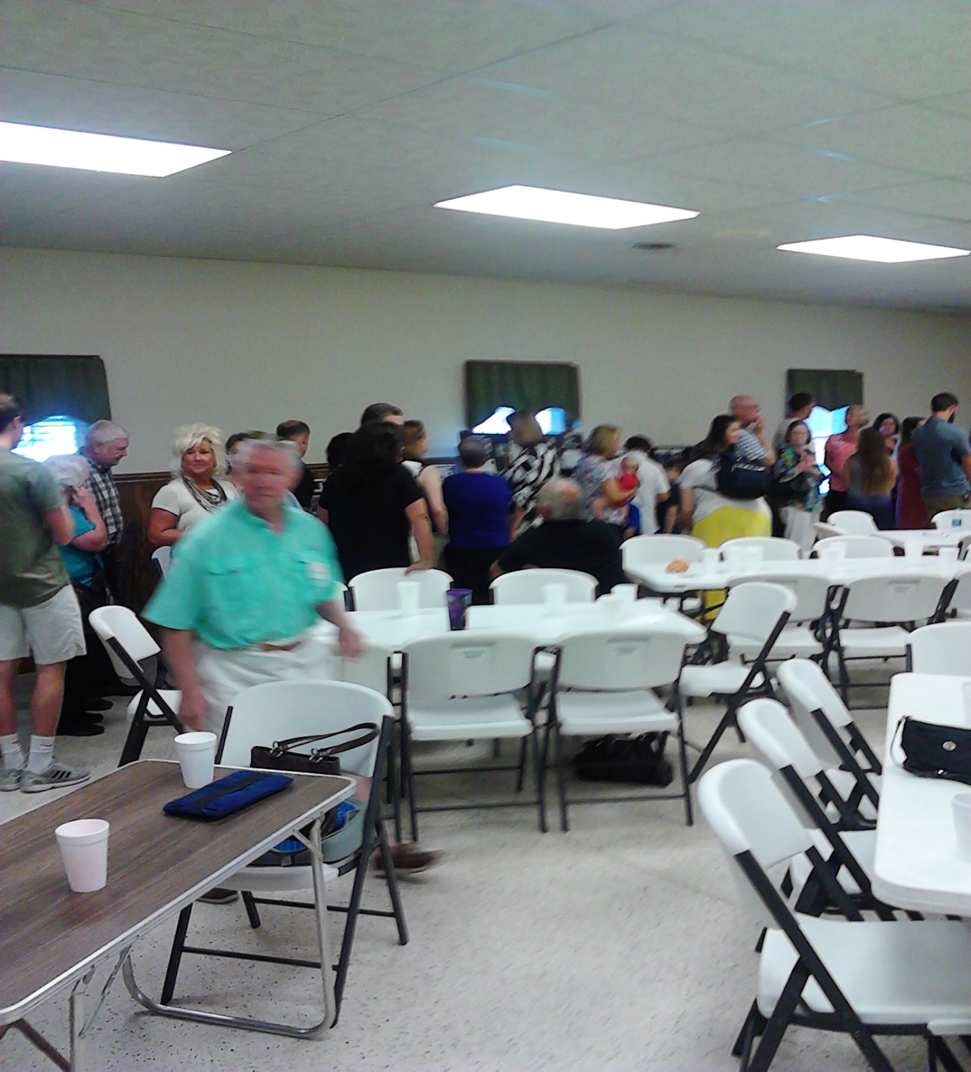
Time to share with Traynham families.
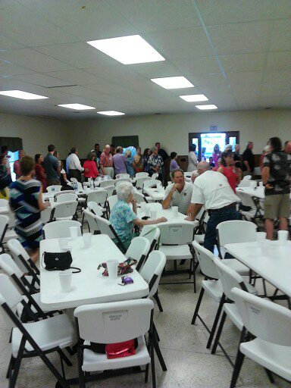
Good attendance today!
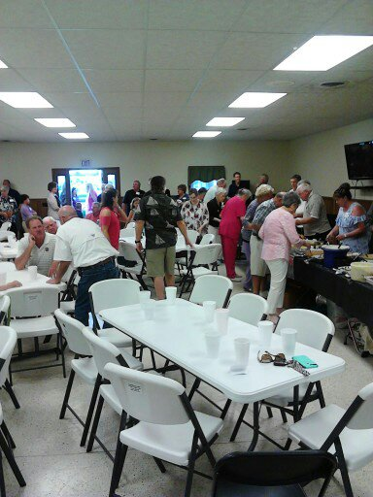
Young AT heart at head of line!
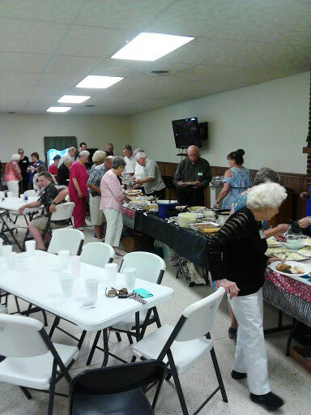
So many choices!
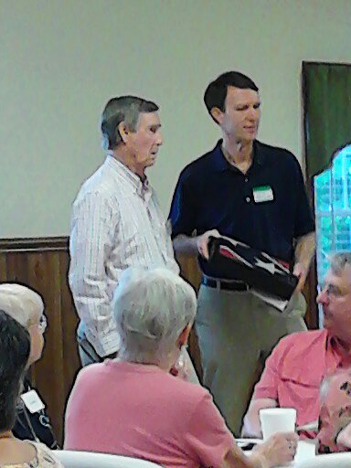
Jasper Carroll Traynham awards John Traynham honorary
Confederate flag for his extensive work at David Traynham Cemetery.
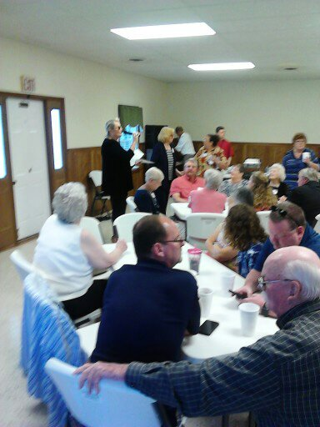
Elaine Traynham Zimney addresses crowd with 2017 Traynham Reunion patrons attentively listening.
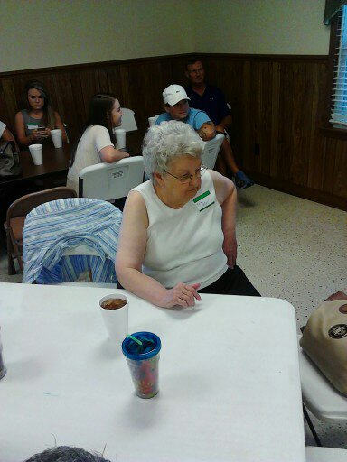
Heavy in thought of past memories.
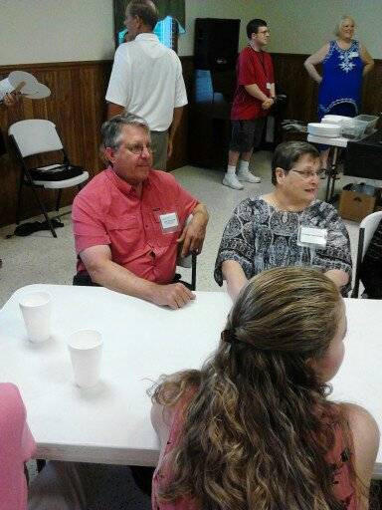
Reaquainting and making memories with Traynham families.
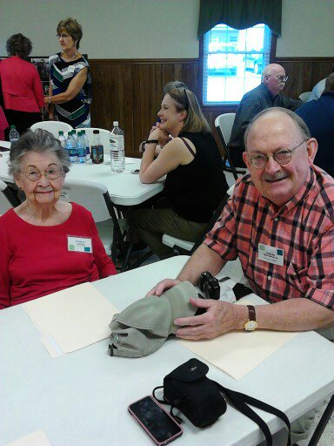
Friendly Traynham’s.
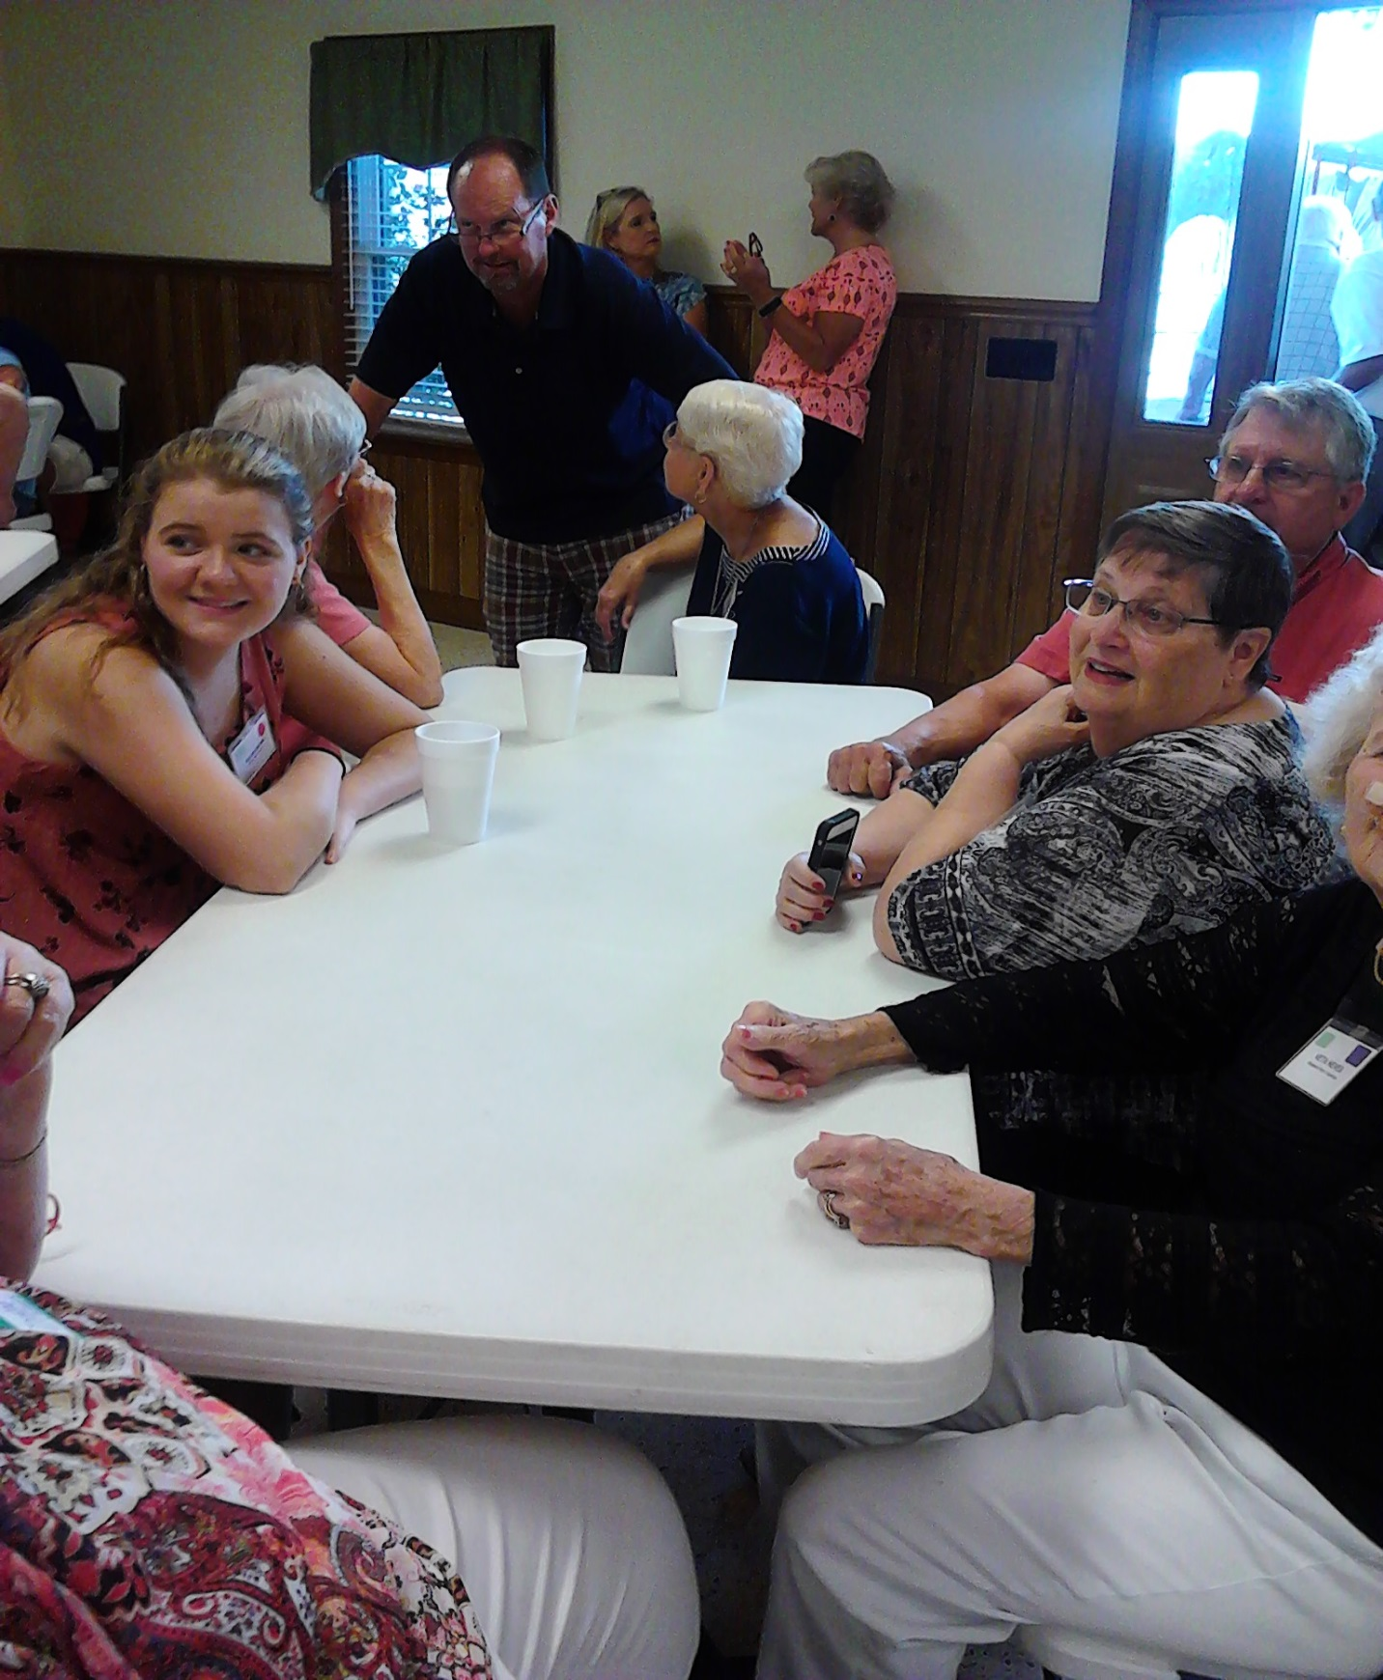
Getting more acquainted.
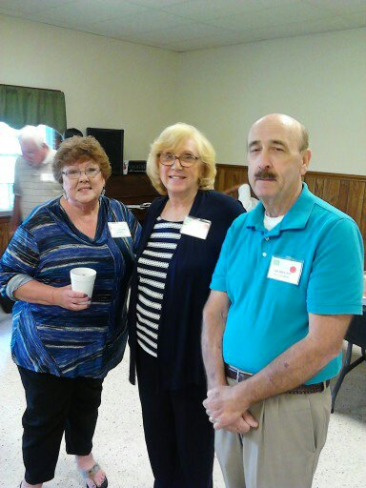
Smiling Traynhams for photographer.
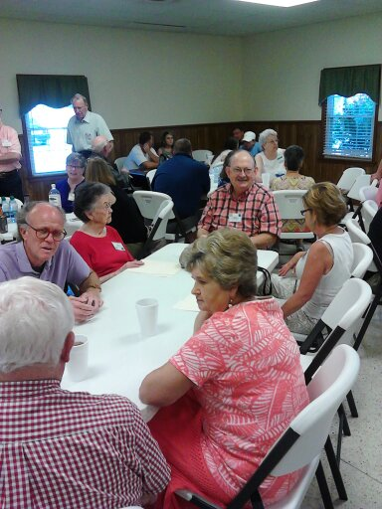
Getting to know us again.
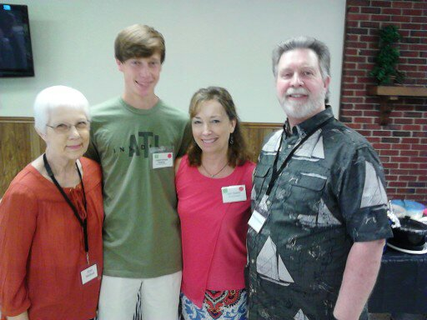
Proud family.
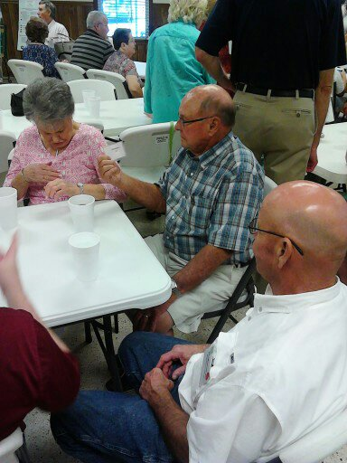
More Traynham family.
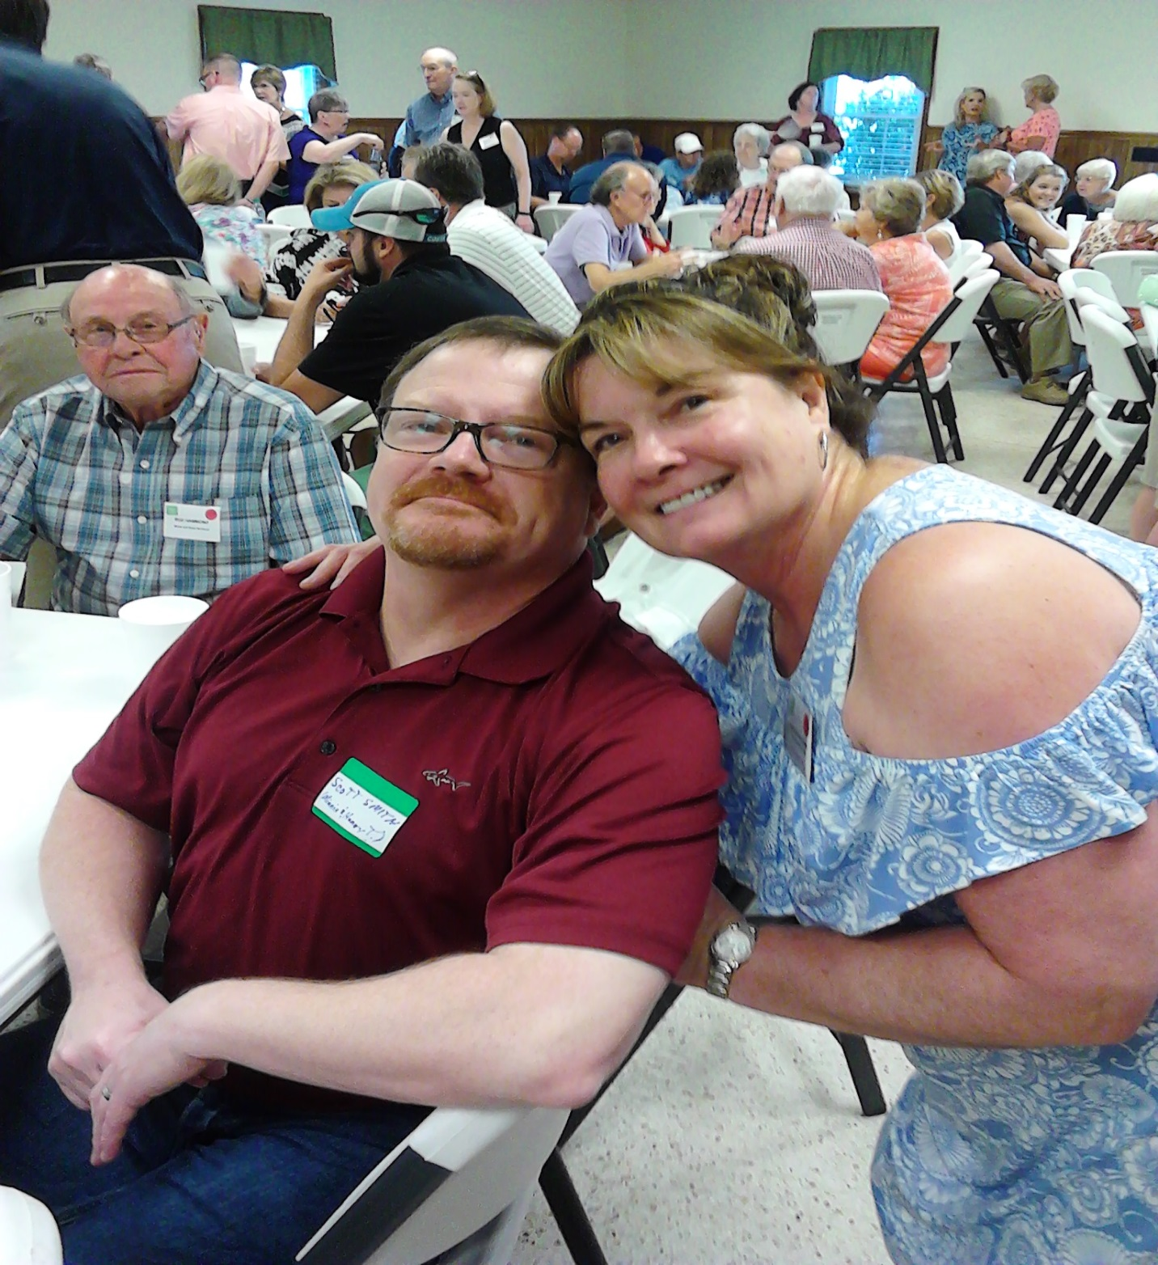
Been awhile.
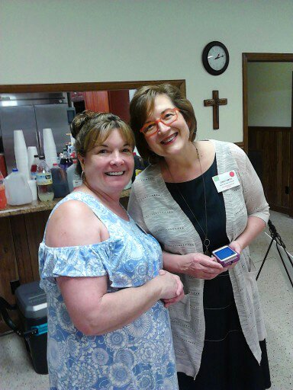
Sharing lasting memories.
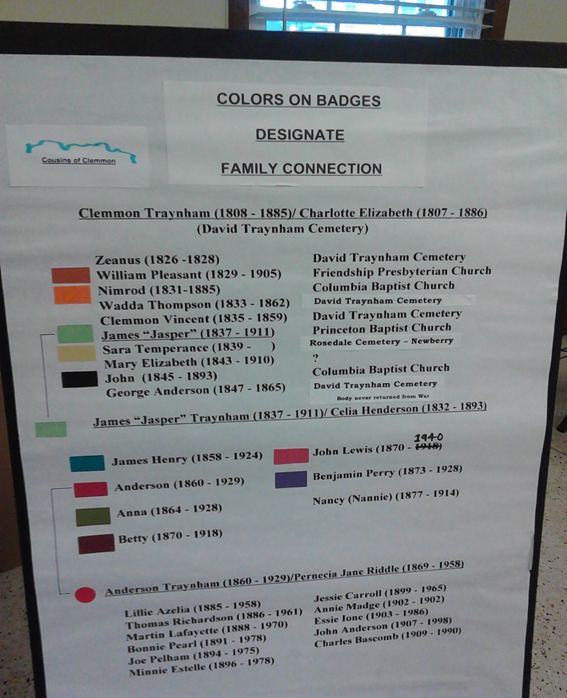
Making a Family Connection.

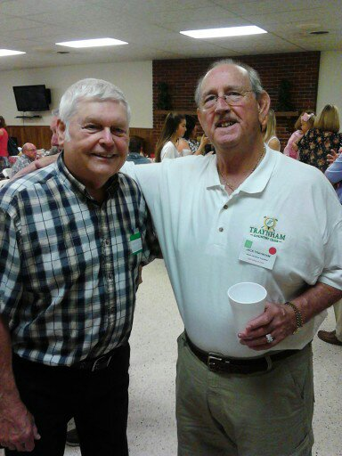
Remember When?
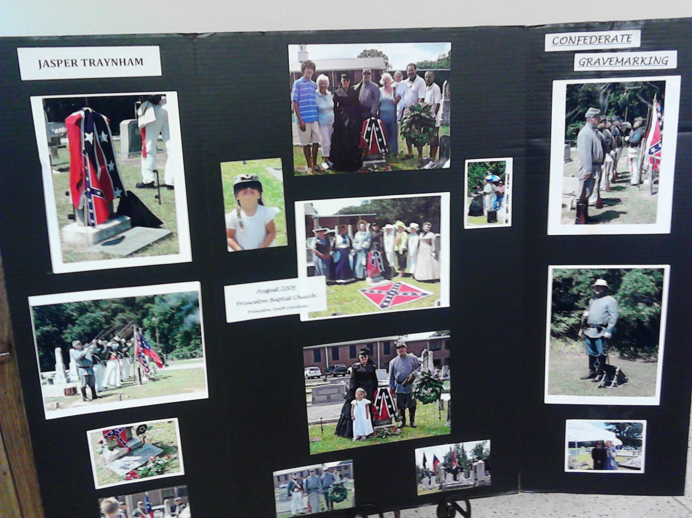
Traynham’s in Confederate Service.

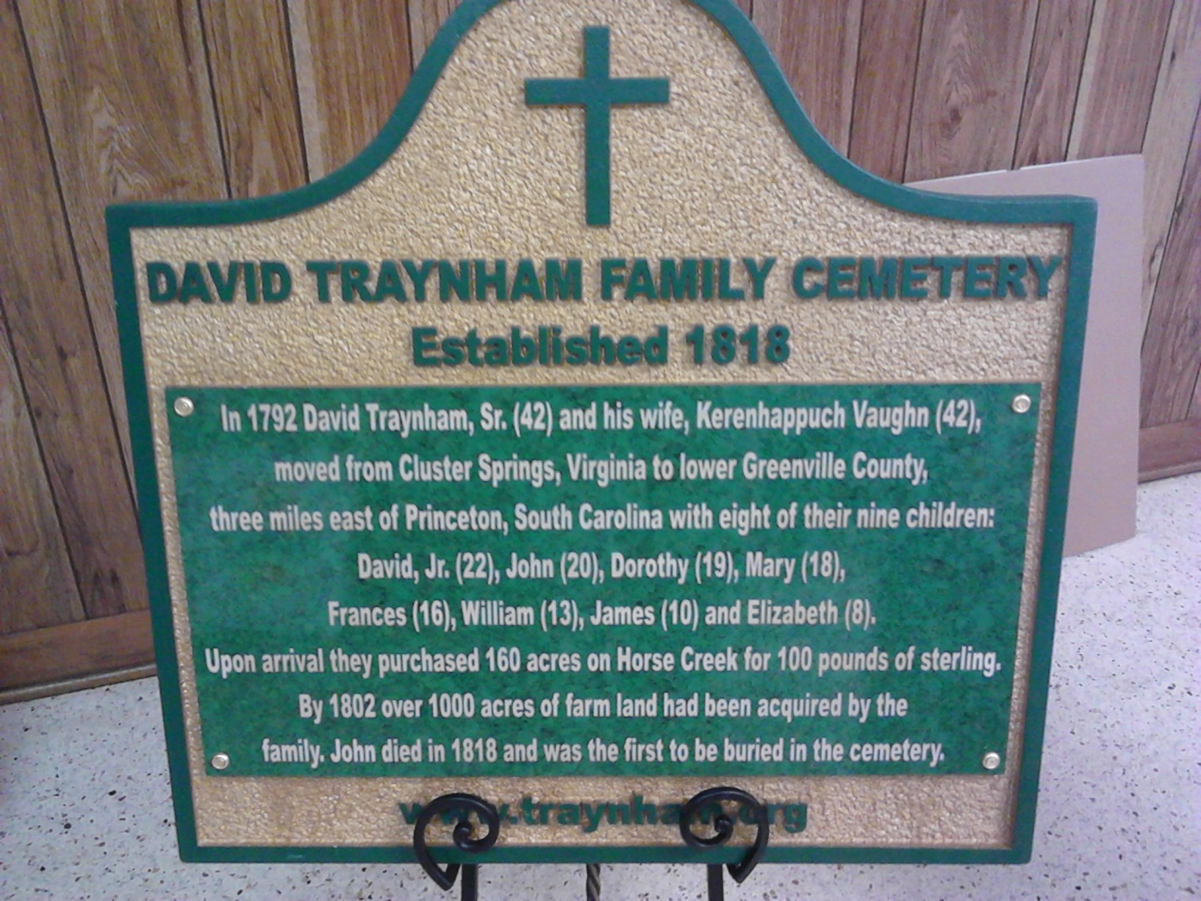
David Traynham Cemetery Plaque
(dedication in August 2018)
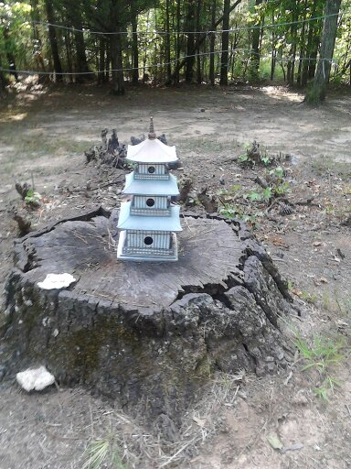
Bird House Cemetery
Yard Art
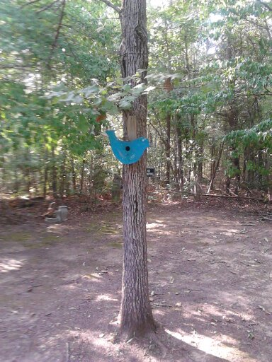
Children’s Art Birdhouses
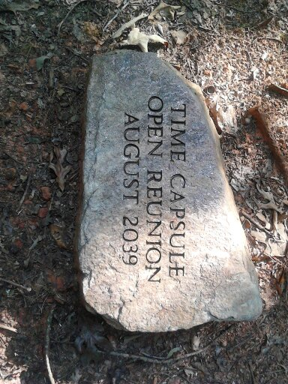
Time Capsule
Open Reunion Aug 2039
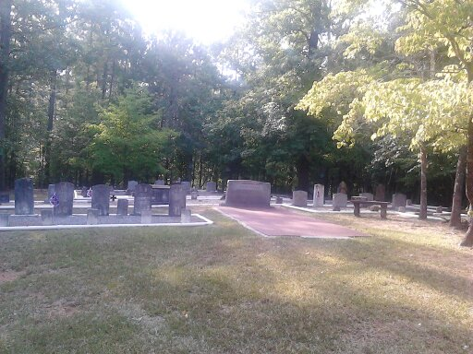
David Traynham Cemetery
Off Hwy 25 South from Pelzer to Latimer Mill Rd. eastbound about 1.3 miles, near old Hamilton place.

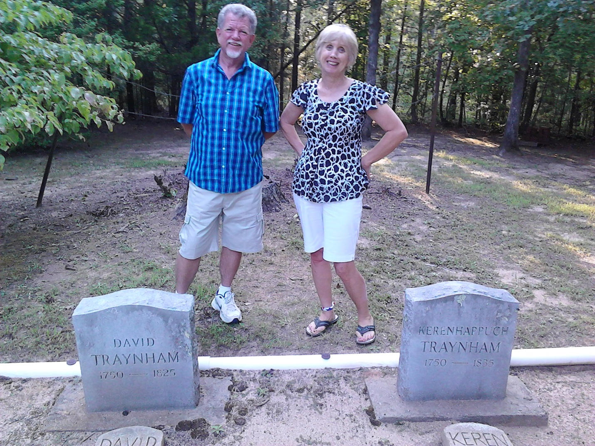
Descendents of Dorothy Traynham
2016 Traynham Reunion
Louis Campbell Boyd & Deanie May Fincher
(double first cousins-May, Boyd)
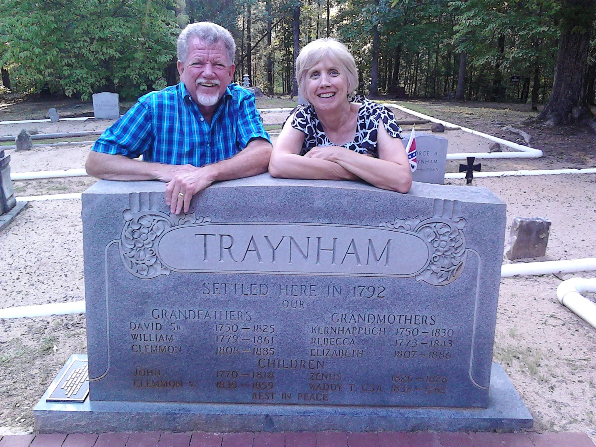
August 2016-David Traynham Cemetery
(first cousins Louis Campbell Boyd & Deanie May Fincher)
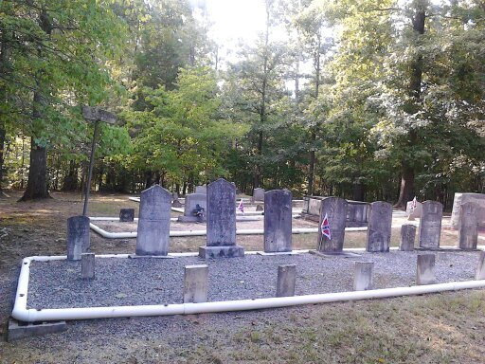
August 2016
David Traynham Cemetery
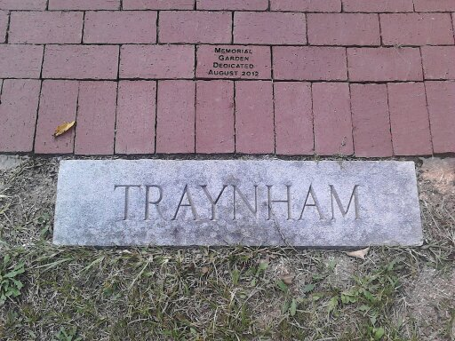
Memorial Garden at David Traynham Cemetery-2016
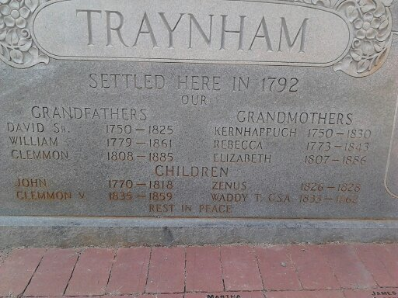
Traynham Family Plaque-2016

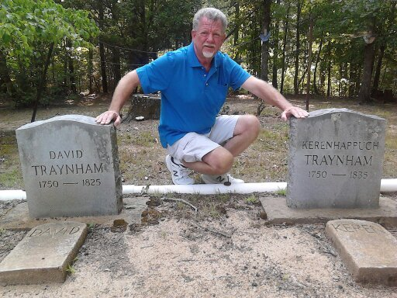
2016- David Traynham Cemetery
(Louis Campbell Boyd descendant)
(David Traynham, Sr. & Keren HappuchVaughn)

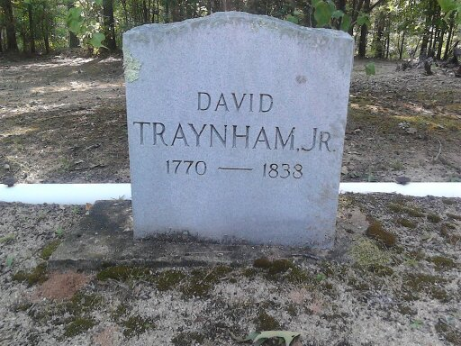
David Traynham, Jr. 1770-1838
(son of David Traynham & KerenHappuch Vaughn)
(married Mary Burns & Elizabeth “Betsy” Key)
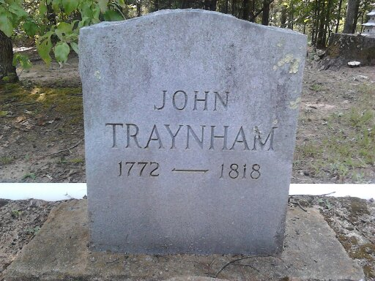
John Traynham 1772-1818
(son of David Traynham & KerenHappuch Vaughn)
(married to Francis “Fannie” Richeson-1779 & Ann Bibb-1805)

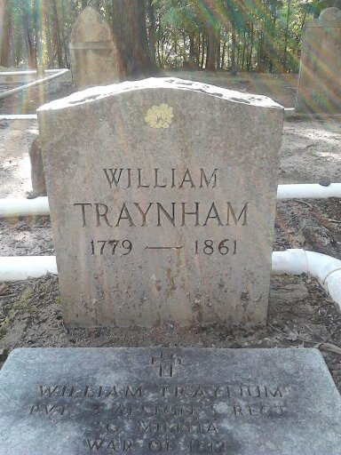
William Traynham 1779-1861
(son of David, Sr. & Keren Happuch Vaughn)
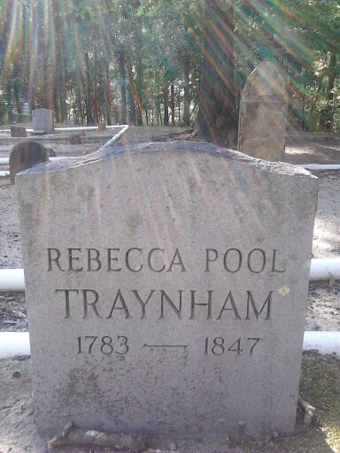
Rebecca Pool 1783-1847
(wife of William Traynham)
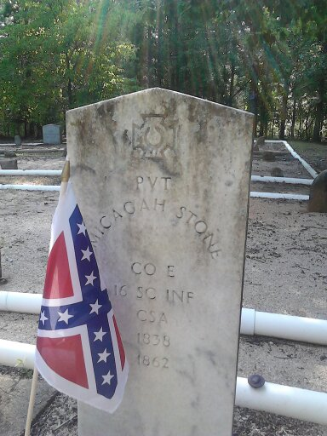
Micajah Stone 1835-1862
(son of Mary Polly Traynham & Mastin Nimrod Stone)
(grandson of William Traynham & Rebecca Poole)
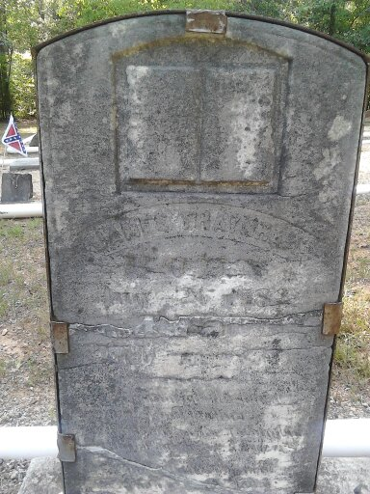
James Sanford Traynham (1782-1859)
(son of David Traynham & Kerenhappuch Vaughn)
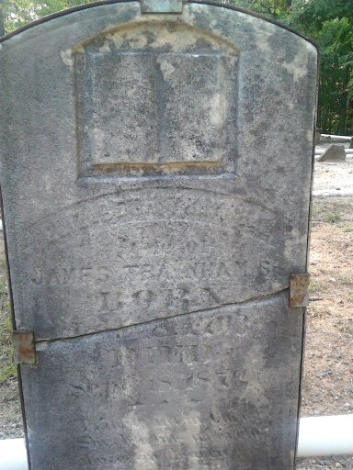
Elizabeth “Polly” Taylor 1793-1876
(wife of James Sanford Traynham)
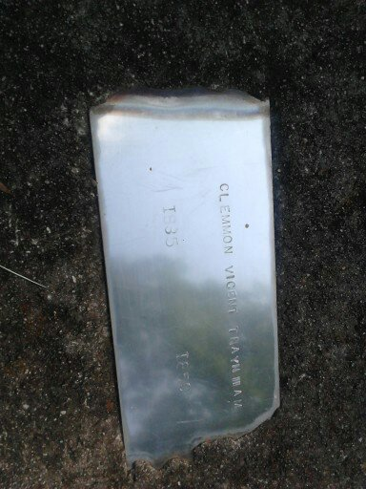
Clemmon Vincent Traynham 1837-1859
(son of Clemmon Traynham & Charlotte Elizabeth Rice)
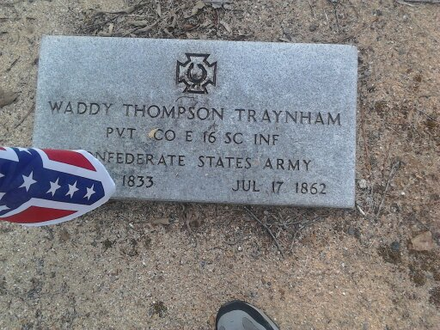
Waddy Thompson Traynham 1833-1862
(son of Clemmon Traynham & Charlotte Elizabeth Rice)
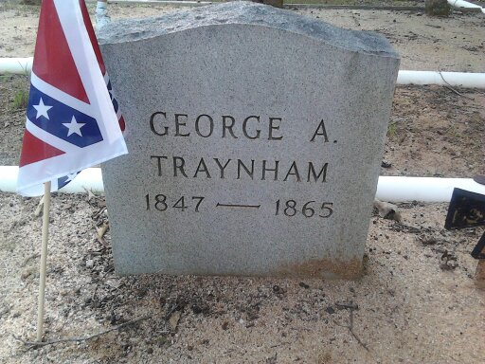
George Anderson Traynham 1847-1865
(son of Clemmon Traynham & Charlotte Elizabeth Rice)

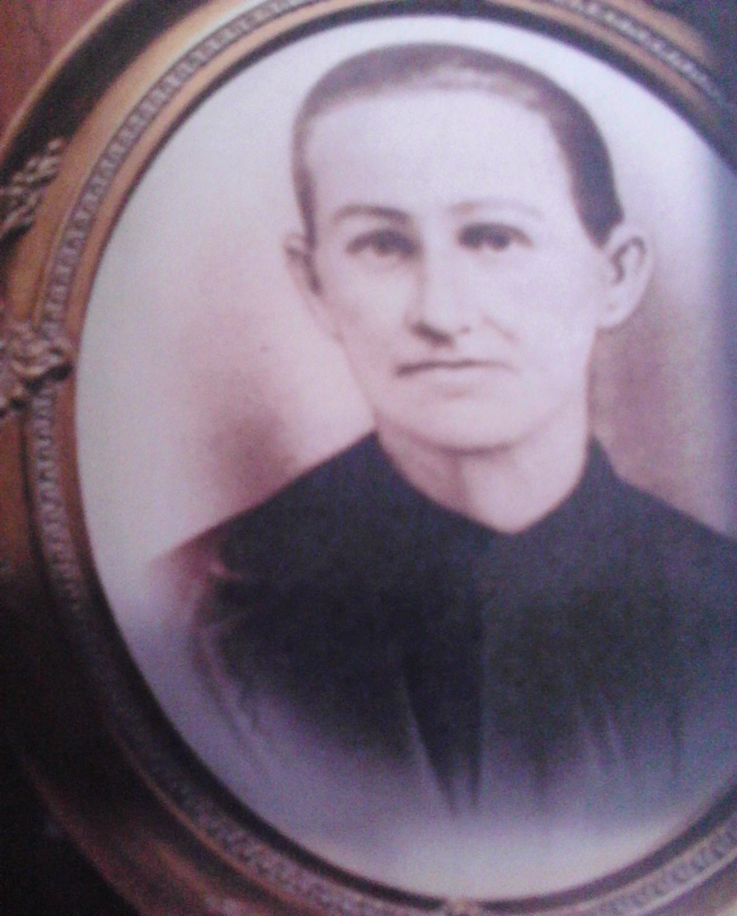
Dorothy Elizabeth Williams
(daughter of Lewis Hampton Williams & Elizabeth Walker)
Grand daughter of Dorothy Traynham
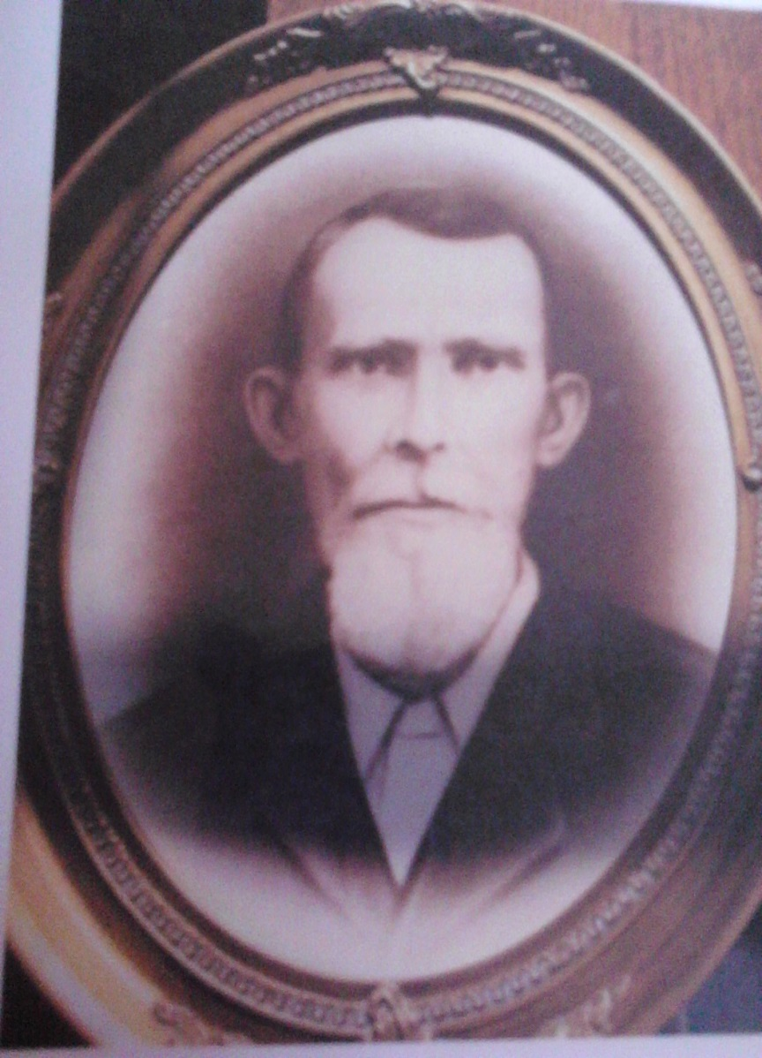
Silas Cicero Boyd
(husband of Dorothy Elizabeth Williams Boyd)
August 2018-Traynham Reunion
Friday, August 24th began the Eighth annual informal "Dutch treat" dinner at the Silver Bay Seafood Restaurant, Simpsonville, S.C. beginning at 7:00 pm. A good attendance offering acquaintances to reflect on missed family events and make new family connections.
Saturday, August 25th: A small group was in attendance for dedication service of David Traynham Family Cemetery beginning at 2:00 pm - weather was warm and lemonade or personal soft drinks were available. Elaine Traynham Zimney and Becky Traynham Henderson shared in dedicating our cemetery sign and rock bench constructed by Tim Thurston in honor of his Great Grandfather Martin Traynham and Grandmother Ruth Traynham White. The Cemetery Memory Walk revealed 32 additional engraved Memorial Bricks with a brief history of those buried in the cemetery. A dedication placement of a Confederate Veteran Marker at the headstone of George Anderson Traynham (1847 - 1865). Anderson was fourteen years old in 1861 and too young to enlist in the Confederacy. One of his older brothers came home on leave and he went back to the war with him - Clemmon and Elizabeth, his parents, received a letter at the end of the war that George Anderson was missing in action - he never returned home.
The service allowed visitors to reflect and become educated about ancestors buried in the cemetery. After this short service, due to heat, it was decided to visit Washington Baptist Church tomorrow for those wanting to view family scrapbooks, family historical data, and new tri-board display of ancestors.
Sunday August 26th: New this year was a water activity and children’s tent. Name tags were hung on felt and Velcro boards preventing them from being blown by winds. Directly across on long tables was the 5 tri-board display of Traynham ancestry. Attendance from many families around South Carolina were greeted by visitor families from Texas, Mississippi, Louisiana, Georgia, Virginia, and California. Mastin Nimrod Stone & Mary Polly Traynham descendant Kenneth D. Stone discovered his descendency. Deanie May Fincher made contact with Keren Happuch Everett Wells. Her family line is through Dina Williams Gunnel's family line. Dina Williams is Dorothy Traynham & William Williams daughter.
Research References:
http://ead.lib.virginia.edu/vivaxtf/view?docId=lva/vi00555.xml;query=;
<head>Acquisition Information</head><head>Biographical/Historical Information</head>

Bailey-Craddock-Lawson Family Letters, 1837-1915, n.d. Accession 28301. Personal papers collection, The Library of Virginia, Richmond, Va. 23219
Yancey Bailey (1755-1804) married Sarah Fowlkes (d. 1833) in 1772 and had nine children, two of whom were John (1795-1871) and Harriet Catherine (1800-1873)
John Bailey married Elizabeth Scott (1797-1884) in 1816 and had two daughters, Frances Madison (1817-1900) and Jane (1819-1899). Frances Madison Bailey married Reuben Charles Traynham (1800-1870) in 1835 and had eight children including, Thomas Benjamin (1836-1910). Jane Bailey married David Lawson (1803-1877) in 1839 and had a daughter, Sallie Fannie (1845-1936). Thomas Benjamin Traynham and Sallie Fannie Lawson married in 1869 and had a son, David Lawson (1869-1930), among other children
Autographed typed letters signed:
R. L. Traynham, Roanoke, Virginia, to Mr. D. L. Traynham, Halifax County, Virginia, <unitdate calendar="gregorian" era="ce">17 December 1884
Sallie F. [Traynham], Harmony, Virginia, to Mr. David L. Traynham, Hyco, Halifax County. Virginia, <unitdate calendar="gregorian" era="ce">7 October 1886
Ruby Traynham, Harmony, Virginia, to Mr. D. L. Traynham, Hyco, Virginia, <unitdate calendar="gregorian" era="ce">27 November 1886
Jannie [___], Danville, Virginia, to Mr. D. L. Traynham, South Boston, Virginia, <unitdate calendar="gregorian" era="ce">27 January 1888
James H. Traynham, Laurens, South Carolina, to Mr. Thomas Traynham, Harmony, Virginia, <unitdate calendar="gregorian" era="ce">11 January 1889
Enclosure - business card of Traynham and Dial, Wholesale and Retail Dealers
J. R. Guthrie, Clover Depot, to Mr. David L. Traynham, South Boston, Virginia, <unitdate calendar="gregorian" era="ce">7 June 1893
With enclosure receipt for taxes on land of Mrs. Rebecca Traynham, Halifax County, Virginia
http://genealogytrails.com/vir/halifax/index.html
This is info from the Benjamin Vaughn Traynham line. This is the one archived by the Traynham family. It contains accurate info on this line. Benjamin's line has so many David and Reuben Charles etc. Many have sought to take the original David and Keren line from parts of this and have grossly been misinformed.The documentation for this info gives us info about how there was communication between the original David's son David Jr. and his cousins there in Va.
you may have this but just wanted to get to you.
Becky
http://ead.lib.virginia.edu/vivaead/published/lva/vi00555.xml

