David&Kerehappuch Traynham Family History

Ms. Becky and Ms Elaine,

How is everyone in South Carolina and Georgia Today?  First may I share Kenneth D. Stone presented me with a research assignment and I'm nearing completion.

Appears a Reuben Reid maternal line is 1st cousin to President Andrew Jackson thru his mother Elizabeth Hutchinson. I have provided a link between Mary Poly Traynham married to John Reid ancestry.  In exchange for his research I have asked him to assist me with the Traynham website. Needing a roadmap to add pics and documents to update the site from 2016.  Large undertaking but I have a few months to chip at it.

(April 2019)

Traynham Line

**Robert Trayne born abt 1641 or Richard Lyon Trayne born abt 1635 (given name R________ blurred)**

Married abt 1658- Roxburghshire, Borders County, Scotland

Mary ___________ born abt 1641- Roxburgh, Borders County, Scotland

**[George Trayne born 1660- York County, England](https://www.ancestry.com/family-tree/person/tree/70596942/person/320017377427)**

[Married abt Jan 1678- York County, England](https://www.ancestry.com/family-tree/person/tree/70596942/person/320017377427)

[Margaret ________________ born abt 1661- York County, England](https://www.ancestry.com/family-tree/person/tree/70596942/person/320017377427)

[Died 1686- Didsbury, Lancashire, England](https://www.ancestry.com/family-tree/person/tree/70596942/person/320017377427)

[Children: William 1678-1727, Richard 1682-1737](https://www.ancestry.com/family-tree/person/tree/70596942/person/320017377427)

**[Stephen Trainum](https://www.ancestry.com/family-tree/person/tree/70596942/person/320017377427)** [born abt 1680- Westmoreland County, Virginia](https://www.ancestry.com/family-tree/person/tree/70596942/person/320017377427)

**[Charles Traynham (father of David Traynham, Sr.)](https://www.ancestry.com/family-tree/person/tree/70596942/person/320017377427)**

[1702 or 1696](https://www.ancestry.com/family-tree/person/tree/70596942/person/320017377427)

[Died- before 12 Aug 1779- Caroline County, Virginia](https://www.ancestry.com/family-tree/person/tree/70596942/person/320017377427)

Married abt 1724- Caroline County, Virginia Colony

**Lydia Griswell**

**Born 1705-died aft 1752 (her burial date not confirmed)**

***both are buried in Doggett’s Creek Church Burial Ground, Poorhouse Corner, Caroline County, VA as per Find A Grave Index

**Children:**

1. **Samuel Trainum** was born abt 1725 in Drysdale Parish, Caroline County, Virginia

On Global, Find A Grave site :

|  |  |
| --- | --- |
| Name | **Samuel Trainum** |
| Birth Date | 1725 |
| Birth Place | Caroline County, Virginia, United States of America |
| Death Date | 1813 |
| Death Place | Caroline County, Virginia, United States of America |
| Has Bio? | Y |
| Children | Obadiah Trainum; Jechonias Trainum |

**Note: two children confirms Samuel Traynham is Obediah Trainum father.

Virginia US, Land Marriage, and Probate Records 1639-1850

|  |  |
| --- | --- |
| Name | **Samuel Traynum** |
| Date | 19 Aug 1772 |
| Location | Spotsylvania Co., VA |
| Property | 100 a. in Berkeley Par., Spts. Co. |
| Notes | This land record was originally published in "Virginia County Records - Spotsylvania County, 1721-1800, Volume I" edited by William Armstrong Crozier. |
| Remarks | James Watkins, of Berkeley Par., Spts. Co., and Mary, his wife, to Elisha Dismukes, of sd. Par. and Co. 40 curr. 100 a. in Berkeley Par., Spts. Co. August Court, 1772. |
| Description | Witness |
| Book | H |

*Samuel Traynum acquired property 100 acres in Berkeley Parish, Spotsylvania County VA

1. **John Trainum** was born about 1728 in Drysdale Parish, Caroline County, Virginia  
     
   On 15 November 1755, John Trainum was ordered to pay his debt of two pounds, 14 shillings and 11 pence to John Allmond by the Caroline County court.  
     
   By 1758, John Trainum had relocated to Granville County (present-day Vance County), North Carolina where he worked as an overseer on the plantation of [John Sims](https://www.findagrave.com/cgi-bin/fg.cgi?page=gr&GRid=160222593) in Nutbush District through 1761.  
     
   On 3 September 1760, John Trainum and his brother [William Traynum](https://www.findagrave.com/cgi-bin/fg.cgi?page=gr&GRid=191872720) were jurors (Blagrave versus Townsend) in Lunenburg County, Virginia, which at the time abutted the northern border of Granville County, North Carolina.  
     
   On 7 May 1761, the Lunenburg County, Virginia court dismissed the case of George Pitt versus John Trainum. [William Traynum](https://www.findagrave.com/cgi-bin/fg.cgi?page=gr&GRid=191872720) served as a witness for his brother. Both Trainum brothers also served on a jury together the same day for the case of Brassie versus Wagstaff.  
     
   By 1762, John Trainum was working as an overseer for William Sims of Nutbush District, Granville County (present-day Vance County), North Carolina.  
     
   On 7 March 1762, John Trainum witnessed a deed for the sale of land on Great Nutbush Creek in Granville County (present-day Vance County), North Carolina from Luke Waldrop to William Sims.  
     
   On 25 October 1763, John Trainum witnessed a deed for the gift of land on Little Nutbush Creek in Granville County (present-day Vance County), North Carolina from Luke Waldrop to his son James Waldrop.  
     
   In 1764, John Trainum was working as an overseer for John Williams (a son of Daniel Williams) in Nutbush District, Granville County (present-day Vance County), North Carolina.  
     
   Later in the 1760s, John Trainum is not found in Granville County, North Carolina records. He may have been living in Halifax County, Virginia during a period of growing unrest and discontentment with the colonial government in Nutbush District.  
     
   On 18 August 1772, John Trainum was listed in the account book of [John Williams](https://www.findagrave.com/cgi-bin/fg.cgi?page=gr&GRid=11631017) of Williamsborough, Granville County (present-day Vance County), North Carolina.  
     
   In 1774, John Trainum was a taxable inhabitant of Granville County, North Carolina.  
     
   John Trainum was an overseer at Montpelier, the plantation of [John Williams](https://www.findagrave.com/cgi-bin/fg.cgi?page=gr&GRid=11631017) (a son of John Williams) for ten months from April 1777 to February 1778 while Williams served in the North Carolina House of Commons. Williams was later a member of the Continental Congress in 1778 and 1779 and a judge of the supreme court of North Carolina from 1779 until his death. John Williams kept a ledger containing the account of John Trainum, which included a saddle, wheat, corn, sugar, molasses, brandy and cloth, including "1 & ½ yds linen to make yr boy a shirt".  
     
   On 17 January 1778, John Trainum was probably serving as overseer for Augustine Davis when he witnessed a deed for the sale of land on Michael Creek from Augustine Davis and his wife Molly (born Mary Jeter) and Absalom Davis to John Penn in Granville County, North Carolina.  
     
   On 22 May 1778, John Trainum took an oath of allegiance to the patriot cause while an inhabitant of the Island Creek District of Granville County, North Carolina.  
     
   By 1780, John Trainum had returned to the Nutbush District of Granville County (present-day Vance County), North Carolina where he died in 1788.  
     
   ══════════════════════════════════════════════════  
     
   John Trainum and Mary [Turner?] were the parents of the following children.  
     
   1. William Trainum, b. 1754 (m. Sarah ______ and Nancy Noel).  
   2. John Trainum, b. 1756 (m. Martha Owen).  
   3. Reuben Trainum, b. 1760 (m. ______ ______).  
   4. Mary Trainum, b. 1764 (m. Reuben Tyler).  
   5. Susannah Trainum, b. 22 June 1766 (m. Francis Griffin).  
   6. Lazarus Trainum, b. 15 October 1771 (m. Judith Owen and Frances Taylor).  
   7. Hannah Trainum, b. 1774 (m. ______ Hester and Stephenton Toney).  
     
   ══════════════════════════════════════════════════

**Gravesite Details**

He was presumably buried at the local parish church, then known as Nutbush Church and consecrated as Saint John's Church in 1825. The church registers before 1844 have been lost.

1. Joshua Trainum born 1734 in Drysdale Parish, Caroline County, Virginia

══════════════════════════════════════════════════  
▫ • ▫ • ▫ • ▫ • ▫ • ▫ • ▫ • ▫ • ▫ Patriot in the American Revolutionary War ▫ • ▫ • ▫ • ▫ • ▫ • ▫ • ▫ • ▫ • ▫  
══════════════════════════════════════════════════  
  
  
He married Elizabeth ______ about 1755-Drysdale Parish, Caroline County, Virginia.  
  
On 14 July 1763, Priscilla Trainham, a daughter of Joshua Trainham, was bound out by the churchwardens of Saint Mary's Parish, Caroline County, Virginia.  
  
In 1764 and 1765, Joshua Trainham was sued by John Wily for debt.  
  
Joshua Trainham enlisted in the Virginia Line of the Continental Army about 1779.  
  
On 14 April 1780, Elizabeth Trainham petitioned the Caroline County, Virginia court as she was unable to support herself while her husband was in military service. She was awarded the sum of sixty pounds.  
  
On 8 May 1781, Elizabeth Trainham applied again to the county court for support assistance for herself and her three children while her husband was in service.  
  
On 11 July 1782, Larkin Trainham and [John] Trainham, children of Joshua Trainham, were bound out by the churchwardens of Saint Margaret's Parish, Caroline County, Virginia.  
  
By 1783, Joshua Trainham had reenlisted as an infantry soldier with the Virginia Line of the Continental Army for a term of 18 months. He died in the line of duty.  
  
On 4 June 1784, the remaining pay for Private Joshua Trainham was received on his behalf posthumously by Colonel Oliver Towles.  
  
On 2 November 1793, widow Elizabeth Trainham made petition to the Virginia House of Delegates by certificates of [Captain Johnston Faulkner](https://www.findagrave.com/cgi-bin/fg.cgi?page=gr&GRid=240463093), [Anthony New](https://www.findagrave.com/cgi-bin/fg.cgi?page=gr&GRid=8626455) and [Captain Beverley Stubblefield](https://www.findagrave.com/cgi-bin/fg.cgi?page=gr&GRid=168429505) showing that her husband, Joshua Trainham, had served 18 months in the army and that he died in the service, requesting that the House of Delegates "grant her some relief from her poverty".  
  
In June 1795, the Overseers of the Poor of Saint Margaret's Parish bound out Thomas Trainham to Joseph Hargrove.  
  
══════════════════════════════════════════════════  
  
Joshua and Elizabeth Trainham were the parents of the following children.  
  
1. Priscilla Trainham, b. about 1756.  
2. Larkin Trainham, b. about 1764.  
3. John Trainham, b. about 1772.  
4. Thomas Trainham, b. about 1780.  
  
══════════════════════════════════════════════════

1. **Charles Trainum** born abt 1740 in Drysdale Parish, Caroline County, Virginia

He married ______ ______ about 1765.  
  
By 18 May 1787, Charles Trainum was living in Louisa County, Virginia where he was taxed for 2 horses and 3 cows. His household included two sons aged between 16 years and 21 years (David Trainham, 20 and Lewis Trainham, 18).  
  
Charles Traynham (as he signed his name) joined his brother [David Traynham](https://www.findagrave.com/cgi-bin/fg.cgi?page=gr&GRid=34577671) in Halifax County, Virginia for a short time, where both men witnessed the will of David Wall on 23 October 1788.  
  
On 4 November 1790, Charles Trainum purchased 30 acres of land on Taylors Creek in Louisa County, Virginia.

On 14 April 1794, Charles Trainum was appointed constable for Louisa County, Virginia.  
  
On 20 July 1798, Charles Trainum (as he signed his name) sold his acreage on Taylors Creek in Louisa County, Virginia.  
  
On 3 December 1798, Charles Trainum purchased 25¼ acres of land on Baileys Branch of the Little River in Louisa County, Virginia.  
  
In 1799, the taxable personal property of Charles Trainum included a chair with two wheels (wheelchair).  
  
By 18 January 1803, Charles Trainham (as he signed his name) had "grown old and infirm and unable of taking care of himself" when he made an agreement with his son David Trainham to be taken care of for the duration of his life. All his estate was to become the property of his son in exchange.  
  
══════════════════════════════════════════════════  
  
Charles Trainham was the father of the following children.  
  
1. David Trainham, b. 1766 (m. Mary Woolliams).  
2. Lewis Trainham, b. 1768 (m. Theodosia Woolliams).  
3. Mildred Trainham, b. 1770 (m. John Glenn).  
4. John Trainham, b. 1771 (m. Susannah Gibson).  
5. Elizabeth Trainham, b. 1773 (m. Story Talley).

**\*\*\*\* 5. Reuben Traynham 1748–aft 1840 (possibly brother of David Traynham, Sr.—unproven documents at this time)**

1. **David Traynham, Sr born btwn 1746-1750 (unknown at this time)**

Married abt 1768-1769- Drysdale Parish, Caroline County, Virginia

Keren-happuch Vaughn born 1750-Virginia

David Traynham, Sr. & Kerenhappuch Vaughn. Here are the 9 family descendent relationships I have gathered so far.

1. David Lawson Traynham, Jr (1770-1838)
2. married abt 1815

Mary Burns (1773-bef. 1824)

resided in Lower Greenville County, SC

Children:

        1). Dr. William B. Traynham (1816-1893)

married 1842

Mary Jane Elizabeth "Eliza" Posey (1829-1865)

moved to Chappel Hill Tx.

       2). Dr. John George Traynham (1819-1879)

married 1842

Amanda O. Arnold (1822-1884)-

resided in Laurens County SC

3). Temperance Elizabeth Traynham (1820-    )

married 20 Feb 1842

George W. Townsend (1818-      )

moved to Chappell Hill, Washington TX

4). Commodore Traynham (1822-     )

Married

Unknown

 5). Carter Traynham (1823-    )

(1) Married 1846

Wife Unknown died early

1. married abt 1824

Elizabeth "Betsy" Key (1810-1850)

resided in Greenville County SC

     1). Mary Ann Traynham (1825- )

married

John W. Posey (1822-      )

moved to Athens MS then

Trinity, Houston County TX

       2). Sarah Traynham (1825- )

married

William B. Thornton (1818)

Resided Laurens, South Carolina

        3). Nancy A. Traynham (1826-1895)

married

Daniel Brown (1824-1880)

resided Rutherford NC moved

to Quarry, Jersey County, IL

      4). Octavia S. Traynham (1829-bef 1900)

married 09 Aug 1865

John W. Posey (1843-     )

moved to Monroe County MS

      5). Benjamin Franklin Traynham (1833-1906)

married

Mary Ann McRae (1835-1879)

moved Aberdeen MS then Shelby, TN

and settled in Lovelady, Trinity, TX

      6). Felix G. Traynham (1834-1886)

Married

Frances A. Puckett (1833-     )

moved to Athens, Monroe County MS

1. Benjamin Vaughn Traynham (1771-1840)

married 1791

Elizabeth "Betsy" Palmer (1768-1839)

remained in Cluster Springs, Halifax VA

Children:

1. )Susan L. Traynham 1792-1874)

married (1) 1826

Peyton Southerland (1786-1831)

resided-Halifax VA married (2) 1859

Isaac Crews (1788-1883)-

-resided-Caroline County, VA

1. )Mary Polly Traynham (1795 -1854

Never married

1850 Census-resided in ClusterSprings, Halifax, VA

with widowed father Benjamin Vaughn Traynham

3.) Kerenhappuch Vaughn Traynham (1796-1866)

married 09 Dec 1829

William B. Bartee (1789-1860)

Resided-Black Walnut, Halifax County VA

Later moved to Reidsville, Rockingham County, NC

4.) David Traynham III (1797-1870)

married 28 Dec 1825

Mary B. Warsham (1810-1880)

Resided- Marseilles, Halifax County, VA

1. )Reuben Charles Traynham (1800-1870)

married 1 Sep 1835

Frances Madison Bailey (1817-1900)

moved from Halifax County, VA to Person, NC

1. )Jeffery Perry Traynham (1802-1883)

married (1) 30 Sep1835

Sarah Frances Bailey (1815-1856)

Resided-Davidson NC

Married (2) Nov 1857

Nancy Davis Mason 1821-1897)

Resided- Person NC

1. )Elizabeth "Bettie" Traynham (1807-1892)

married 26 Dec1825

Robert W. Mackey (1800-1876)

-resided in Cluster Springs, Halifax VA

-after 1879 relocated Henderson County, TN

8. ) John Henry Traynham (1810-1870)

Married (1) 22 Dec 1834

Rebecca Hodges Locks (1813-1843)

Resided-Hodge, Halifax VA

Married (2) abt 1844

Amanda Rebecca England (1821-1900)

3. John Traynham (1772-1818)

married 1805

Ann Francis "Fannie" Bibb (1790- )

resided Cluster Springs, Halifax VA

no children found

4.Dorothy "Dollie" Traynham (1773-1858)

married 1791-Caroline County, VA

William Williams (1770-1839)

-moved 1792 from-Caroline VA

- Greenville County, SC with family

- sold Greenville, SC property to brother

- moved to Ruth, Lincoln County, MS

1. )Jordan Williams (1794-1872)

married 1820-Jefferson County, GA

Mary S. Thompson (1804-1854)

-settled in Coffeeville, Yalobusha, MS

1. )John “Byrd” Williams (1796-1860)

married (1) 4 Mar 1816-Madison, AL

Mary Hill (1799-1835)

-resided Madison County, AL

married(2) 1836- Winston, AL

Rebecca Jane Bridges (1811-1860)

-by 1840 in Topisaw Creek, Lawrence County, MS

3.) Dinah “Diana” Williams (1797-1860)

married 28 Jan 1821-Lawrence County, MS

Nicholas Gunnell (1790-1845)

-resided Topisaw Creek, Lawrence County, MS

4.) Dorothea Williams (1797-1850)

married 12 Mar 1818- Jasper County, GA

Andrew James Weldon (1791-1860)

-resided 1814 Jasper County, GA

& 1818 Harris County, GA

5.) Roland “Rollin” Williams I (1802-1862)

married (1)27 Feb 1823-Lawrence County, MS

Olive “Ollie”Miller (1805-1875)

-resided Lexington, Holmes County, MS

In Aug1850 – Census in Newton County, MS

Has Nancy Granberry Ballard (1809-1857)

Caring for his children from about 1850-1857

From May 1858-abt. 1861has Sarah J. Turner

(1813-1875) then 1870 census has son born 1865

-resided on property in Columbia on Ouachita River

In Caldwell Parish LA

6.) Benjamin M. Williams (1804-1842)

married 29 Nov 1825-Lawrence County, MS

Mary Miller (1804-1880)

-resided Lawrence County, MS

7.) Mary Elizabeth Williams (1806-1860)

married 13 Jan 1825-Greenville, SC

James S. Miller (1805- 1847)

-resided from 1825- 1835 Hackleburg Marion, AL

1837-1858 Louisville, Winston, MS

-after 1858 in French Camp, Choctaw, MS

1. Wyott Williams (1809-1838)

unmarried

-resided Ruth, Lincoln County MS

1. Savilla Williams (1811-1890)

married 1 Mar 1832-Monticello, Lawrence, MS

Robert Bridges (1809-1875)

-resided in Cato, Rankin County, MS

1. William Minton Williams (1814-1884)

Married abt 1834- Washington, AL

First Wife unk (1816-1843)

married 1845-Hopewell, Calhoun, MS

Elizabeth Walker (1817-aft1900)

-resided Lexington, Holmes County, MS

1. Lewis Hampton Williams (1817-1852)

married 1839-Pike County, MS

Elizabeth Walker (1817-1901)

- resided Carter’s Creek, Pike County, MS

1. Parham Boyd Williams (1819-1862)

married 19 Dec 1839-Pike County, MS

Frances Elizabeth Brent (1818-1887)

-resided Topisaw Creek, Lincoln County, MS

5. Mary Poly Traynham (1774-aft 1811)

married 1806 – Caroline County, VA

John Reid (1774-1860)

- resided near Horse Creek, Greenville, SC

1. )Nancy Powell Reid (1808-1872)

married 03 Feb 1820 –Reid’s Gap, Blount County, AL

Redden Reid(1795-1837)

-1828-1837 resided Walker County, AL

Married abt. 1865- Clay County, AL

James M. Jones (1807- )

-1865 relocated Clay County, AL

2.) Karen Happuch Reid (1811- 1861)

married Oct 1831-Laurens County, SC

William L. P. Bolt (1811-1898)

-resided Hickory Tavern, Laurens County, SC

1. Frances "Fannie" Traynham (1776-1865)

married abt 1791- Greenville, SC

Robert Nabors (1773- )

- resided Rabun Creek, Greenville County, SC

Children:

1.) Elizabeth Nabors (1791-1853)

married 26 Feb 1844 – Shelby County, AL

William McWilliams (1804-1865)

-resided Shelby County, AL

1. William Traynham (1779-1861)

married abt 1803

Rebecca Poole (1783-1847)

- resided Princeton, Laurens County, SC

1. )Alethia Jane "Allie" Traynham (1804-1885)

married 17 Mar 1825- Greenville, SC

Jesse French (1805-1885)

resided Dunklin, Greenville, County, SC

1. )Mary Polly Traynham (1806-1858)

married 1831- Greenville, SC

Mastin Nimrod Stone (1806-1865)

-resided Lower Greenville County, SC

1. )Clemmon Traynham (1808-1885)

married 27 Mar 1825- Greenville, SC

Charlotte Elizabeth Rice (1807-1886)

-resided Tumblin Shoals, Laurens County, SC

1. James Sanford Traynham (1782-1859)

married Jan 1811- Greenville, SC

Elizabeth "Polly" Taylor (1793-1876)

-resided near Tumblin Shoals, Greenville County, SC

1. )Clarissa Hartness Traynham (1812-1880)

married Apr 1830

Elijah Baker Ridgeway (1806-1880)

-left Lower Greenville, SC abt 1835

resided Claysville, Marshall, AL

1. )Elmira Traynham (1813-1858)

never married

resided in Greenville, SC

1. )David Anderson Traynham (1816-1911)

married 1848 – Honea Path, SC

Malinda Elizabeth Martin (1821- 1887)

-left Greenville District, SC after 1860

Then found 1880 Ellistown, Pontotoc, MS Employed as physician- Sun Flower County, MS

widowed by 1887 in Sumner,Tallahatchie, MS

1. )Benjamin Garrison Traynham (1818-1896)

Married 7 Nov 1839- Laurens County, SC l

Mahala Mangeline Riley (1820-1896)

moved 1850 to Newton GA, then

1864 Warren GA, 1880 Gumm, Baldwin, GA

1. )Thomas Walker Traynham (1820-1895)

remains unmarried

Resided with parents 1850 in Sullivan,

Laurens County, SC, 1860 & 1870 is single

living with Elizabeth (mother), sisters Amanda,

Jane Carolina, & Elizabeth, by 1880 only he &

his sisters; Amanda, Jane Carolina, & Elizabeth.

1. )William Taylor Traynham (1822-1915)

married 1854- McDonough, Henry County, GA

Mary Ann Russell (1836-1920)

moved to Honea Path, SC 1870 teaching school,

by 1880 McDonough, Henry GA; south Atlanta.

1. )Jane Carolina Traynham (1826-aft 1910)

unmarried 1850 with parents Sullivan,

Laurens, SC, 1860 with 1870 living among

Elizabeth(mother) in Thomas home, Sullivan, Laurens County, SC &

1880 living single with siblings Thomas W.,

Amanda, & Elizabeth, by 1900 in home with sister Amanda P. Traynham as two spinster sisters.

1. )Sanford Gaines Traynham (1827-1854)

unmarried 1850 with parents Sullivan, Laurens, SC

1. )Amanda Parmer Traynham (1829-Aug 1911)

unmarried 1850 with parents Sullivan,

Laurens, SC, 1860 with 1870 living among Elizabeth(mother) in Thomas home, Sullivan, Laurens County, SC & 1880 living single with siblings Thomas W., Jane Carolina, & Elizabeth,

by 1900 in home with Jane Carolina Traynham as two spinster sisters.In 1910 in home at 71 yrs with boarder Inez Robertson.

10.) Elizabeth Terzah Traynham (1831-1900)

unmarried 1850 with parents Sullivan,

Laurens, SC, 1860 with 1870 living among

Elizabeth(mother) in Thomas home in

       Sullivan, Laurens County, SC & 1880 living

single with siblings Thomas W., Jane Carolina,

& Amanda Parmer Traynham.

11.) Martha Turner Traynham (1 Nov 1834 - 14 Nov 1834)

died at home at 13 days Sullivan, Laurens, SC

1. ) James Hamilton Traynham (1837-1911)

married 26 Oct 1875 – Laurens County, SC

Mary F. "Pressley" Brown (1849-1900)

resided in Laurens County, SC,

Confederate POW captured 17Dec1864-

Franklin TN interred Louisville KY until 23 Jan 1865,

Col. James Hamilton Traynham died in private Sanatorium.

9. Elizabeth Traynham (1784-1864)

married 1811 – Laurens County, SC

John Brownlee (1780-1864)

-resided Waterloo, Laurens County, SC

Children:

1. )Esther Brownlee (1812-1864)

married 11 Nov 1853 Drumaul, N. Ireland

Robert Craig (1793-1863)

resided Pleasant Mound, Laurens, SC

1. )Joseph Jackson Brownlee (1814-1877)

married Aug1846- Dials, Laurens, SC

Nancy Garner (1827-1902)

resided Waterloo, Laurens, SC

1. )Matilda S. Brownlee (1816-1898)

married abt 1843 – Pleasant Mound, SC

Sampson Babb (1798-1855)

resided Mt. Airy, Anderson County, SC

1. )Mary Emily Brownlee (1817-aft1880)

married abt 1837- Cross Hill, Laurens, SC

Tryon Nelson (1812-1881)

resided Rural Laurens County, SC

1. )John Traynham Brownlee (1819-1877)

married 4 Feb 1847- Waterloo, Laurens, SC

Mary Ann Riddle (1822-1919)

resided Dials, Laurens County, SC

1. )Elizabeth "Betty" Brownlee (1819-1884)

married 1836- Waterloo, Laurens, SC

Youngsett Nelson (1813-1884)

resided Waterloo, Laurens, SC

                        7.) Kerenhappuch Brownlee (1821-      )

No marriage record, believed died young

 resided in Waterloo, Laurens County, SC

8.)unknown infant female Brownlee (1824-1824)

from Waterloo, Laurens, SC

9.)unknown infant male Brownlee (abt 1825-1825)

from Waterloo, Laurens, SC

Next Item of business is ordering bricks? Question? How many rows allowed on 1 single brick?

 Can we get 4 rows of print on each brick? Louis and I are wanting the following orders.

                          Dorothea "Dollie" Traynham          Lewis Hampton Williams

                              1773                     1858                  1817            1852

                                   William Williams                         Elizabeth Walker

                              1770                     1839                  1817            1901

                         Dorothy Elizabeth Williams               Dewitt Webster Boyd

                              1846               1932                         1881           1958

                                Silas Cicero Boyd                            Rosabelle May

                              1843              1908                          1881           1928

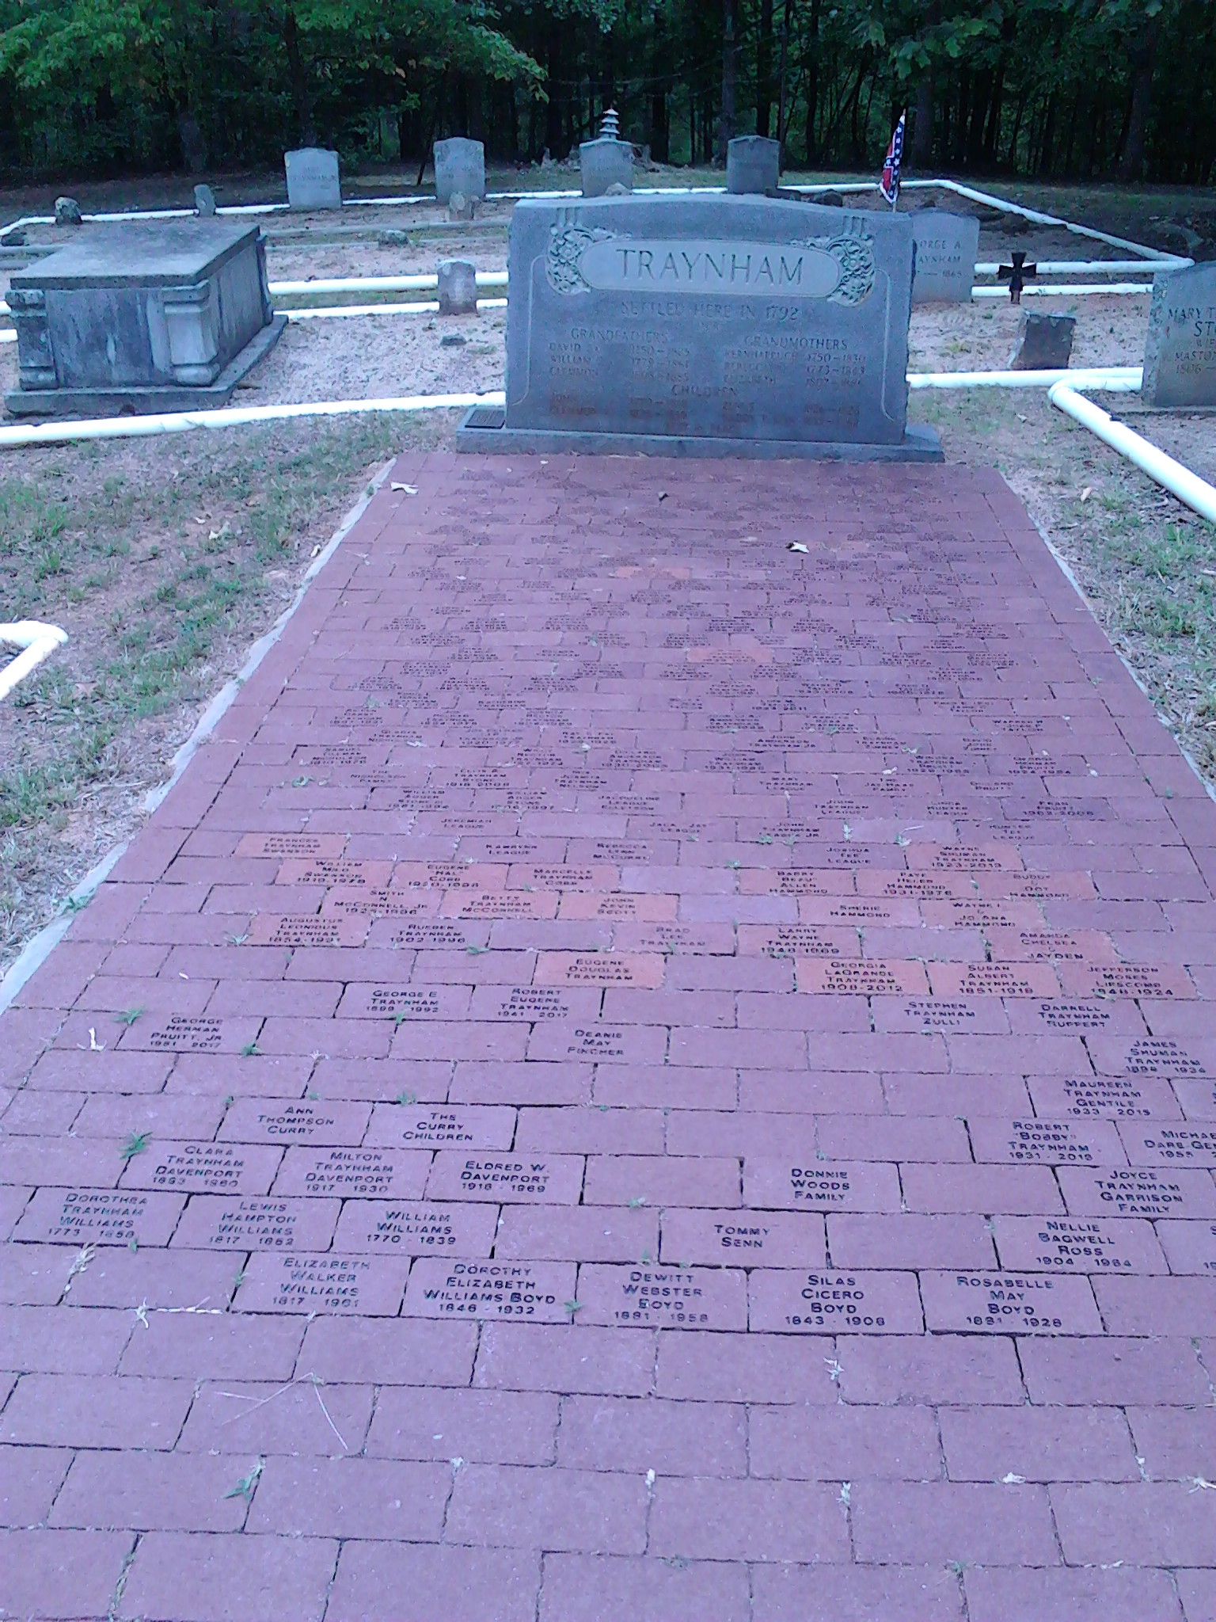

David Traynham Cemetery, at 794 Lattimer Mill Rd., Honea Path, SC

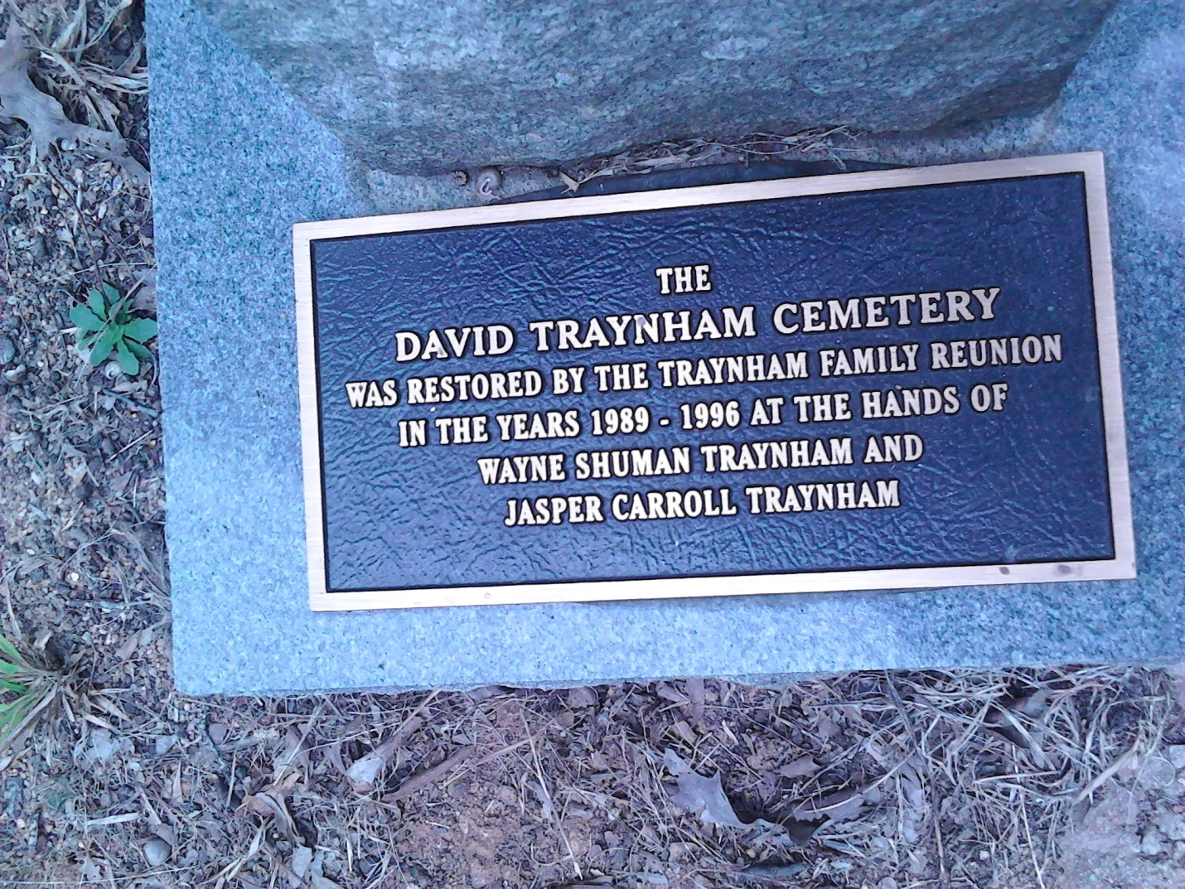

Base of Traynham monument

Here are descendants of Dorothy E. Traynham bricks on path.

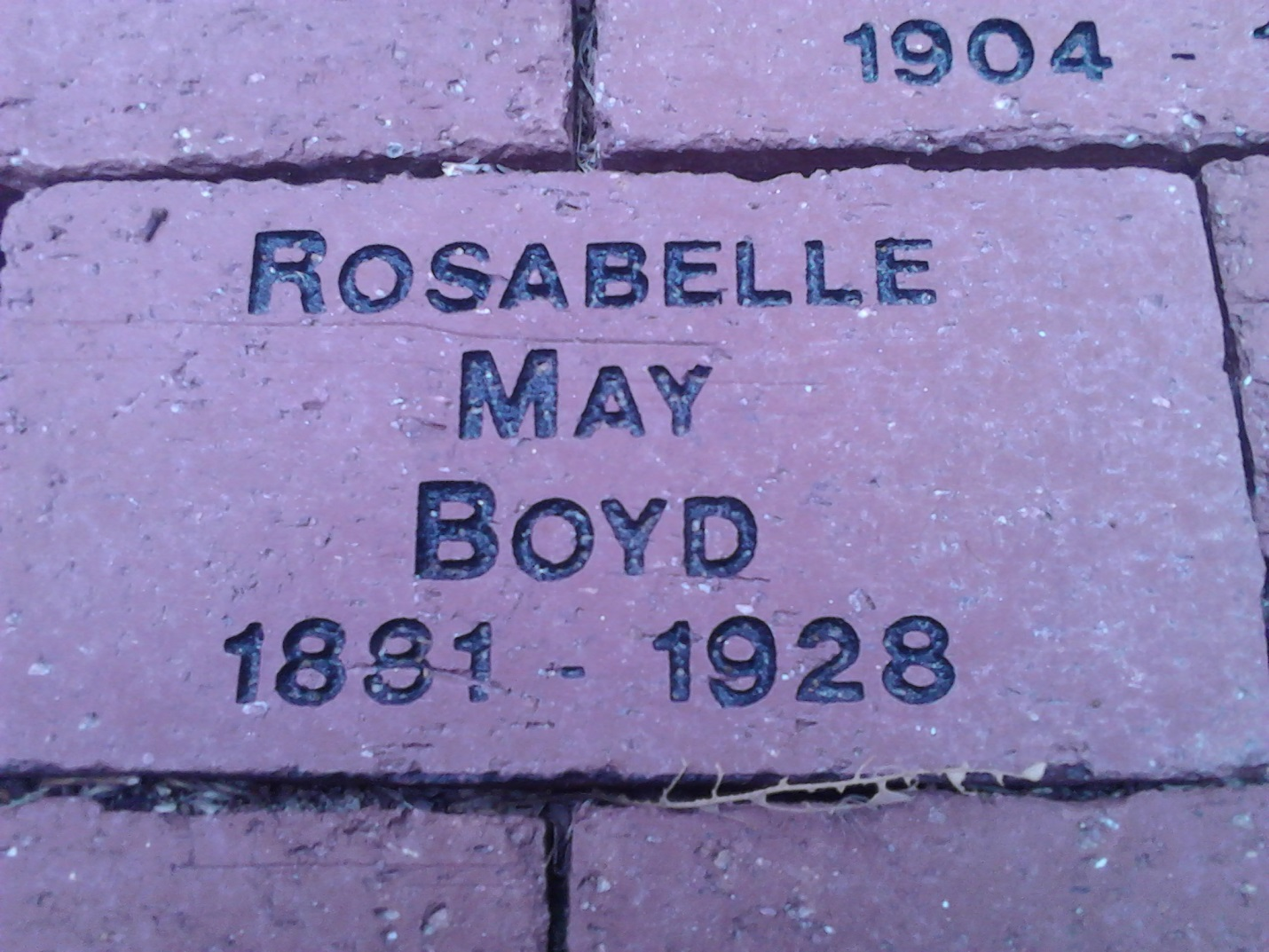

RosaBelle May wife of Dewitt Webster Boyd, grandparents of Louis C. Boyd

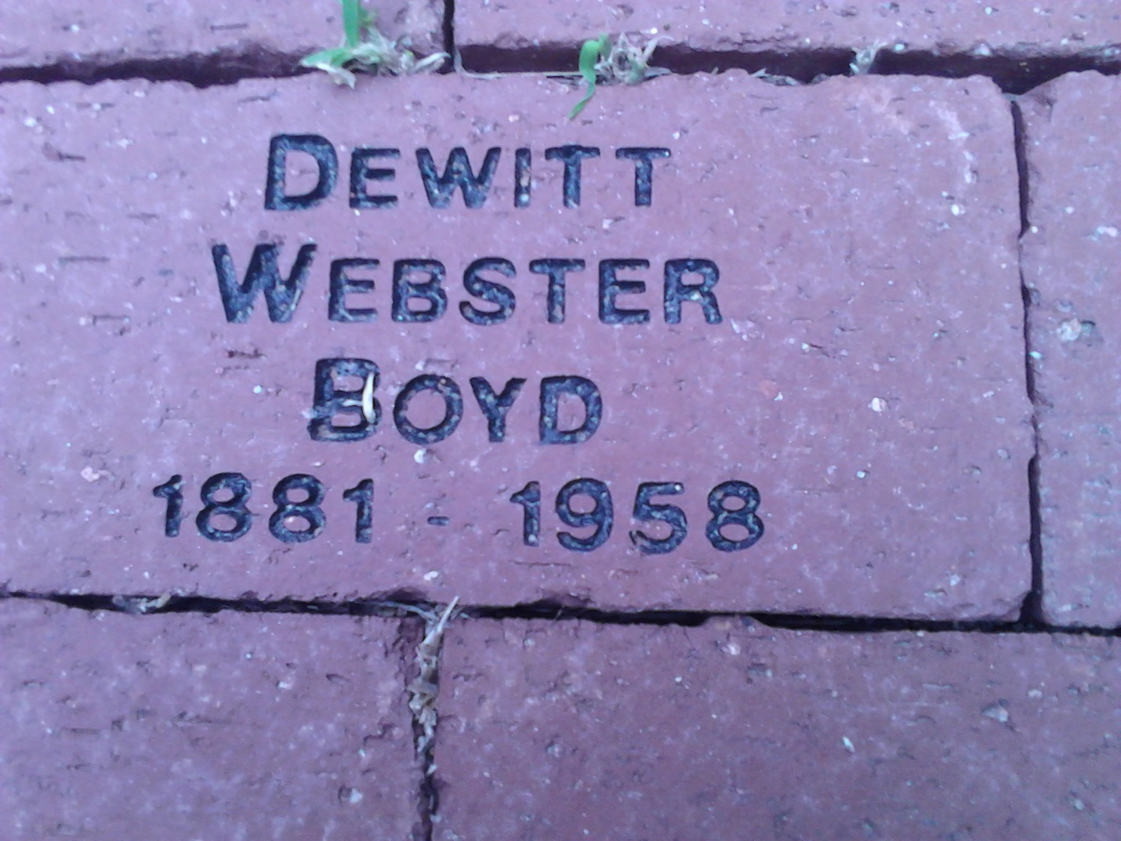

Dewitt Webster Boyd son of Dorothy Elizabeth Williams wife of Silas Cicero Boyd, grandfather of Louis C. Boyd

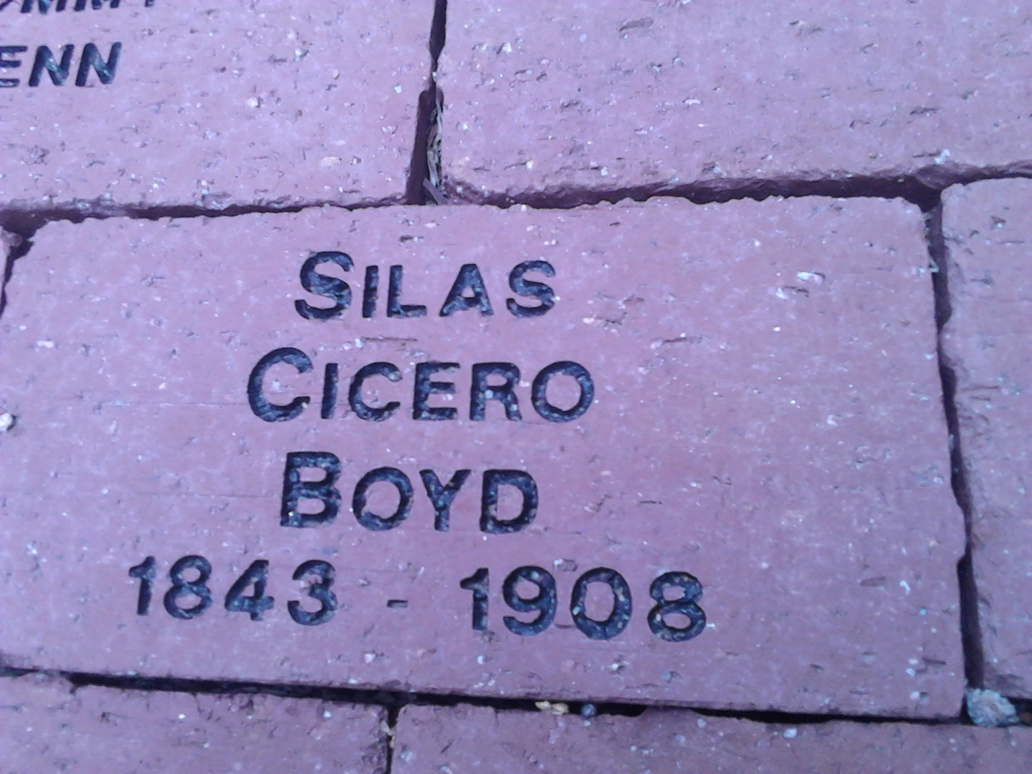

Silas Cicero Boyd husband of Dorothy Elizabeth Williams

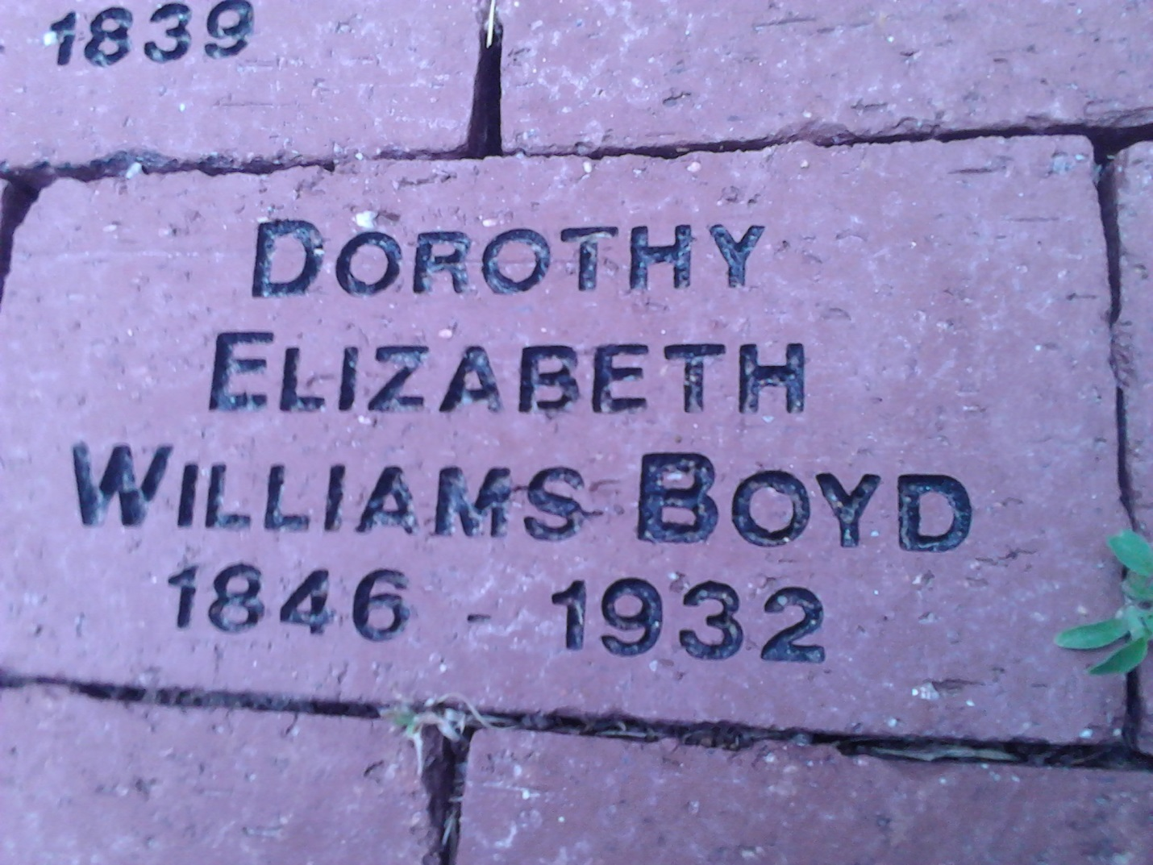

Dorothy Elizabeth Williams wife of Silas Cicero Boyd

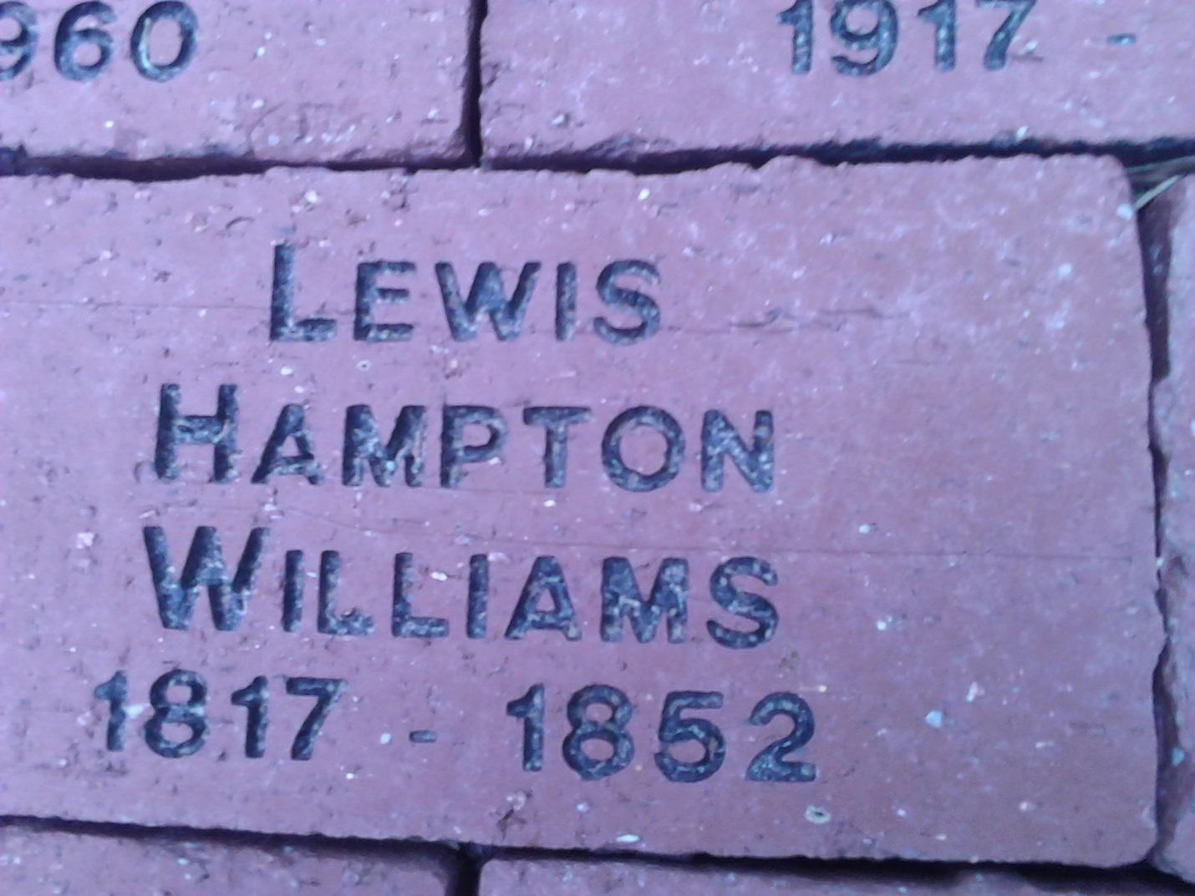

Lewis Hampton Williams father of Dorothy Elizabeth Williams

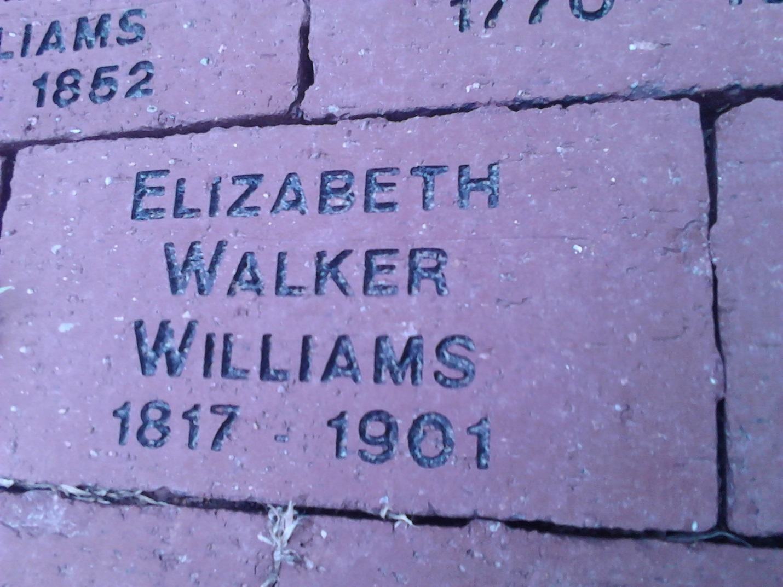

Elizabeth Walker wife of Lewis Hampton Williams

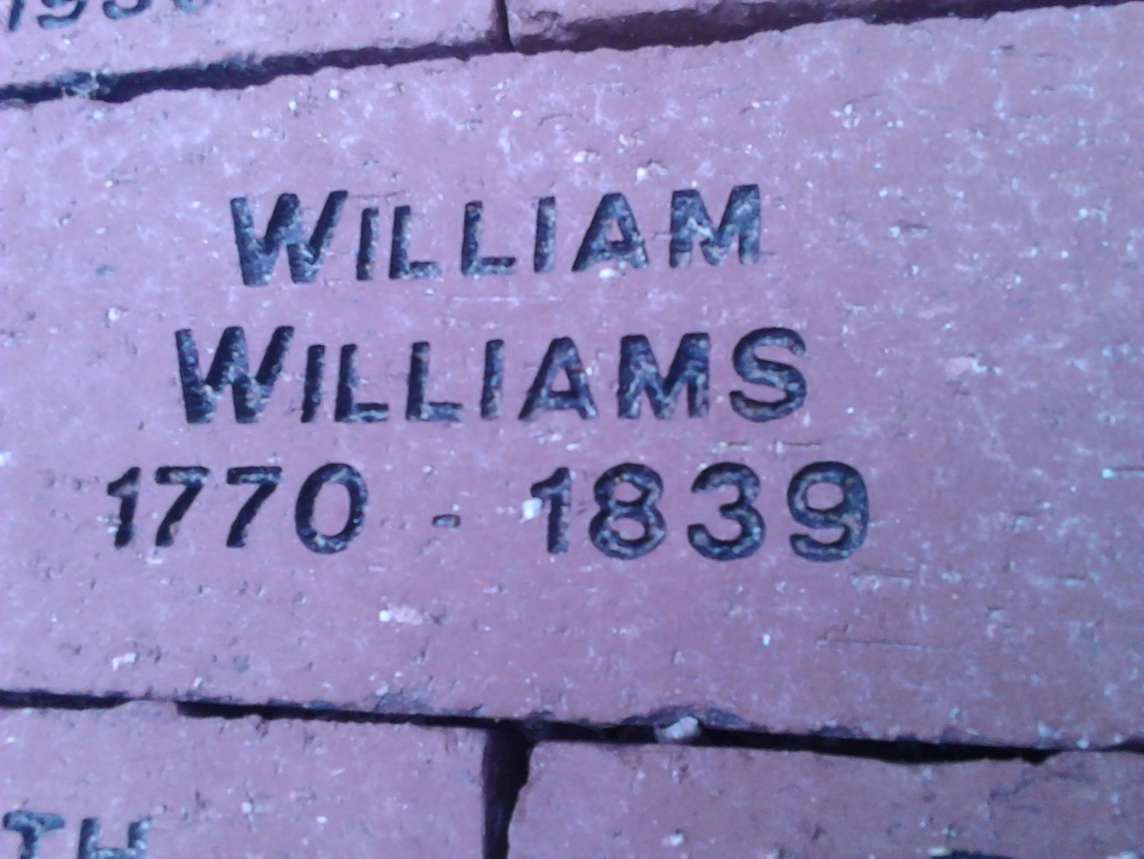

William Williams father of Lewis Hampton Williams

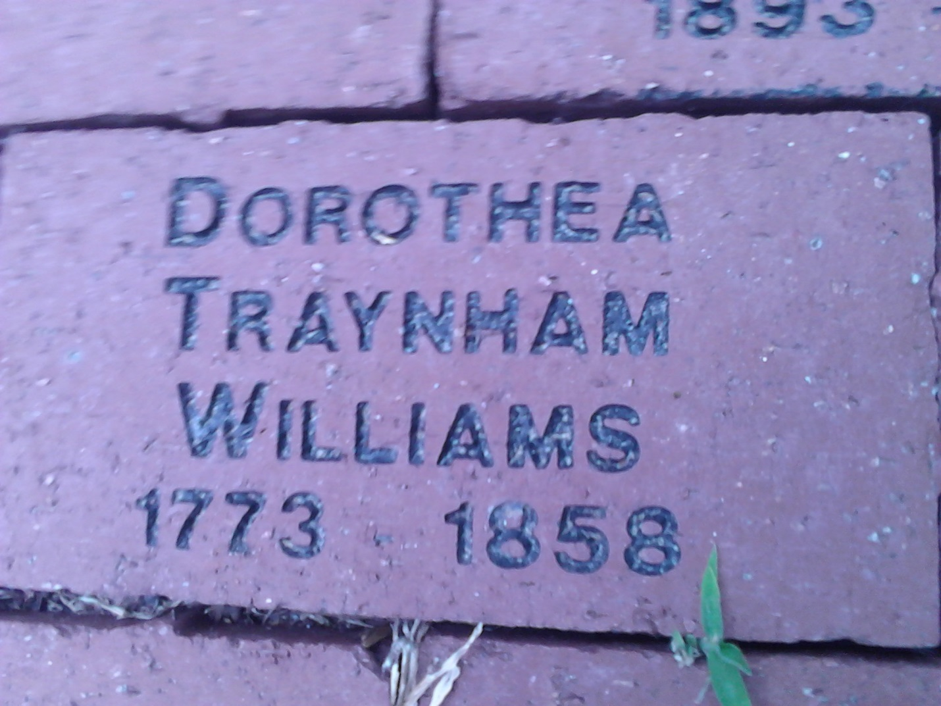

Dorothea Traynham wife of William Williams, parents Lewis Hampton Williams

HISTORY GATHERING 2016 Wow! I can tell you definitely that there was a total of 30 Traynham descendants at our 2016 gathering. However, there is no way to measure the excitement and contributions made by those attending. Many traveled a great distance to bring their stories, pictures, family records, and other genealogical information. They were eager to share and place their information into their family line’s book. We now have a book for almost each line of David and Keren’s descendants. Our story is growing and becoming more and more complete! As I observed those who attended, I was reminded of how this is indeed a time of gathering our history…but more important, it is a gathering of the “Story Tellers”. May I introduce you to them? The Story Tellers are the chosen…My feelings are that in every family there is one or more who seems to be called to find the ancestors. To me, discovering the genealogy is not a cold gathering of facts. Instead, it is breathing life into all who have gone before us. Some are the researchers. Some are the listeners…the collector of stories and memories shared around the table, those who take the time to scribble notes to tell others. I, personally, belong to these. We might be called the story tellers of the “tribe”. Each tribe has one or more. We have many, I am discovering! We have been called, as it were by our genes. Those who have gone before us cry out to us to “tell our story”, and, so we do. In finding our ancestors, we sometimes find ourselves. How many graves have I stood before and wondered what they looked like. I have lost count. How many times have I told ancestors, ”You have a wonderful family. You would be proud of us.” How many times have I walked up to a grave and felt, somehow, there was love there for me? I cannot say. It goes beyond just documenting of fact…it extends to who I am and why I do the things I do. It extends to seeing a cemetery about to be lost forever to weeds and indifference, and saying, “I can’t let this happen”. The bones here are bones and flesh of my flesh. It extends to doing something about it…it extends to pride in what our ancestors were able to accomplish. It is about how they contributed to what we are today. This brings us to respecting and embracing their hardships and losses, their never giving in or giving up, and their resolutions to go on and build a life for their family. It produces a deep respect and PRIDE in their willingness to fight for and defend our freedom and the rights we have today. It was that we might remember them. So we do with love and caring…scribbling each fact of their existence, with the hopes of preserving the memory of a time and place…the memory of them…the ones who lived in that time and place. So, as a collector…a scribe, or a scribbler, called to tell the story of my family…it is up to the next one called in the next generation to answer that call. It is up to them to take their place in the long line of story tellers. This is the reason for my passion for my family genealogy. This is what calls those young and old to step up and put flesh on the bones, and provide names in our family history. All this is for the purpose of remembering our ancestors as part of our family, those who lived …loved….cried….and died. Story Tellers become the voice of ancestors…to tell their stories. Therefore, tell their story…pass it on…EVERY FAMILY HAS A STORY! A special thank you to all who attended our 2016 gatherings, or sent information to us to continue our wonderful Traynham Story! You are now one of our “Story Tellers!” Note: William and Ed Pool attended bringing the Pool information and how Traynhams connect. Roger Hulsey, Luke, Tom Hulsey, and JoAnn Hulsey Pasley attended bringing information on the line of Obadiah, Jeremiah, and Willis Traynham. We are still seeking to find the link which connects. Deannie Fincher, Louis Boyd and Marlon Bourque came with information on the Dorothy Traynham Williams line. Unable to attend gathering but brought information or sent to us: Julia Hicks, descendant of Margaret Etta Traynham Latimer. Laura Coleman, a daughter of Delk Traynham, son of David Milton Lafayette Traynham. Both David Milton Latimer Traynham and Margaret Etta Traynham Latimer are from the line of William Pleasant Traynham, son of Clemmon Traynham. We could never forget Steve Traynham Zulli, who attended, seeking to find his connection to a wonderful and receptive family. And, of course all those who are so faithful each year, many traveling a great distance…like Gene, Brad, and Susann Traynham, Virginia Cornwell and her family...John and Shirley Cornwell, Terry and Lynda Holland.

Thank all of you for your generosity… Becky Henderson

Stephen Jordan Zulli…. The journey to find his Traynham roots ….. This story begins on January 5, 1960 in Long Island, New York. A baby boy was born weighing 6 lbs. 15 oz. to a seventeen year old girl who, because of her family situation (her mother 5 had just recently passed away and her father – the Traynham - was not in the picture) would be giving him up for adoption. The adoption was helped along by a Dr. Henry Thayer. His birth mother had selected a name – Donald Edward. She was a Traynham from South Carolina according to the adoptive parents who named the baby Stephen Jordan Zulli. His birth mother went to New York to live with a single Aunt who was a nurse working for Dr. Thayer. After his birth, the story goes that she was sent to California to live with a relative and complete high school. His birth father’s name was not on record at the time of his birth. Stephen knew from a very early age that he was adopted. He shared a very happy, privileged life growing up with three siblings – one younger sister who was also adopted and another brother and sister who were born to his adoptive parents. In 1991 Stephen was anxious to locate his Traynham family so he hired an investigator - to no avail. However, he never lost sight of his journey to find his roots. For twenty-six years he posted information on the parents/children sites for those looking for their birth parents/children – to no avail. Over the years Stephen would see people who looked like him and wonder if they were a Traynham. For those of us who have distinguishing Traynham features, it might be difficult to understand Stephen’s need deep in his heart to locate his birth parents. He wanted to find others who looked like him and ancestors he could celebrate as being his own. DNA testing came along thru ancestry.com and Stephen knew this might finally be his opportunity to find his birth family. On February 16, 2016 he left a message in my message box on ancestry.com. We showed up as 4 th cousins and I had Traynham in my name. I submitted a DNA test in 2014 and was certainly not an active participant on the web site. By “divine design” I signed into ancestry.com on February 21, 2016 and saw that I had 14 messages dating back over 12 months. The first message that came up was from Stephen: “Traynham Adoption… my name is Stephen J. Zulli …” he relayed the story above adding … “the story goes that a nurse in Dr. Thayer’s practice was related to my birth mother and she made arrangements to get her to New York … I haven’t been able to get very far with my research … I live in Connecticut with my wife, dog (Calvin) and some honeybees … if you have any information that could help I’d really appreciate it.” My heart jumped up into my throat. A “lost” Traynham has been trying to find his family for twenty-six years – tears came to my eyes. I immediately wrote back telling him about the Traynham Family Reunion of South Carolina and the large data base of information available to possibly help him in his search. Thanks to the tedious work of J. Carroll Traynham over the last many, many years to document our Traynham beginnings in Halifax County, Virginia in the 1700’s and their journey to settle in South Carolina in 1792, I felt certain that with that information and with the help of the many DNA profiles that Stephen and I shared we would eventually have success in finding the Traynham arm of his family. I must say that I have learned more about the Traynham family and have connected with relatives I did not know even existed. Everyone has been welcoming and warm in their response to my pleas for help. Some have even agreed to take DNA tests themselves to aid in Stephen’s search. Those tests have been very helpful. Our search has lead us thus far to the John Lewis Traynham family. John Lewis was the son of Jasper James Traynham and the brother of James Henry and Anderson Traynham. Based on DNA profiles available to us and months of eliminating individuals, we need to find the family of Uyuless Clinton Traynham, John Lewis’ youngest son. Uyuless was born in 1907 in Greenville County, S.C. and left for New York around 1924 at the age of 17. He married a Monica in 1930 in New York – he was 23 she was 16. She died in 1931 at the age of 17. Uyuless completely disappears after this date. We can find no footprint for him. Since there is strong DNA evidence that Steve’s mother resides in this family line, we are hopeful that we can find the Uyuless Traynham family by a second wife. Stephen and his beautiful wife, Alyse, attended our Traynham Family Reunion of South Carolina this year where they found many warm hugs, kisses and reflections of himself in so many Traynhams. He visited our David Traynham Cemetery and was able to spend some quiet time with those ancestors he has been looking for over the last twenty-six years. The perfect ending to Stephen’s journey would be for him to be reunited with his Traynham birth mother. Update: Stephen located his birth father, Donald Edward Hensley, thru Family Tree DNA in midSeptember. Unfortunately, he died in an automobile accident in 1967 at the age of twenty-five. He never married. His birth mother left Steve a wonderful, heartfelt clue to his identity by choosing his birth father’s name for him and insuring that his adoptive family knew the name she had chosen. Then on October 20th he found his birth mother! She is the daughter of John “Uyuless” Clinton Traynham. Her name is Darrell Traynham Ruppert. She lives in the State of Washington. She has three lovely daughters and seven grandchildren. Let’s all celebrate with Steve as his journey has come to the happiest end possible! Mother and son reunited!

…. lovingly written by Elaine Traynham Zimney

From Stephen Zulli:

Embraced, I was…I can never express the warmth, passion and just pure love that the Traynham family showed me and my wife Alyse this part weekend. We were invited into their hearts and homes with open arms. The search for my birth Mother is a journey that has been an emotional roller coaster. Thrilling highs and devastating lows. The Traynhams could have just shrugged and moved on. But instead, they took my search to heart and have never let go. It’s all little overwhelming, but in a good way. I’m so very grateful to have met so many of you. Your kind words of love and support are still ringing in my ears. Thank you all (or Y’all, as I’ve been reminded many times.) I’ll never forget seeing people who look like me for the 1st time. There are too many people to thank, but I owe so much to your reunion President, Elaine Zimney. You should be very proud of the countless hours, emails and phone calls she put in (with help from all of you.) She gave me a very private and very emotional tour of the cemetery, it remains a touchstone memory that I will never forget. Thank you for taking me in. You’ll be seeing more of us in the future. Love, Stephen “Traynham” Zulli

After twenty five years of searching for his Traynham birth mother, Stephen Jordan Zulli aka Donald Edward Traynham has located her in Washington State. She is the daughter of Kathryn Russell and John Uyuless Clinton Traynham, Granddaughter of Anna Woods and John Lewis Traynham and Great Granddaughter of Celia Henderson and James Jasper Traynham. A reunion with her and his three half sisters is in the works! An update on Steve's miracle journey will follow sometime in the near future!

David Traynham, Sr. Cemetery

Cemetery Directions: From I-85 and US25/291 intersection travel south on US25 (Augusta Road) approximately 11 miles to intersection SC Rt. 8 (Pelzer Highway) – there is a four way light at that intersection. Continue on Highway 25 for 10.8 miles veering left onto Highway 76. Once on Highway 76 take an immediate left onto Latimer Mill Road. You will pass Traynham Road, but do not turn there. The cemetery is approximately 3.3 miles from Highway 76 and Latimer Mill Road. There is a wooden sign on your left that reads “David Traynham Cemetery” – you have to look carefully to see it. You will be able to drive down to the entrance to the cemetery.