Dart Player Reminders
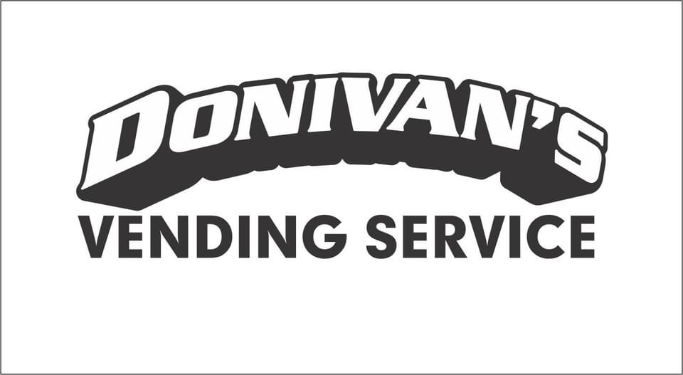
- If you need to reschedule, reach out to captains to figure out the best time to reschedule games.
  - Also, reach out to Kennedie to let her know not to expect stats from your team your expected night of play.
- Please fill out Donivan’s Vending registration forms completely. They help to make registration for tournaments a lot easier!
- All team members use first and last names on dart boards. No last name means your stats won’t be under your correct name and recorded properly.
  - When adding subs, please use first and last names. No nicknames!
- At the beginning of every dart season, Kennedie will set up a group chat with all captains for reminders about league and tournaments for the season.
- Donivan’s Vending dart leagues are WAMO and MOMA sanctioned
- Tournament entry forms and fees should be turned into drop boxes located at Happy Hollow, Elbow Room, and Hobbsy N Me. Our website and Facebook will be updated with dates as soon as they become available.
- Entry forms for tournaments will be on our website as soon as they are available.
- If you have any questions or concerns throughout the league season, please reach out to Kennedie. Contact information available at the top of this page.
- Most of all, have a great dart season!!

Please follow our Facebook page and save our website for all up-to-date information on leagues and tournament info!
Facebook: Donivan’s Vending Service INC. Website: www.donivansvending.com
