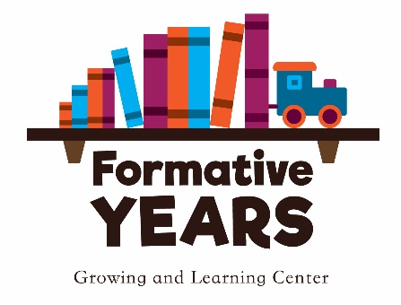
Photo Release Form

I grant Formative Years Growing and Learning Center the right to take photographs of my child. I authorize Formative Years Growing and Learning Center to copyright, use, and publish the same in print and/or electronically.
I agree that Formative Years Growing and Learning Center may use such photographs of my child with or without my name and for any lawful purpose, including such purposes as publicity, illustration, advertising, and Web content.
I have read and understand the above:

Signature: _________________________________________________________________________________________________

Printed Name: ____________________________________________________________________________________________

Child’s Name: _____________________________________________________________________________________________

Date: _______________________________________________________________________________________________________

