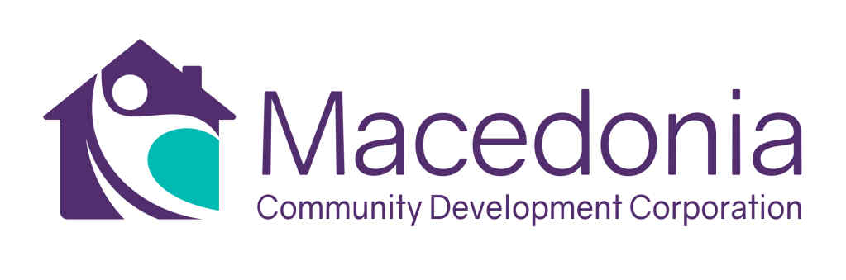
JOB DESCRIPTION: PORTFOLIO MANAGER
Immediate Vacancy – May 2024

Position Summary
The Portfolio Manager (“Manager”) is responsible for maintaining strong relationships with each client and or company in the organization’s lending portfolio. The manager will specialize in providing small business assistance in achieving their business and entrepreneurial goals. The manager will serve as the main point of contact for clients, providing personalized assistance, guidance and resources to help them navigate various aspects of operating a small business successfully. The manager will report to the managing director of the organization. This position is 100% onsite in the organization’s office in the community of Watts in South Los Angeles.

Roles and Responsibilities

- Client Relationship Management
  - Serve as primary point of contact for clients.
  - Communicate with clients on a regular basis.
- Needs Assessment and Solution Provision
  - Conduct thorough assessments of clients’ business needs, identifying opportunities to provide assistance.
  - Collaborate with clients to develop customized solutions and action plans to address challenges and to achieve their goals.
- Resource Referral and Coordination
  - Connect clients with specialty advisors and follow up on strategic plans, milestones and inputs, outcomes and results.
  - Connect clients with relevant resources, programs and services offered by the organization and other community partners.
  - Stay informed about available resources and programs for small businesses, continually expanding the network of support for clients.
- Performance Monitoring and Reporting
  - Track client progress towards goals and objectives.
  - Prepare reports and presentations summarizing client engagement outcomes and impact for internal and external stakeholders.
  - Use data and feedback to evaluate the effectiveness of assistance programs and identify areas for enhancement.

Qualifications and Experience
- Demonstrated experience working with small businesses, as a consultant, advisor or support role.
Portfolio Manager
Page -2-

Qualifications and Experience (continued from previous page)
- Strong understanding of small business operations.
- Excellent communication skills both verbally and in writing.
- Excellent computer skills using Microsoft suite including WORD, PowerPoint, Excel or equivalent programs.
- Knowledge of business financing and lending programs.
- Experience working with clients from diverse cultural backgrounds.
- Bachelor’s degree in business, entrepreneurship or related field.
- Superior knowledge of the South Los Angeles community.

About the Macedonia Community Development Corporation (“MCDC”)

The MCDC was formed in 2015 by the socially minded leaders of the Macedonia Baptist Church. The MCDC has its own federal tax exempt status and is led by a volunteer board of directors who work in the community. MCDC is committed to transforming the Watts community from the fringes of marginalization into a vibrant, healthy community. Our mission is to “inspire, support and empower the people of the Watts community by identifying and addressing disparities in education, mental health and economic vitality.

Through this initial beginning in 2015, the Watts and South LA Entrepreneurship Accelerator (“WSLEA”) was formed as a primary initiative of the MCDC. The WSLEA economic development model is based on capital infusion to local small business enterprises to generate economic opportunities for the community.

Additionally, the Macedonia Community Development Corporation also operates the Macedonia Microloan Program. This program was launched in 2017 with a generous grant from the US Office of Community Services (“OCS”).

To submit a resume for this position, please send updated resume to Pegi Matsuda, pegi@onboard.biz. No phone calls, please.

May 2024

