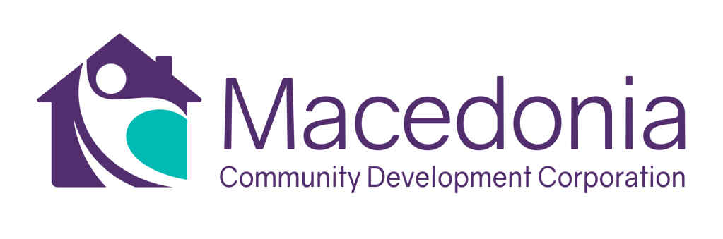
JOB DESCRIPTION: PROGRAM COORDINATOR
Immediate Vacancy

Position Summary
The Program Coordinator (“Coordinator”) is responsible for coordinating programs and general administrative support at the organization’s offices located in South Los Angeles. The Coordinator will design, develop and implement community workshops and events that meet established program and community metrics. The program coordinator reports to the project manager. This position is 100% onsite in the organization’s office in the community of Watts in South Los Angeles.

Roles and Responsibilities - Programs
- In a team environment, Identify and create workshops, materials, and general business information for entrepreneurs.
- Maintain contact database of entrepreneurs to attend virtual and in-person workshops and seminars.
- Lead all workshop/seminar logistics including scheduling speakers, preparing and distributing materials, registration, creating marketing materials and monitoring workshop/seminar attendance and results.
- Support small business owners and aspiring entrepreneurs with general information on starting and sustaining a business, business registration, potential financing opportunities, serve as a referral source to other partner organizations.
- Assist the portfolio manager by providing general lending information.
- Attend program meetings, community events and other outside activities to represent the organization and its programs.
- Other program duties as assigned.

Roles and Responsibilities – Administrative
- Serve as an onsite office manager. Respond to inquiries, answer phones, distribute messages, etc.
- Schedule meetings and appointments, as requested.
- Create and design reports.
- Manage the web site; update web site content as needed.
- Adhere to all administrative and program requirements as documented.
- Take meeting minutes and notes.
- Other administrative duties as assigned.

Program Coordinator
Page -2-

Qualifications and Experience
- Two years experience serving clients or providing general business assistance.
- Excellent computer skills using Microsoft suite including WORD, PowerPoint, Excel or equivalent programs.
- Superior knowledge of the South Los Angeles community.
- General knowledge of business financing and lending programs.
- Experience working with clients from diverse cultural backgrounds.
- Bachelor’s degree in business, finance, communications, etc.

About the Macedonia Community Development Corporation (“MCDC”)

The MCDC was formed in 2015 by the socially minded leaders of the Macedonia Baptist Church. The MCDC has its own federal tax exempt status and is led by a volunteer board of directors who work in the community. MCDC is committed to transforming the Watts community from the fringes of marginalization into a vibrant, healthy community. Our mission is to “inspire, support and empower the people of the Watts community by identifying and addressing disparities in education, mental health and economic vitality.

Through this initial beginning in 2015, the Watts and South LA Entrepreneurship Accelerator (“WSLEA”) was formed as a primary initiative of the MCDC. The WSLEA economic development model is based on capital infusion to local small business enterprises to generate economic opportunities for the community.

Additionally, the Macedonia Community Development Corporation also operates the Macedonia Microloan Program. This program was launched in 2017 with a generous grant from the US Office of Community Services (“OCS”).

To submit a resume for this position, please send updated resume to Pegi Matsuda, pegi@onboard.biz. No phone calls, please.

May 2024

