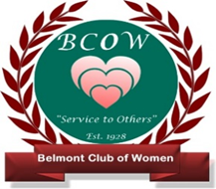

**BELMONT CLUB OF WOMEN**

7124 Belmont Road, Mineral, VA 23117

**WHO WE ARE** We are a 501C3 Charitable Organization supporting the counties of Louisa, Orange, & Spotsylvania.

**Community Outreach** **Annual Fundraising Events** **Networking & Fellowship**

- College Scholarships - Plant and Yard Sale -Elegant 80s Tea

- Charitable Giving - Ham & Oyster Dinner - Christmas Party

- Christmas Baskets - Arts & Craft Fair - Field Trips

- Roadway Clean-up - Scrapbooking Crop - Mahjong & Cards

**PLEASE JOIN US** We meet at 9:30 on the first Wednesday of each month at the Belmont Community Center.

Meetings include time for networking, a guest speaker or activity, and our business meeting.

*You are invited to attend an upcoming meeting to meet our members, enjoy a presentation, observe*

*our business meeting, and see how the Club is fundraising, serving our communities, and hosting*

*member activities. All are welcome!*

**Learn More About Us**

**www.BWC7124. Org**

**Facebook.com/Belmont Club of Women**

**To Join Belmont Club of Women: Fill out the form below and bring it to a meeting. Dues are $35.**