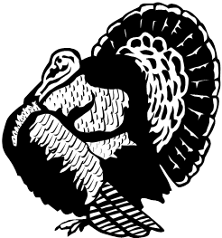**C:\Users\Tutkeyfoot Fich\AppData\Local\Microsoft\Windows\Temporary Internet Files\Content.IE5\AM8ER1NU\MC900155537[1].wmfTurkeyfoot**

**Fish & Game Menu**

**Kitchen & BAR Hours**

Everything Subject to change.

Monday 4 – 9 p.m.

Wednesday 4 - 10 p.m.

Friday 4 -10 p.m.

Saturday 12 - 10 p.m.

Sunday 8 A.M. – 12 P.M

Salads

**BUFFALO CHICKEN, STEAK or GRILLED CHICKEN** - Lettuce, Tomato, Onion, Beets, Celery, Carrots, Cheese, Beer Battered Fries, Chicken or Steak

**CHEF**  - Lettuce, Tomato, Onion, Beets, Celery, Carrots, Swiss Cheese, Hard Boiled Egg, Ham & Turkey

**TOSSED**  - Lettuce, Tomato, Onion, Beets, Celery, Carrots & Cheese

**TACO** - Taco Meat, Lettuce, Tomato, Onion, Cheese, Salsa & Sour Cream

**SANDWICHES**

HAMBURGER

CHEESEBURGER

BACON CHEESEBURGER

MUSHROOM SWISS BURGER

DUNBAR DELUXE - Bacon, provolone cheese, onion ring & Dunbar Sauce

FISH & GAME BURGER - Grilled Mushrooms & Onions, Provolone Cheese,

Lettuce, Tomato & Mayo

FISH Sandwich

HOT DOG

Wings

In House or Take Out

HOT–MILD–SLOPPY HOT–ZESTY RANCH-BBQ-BBQ HOT-BUTTER & GARLIC- BUTTER & GARLIC HOT-BUTTER & OLD BAY DUNBAR SAUCE–SRIRACHA BOURBON CLUB – HABANERO

MUNCHIES & SIDES

* SMALL FRENCH FRIES
* LARGE FRENCH FRIES

Beer Battered, Shoestring, or Waffle

* Onion Rings
* BREADED CAULIFLOWER
* BREADED MUSHROOMS
* CHEDDAR CHEESE BALLS
* HOT PEPPER CHEESE BALLS
* CHEESE STICKS
* CHICKEN TENDERS
* NACHOS WITH CHEESE & JALAPENO PEPPERS
* 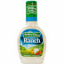ZUCCHINI PLANKS
* CELERY W RANCH OR BLEU CHEESE
* 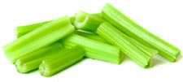Pretzel
* CHEESE DIP
* RANCH OR BLEU CHEESE

# Subs

**ITALIAN** – HOT OR COLD

Ham, Capicola, Salami, Provolone Cheese, Banana Peppers, Onions, Pickles, Lettuce, Tomato, & Dressing On The Side

**steak & cheese**

Grilled Steak, Provolone Cheese, Onions, Mushrooms & Green Peppers

**turkey bacon swiss**

Lettuce, Tomato & Mayo

**BLT** – SUB

Dinners - Fish

Eggs and steaks are cooked to order. Consuming raw or undercooked meats, poultry, seafood, shellfish or eggs may increase your risk of food borne illness.

ADDITIONAL CHARGE FOR EACH TAKE OUT CONTAINER

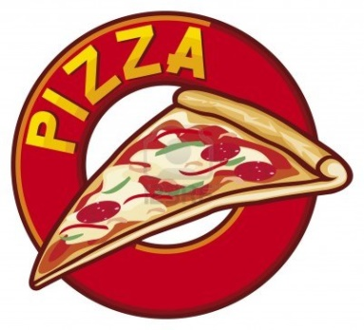

16 in Pizza

1 topping

To go extra.

Extra Toppings each

Pepperoni, Ham, Bacon, Sausage,

Green Peppers, Banana Peppers Onions, Mushrooms

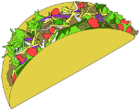**Specials:**

Monday - Taco Night Eat In

Taco Hard or Soft Beef Taco

Chicken Taco

Chicken Burrito

CHICKEN QUUESADILLA

Taco Salad

**Monday -** Taco Night **To Go**

Taco - Hard or Soft Beef Taco

Chicken Taco

Chicken Burrito

CHICKEN QUUESADILLA

Taco Salad

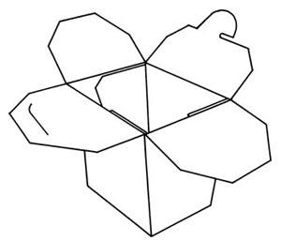ADDITIONAL CHARGE FOR EACH TAKE OUT CONTAINER

**Turkeyfoot Fish & Game Club**

**Sunday Menu 8 - 12**

* fried-egg-15149-large[1] 1 Egg, Toast, 3 Pieces Bacon or 3 Sausage Links
*  fried-egg-15149-large[1]C:\Users\Tutkeyfoot Fich\AppData\Local\Microsoft\Windows\Temporary Internet Files\Content.IE5\40NRDQ6M\fried-egg-15149-large[1].png 2 Eggs, Home-fries, toast, 4 Pieces Bacon or 4 Sausage Links
* 3 Pancakes and 3 Pieces Bacon or 3 Sausage Links

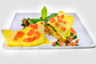

* Omelet

Choice of 1 Meat, Cheese, Green Peppers, Onions, Tomatoes, Mushrooms

Extra: Meat- Ham, Bacon, Turkey, Sausage



* Breakfast Burrito

1 Meat, Egg, Cheese, and Salsa

* BELT Sandwich Bacon, Egg, Lettuce, & Tomato
* Egg, Bacon, Cheese Sandwich - 
* Sausage Gravy and Biscuits

**Add:** C:\Users\Tutkeyfoot Fich\AppData\Local\Microsoft\Windows\Temporary Internet Files\Content.IE5\40NRDQ6M\fried-egg-15149-large[1].pngEgg, Home-fries, Cheese,

3 Pieces Bacon or 3 Sausage Links,

1. Pancake, or toast

* Juice Orange or Apple

Eggs and steaks are cooked to order. Consuming raw or undercooked meats, poultry, seafood, shellfish or eggs may increase your risk of food borne illness. 4/1/21

Pretzel

$1.41

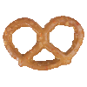

CHEESE DIP 71₵