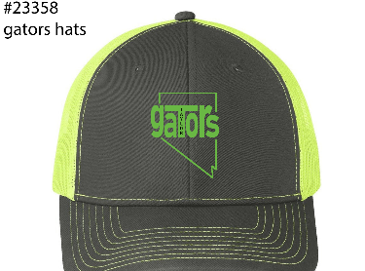
Adult $20 and Youth Hats $15

Adult Quantity | Youth Quantity | Parent Name | Childs Name | Teacher
Total$ | Cash | Check#

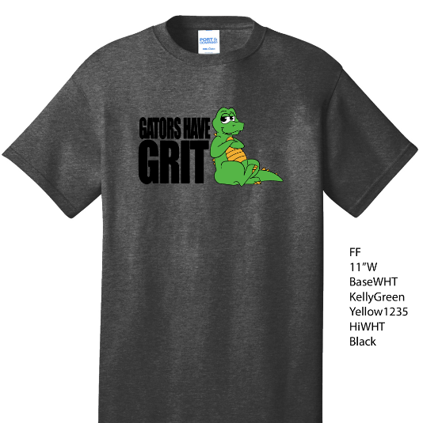
Youth Kids Gator Gear $15
Size Chart:
XS----4/5
S------6/8
M-----10/12
L------14/16
Size: XS, S,M,L,XL | Parent Name | Childs Name | Teacher
Total$ | Cash | Check#
XL--- 18/20
