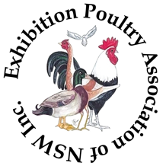

2024 NSW STATE POULTRY CHAMPIONSHIPS

Young & Novice Judges Competition

The Young and Novice Judges Competition offers individuals aged 25 years and under a unique opportunity to showcase their poultry knowledge to esteemed figures in the exhibition poultry world.

This competition not only serves as a platform for participants to have their expertise evaluated but also provides invaluable experience in a formal judging setting. The aim is to enhance their understanding and confidence, nurturing them to become the future leaders in the field of poultry adjudication.

NAME
CONTACT ADDRESS
TELEPHONE
EMAIL
MEMBER OF (club/s)
AGE
SIGNATURE

