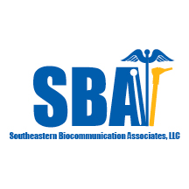
ENDOSCOPY REFERRAL FORM

Request for Services from Southeastern Biocommunication Associates, LLC

To make an endoscopy referral, please contact:

Chris Gaskill, PhD, CCC-SLP/Robert Arnold, SLP.D, CCC-SLP
Telephone: 205 340-6068 or 205 516-5129
Fax: 1-800-221-0895

Patient Name | Room No. | Comprehensive Swallow-Voice Assessment CSA™ | Audiology | Comments

Physician/Nurse Practitioner Order Received: ⁯ Yes ⁯ No

Facility: ____________________________________________

Requesting Therapist___________________ Date____________

Therapist Cell:_________________________

Email:________________________________

