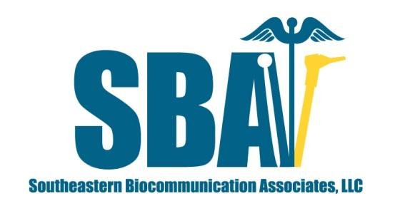
Southeastern Biocommunication Associates, LLC
1678 Montgomery Hwy #104, PMB 180
Birmingham, Alabama 35216

Patient Name:_________________________________

Physician / Nurse Practitioner Order

1). Comprehensive Swallow/Voice Assessment (CSA) per SLP to R/o aspiration; delineate the nature, extent, and severity of oral, pharyngeal, and/or esophageal dysphagia; and to assess stimulability for potential swallow interventions; and/or voice treatment interventions.

2). Spray up to 0.5 - 1 oz. of 0.05% solution of Oxymetazoline HCL to nose if indicated per SLP.

3). May use up to 5 cc per Naris of Surgical Lubricant if indicated.

4). NPO for at least 4 hours prior to CSA except for water/ice chips, medications and medically necessary snacks.

Additional Orders:__________________________________________

___________________________________________________________

___________________________________________________________

Verbal Order Received By:_____________________ Date:_____________

_______________________________ _______________
Physician /Nurse Practitioner Signature Date

