A look back at the last few weeks

The Q2 early-summer surge driven by tariff uncertainty has now transitioned into a cooling phase for Q3, with clear signs of demand softening, rate normalization, and capacity imbalance across key trade lanes. Some key takeaways:

- China's Economic Slowdown: China reported its weakest GDP growth since 2023, with manufacturing activity slipping back into contraction territory. This is due to emerging market growth in India and Malaysia.
- Retailers and manufacturers are now recalibrating inventory strategies, with many shifting to cautious replenishment cycles which is affecting Q3 and “peak season”.
- Carriers are still reinstating blank sailings to address excess capacity, particularly on the West Coast where utilization has fallen below 90% and some routes are running below breakeven.
- Rates continue to drop along with peak-season surcharges after a six-week surge in June. Asia–U.S. spot container rates have plunged—58% to the West Coast and 46% to the East Coast—as overcapacity intensifies ( Reuters).

What you need to know now

- New sweeping U.S. tariffs came into force on August 7, with duties ranging from 10–50% on imports from many countries. We’ve attached Trump's Executive Order which includes a list of those rates.
  - https://www.whitehouse.gov/presidential-actions/2025/07/further-modifying-the-reciprocal-tariff-rates/#_ftn1

- Disruptions continue in the Red Sea, and most carriers continue to avoid this major shipping lane.
- Despite strong Q2 earnings, carriers are issuing cautious guidance for the remainder of 2025, anticipating weaker volume growth, which has led to the removal of Peak Season Surcharges. While some routes see temporary tightening, trans-Pacific lanes remain oversupplied.
- Companies continue to reshore or near shore their manufacturing operations to tariff free region around the globe.
- Consumer prices remain elevated. Tariffs will continue to be a passthrough to consumers at a 60-80% rate, translating into price jumps 20-50% at the retail level. . KiplingerUS Import DataThe Washington Post
- As tariff information continues to fluctuate, contact Steve Fodor to receive frequent updates via email. (Steve@CSSbrokers.com)

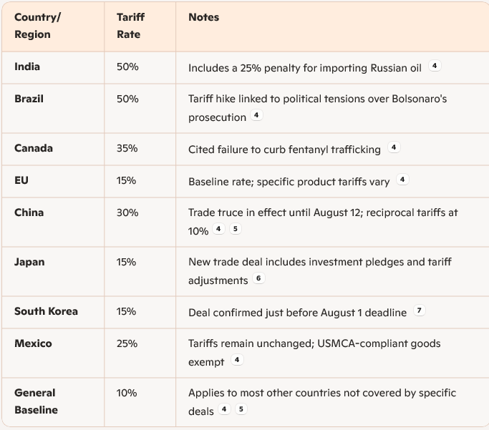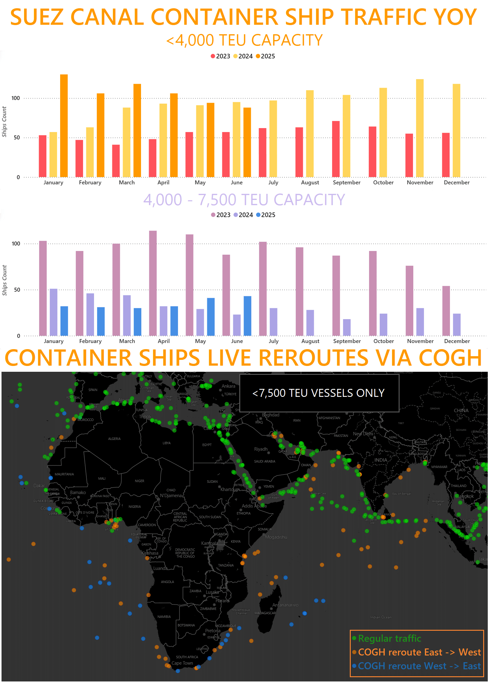

Forecasting what’s ahead

The demand spike seen in June has faded, leaving carriers with excess capacity across major trade lanes. Overcapacity, combined with cautious inventory replenishment by importers, is pushing rates lower through Q3 and likely into Q4.

- Carriers continue to use blank sailings and suspend various strings to control the market and rates.
- A structurally softer rate environment as fleet capacity continues expanding into 2026.
- Introducing US Port Fees on China Ships: The USTR has set charges from $50 to $140 per net tonne (by 2028) for vessels linked to China, aiming to influence global shipping and support US maritime interests. More confirmed details to be announced.

Recommended Actions

- Lock in rates and allocations to reduce exposure to spot rate swings once the tide turns.
- Review carrier performance and schedule reliability, delays and rolled cargo likely to increase.
- Evaluate routing and inland transport options to mitigate port disruptions.
- Leverage FTZs & Duty Drawbacks: Utilize Foreign Trade Zones and re-export programs to reduce landed costs.
- Monitor Policy Shifts and HTS codes: Stay agile with real-time tariff trackers and trade negotiation updates.

The Tradewinds: Highlights of Gulfstream and Bluewater

Did you know Gulfstream recently launched a new container tracking portal? Designed with importers in mind, our new TMS, GNOSIS, gives you full visibility over your shipments. Check out the below to see a few highlights:
- Real-Time Container Visibility - Track every shipment with up-to-date status, key milestones, and exception alerts - no more chasing updates.
- Centralized Dashboard - View all inbound and outbound containers across carriers in one place for better planning and decision-making.
- Proactive Exception Management - Get notified early about delays or disruptions so you can adjust plans and keep your supply chain moving.

See below links to help give a Gnosis overview, set up your own personal portal, and a brief demonstration of the system.

Gnosis Intro Video: https://www.joc.com/video/bringing-a-holistic-approach-to-technology-5659206

Access the portal here: https://app.gnosisfreight.com

Brief Demo - https://guides.gnosisfreight.com/demo/cm6fi0v1o0005xo0hjk2rhvuc

