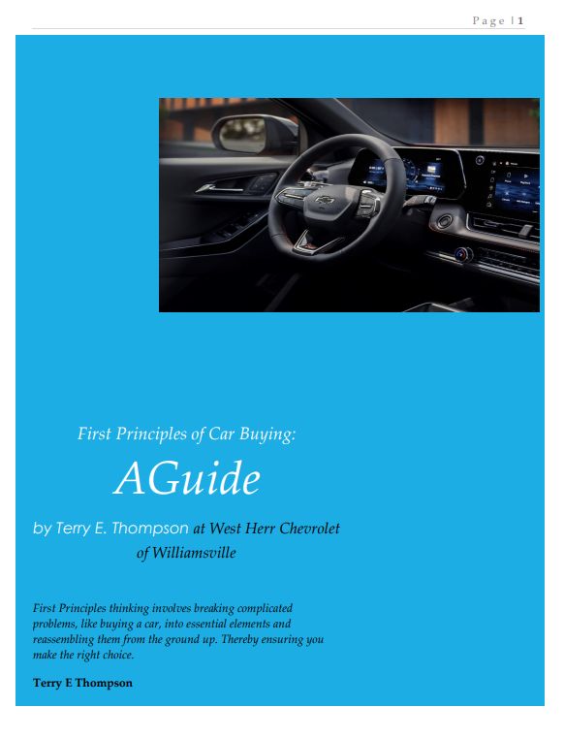

Table of Contents
First Principles of Car Buying: A Guide 1
Table of Contents 2
Introduction 3
The Ten Principles 4
1. Understanding Transportation Needs 4
2. Financial Considerations in Car Buying 4
3. Lifestyle Fit: Cars That Reflect You 4
4. Brand Loyalty and Trust 5
5. Safety Features: A Top Priority 5
6. Eco-Friendly Choices: Driving Towards a Greener Future 6
7. Embracing Technology in Modern Cars 6
8. Comfort and Convenience: Your Mobile Haven 6
9. Investing in the Future: Resale Value Matters 7
10. Special Offers and Incentives: The Final Push 7
Contact Information 8

Introduction
I'm Terry Thompson, a New Jersey National Guard veteran of eleven years and a West Herr Chevrolet of Williamsville Sales Consultant for 5 years. I received the Chevrolet Mark of Excellence Award and have a bachelor's degree in business administration. This is my second career, following a successful career in the computer industry for over 30 years. I wrote this guide to help you through the crucial aspects of choosing the right vehicle.

First Principles thinking involves breaking complicated problems into essential elements and then reassembling them from the ground up. It's about getting to the core of what matters to you when buying a car, stripping away assumptions, and focusing on fundamental needs. This method ensures that your vehicle purchase perfectly aligns with your budget requirements, lifestyle, and values.

In a world overflowing with options, finding your ideal vehicle begins with a simple yet profound understanding of your daily transportation needs. Imagine a vehicle that not only takes you from point A to point B but enhances every aspect of your journey—efficiency, safety, comfort, and style. This guide will help you cut through the noise and focus on what truly matters to you.

The Ten Principles

1. Principle

Understanding Your Transportation Needs
At the heart of every car purchase is the need for transportation, but this encompasses more than just getting from point A to point B. It's about understanding the specifics of your daily routes, driving conditions, and what you expect from your driving experience. What fundamental transportation needs must my vehicle meet?
If I don't align my vehicle choice with my actual transportation needs, I could end up with a car that doesn't suit my daily activities. This could mean anything from lacking necessary space for family or equipment to owning an inefficient vehicle for my commute, affecting my daily satisfaction and convenience.

2. Principle

Financial Considerations in Car Buying
Your budget is not just a number; it reflects your financial priorities and constraints. By applying First Principles, we examine the actual cost of owning a car, from initial purchase to maintenance and operation. What value does the car bring, and how does it fit within your financial landscape?
Without considering my core needs, I might be swayed by features or models I don't truly need, leading to unnecessary financial strain. Overpaying for a vehicle or features that don't serve my practical needs can result in higher loans, increased debt, or regret over not investing in a vehicle that better suits my lifestyle and budget.

3. Principle

Lifestyle Fit: Cars That Reflect You
Your vehicle is an extension of your lifestyle. Whether it's accommodating family, hobbies, or work, the car you choose should enhance your daily life. How does my vehicle need to function to support my lifestyle?
Reflect My Values: The vehicle I choose reflects my personal values, such as environmental responsibility. Understanding my transportation needs allows me to pick a vehicle that aligns with these values, like choosing an electric or hybrid model if reducing my carbon footprint is essectial to me.

4. Principle

Brand Loyalty and Trust
While past experiences or recommendations can influence brand loyalty, First Principles thinking challenges us to look beyond the brand. What qualities do I value in a vehicle, and which brand best embodies these?
"Is brand loyalty influencing your car buying decision? Dive into 'First Principles of Car Buying' to see how trust and quality shape our choices. Discover why Chevrolet could be the brand that meets your fundamental needs.

5. Principle

Safety Features: A Top Priority
Safety is a fundamental concern. By focusing on what safety truly means to you, you can prioritize features that align with your real-world needs. What safety features are non-negotiable for my driving conditions and peace of mind?
Safety and Comfort Concerns: Ignoring my specific transportation requirements might lead me to choose a vehicle that compromises safety or comfort, which is essential for my driving conditions. This could have direct implications for my well-being and that of my family.

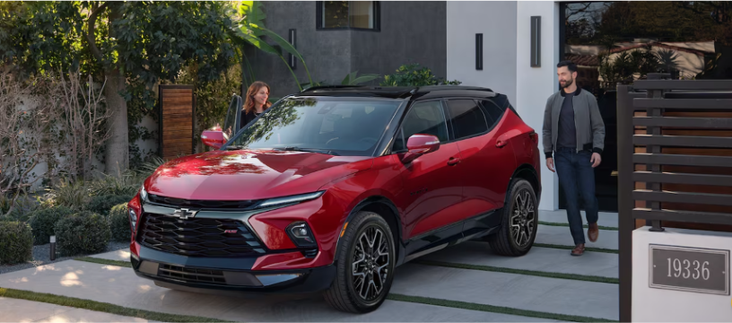

6. Principle:

Eco-Friendly Choices: Driving Towards a Greener Future
Environmental impact and fuel efficiency are not just trends but reflections of your values and the practicalities of car ownership. How significant is the environmental impact of my vehicle, and what are the most effective ways to minimize it?
"Unlock the perfect match between your life and your drive by aligning your car with your true transportation needs to make informed, fulfilling choices."
-Terry E. Thompson

"Looking to make a greener choice with your next car? First Principles of Car Buying' explores how eco-friendly options like hybrids and electrics can align with your values and driving needs. Join the journey towards a greener future.

7. Principle

Embracing Technology in Modern Cars
Vehicle technology can range from necessities to advanced features that enhance the driving experience. Key Question: By returning to First Principles, which technologies serve my essential needs and improve my driving experience in meaningful ways?
"In a world where technology evolves daily, how does it enhance your driving experience? First Principles of Car Buying' delves into the tech that matters in modern cars. Find out how to choose tech that enhances your life on the Road.

8. Principle

Comfort and Convenience: Your Mobile Haven
Comfort and convenience features should directly contribute to your daily driving experience. What features make my car a true sanctuary on the road?
"Imagine a car that feels like a home away from home. First Principles of Car Buying' helps you prioritize comfort and convenience in your next vehicle. Discover how to turn every drive into a journey of relaxation.

9. Principle

Investing in the Future: Resale Value Matters
Consider the longer-term implications of your car purchase and how it affects your financial future. How does the expected resale value of this car affect its overall cost over time?
Thinking about your next car purchase? Remember, it's not just about the ride today, but its value tomorrow. Investing in a vehicle with strong resale value is investing in your future. Let's apply First Principles Thinking together and consider how your choice today impacts your wallet. Your smart choice now means more savings and options later. Ready to make an informed decision that pays off in the long run?

10. Principle

Special Offers and Incentives: The Final Push
Who doesn’t love a great deal? First Principles of Car Buying uncovers how to smartly navigate special offers and incentives. Let’s ensure these deals align with your core needs. Dive into the guide for savvy car-buying tips.
While special offers can provide significant savings, they should align with your fundamental needs and financial plans. Do these offers align with my fundamental needs and financial plans?

Personal Authorship Declaration:
The content, insights, and recommendations shared in this document reflect my personal professional experience and knowledge as an automotive sales professional. While I am currently employed as a Sales and Leasing Consultant, this material represents my individual perspectives and should not be construed as official statements or positions of West Herr Automotive Group or any of its affiliates.

Contact Information

Terry E. Thompson
Certified Chevrolet Sales Consultant

West Herr Chevrolet of Williamsville
8040 Transit Road
Williamsville, NY 14221
Direct: 716-932-4793
Mobile/Text: 609-865-8811
Email: terry.thompson@westherr.com

[The following should be set up as hyperlinks in Word]
LinkedIn Profile: https://www.linkedin.com/in/terryethompson/
Is the 2024 Traverse Right for You? https://terry-ud9raylp.scoreapp.com/
Visit my Website: https://westernnewyorkchevydude.com/contact
Terry's Blog: https://westernnewyorkchevydude.com/terrys-blog?blog=y

Copyright © 2025 Terry E. Thompson. All rights reserved.

