***Toxic Spring Time Flowers***

 Spring Flower Toxin 1: Tulips and Hyacinths The toxic principle of a Tulip is concentrated in the bulbs, as opposed to the leaf or flower. Pet owners should prevent dogs from digging up, then eating these bulbs. When ingested, the bulbs can irritate the mouth and esophagus. Toxicity signs can include profuse drooling, vomiting and diarrhea. With large amounts of bulb ingestion, more severe symptoms such as an increase in heart rate and changes in respiration may be seen. These severe cases require immediate medical treatment. There is no specific antidote for bulb ingestion. But a pets' prognosis is good with the right veterinary care, including rinsing the mouth, giving anti-vomiting medication and possibly administering subcutaneous fluids.

** Spring Flower Toxin 2: Daffodils**

Ingestion of the Daffodil bulb, plant or flower can cause severe vomiting, diarrhea, abdominal pain and possibly even cardiac arrhythmias or respiratory depression. Similar to Hyacinths, crystals found in the outer layer of the bulbs can cause severe tissue irritation and secondary drooling. Daffodil ingestion may result in severe symptoms that require immediate treatment and supportive care.

Spring Flower Toxin 3: Lilies

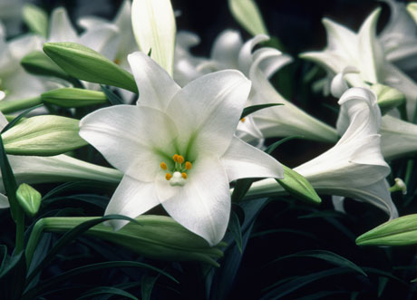There are dangerous and benign lilies--and the dangerous ones can be deadly. Peace, Peruvian, and Calla lilies contain oxalate crystals that cause minor signs of illness, such as tissue irritation in the mouth, tongue, pharynx, and esophagus, which in turn causes minor drooling. The potentially fatal lilies are true lilies, including Tiger, Day, Asiatic, Easter, and Japanese Show lilies. These are all highly toxic to cats. Even small ingestions (such as eating the pollen or just two to three petals or leaves) can result in kidney failure. Cats that consume any part of a lily require immediate medical care to effectively treat the poisoning. If you see your cat eating a lily, you should immediately bring the cat and the lily plant to your clinic. Decontamination (inducing vomiting and giving binders such as activated charcoal) is imperative in the early toxic stage. Additionally, aggressive intravenous fluid therapy, kidney-function monitoring tests and supportive care can greatly improve prognoses.

**Spring Flower Toxin 4: Crocuses**

Some crocuses bloom in the spring, while others bloom in the fall. The spring plants, which are more common, can cause general gastrointestinal upset, including vomiting and diarrhea. These should not be mistaken for autumn crocus plants which contain colchicine. The autumn crocus, also known as Meadow Saffron, is highly toxic and can cause severe vomiting, gastrointestinal bleeding, liver and kidney damage, and respiratory failure. These signs can begin immediately after ingestion or may be delayed for a number of days. Regardless of when the signs begin, the pet should be brought in, as well as the plant, for medical treatment immediately after ingestion.

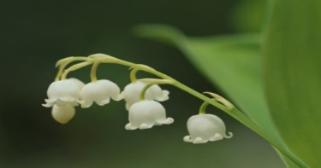 **Spring Flower Toxin 5: Lily of the Valley**

The lily of the Valley plant contains cardiac glycosides, a naturally occurring substances that, when ingested, can cause vomiting, diarrhea, a drop in heart rate, severe cardiac arrhythmias and possibly seizures. If your pet has eaten this plant, you should bring them in for an examination and treatment.