Lee’s School Supplies was founded in 1978. We are a fully Insured, approved vendor!

Currently running with agreements in 400+ schools throughout the Dallas, Fort Worth, Austin and San Antonio markets.

Major ISD’s include:

- Dallas ISD
- Ft Worth ISD
- Mesquite ISD
- Aledo ISD
- McKinney ISD
- Mansfield ISD
- Waxahachie ISD
- Arlington ISD
- HEB ISD
- Garland ISD

The benefits of having a Lee’s School Supply vending machine in your school:
- The machines cost you nothing – (We own the machines and loan them to the school)
- We keep them filled and in working order by servicing the machines 1x/month.
- We collect and count the quarters
- We pay all of the state taxes.
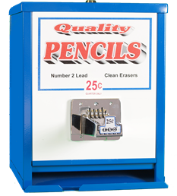
- You Receive 15% of all sales!

We provide maintenance, supplies, and labor. No coin counting!

