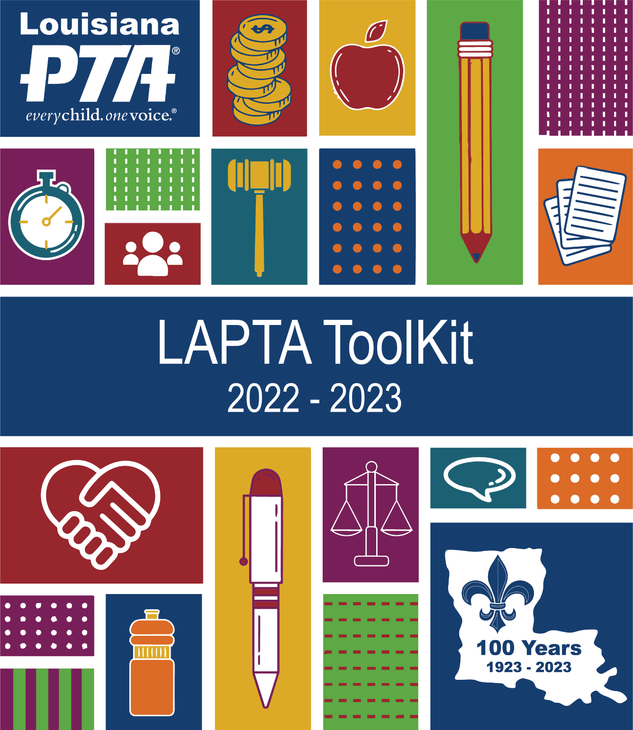

Diversity, Equity, and Inclusion
2022 – 2023
Section 8

INDEX
About National PTA 3
Leadership Traits 4
Introduction 4
Promote Diversity in Your School 5
Hold an Inclusive PTA Meeting 6
Organize an Inclusive PTA Event 7
Icebreakers 8
DEI Resources 9
Communications and Social Media 10

ABOUT NATIONAL PTA
The Local PTA Unit is a member of the Louisiana PTA (LAPTA) and National PTA organizations, maintains the requirements for active affiliation, and shares the mission, purposes, values, and standards of National PTA. Find more information at LouisianaPTA.org and pta.org.

Why are we here? Mission: To make every child’s potential a reality by engaging and empowering families and communities to advocate for all children.

Purposes
- To promote the welfare of children in home, school, places of worship, and throughout the community;
- To raise the standards of home life;
- To advocate for laws that further the education, physical and mental health, welfare, and safety of children;
- To promote the collaboration and engagement of families and educators in the education of children;
- To engage the public in united efforts to secure the physical, mental, emotional, spiritual, and social well-being of all children;
- To advocate for fiscal responsibility regarding public tax dollars in public education funding.

Values
- Collaboration: We work in partnership with a wide array of individuals and organizations to broaden and enhance our ability to serve and advocate for all children and families.
- Commitment: We dedicate ourselves to children’s educational success, health, and well-being through strong family and community engagement while remaining accountable to the PTA’s founding principles.
- Diversity: We acknowledge the potential of everyone without regard to age, culture, economic status, educational background, ethnicity, gender, geographic location, legal status, marital status, mental ability, national origin, organizational position, parental status, physical ability, political philosophy, race, religion, sexual orientation, and work experience.
- Respect: We value the individual contributions of members, employees, volunteers, and partners as we work collaboratively to achieve our PTA’s goals.
- Accountability: All members, employees, volunteers, and partners share responsibility to align their efforts toward the achievement of our PTA’s strategic initiatives.

National PTA Standards for Family-School Partnerships
- Standard 1: Welcoming All Families Into the School Community – Families actively participate in the life of the school, and feel welcomed, valued, and connected to each other, to school staff, and to what students are learning and doing in class.
- Standard 2: Communicating Effectively – Families and school staff engage in regular, two-way, meaningful communication about student learning.
- Standard 3: Supporting Student Success – Families and school staff continuously collaborate to support students’ learning and healthy development both at home and at school and have regular opportunities to strengthen their knowledge and skills to do so effectively.
- Standard 4: Speaking Up for Every Child – Families are empowered to be advocates for their own and other children, and to ensure that students are treated fairly and have access to learning opportunities that will support their success.
- Standard 5: Sharing Power – Families and school staff are equal partners in decisions that affect children and families and together inform, influence, and create policies, practices, and programs.
- Standard 6: Collaborating With Community – Families and school staff collaborate with community members to connect students, families, and staff to expanded learning opportunities, community services, and civic participation.
LEADERSHIP TRAITS
Successful leaders are effective leaders. Their skills and abilities allow them to step into a variety of roles, and they see the value people have to offer and seek their involvement. They provide a clear purpose that others want to follow. They lead with integrity and strive to continually improve.

The following are competencies effective leaders demonstrate and use to make every child’s potential a reality.
- Self-Awareness – Has the ability to assess their own strengths and weaknesses
- Vision – Demonstrates a clear understanding of the future and how to get there
- Relationship Building – Develops trust and mutual respect, and values diversity
- Critical Thinking – Obtains all the relevant information, identifies problems and causes, evaluates information, and determines criteria that indicate solutions
- Time & Resource Management – Effectively prioritizes and manages resources to accomplish goals
- Motivation – Demonstrates and promotes interest and enthusiasm
- Empathy – Recognizes verbal and nonverbal feelings, needs, and concerns of others
- Creativity – Sees and thinks of innovative ideas, alternatives, and ways to do things
- Communication – Listens actively and conveys information clearly, concisely, and accurately in both writing and speech
- Collaboration – Works with a team to achieve a common purpose; puts service before self
- Delegation – Shares responsibilities including guidance and follow up, fostering leadership in others
- Continuous Learning – Pursues development of skills and knowledge
- Integrity – Does the right thing when no one is watching
- Initiative – Steps up unprompted going above and beyond with excellence

INTRODUCTION TO DIVERSITY,
EQUITY, AND INCLUSION
PTA is a powerful voice for all children, a relevant resource for families and communities, and a strong advocate for the education and well-being of every child. Diversity, equity, and inclusion supports every child with one voice, no matter their race, ethnicity, zip code, income, gender identity, sexual orientation, immigration status, or abilities. LAPTA recognizes that advancing diversity, equity, and inclusion is an integral part of PTA’s work and its vision of making every child’s potential a reality. LAPTA Toolkit: Diversity, Equity, and Inclusion is a resource for PTA leaders to develop and advance their own diversity, equity, and inclusion plans and programs in their school and community.
Diversity is the range of human differences such as race, ethnicity, gender, gender identity, sexual orientation, age, social class, physical ability or attributes, religious or ethical values system, national origin, and political beliefs.

Equity is the fair and impartial treatment, access, opportunity, and advancement for all individuals considering systemic inequalities and outcome disparities within society.

Inclusion is active, intentional, and ongoing engagement in diversity in which different individuals or groups who may otherwise be excluded or marginalized are accepted, engaged, and welcomed.

To best serve all students, PTA leaders should become familiar with their school and community demographics. This provides useful student and school data such as total number of students, enrollment data by gender, ethnicity, disabilities, economic disadvantage, English language learners, migrants, homeless, and foster care. To access additional specific data, request information from the school or district administration.
PROMOTE DIVERSITY
IN YOUR SCHOOL
As a powerful voice for ALL children, a relevant resource for families and communities, and a strong advocate for the education and well-being of EVERY child, PTAs are well-equipped to foster the principles of diversity, equity, and inclusion in their schools and community. Our diversity is our strength! PTA volunteers who are “intentional” in their DEI efforts are most likely to experience great outcomes that benefit all children and their families rather than just isolated patches of success.

A great place to start DEI work in your school is through establishing PTA as a sanctuary for all families to be able to gather information, express opinions, concerns, and needs, and feel heard and embraced. PTA can be a resource empowering those traditionally less likely to be engaged in their children’s learning and well-being by organizing parent or guardian trainings and events as well as sharing information on relevant topics. Analyze the diversity and level of inclusion and equity in your PTA’s membership, governance, programs, and advocacy efforts. Identify areas of success and other areas in need of more work. Set goals and action plans to address each of these areas.

Form a DEI Committee in your unit with clearly defined charges and goals that are periodically reviewed and updated. PTA needs to seek a diverse membership that reflects the diversity of the student body and community it serves through “targeted outreach” efforts. Consider which groups are less likely to join your PTA or participate in meetings and events. To achieve successful outreach, we need to educate ourselves regarding cultures, traditions, challenges, and restrictions of groups we aim to reach.

Address issues that matter the most to those you need to engage. Ensure PTA’s advocacy efforts represent all children including those typically marginalized and those whose families may not be equally engaged. PTA’s advocacy initiatives must be non-political and non-biased. Create a welcoming environment for conversations considered difficult, with a clear understanding that we may not agree on everything but must agree to uphold PTA’s mission and values and our collective goal to serve and to keep all children safe. Engage in ongoing meaningful conversations with school and district administration, school boards, and other stakeholders that recognize the principles of diversity, equity, and inclusion in all decisions.

PTA leadership should also be representative of the student body and community it serves. In their constant efforts to seek new volunteers, PTA leaders are encouraged to recruit leaders from underrepresented groups. When recruiting diverse leaders, consider the “whole person” such as individual interests, passions and expertise, color, gender, cultural background, or spoken languages. Recruiting people in areas of PTA work that they are passionate about and interested in is more likely to set them up for success and encourage them to grow as leaders. Recruitment does not end with identifying individuals with leadership qualities. It is important to set them up for success and offer support while providing them with the space they need to put their own personal stamp on their work. Establish fair and equitable practices in all areas of PTA’s work, including decision making, nominations, elections, appointments, participation, events, topics, and services. Such practices establish trust and respect for the organization as a whole and its leadership.

Assure that all PTA meetings and events reflect a welcoming and inclusive environment for all. Most importantly, if leaders are reminded of PTA’s mission, vision, and core values as the focus and purpose of all PTA work, they are on the right path to applying the principles of diversity, equity, and inclusion in their service to school, community, and to EVERY child with ONE voice. Refer to How to Hold an Inclusive PTA Meeting and How to Organize an Inclusive PTA Event later in this section.

HOLD AN INCLUSIVE
PTA MEETING
When scheduling PTA meeting dates and times, consider possible conflicts, religious holidays, and work limitations that might prevent some from attending. Possibly alternate days of the week and times of the day when scheduling PTA meetings. Meetings could be offered at two times on one day, such as 11:00 am and 7:00 pm. Survey the school community to find best ways to reach most families.

Assure your meeting location, restrooms, and other needed facilities are accessible to all attendees. A location easy to find makes for prompt arrivals of attendees. Use signage that is clear and legible by all. If the meeting is outside the school, consider locations that are near public transportation and have ample parking.

When publicizing the meeting, consider digital access limitations when sending out fliers electronically and provide printed notice when needed. Ask teachers to include a reminder on the day of the meeting when children write their homework in their agenda planners. Send out by email and post on the PTA website, Facebook page, and other social media platforms. Ask room parents to reach out to their rosters. Have handouts with all monthly meeting dates at school and PTA events. Assure digital and paper fliers are sent in all spoken languages in your school. When using any electronic translation such as Google Translate, try to have a native speaker proofread the translated flier for accuracy.

Thoughtfully set up the meeting space. All those who attend should be able to have a good view of speakers, screens, etc. so all attendees are able to see, hear, and engage with each other. Have all handouts, sign-in sheets, etc. near the entrance and easily accessible. Consider seating arrangements that make everyone feel equally engaged and significant rather than classroom style or the PTA Board facing the audience. Board members, when possible, can spread throughout the space to mingle and meet other members. When holding a virtual meeting, ensure microphones are placed in locations able to pick up the voice of anyone speaking so those attending virtually can hear them.

For the meeting environment, leaders need to be open-minded, presentable, and approachable, making others feel comfortable. Always realize the significance and responsibilities of leadership roles and how they can impact perceptions and recruitment of members and future leaders. Consider PTA Board members taking turns greeting attendees as they arrive at meetings. Acknowledge new members and attendees as they come in. Name badges make it easier to properly address individuals and learn their names. Take the time to learn how to pronounce names correctly. Correct pronunciation of names is more than a common courtesy. It is a significant sign of caring and inclusion. Consider having crayons, coloring books, and activities for children accompanying their family members to quietly entertain themselves. Adhere to the meeting agenda, lay the ground rules at the start of the meeting, and treat all with respect and consistency. Allow opportunities in the agenda for feedback and attendee engagement when appropriate, making it clear to all that their suggestions are welcome. Avoid terms that may offend others. When holding a virtual meeting, assign someone to check and address the chat.

If food or beverages are provided, proper sanitary precautions need to be observed. Be sure to take into consideration dietary and religious restrictions as well as food allergies. Provide clear and accessible packaging information and ingredients for those purposes. Serving tables should be accessible to all attendees.

Finally, collect contact information and follow up regarding topics or issues that need to be addressed later. Unless people feel heard, they are unlikely to return to future meetings. Reach out and thank any newcomers. Remember the first time you went to a meeting or did something outside of your comfort zone? Make the effort to engage and follow up to create lasting relationships and future leaders!

ORGANIZE AN INCLUSIVE
PTA EVENT
Advertise PTA events through all possible electronic methods, social media, print, mail, and school backpack. Assure event fliers and invitations are translated into all languages spoken in your school community. Avoid communication and participation barriers ensuring all attendees can participate no matter what their spoken language and physical or mental abilities are. Provide clear and transparent explanations of all PTA events and activities, especially to first timers not familiar with the activities, past traditions, and customs of the PTA. The better informed and prepared everyone is, the more comfortable they will feel and more likely to return.

Anticipate potential need for anything participants might need to attend and take part in the event such as transportation, directions, time commitment, special accommodations, material, or electronic devices. Support remote platforms providing virtual options such as Zoom and Google Meets when possible. They present great opportunities for families with time restraints and travel or accessibility challenges.

Consider holding certain events at locations other than the school building, taking the event to the people you seek to engage. Alternate locations so everyone can feel important and embraced. Provide calm or quiet spaces if your event has the potential to be loud or filled with excitement. Sensory overload affects many people, young and old. Make sure to advertise that these spaces are available on your communication materials. You can also consider holding “Sensory Friendly” events, like a Bedtime Book Reading family engagement activity or a board game night, or by limiting the number of families who can attend an event at a time and simply offer more of those events. Utilize icebreakers (see Icebreakers later in this section) at the start of events as they present a great tool to put everyone at ease.

Consider inclusive, culturally sensitive, and diverse topics and speakers and invite others to make suggestions for topics they would like to see addressed. Food, beverages, giveaways, and prizes can be utilized as attractive incentives for participation. Families with children are more likely to attend and stay through events that feature fun and engaging activities for children of different ages and abilities.

Your PTA’s DEI Committee can plan a school or district-wide DEI event that promotes diversity and inclusivity through themes, messages, and activities. Celebrate our differences! Promote and organize events where all groups can educate others, share information, promote, and advocate for themselves. Connect and collaborate with community-based organizations that share a focus on diversity and inclusion. Engage in active and two-sided dialogue, allowing for opportunities for all stakeholders to express their opinions and needs and those organizing the event, not only speaking, but actively listening and following up.

In addition to families, be sure to invite teachers, school and district administrators, staff, and community partners to PTA events. Building strong connections with all groups assures good relations and positive outcomes for children and families. Organize events that develop positive relationships between teachers and families to help overcome cultural barriers that interfere with active family engagement in children’s education and schools. Plan PTA events that help level the parent/family education field and close the information gap that may hinder family involvement in their child’s education. Events may include family math or science nights, technology, child development topics, and college or career prep and funding, to name a few.

ICEBREAKERS
An easy way to promote inclusion at PTA meetings is to encourage members to interact with each other. Including an icebreaker at your PTA meeting is a fun way to get people acquainted and to feel included. It’s a great way to start meetings, encouraging engagement and meaningful introductions before diving into business.
- What is our main goal with this ice breaker? Determine whether your goal is to help people get to know each other better, to inspire some fun competition, or to have folks walk away having learned something new.
- How is our ice breaker inclusive? Keep in mind that your participants might have different abilities, interests, and beliefs. Make sure it is accessible and does not exclude anyone from actively participating.
- How is our ice breaker interactive? Ice breakers are a great way to help folks mingle and step out of their zone of comfort. Plan an ice breaker that helps participants spark new connections and relationships.

What Do You Love?: Each person states one thing that is non-PTA related that they love. Then others who also love the same thing raise their hands or otherwise gesture.

Culture Club: Participants break into small groups and pick three areas of their families’ cultural values from a list including traditional foods, typical dress, and what is or is not acceptable in overall appearance, histories, traditions, and holidays that are a source of pride, taboo topics, etc. Each person shares their answers.

Meet Someone New: Each person shares what month they were born and finds someone born the same month that they don’t know well. What’s one other thing they have in common?

Name Tag: This icebreaker could be used as an initial get-acquainted exercise. As each participant enters the meeting room, they can sign their name as usual, but present them with a different person’s name tag. They should seek one another out and introduce themselves to other participants.

Name Game: Everyone’s name carries history, fun anecdotes, or familial values. Ask each attendee to introduce themselves then talk about how they got their name or the history behind it. Perhaps they are named after someone specific, or maybe their last name means something in an ancestral language.

Just By Looking at Me: This activity allows participants to disclose some personal information that others may not know. The goal is to demonstrate that there is much more to a person than “meets the eye” or what comes out in face-to-face encounters. Form a circle with chairs if participants are able. Pass around the following script on paper: “My name is ___ and I am from ___. One thing you cannot tell just by looking at me is ___.” Demonstrate the prompt by filling it in yourself and model the exercise. Ask participants to take turns reading the above statement after filling in the blanks with pertinent information about themselves.

Trivia Game is a way to spark fun competition between participants, while also providing an opportunity to learn something new. Create a list of 15-20 interesting and fun facts related to the theme of your trivia game. Choose the format you’d like to use to host your trivia game. You can use an online trivia platform to build out your activity for a gameshow effect or take a more traditional approach of using paper or whiteboards. Both options could work in a virtual or in-person setting.

Guess Who helps you get to know people in the room through interesting facts without having participants introduce themselves. Instead, participants guess whose interesting fact is being read aloud, creating a more fun and playful dynamic. Have each participant write one or two facts about themselves, either on a piece of paper or have them submit anonymously via email or a google form prior to the meeting. Take turns reading the facts out loud and after each one guess who the fact belongs to. Once the correct person is identified, they can elaborate on their fact and then they will read the next one. Repeat process until all facts have been read.
DEI RESOURCES
The world of Diversity, Equity, and Inclusion is vast and ever-changing. National PTA has excellent materials and resources for your use. Find these resources and more at PTA.org/home/run-your-pta/Diversity-Equity-Inclusion where all documents are also available in Spanish.

PTA Commitment to DEI:
PTA.org/docs/default-source/default-document-library/dei-brief-final-072720.pdf

Local Leader DEI Guidance:
PTA.org/docs/default-source/files/runyourpta/2020/diversity/dei-guide-for-pta-local-leaders.pdf

How to Welcome Diverse Perspectives Into Your PTA:
PTA.org/docs/default-source/default-document-library/diversity-outreach-2-pager_v3.pdf

DEI Initiatives: Frequently Asked Questions:
PTA.org/home/run-your-pta/Diversity-Equity-Inclusion/leadership-tips-and-tools/Diversity-and-Inclusion-Initiatives-Frequently-Asked-Questions

DEI Community Profile Template:
PTA.org/docs/default-source/default-document-library/dei-community-profile-template-final.pdf

Enhancing DEI Facilitator’s Guide:
PTA.org/docs/default-source/default-document-library/enhancing-dei-facilitator's-guide-final.pdf

DEI Action Plan Template:
PTA.org/docs/default-source/default-document-library/dei-action-plan-template-final.pdf

Inclusive Holiday Planning:
PTA.org/docs/default-source/files/runyourpta/diversity/inclusive-holiday-programming.pdf

Inclusive Communication During the Holidays:
PTA.org/docs/default-source/files/runyourpta/diversity/inclusive-communication-during-the-holidays.pdf

Inclusive Curriculum in K-12 Schools:
PTA.org/docs/default-source/files/advocacy/position-statements/inclusive-curriculum-in-k-12-schools-ps.pdf

LGBTQ Glossary:
PTA.org/docs/default-source/files/runyourpta/2020/diversity/lgbtq-glossary.pdf

How to Talk About Race and Justice in America:
PTA.org/docs/default-source/default-document-library/how-to-talk-about-race-justice-in-americaaa2a48f1aa3e63899f67ff00009b2bd9.pdf

COMMUNICATIONS

AND SOCIAL MEDIA

Social Media Administrators
Local PTA Units are encouraged to have an online presence through social media and other platforms. All PTA social media posts must be respectful, truthful, discreet, and responsible. Posts must be noncommercial, nonsectarian, and nonpartisan according to PTA policies. The purpose is to increase awareness, promote participation, and increase membership in PTA. Social media accounts must include “PTA/PTSA” or “Parent Teacher Association” to designate a different entity from the school. The administrators of social media accounts must be PTA Executive Committee or Board Members with a minimum of two administrators per account. The PTA has authority over the PTA social media accounts. Local PTA Units must respectfully work with their principals who shall be informed of any online accounts. Content must follow all school and school board rules, guidelines, and policies. No school may operate social media accounts with PTA/PTSA in its name.

Communication Strategy
Before posting on social media, take time to consider what information will be most useful for members and what communication methods will be most efficient. Use a variety of communication methods to reach all constituents. Not all communities have equal access to technology. Be aware of cultural and language differences and translate your materials into other languages as needed.

Social Media
Social media platforms allow PTA to connect to members and potential members in a very interactive way. PTAs can share information, photos, and videos that can help to increase membership, communicate with current and potential members, fundraise, generate positive exposure, receive feedback, and network. Use social media to teach, remind, and recognize the members. Consistently monitor the sites. Give credit where it is due. In the process of gathering ideas and being influenced by others, remember to provide a link to the original content and use the author’s name and/or organization whenever possible. Keep content and comments professional and respectful. Be consistent. Be sure to maintain consistency across platforms with PTA brand guidelines. Be safe. Be particularly mindful of child and family privacy.

Choose PTA individuals who are willing and able to provide high-quality basic social media posts, produce content, and moderate content posted by others. Disagreements are central to growing ideas, but do not attack anyone personally. Quickly address any inappropriate messages or misuse of the PTA brand. Be prepared to respond to negative or inaccurate posts if a reply is warranted; however, some negative comments do not require a response, while others should be taken seriously and addressed.

Personal lives and professional work can intersect on social media. Navigating between them can be difficult. Communicate the ground rules ahead of time to ensure that all volunteers are clear about the expectations. When volunteers communicate through social media, unless authorized to speak on behalf of PTA, they are representing themselves and should use a disclaimer that what is being said is representative of their own views and opinions. If an individual is speaking on behalf of PTA, that should also be made clear.

Privacy and Permission

PTA should not post photographs or images of any volunteers, families, children, etc., on any social media without having their express permission to do so. Secure a written consent form at events or at the beginning of the school year releasing the rights to use and post pictures. Do not discuss a situation involving individuals on a social media site that might identify the person. Don't post anything that would not be appropriate to present at a conference or in person. When sharing information from another source, assume that it is copyrighted and properly cite the source or provide a link to the original content.

AIM Insurance offers additional coverage for Media Liability to cover online liability.

COMMUNICATIONS

OVERVIEW

Remember, You Are Representing the PTA
- Adhere to PTA policies regarding noncommercial, nonpartisan, and nonsectarian content.
- Inform every family in the school about the aims and accomplishments of the PTA.
- Encourage and highlight attendance at PTA meetings and family engagement in PTA programs.
- Foster cooperation with the school in keeping parents informed about school functions, regulations, and procedures on child-related issues.
- Inform the community about PTA activities and school functions.
- Express appreciation to those participating in or contributing to programs.
- Tackle barriers such as language and culture by translating materials.

Ensure Quality Communication
- The principal is responsible for the accuracy of school information and compliance with the State Education Code and school district policy, while the PTA president is responsible for the accuracy of PTA information and compliance with PTA policies.
- Use the PTA logo in all communications.
- Abide by copyright laws and republish articles and art in an ethical manner.
- Do not include photographs of or specific information (names, class, email, address, etc.) about adults or students without written permission.
- Create visually interesting communications with careful use of photographs, bullets, quotes, and graphics.
- Have 2-3 people other than the author proofread prior to publishing or posting.
- Keep your message brief and to the point.
- Arrange for translation services.
- Date all materials.

Social Media Guidelines
- All PTA social media posts must be respectful, truthful, discreet, and responsible. Posts must be noncommercial, nonsectarian, and nonpartisan according to PTA policies.
- Have at least two administrators for each site.
- Posts should be PTA-related such as flyers, events, grants, PTA and school deadlines, and other information valuable to PTA members.
- Keep information current.
- Respond promptly to messages and comments.
- Cite or link the source of original content.
- State when someone is speaking on behalf of the PTA.
- Contact the insurance company to discuss additional coverage for Media Liability.
- Consult Louisiana PTA for further guidance at President@LouisianaPTA.org.

