Health Equity Champion Trainer Toolkit

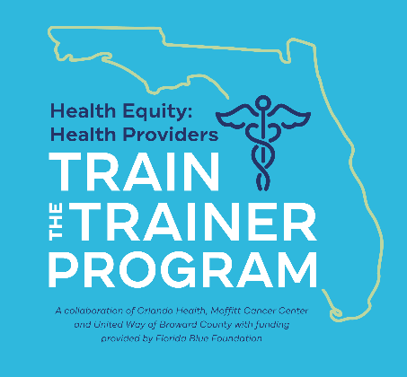

You are now a Health Equity Champion! This toolkit contains all the necessary resources to implement the Health Equity Training Program at your organization, team, or department. It includes training curricular content, planning tools, marketing materials, and strategic communication templates ready to customize and utilize. This toolkit is designed to be followed sequentially as it is presented, to ensure the efficiency of your time, the fidelity of the content, and organization of your resources. All resources discussed in this toolkit can be found at https://healthequityprogram.org/trainer-toolkit.

Please visit the Health Equity Technical Assistance Center (https://healthequityprogram.org/technical-assistance) for additional support and find fellowship among other Health Equity Champions throughout Florida. You will also find additional assets to leverage the implementation of your training, as you advocate for change and address health disparities as a health provider in your organization.
HETTT= Health Equity: Health Providers Train-the-Trainer Program (Completed by you).
HETP= Health Equity Training Program (To be implemented by those who you train at your organization).

Program Partners:
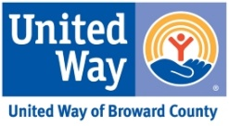

Funded by:
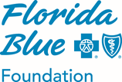

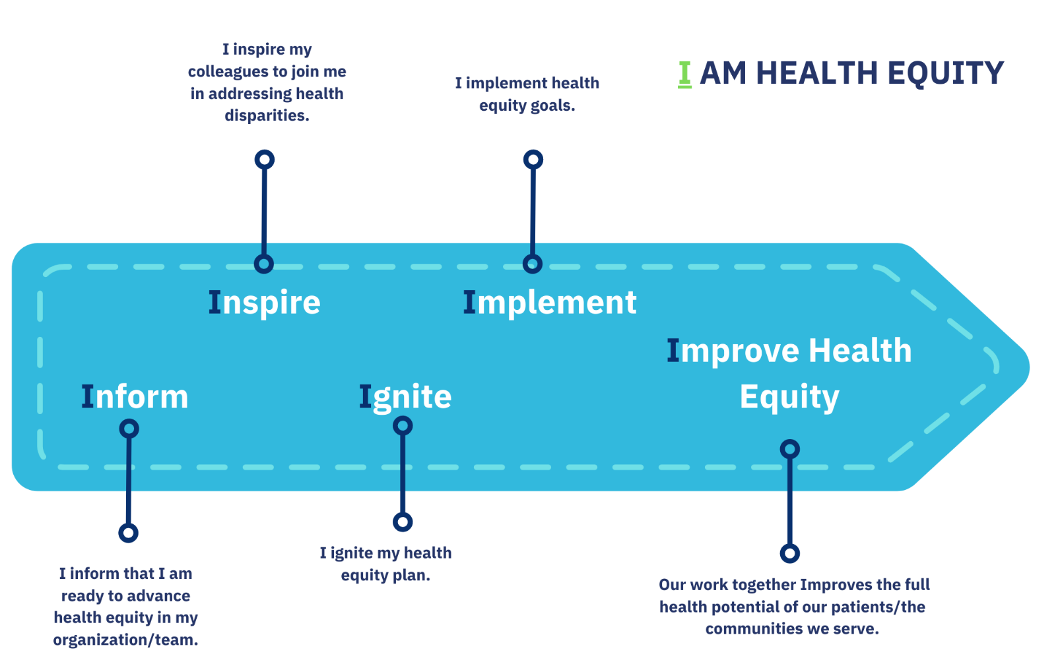

- Inform - If applicable, notify your leadership that you have completed the Health Equity: Health Providers Train-the-Trainer Program
(HETTT). Share your interest in investing back in your organization what you learned in this training program.
☐ Email for leader (LeaderEmail.doc) Customizable overview of the HETTT Program and request to launch training in your organization
☐ Program slide deck (ProgramOverview.pptx) Customizable overview of Health Equity Training Program (HETP) goals, rationale,
outcomes, and curriculum
☐ Program flyer (ProgramFlyer.pdf) Marketing piece to advertise the HETP

- Inspire - Invite your colleagues/team members via email to participate in the HETP and inspire them to address health disparities in your
organization.
☐ Email invitation (RecruitmentEmail.doc) Customizable overview of the HETP content and invitation to participate
☐ Elevator speech (ElevatorSpeech.pdf) Brief summary of the HETP to describe and market in the community
☐ Program flyer (ProgramFlyer.pdf) Marketing piece to advertise HETP

- Ignite - Prepare for training in your organization. Refer to the “Health Equity Workplan” that you completed in Landing Day.
☐ Registration and sign-in sheet (RegistrationTracking.xls) Organization tool to track all potential and actual recruited participants
☐ Facilitation essentials (Launch and Landing Day slide decks, and facilitation guides can be found at
https://healthequityprogram.org/trainer-toolkit.

- Implement - Implement your Health Equity Training Program and start advancing health equity.
☐ Scheduling email (SchedulingEmailTemplate.doc) Email invitation to secure Launch & Landing Days on participants’ calendars
☐ Launch Day Email (LaunchDayEmailTemplate.doc) Reminder to your participants to join Launch Day including Handbook
☐ Weekly communications (WeeklyEmailTemplates.doc) Module introduction and reminders to complete e-learning modules
☐ Module links (ModuleLinks.doc) Module links included on weekly communications
☐ Your Health Equity Intervention Plan (HealthEquityActivities.doc) Weekly health equity activities you completed as a Trainer
☐ Landing Day Email (LandingDayEmailTemplate.doc) Reminder communication for your participants to join Landing Day
☐ Wrap-up Meeting Form (WrapupMeetingForm.doc) Sample document for notation of your next steps beyond Landing Day
☐ Digital badge of participation (DigitalBadge.png) To be distributed among successful participants after completion of HETP
☐ Completion Certificate (CompletionCertificate [doc or pdf]) To be distributed to your successful participants after completion of HETP

- Improve Health Equity You are now closer to address health disparities and advancing health equity in your organization!

