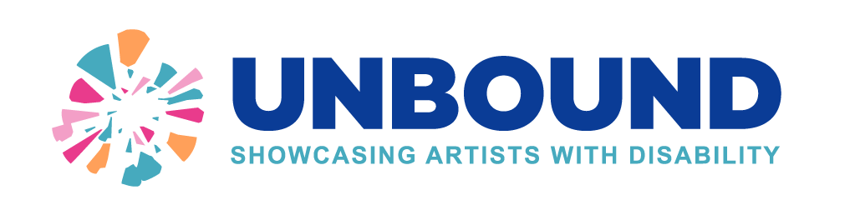2026 UNBOUND Submission Form
Artists should submit one artwork for award entry. Please complete all the details in this form. Applications with missing information may not be entered into the awards. We may also check information such as lived experience of disability and residential location.

You can check the entry criteria on the webpage: https://shareddirection.com/unbound-2026

Email complete submissions to: unbound@shareddirection.com

About You

Full Name (include title or pronouns if desired)
Do you identify as: Aboriginal and/or Torres Strait Islander, or LGBTQIA+
Which suburb do you live in?
Please check you live in an eligible areas.
Age | (People 25 years and younger will be considered for the Emerging Artist Award)
Disability Type
Overview of your lived experience with disability

Overview of you as an artist

About the artwork
This information will be provided to the judging panel and, if shortlisted, included in information for the exhibition.

Name of Artwork
Describe your artwork.
What do you want to say about this artwork?
Size / Dimensions (including frame)
Media used
How does your artwork showcase originality, freedom in expression and diversity in talent?
Is your artwork hang ready? Please use D rings on the side. | Yes or No
Have you included an image of your artwork with your submission? | Yes or No
Is your artwork for sale? If so, what’s the asking price? | Yes or No  If Yes, Price: $  Did you want to handle the sale or for SDC to facilitate payments?  - Self  - SDC

INSERT AN IMAGE OF YOUR ARTWORK OR EMAIL WITH YOUR SUBMISSION.

Confirmation of participation

If shortlisted, are you able to drop your artwork off for exhibition between 24th to 29th November 2026? This will be at the Benalla Visitor Information Centre | Yes or No
Are you able to attend the award presentation at 10:30am on 10 December 2026?  This will not impact on the judging. | Yes or No
Do you consent to using the digital image for the purposes of promotion of UNBOUND? | Yes or No
Do you agree that you have provided the correct information about your lived disability experience and residential suburb? | Yes or No
Confirm you have only entered one item? | Yes or No

Contact details

Your email:
Your phone number:
Do you have any communication or engagement needs?
If you have another preferred contact, please enter their details.  For artists under 16 please provide your parent/guardian details. | Name:  Relationship:  Contact email:  Contact phone:

By emailing this submission form you consent to entry into the UNBOUND art competition.
unbound@shareddirection.com

Best of luck!

