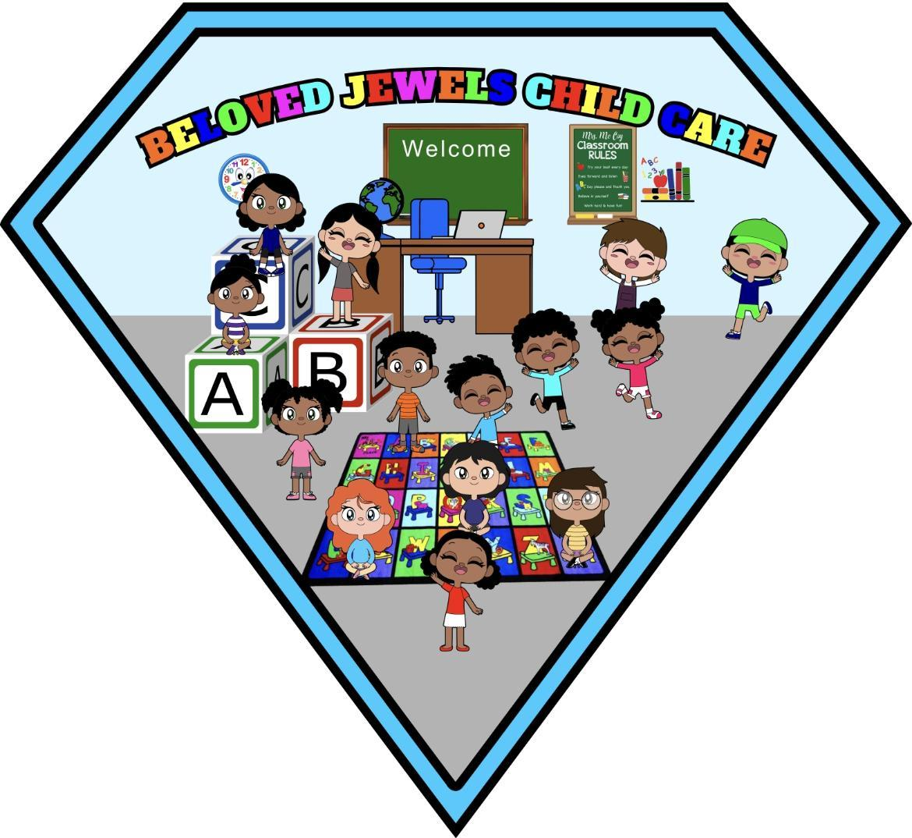

BJC Tuition Rates

**Registration Fee**

Annually $100

**Infants to 5 year old toddlers**

Infant full time-$260 (Part time-$195)

1 Year old full time-$230 (Part time-$165)

2 Year old full times-$210 (Part time-$135)

3 Year old full time-$180 (Part time-$115)

4 Year old full time-$160 (Part time-$90)

5 Year old full time-$155 (Part time-$80)

School Age-$100 (Part time-$65)

FULL TIME SCHEDULE IS MONDAY-FRIDAY

PART TIME IS 3 DAYS OUT OF THE WEEK

**Other fees and charges**

Late pick up fee-$2 per minute

Late tuition payment-$25

Sibling Discount-$20 off total balance

Return Check-$35

Uniforms-$20