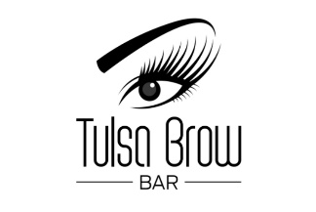
Machine Powder Brow Aftercare
Day 1/Day of the appointment: Very Important!! Be BLOTTING your brows!! Blot every 30 minutes to each hour with a lightly dampened cotton pad!! This will remove lymph which will help preserve color.
Day Two: Start your ointment that is provided for you. You will only use a grain of rice size amount for both brows! Please apply with a Q-tip only.
Day 3 – Day 10 to 14
Everyone’s skin has its own healing process and duration. It is recommended to apply ointment as long as the skin is still scabbed, and even after if needed. The ointment will help your skin regenerate fast and better.
During HEALING Days 1-10 to 14 or ( until scabs are gone ) AVOID water for the tattooed area! Please do no wear any kind of topical makeup on this area, AVOID sweating, no sauna, pools, tanning, and do NOT PEEL any scabs at all. This WILL cause color loss and scarring. Do not apply anything but the ointment given to you on the tattooed area.
During initial and touchup healing process, including 4 weeks after the procdure, it is recommended to not use creams that contain acids or ingredients that will lighten or exfoliate the skin such as glycolic, retin-A, retinol, glycolic acid, salicylic acid, hyaluronic acid, enzymes, etc. Using these can cause color loss and can also cause color to turn ashy blue/grey.
What to Expect:
Day 1-3 Your eyebrows are about 15 to 20% darker then they will heal to be. This pigment will also look a little warmer than what they will heal to be. Sometimes, due to oxidation and swelling, the brows can appear thicker than what we drew. Don’t be concerned with this as this is part of the healing process. You may also have redness that will subside within the first 48 hours.
Day 4 The peeling begins. The dark outer color will start peeling off revealing the softer lighter color. Keep moist with your ointment but don’t over do it.
Day 5-8 Dark outer color finishes peeling off. The color is lighter and softer and the brows themselves are a little thinner. The color may have an ashy tone until the color clarifies. It could appear that you are missing color or have lighter areas at this time do to layers of dry skin over the new pigment. Give your brows 3 full weeks to heal and for color fully bloom.
Please call or text with any questions or concerns!!
918-864-9227

