History of the Caro Chamber of Commerce

1922 to 2022

  - Also, Its Related Precursory Business Organizations
  - Written for the Caro Chamber of Commerce Centennial
By Mark Putnam – Community Member

Mark Putnam volunteered to compose and gather the historical information for the Caro Chamber of Commerce.

Written in 2022 and a working document, where information will be added as information is discovered from archives.

Nearly, all the information in this document was found in the Caro Area District Library Archives for The Tuscola Advertiser. I would like to thank them for making the information available to the public.

Table of Contents

Epilog 14
The Time-line 15
The Caro Board of Trade 15
1904 15
Introductory note 15
Initial Meeting to Organize 15
1905 17
Interest Wanes 17
1906 17
Interest Marginal 17
1907 18
Revitalization 18
1908 18
New Leadership 18
1910 18
Dissolution 18
Caro Businessmen 19
The Caro Businessmen’s Association 19
1912 19
Organization 19
1915 19
Community Involvement 19
1920 20
Women’s Movement 20
The Caro Board of Commerce 20
1921 20
Name Change 20
1922 21
Caro Board of Commerce Incorporates 21
1923 22
Meetings Well Attended 22
Michigan Milk Producer’s Assoction 22
Bay City Boosters 22
Canning Factory 23
Contacts with Farmers Negotiated 23
Principles of Business Mastery 23
Caro’s Portion of the W. C. Canning Factory 23
1924 24
Clark Canning Factory—Last Building Started 24
Hotel Montague Burned 24
Hotel Montague 24
Fourth of July Celebration 24
Railroad Talk 24
Ladies Night 25
1925 25
240 People Attend Caro Board of Commerce Meeting 25
Courthouse Square was Skating Rink 25
1926 25
Membership Greatly Increases 25
Window Night 26
Airplane Landing Field 26
1927 26
Creamery Owner Elect President of Caro Board of Commerce 26
1928 26
Dairymen Highlighted 26
Fred J. Purdy heads the Caro Board of Commerce. 27
Plans for the Airport Started 27
Caro Airport Land Donated 27
1929 27
Caro High School Band Uniforms Bought 27
Mr. Park Elected President & Dr. Dixon Speaks 27
Caro Schools Gives Program 28
1930 29
Road from Lapeer to Caro 29
Sugar Beet Day 29
State Highway—M-81--Extended 29
Board to Meet at the Caro High School Auditorium for a Year 29
Michigan Central Railroad 30
1931 30
Annual Election of Directors 30
Mr. Meyers Elected as President 30
University of Michigan Presentation 30
1932 30
The New Slogan—Run the Plant 31
Beet Growers Get Federal Aid 31
Lansing Chamber of Commerce 31
1933 31
Alison Stone—New President 31
Caro Trade-dollars 31
New Tuscola County Courthouse 32
Caro Airport Improved by State of Michigan 32
1934 32
Crowds Present at Caro Grain Show 32
Rebirth Promised for Caro Board of Commerce 32
Ms. Helen Marie Quinn 32
Skating Rink Discussed 33
Caro Bedecked in Holiday Grab 33
1935 33
Collaboration 33
State of Michigan Commissioner of Agriculture 33
1936 33
Three Days of Fun Over the 4th of July 34
1937 34
Big Meeting of Beet Growers 34
1938 34
Americanism 34
The Lights at the Fairgrounds 35
Santa Claus 35
1939 35
Seven Directors of the Caro Board of Commerce are Named 35
The Caro Board of Commerce Opens the Year with a Dinner 36
Cornerstone for New Post Office 36
Joint Meeting 36
Lady’s Night 37
1940 37
New, Young, President of the Caro Board of Commerce 37
Professor John L. Brumm—University of Michigan 37
Building Birdhouses 37
Farmer’s Night 38
Christmas Carols 38
1941 38
Caro Attorney Elected Head of Caro Board of Commerce 38
New Roadside Park Proposed South of Caro 38
Caro Board of Commerce Plans Celebration of Opening of New Bridge 39
Night School for Salespeople Started 39
Caro High School Team Honored in Community Gathering 39
Christmas Music in Downtown is Presented 39
Caro Board of Commerce Creates War Committee 39
1942 40
Nucleus of Caro War Board Named 40
Directors of Caro Board of Commerce Elected 40
Caro Board of Commerce has 130 Members 41
1943 41
Directors of Caro Board of Commerce Named 41
O. H. Dibble Elected President 42
Caro Board of Commerce had Big Meeting 42
Amazing World is Coming After War 42
1944 42
President of the Caro Board of Commerce—1944 42
Caro Board of Commerce Suggest V-Day Procedure 42
1945 43
Peoples State Bank Cashier is President 43
1946 43
Almon C. Peirce President 43
Lighted Field at Fairgrounds Hailed a Success 43
1947 43
Caro Board of Commerce Sends Questionnaire 43
New Retail Merchants Division Charge with Meeting 43
1948 44
Board Meetings Open to Members 44
4-H Dormitory 44
Caro Football Team to Get Big Banquet 44
Tuscola County 4-H Council Fund 44
1949 45
Frank J. Rolka is President 45
New Swimming Pool Discussed 45
Caro Retailers Show 45
Shetland Pony Given Away at Fair 46
Pool Pledges Above $11,000 46
Second Annual Harvest Festival 46
1950 46
Second Annual Merchants Show 46
Mr. Scott Speaks at Meeting 47
1951 47
Merchants Schedule Third Annual Merchants Show 47
Getting M-24 Paved 47
1952 47
1953 47
Coach Don Stamats’ Silver Anniversary 47
1954 48
1955 48
1956 48
1957 48
Caro JC’s Elect Officers 48
1958 48
1959 48
Caro Board of Commerce Involved with livestock Sale 48
1960 49
1961 49
Caro JC’s 49
1962 50
1963 50
Caro Board of Commerce has Large Meeting 50
Area Chamber of Commerce Collaborate 50
Dollar Days 51
Holiday Decorations 52
The Caro Board of Commerce & Caro Chamber of Commerce Coexist 52
1964 52
Caro Chamber of Commerce Brochure 52
1965 52
1966 52
1967 52
1968 53
1969 53
Caro Chamber of Commerce Officers Elected 53
The Caro Chamber of Commerce 53
1970 53
Caro Board of Commerce Meets at Caro High School Cafeteria 54
Caro Board of Commerce Presents the First “Citizen of the Year” Award 54
Community Calendar 54
Caro Chamber of Commerce Reorganized 55
Caro Board of Commerce—Involved with 4H 55
Advertisement 56
1971 57
Citizen of the Year 57
1972 57
Citizen of the Year 57
First Annual “Caro 150” 57
Harvest Festival 57
1973 58
Citizen of the Year 58
Second Annual “Caro 150” 58
Welcome to Caro Sign 58
Caro 150 58
Egg Extravaganza 59
1974 59
Citizen of the Year 59
Caro Board of Commerce Advertising 59
1975 60
Citizen of the Year 60
1976 60
Citizen of the Year 60
1977 60
Citizen of the Year 60
1978 60
Citizen of the Year 60
Caro Board of Commerce Award 4-H & FFA Livestock Ribbons 60
1979 60
Citizen of the Year 60
Ribbons for 4-H & FFA 61
Christmas Store Hours 61
1980 61
Citizen of the Year 61
64 exhibits & Dancing highlighted Caro Art Fair 61
Big Crowd Moves Dinner 61
1981 62
Citizen of the Year 62
The First Annual Pumpkin Festival was Compete with a Flag 62
Santa Clause & his Wife Come to Caro 63
1982 63
Citizen of the Year 63
Pumpkin Clues Announced for Pumpkin Festival 63
1983 64
Citizen of the Year 64
1984 64
Citizen of the Year 64
Dollars Days 64
Dignitaries to Visit Caro During Pumpkin Festival 64
1985 64
Citizen of the Year 64
Bringing Community Together is New Director’s Aim 65
1986—Citizen of the Year 65
Advertisement for the Citizen of the Year Award 65
Citizen of the Year 66
The Helm of the Caro Chamber of Commerce 66
Community Calendar & Chamber Quarter Event 66
Arts, Crafts, &Fair 67
Sidewalk Sale 67
Business Ombudsman Meet Caro Merchants 68
1987 68
Citizen of the Year 68
1988 68
Citizen of the Year 68
1989 69
Citizen of the Year 69
1990 69
Citizen of the Year 69
1991—Citizen of the Year 69
Citizen of the Year 69
1992 69
Citizen of the year 69
70th Anniversary Celebration 69
1993 70
Citizen of the Year 70
1994 70
Citizen of the Year 70
Citizen of the Year 70
1995 71
1996 71
Citizen of the Year 71
Early Celebration of 75th Anniversary of the Caro Chamber of Commerce 71
1997 71
Citizen of the Year 71
1998— 71
Citizen of the Year 71
1999—Citizen of the Year 72
Citizen of the Year 72
2000 72
Citizen of the Year 72
2001 72
Citizen of the Year 72
2002 72
Citizen of the Year 72
2003 73
2004 73
2005 73
Citizen of the Year 73
2006 73
Citizen of the Year 73
Ginger-bread Village 73
2007— 74
Citizen of the Year 74
Second Annual Gingerbread Festival 74
2008 74
Citizen of the Year 74
2009 74
Citizen of the Year 74
2010 74
Citizen of the Year 74
2011 75
Citizen of the Year 75
2012 75
Citizen of the Year 75
2013 75
Citizen of the Year 75
2014 75
Citizen of the Year 75
2015 75
Citizen of the Year 76
2016 76
Citizen of the Year 76
2017 76
Citizen of the Year 76
2018 76
Citizen of the Year 76
2019 76
Citizen of the Year 76
2020 77
Citizen of the Year 77
2021 77
2022 77
Postlog 78

Epilog

The beginning of an organizational structure for business support in Caro was largely first represented by the Caro Board of Trade, which lasted from about 1904 to 1910.
The group known simply as the “Caro Businessmen” was an integral part of the Caro Board of Trade.

The Caro Businessmen made excursions that involved many people from Caro to other parts of eastern Michigan after the fall harvests were done. For these excursions, many Caro businesses were closed during this time.

The Caro Board of Trade, became the Caro Businessmen’s Association, which was formed near 1912.
The Caro Businessmen’s Association changed its name once again to the Caro Board of Commerce in 1922

The Caro Board of Commerce acted much like the Economic Development Corporation, today, but also had social meetings. The Caro Board of Commerce reorganized two the Caro Chamber of Commerce in 1970. The story of the Caro businesses and the Caro Chamber of Commerce is incredibly powerful and influential. The recognized foundation date of the Caro Chamber of Commerce was the incorporation date of the Caro Board of Commerce, 1922.

The Caro Chamber of Commerce particularly in it antecedent the Caro Board of Commerce was a great source of energy for community get-togethers, entertainment, and music along with the conduction and organization of local business.

Mark Putnam

The Timeline

The Caro Board of Trade 1904

Introductory note

Boards of trade were common before 1900 but were usually established in larger cities.
Black’s Law Dictionary describes a board of trade as . . ..
An organization of Merchants, manufactures, etc., for furthering its commercial interests, advancing its prosperity and protection of a particular trade or line of commerce. Also, “An exchange or association engaged in the business of buying and selling commodities e.g. Chicago Board of Trade.

Initial Meeting to Organize

In October of 1904, 76 charter members of the Caro Community attended an initial meeting to organize a Caro Board of Trade. Forty-seven of that number were business people.
The objective of the Caro Board of Trade was the common commercial and financial interests of the town. The meeting was held at the City Hall Council Room where H. S. Johnson was asked to act as the temporary chairman and H. R. Howell was made temporary secretary.

The citizens of the community referenced the advantages to be attained by a Caro Board of Trade and the necessity of united, business community action. The membership unanimously approved the motion to organize the Caro Board of Trade.
Every citizen present signed the papers and became members after paying a membership fee of $3.00 The annual dues were set at $2.00

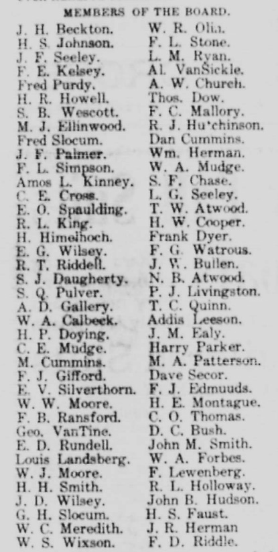

motion was made that the chair appoint a nominating committee of three to nominate fifteen members to be directors who would report at the next meeting. At the following meeting, it was decided to officially name the organization the Caro Board of Trade.
The Nominating Committee presented a list of directors to the assembly, and the following were voted on the Executive Board:
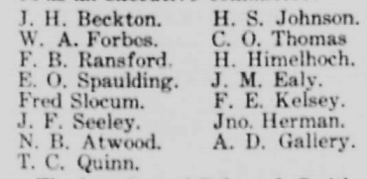

The law firm of Pulver & Smith was instructed to prepare papers for filing with the Secretary of State to have the organization chartered. The following day, those elected as officers follow:

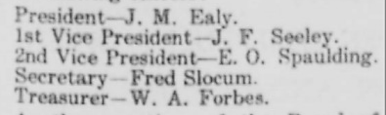

The Caro Board of Trade then was regarded as being one of the most significant actions ever taken by the citizens of Caro.

1905

Over the next year, enthusiasm waned. In November 1905, for two meetings, there had not been enough members, to have a quorum. The few faithful, who did show up, went home disappointed and somewhat disgusted with the now general lack of interest in the Caro Board of Trade.

1906

Interest Marginal

For another year, the faith and interest in the Caro Board of Trade was minimal.

1907

Revitalization

The Caro Board of Trade was revived when C. O. Thomas was elected as president.
The by-laws were amended to reduce the number of directors from fifteen to seven plus the four officers. A quorum for the Board of Directors was set at five, and for members it was set at ten.
The work of acquiring subscriptions increased, and the substantial progress was made in building of a mile or more of the stone road leading toward Ellington.

1908

New Leadership

In November of this year, at the meeting of the Caro Board of Trade, members that did attend took advantage of the absent members and held an election of officers. The following were declared: President, A. D. Gallery; Vice-president, J. McNair Ealy; Secretary, E E. Gurney; Treasurer, Henry Parker.

1910

Dissolution

In April of 1910, the owner of the street sprinkler system refusing to use it. He wanted a different arrangement than that of the year before. The question became acute. A meeting was held with the Caro Board of Trade and others at City Hall to resolve the situation. Those present expressed that the Caro Village Council should be charged with the work. Many expressed that sprinkling should be done just as the streetlight maintenance, fire and police protection furnished, street cleaning, and rubbish removal, but no attempt to secure such action by the council was expected. A committee consisting of John Herman, H. W. Cooper, and John F. Palmer was organized to solicit subscriptions, payable partly at least in advance.

It is unknown exactly when the Caro Board of Trade dissolved and the Caro Businessmen’s Association began, but the phrase Caro “Businessmen’s Association” came into popular use around 1910.

Caro Businessmen

In August of 1910, at Richardson’s Park (property known as the current Tuscola Recycling Center) the Farmer Friends and “Caro Businessmen” had a big picnic.
All the Caro Stores closed from 9:00 am to 5:00 pm to give everyone a chance to take part in visiting playing games and other activities of the picnic. The Tuscola Advertiser projected that everyone would have a “rattling” goodtime. To add zest to the games, the Caro businessmen added prizes for the victors in the events that included a pie eating contest, 100-yard foot races, three legged races, and other games of interest.

The Caro Businessmen’s Association

1912

Organization

As published in the Michigan Manufacturer and Financial Record, the “businessmen” of Caro had organized the Caro Businessmen’s Association. They elected Henry Martini, President; J. J. England, Vice-president; and J. J. McAlister as Secretary and Treasurer.

1915

Community Involvement

In May 1915, the “Caro Businessmen” presented a well-attended meeting of their association. They went on record as favoring the extension of the concrete pavement on State Street and to do it, within the year.

The Caro Board of Commerce

1921

Name Change

In January of 1921, the membership of the Caro Businessmen’s Association renamed its organization to the Caro Board of Commerce. The organization then had a new modern name and was showing “more pep and ginger.” That is according to the Tuscola County Advertiser article. They held the board business meeting at the Odd Fellow’s Hall. When the meeting convened, they adoption of the new name, the Caro Board of Commerce. Afterward, they took part in lively songs, listened to short speeches, and planked down dues for the full year in advance, which amounted to $200.00 Fred Striffler then was the first president of the Caro Board of Commerce.
The membership fixed the dues each year at $6.00 for proprietors and managers of business houses. For clerks, other employees ,as well as, farmers and others not actively engaged in business or manufacturing in the Caro, dues were $2.00

1922

Caro Board of Commerce Incorporates

In February, the Caro Board of Commerce voted to incorporate. The amount pledged for that purpose was $800.00 About 175 people attended, and the Odd Fellows Hall members served an excellent meal. H. P. Orr explained the advantages of the Board of Commerce becoming a body corporate. It was voted to officially organize under the special act for Board of Commerce. President Fred Striffler announced the appointment of the committees that were composed of Public Utilities, City Decorations, Membership, Finance, Publicity, Commercial & Industrial, and Agricultural. Rev. Greene gave a rapid-fire speech in which he said that “the home, the church, the store, or other business house are the foundation of our country’s greatness. In back of them all, is the individual integrity of the average man and woman.”

In March of 1922, the officers of the Caro Board of Commerce announce that Howard J. Clifford of Flint, would be the speaker at the meeting held at the Odd Fellow’s Hall.
Mr. Clifford was no stranger in Caro, as he spoke the previous June at the Commencement of the County Normal. He was connected for some time with the Welfare Department of the Buick Motor Company.

At the following meeting, Articles of Incorporation were presented for adoption.
With the incorporation, a formal election of officers was necessary. A report also was present on the collection of funds subscribed to equip the Legion Hall with a community kitchen. Farmers were welcomed to attend.

Late in March, an inspiring meeting was held and well attended by businessmen who enjoyed the addresses given by both members and guests. Dr. Howard J. Clifford of Flint gave a stirring address on “The Challenge of 1922.”Nearly every seat at the banquet tables was filled. President Striffler presided over the business portion of the meeting following dinner. H. H. Smith was called to the chair to conduct the election of officers.

In November, the Caro Baseball Club, 1922 champions of the Tuscola County League, requested united support of the businessmen and citizens of Caro. The final game with Marlette in the Tri-county Championship Series was supported unanimously by the board of directors of the Caro Board of Commerce at a meeting held at the Peoples State Bank. It was voted to ask every business in the city to close for the game in the afternoon. Employers and employees alike took the train to Vassar to see the contest and root for the hometown team. To add to the occasion, the Caro Band went along to inspire players and fans.

1923

Meetings Well Attended

In March, the Caro Board of Commerce held another meeting with upwards of 200 men gathering to eat and sing rousing songs under the leadership of Rev. N. D. Braby, Fred Gunsell was at the piano. They also learned in a presentation why Consumers Power Company had agreed to sell the Caro electric plant to the Great Lakes Company.

Michigan Milk Producer’s Association

In March, the Board of Commerce met at Legion Hall with M. L. Noon, Director of Michigan Milk Producer’s Association to give the address.

Bay City Boosters

In July, the Bay City Boosters were dined by the Caro Board of Commerce. The interaction was full of pep and promotion. About 200 members who were also part of the Bay City Board of Commerce were guests of the Caro Board of Commerce at the American Legion Hall. The visitors were on a good fellowship tour through Tuscola County and had stopped in Fairgrove and Cass City before arriving at Caro.
President Moore welcomed them. Mr. A. W. Black in a happy manner took charge of the meeting and proved to be a speaker of much fluency and pep. Col. A. H. Ganger was the principal speaker. Singing brought out considerable enthusiasm, and two quartettes accompanying gave excellent selections. A band also furnished the music.

Canning Factory

By August, the Caro Board of Commerce had been negotiating for several months with a long-established canning company that was interested in locating a branch factory in Michigan.
The officers of the company investigated the soil, climate, and water supply, drainage and shipping facilities and were so impressed with conditions here that a representative of the company attended this public meeting at Legion Hall.
He explained the needs of their company and learned the sentiment of businessmen and famers. He asked for a suitable site and railroad siding together with exemption from local and school taxes for a period of five years. Further the company asked that contract be secure for the growing of vegetables with the farmers.

Contacts with Farmers Negotiated

In September, States Canning Company hoped to begin building a canning factory in Caro by October 1. The Board of Commerce guaranteed acreage and undertook to secure the required supply of material for the 1934 pack. The President of the canning factory was in Caro. The citizens authorized the Caro Board of Commerce to guarantee 1,550 acres of land to be devoted to raising crops to be used by the canning factory. The factory was expected to cost upwards of $100,000. Farmers and townspeople at the meeting were enthusiastic about the outlook.

Principles of Business Mastery

In October, Frank Jewel Raymond from New Jersey spoke to the Caro Board of Commerce on the “Principles of Business Mastery."

Caro’s Portion of the W. C. Canning Factory

Late October, at a special meeting of the Caro Board of Commerce, was held to address the provisions for financing Caro’s portion of building of the W. N. Clark Canning Factory. A resolution was adopted to the effect that the Executive Board of the Board of Commerce was authorized to borrow not more than $9,000 on the faith and credit of the organization to purchase the land for the site and building and a siding from the Michigan Central Railroad.

1924

Clark Canning Factory - Last Building Started

In January, workers began the construction of the final building.
The Clark Canning Factory started construction 2 and ½ months earlier and was on a record pace. Fifteen railcars of machinery were on their way.

Hotel Montague Burned

In February, the Board of Commerce would be involved in the rebuilding of Hotel Montague. Mr. Moore, who was President, appointed F. C, Striffler and S. R. Park as a finance committee that took charge of raising $50,000.00 for the rebuilding of the hotel.
The dues of the Caro Board of Commerce were then, $6.00 a year.

Hotel Montague

In March, the Caro Board of Commerce voted unanimously to subscribe $2,000 in stock and bonds in about 10 minutes time. Eighteen other businessmen offer additional subscriptions totaling $2,200. The Chairman of the Finance committee, Fred C. Striffler said that the total was then $54,650 and the goal was $60,000.
The Montague Hotel had burned in November 1923.

G. W. Moore was the retiring President, and A. O. Purdy became the new President of the Caro Board of Commerce.

Fourth of July Celebration

In May, work on the new Hotel Montague is started. The Caro Board of Commerce sponsored the Fourth of July celebration for this year. Cooperation was asked of the Tuscola County Baseball League to schedule two games in Caro for that day.

Railroad Talk

In October, James Findley, assistant general freight agent for the Michigan Central Railroad, was the speaker at Caro Board of Commerce meeting.

Ladies Night

In December, the Bay City Times and Tribune printed that the Caro Board of Commerce will hold a “Ladies Night” at which Judge Arthur J. Tuttle, of the United States Court, was the speaker. There was dancing from 10:00 until 12:00 p.m. The Bay City Times Tribune Newsboys’ band furnished the music.

1925

240 People Attend Caro Board of Commerce Meeting

In December, the Caro Board of Commerce held a meeting that taxed the capacity of the American Legion Hall. Supper was served to 240 people.
Local farmers accepted invitations from members of the Caro Board of Commerce to break bread with them and heard the talks and orchestra joined in the community singing.
Dr. Kenyon L. Butterfield, president of Michigan State College, was the main speaker.
The topic was “The Forward-Looking County."
He argued that the County should plan for the future no less than an individual or a city; that it would be well for all to consider the county as the unit for all civic effort.”
He also pleaded for a more careful consideration of home life for the child rather than leaving much of the work to teachers.

Courthouse Square was Skating Rink

Also, in December, the south and west portion of the Courthouse Square was banked up and flooded so that a large span of ice could be used by skaters.

1926

Membership Greatly Increases

In February, new members of the Caro Board of Commerce grew by the number of nearly 100 who gathered at American Legion Hall for the supper and the first meeting of the Board under the leadership. After supper, the Campbell Orchestra furnished music and lead some community singing. As retiring president, Carl Palmer presented C. A. Klein and S. H. Park with certificates of merit for getting the highest number of new members in the 1925 contest. Mr. Palmer then turned over the gavel to the new president Dr. C. N. Race.

Window Night

In March, to simulate some good window trim, the Caro Board of Commerce, through Its directors decided to offer three prizes for the best trimmed windows. The board decided to make “Window Night” an annual event.

Airplane Landing Field

In June, further steps toward the development of an airplane landing held for Caro were taken into consideration at Caro Board of Commerce meeting. Carl Palmer, chairman of the committee, was charged with locating a suitable field. He reported that the land owned by the village as part of the waterworks purchase was suitable. The field was large enough, was located on a good road within only a short distance of gasoline supplies. He told the group that some firms then were making airplane delivery of merchandise.

1927

Creamery Owner Elect President of Caro Board of Commerce

In January, Edward J. Riley becomes the new president. Mr. Riley bought the Caro Creamery in 1818 and paid close attention to business and built it into a thriving enterprise. He had served as trustee of the village and a member of the Caro School Board. The line of presidents was Fred C. Striffler, George H. Moore, A. O. Purdy, Carl Palmer. Dr. C. N. Race. A “Lady’s Night” would be a feature of the regular meetings.

1928

Dairymen Highlighted

In January, the interest in the dairy industry increased In Tuscola County. A crowd of farmers accepted an invitation from the Caro Board of Commerce and the Detroit Creamery Company to lunch. The American Legion Hall was well filled, and more tables were required to provide places for the guests. Following the luncheon, everyone went to the Strand Theater where Edward J. Riley, president, introduced D. B. Jewell the county agricultural agent who acted as chairman and introduced several speakers.

Fred J. Purdy heads the Caro Board of Commerce.

In January, Fred J. Purdy was a well-known businessman for 25 years beginning with the Purdy Brothers Hardware store. After selling his business, he managed the Maytag Washing Machine agency in Tuscola County and a member of the Board of Directors of the People’s State Bank.

Plans for the Airport Started

In March, President Purdy had appointed a committee that with the help of Mr. Koephfgen of Bay City gained an interest in 75 acres of the land that was owned by the village across the Lower Bridge from which section the village got its water.

Caro Airport Land Donated

In June of 1928, the Charlevoix Herald printed that fifty-seven acres of land near the Michigan Farm Colony at Wahjamega was donated to Caro for an airport. President Fred Purdy announced that Govern Fred Green donated the land and expressed gratitude that aviation was advanced. The Caro Board of Commerce was to provide markings and a hanger.

1929

Caro Board of Commerce bought band uniforms for the Caro High School Band

Mr. Park Elected President & Dr. Dixon Speaks

In February, the Caro Board of Commerce announced its new president S. R. Park.
It was one of the largest crowds in four years for the American Legion Hall.
Throughout the meal, the men were entertained by music by the Caro High School Band and community singing led by Karl K. Kinsey followed the supper.
Dr. R. L Dixon, chairman of the Tuscola Board of Commissioner spoke about the Caro Community Hospital and then presented a complete report of hospital activities for the period from the opening of the hospital February 2, 1928, to January 1, 1929.

In April, the meeting of the Caro Board of Commerce was held at the American Legion Hall with entertainment stars of WBCM George Meyers & Fred Gunsell.
Fred Gunsell was originally from Caro.

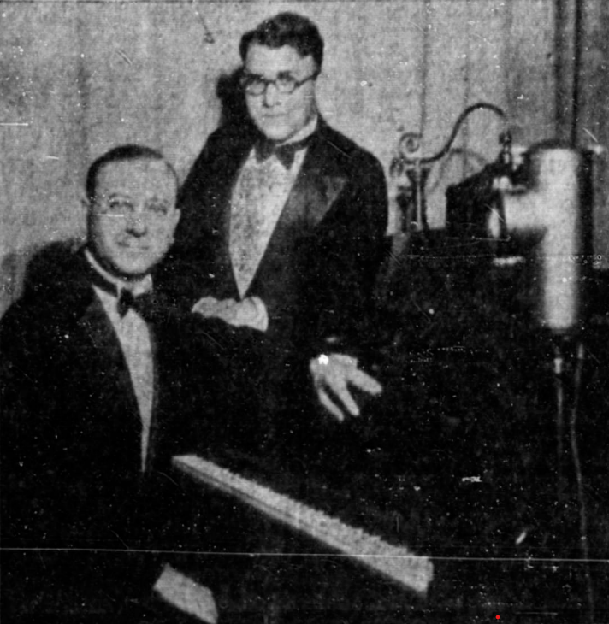

George Meyers & Fred Gunsell—WBCM

Caro Schools Gives Program

In May, under the direction of Superintendent M. J. Crawford, the school had charge of the Caro Board of Commerce meeting that was held at the Legion Hall. The program was by school children of the grades and high school. Because mothers as well as the "dads” will be interested in the program, the board of directors decided to invite the ladies. The Road Committee reported that for the State Highway bids would he asked this week for the construction of six miles of pavement from Wahjamega to Carr's Corners. The announcement received abundant applause.

1930

Road from Lapeer to Caro

In February, Andrew Larsen is the new president of the Caro Board of Commerce and appointed members to committees. J. H. Beckton chairperson of committees sought a state trunk line from Lapeer north to Caro told of the expedition to Lansing of 150 men who called on the governor and administrative board.

Sugar Beet Day

In April, approximately 600 farmers were guests of the Caro Board of Commerce. At the second annual “Sugar Beet Day.” Visitors Included H. H. Wallace, President, and general manager, of the Michigan Sugar Company.

State Highway - M-81 Extended

In April, Andrew Larsen, President of Caro Board of Commerce was told by Saginaw Chamber of Commerce, that the State Highway, M-81, would be paved that summer from Carrs Corners through Reese and into Saginaw County to connect with the pavement coming out of Washington Avenue in Saginaw City.

Board to Meet at the Caro High School Auditorium for a Year

In October, after three months of vacation, the Caro Board of Commerce resumed its regular meetings. The October meeting was at the auditorium of the Caro High School.
An agreement between the school board and the Board of Commerce provided for the use of the auditorium for meetings for a year. Caro bankers oversaw this program. The Caro High School Band furnished the music.

Michigan Central Railroad

In December, Frank C. Robson, Vice-president of the legal department of the Michigan Central Railroad presented figures dealing with the railroads of Michigan.
Andrew Larson president of the Caro Board of Commerce appointed a nominating committee that would suggest names of those to serve as directors the next year.

1931 Mr. Meyers Elected as President

Annual Election of Directors

In January, at the annual meeting, members elected the following people by acclamation: H. W. Cooper, Allison Stone, W. H. Gildart, H. H. Purdy, H. O. Dibble, J. W. MaClaughlen, C. R. Myers. Directors met during the week to choose the officers.
Thirty-three families were given help from the fund created by the Charity Dance that was given by the employees of the Michigan Farm Colony and the Caro Board of Commerce.

In February, the directors name Clarence H Myers, cashier for the State Savings Bank, as the new President of the Caro Board of Commerce.

In March, Rev. C. E. Holy of Bay City, a former pastor of the Caro Methodist Episcopal Church, was the speaker of the evening.

University of Michigan Presentation

In December, Dr. J. L. Brumm of the Department of Journalism of the University of Michigan gave an arousing address at the meeting of the Caro Board of Commerce.
The Caro Garden Club asked the board if businesses could do an extra effort this year in decorating the interior of stores during the Christmas season.

1932

The New Slogan - Run the Plant

In February, conferences between officials of the Caro Bard of Commerce and Manager W. H. Wallace brought good news. The assessed tax valuation of the Michigan Sugar Company Caro plant would be reduced to $100,000 from $300,000. Which was good news for the residents of the area. This would mean thousands of dollars of “trade” in Caro.

Beet Growers Get Federal Aid

In April, the Caro Board of Commerce and the two Caro service clubs, the Rotary Club and the Exchange Club , co-operated with the Tuscola County committee in charge of seed loans authorized by the Federal Reconstruction Finance Corporation. More than eight hundred farms will apply for government Loans.

Lansing Chamber of Commerce

In April, President R. O. Kern of the Caro Board of Commerce secured William C. Otto of the Lansing Chamber of Commerce as speaker of the meeting

1933

Alison Stone - New President

In February, a member of the firm of Stone Brothers, Jewelers, and Opticians, Alison Stone who grew up in the business since boyhood in Caro, became the President of the Caro Board of Commerce.

Caro Trade Dollars

In March, over seventy-five professional men, doctors, dentists, and merchants have agreed to issue and guarantee Caro Trade Dollars in merchandise transactions.
Each transaction in which the Trade Dollar was used was validated by affixing a two-cent trade stamp.
After the Trade Dollar has had 52 stamps affixed the secretary of the Caro Board of Commerce paid one dollar in 1 cash.

New Tuscola County Courthouse

In March, President Andrew Larson of the Retail Merchants Division of the Caro Board of Commerce held a meeting in the courtroom of the new Tuscola County Courthouse.

Caro Airport Improved by State of Michigan

In November, A R. Stone, president of the Caro Board of Commerce, was notified that the State of Michigan funded $6,000.00 to improve the Caro Airport that included the construction of runways.

1934

Crowds Present at Caro Grain Show

In March, Russell Hill, a teacher who taught agricultural subjects at the Caro High School and who directed the efforts of the Future Farmers Club was very appreciative that the Caro Board of Commerce approved financial support as did individual members. The board helped to attract quality exhibits to the show.

Rebirth Promised for Caro Board of Commerce

In April, H. H. Purdy accepts presidency of the Caro Board of Commerce and begins a drive for membership.
One-hundred twenty members pledge support for the maintenance of the organization.

Ms. Helen Marie Quinn

In August, the Caro Golf Club, Moore Telephone System, The Strand and Temple Theatres formed a group of Caro Board of Commerce to pick a candidate for Miss Caro.
Their choice was Helen Marie Quinn the daughter of Mr. and Ms. Joseph Quinn of Elmwood Township. Ms. Quinn was nineteen during the Sugar Festival at the Tuscola County Fair. Various groups of Caro Board of Commerce made other nominations.

Skating Rink Discussed

In October, J. P. Carey of Geology Department from Mount Pleasant talked about oil development. Discussion was on the possible creation of a skating rink on a vacant property in Caro. A committee collaborated with members of Caro Village Council.

Caro Bedecked in Holiday Grab

State Street of Caro present a gorgeous appearance with the most extensive Christmas decorations ever attempted. A committee appointed by President H. K. Purdy of the Caro Board of Commerce and headed by A. R. Stone secured the services of Mr. Shubel to make necessary Improvements to hold evergreen trees for display along the street.

1935

Collaboration

In February, the Caro Board of Commerce planned a joint meeting with the Rotary Club and the Exchange club.

State of Michigan Commissioner of Agriculture

In March, James F. Jameson the new Commissioner of Agriculture for the State of Michigan spoke in Cass City in the afternoon and ended with a meeting at the Caro Board of Commerce in the evening.

In April, Henry A. Perry Director of the Michigan Centennial was the speaker at a meeting of Caro Board of Commerce that was held at the Auditorium of the Caro High School. The Lutheran women prepared the dinner. The business session followed.
President George J. Bieth called on County Clerk B. W. Morrison to Introduce the speaker. Mr. Morrison expressed the hope that Caro and the whole county would join with the Village of Tuscola in celebrating the 100th anniversary of that first settlement in Tuscola County because this year was also the 100th anniversary of the statehood of Michigan.

1936

Three Days of Fun Over the 4th of July

In July, Caro merchants and the Caro Board of Commerce are co-operating with the veterans. An old-fashioned celebration was in store. O. A. Zemke, director of the Caro Board of Commerce Retail and Wholesale Division took a vote of the merchants who decided to keep the stores open.
Fred Gunsell’s Orchestra played for a pavement dance near City Hall. Sports program also took place during the day.

1937

In January, the Caro Board of Commerce had its annual meeting that they held in the Community Room of the Hotel Montague. They elected seven directors.
The meeting also featured the presence of the general manager of the Michigan Sugar Company who gave a short talk.

Big Meeting of Beet Growers

In March, Caro Board of Commerce hosts over five hundred farmers at school for dinner. Mr. A. J. Geib president of the Caro Board of Commerce expressed his personal thanks to all whose who helped. Ladies of Caro baked bake beans for the dinner; W. N. Clark Co. furnished canned peas; A. Fenster Corporation provided dill pickles; the Beechnut Coffee Company furnished the coffee; Lea Huston installed his loud speaking apparatus; and Caro businesspeople waited on tables and wore white coats and caps, provided by the Thumb Laundry.
R. V. Gunn and George Wenner, respectively economist and sugar beet specialist, from the Michigan State College spoke.
O. S. Childs executive Vice President of the Michigan Sugar Company complimented Caro businesspeople on the success of the meeting. He declared that it was the aim of the Michigan Sugar Company to improve friendly relations with farmers.

1938

Americanism

In May, more than 70 attended the May meeting of Caro Board of Commerce held at Hotel Montague. They heard a talk on "Americanism” by Leelle Kefgen, Bay City.
They discussed the proposed flood lighting of the athletic fields at the fairgrounds.
Mr. Kefgen was the past commander of the American Legion Department of Michigan, departmental chairman of the committee on Americanism, and secretary of the Michigan prison commission.

The Lights at the Fairgrounds

In June, civic organizations of Caro were determining the cost of constructing, equipping, and maintaining the softball and football fields and the tennis courts at Caro fairgrounds. The related committee met in council rooms at the call of Guy G. Hill, President of Caro Board of Commerce. The cost of lighting the fields and tennis court and erecting bleachers for the fields was placed at $4,500 by President C. H. Boughner of the Caro Athletic Association that sponsored the lighting proposal. Without the bleachers, it was $3,500.

Santa Claus

In December, Santa Claus came to town. Santa Claus appeared in a sleigh in downtown in the evening. He made his annual visit to distribute candy to children of the community. The Caro Board of Commerce put a lighted tree at the front of the courthouse. There are no chimneys on the courthouse for Santa to use, so just how he got to the tree remained a mystery.
State Street in the block in front of the courthouse was blocked to traffic while the outdoor program went on. The Caro High School Band provided music. Every boy and girl in the community was invited to the party.

1939

Seven Directors of the Caro Board of Commerce are Named

In January, the membership elected Reid Thurston, E. H. Dyer, I. L. Baguley, L. W. Watrous, O. A. Zemke, Frank Turner, and A. C. Metcalf as the directors. Seven-six members voted. The directors would among them vote for the president in the next week. The dance for the Caro Community Hospital had netted $266.
A new hangar for the Caro Airport was discussed. The year ending balance for the Caro Board of Commerce was $289.
Two representatives from the State Highway Department, Edward F. Kennedy, chief clerk of the Saginaw office and J. G. Schwab, engineer in charge of construction at the Lansing office of the State Highway Commissioner spoke about the roads and the state’s plans for Tuscola County.

The Caro Board of Commerce Opens the Year with a Dinner

In March, letters to old members were sent out that requested suggestions for the program during this year. Four hundred invitations went out to potential members.
Otto A. Zemke accepted the position of president of the Caro Board of Commerce for 1939 with reservations. He told members of the Board of Directors that he would act as President only through the cooperation of the board and the active support of Caro Board of Commerce members who are in charge of carrying out projects.
Those receiving an invitation were asked to send back the enclosed postcard and list three things the Caro Board of Commerce should accomplish in this year.
To the members Mr. Zemke said that in his opinion that there are plenty of projects and work for the Caro Board of Commerce to do from the early replies.
“With such replies,” he said, "With such objectives and the co-operation of all members we will have an active organization."

Cornerstone for New Post Office

In April, Otto A. Zemke president of Caro Board of Commerce was the chairperson of the program to set the cornerstone of the new post office. The Caro High School Band led the singing of America. Remarks were made by A. R. Meredith Village President.
The price of the lot where the Post Office located on West Lincoln Street in Caro was $6,500 in cash. It was for many years known as the Cora Gibbs House.
The cost of construction was about $45,000.

Joint Meeting

In August, the Caro Board of Commerce invited the Rotary Club and the Exchange Club to a joint meeting.

Lady’s Night

In November, not only will the meeting “Lady’s Night,” the Caro Board of Commerce invited the Rotary and Exchange Clubs. Also, invited was the Theron W. Atwood Jr., Post of the American Legion. Arthur F. Brles of Chicago who was known as “America's Knight Satire,” was the speaker. The meeting was held in the school auditorium and preceded by a dinner.

1940

New, Young, President of the Caro Board of Commerce

In March, William Fitzgerald, proprietor of the Fitzerald Shop, was elected President of Caro Board of Commerce for 1940 by the directors and the organization at a meeting in the council rooms. The Vice President was Tim C. Quinn, Secretary & Treasurer was W. H. Gildart. Other directors were Ellet Atwood, A. B. Cumings, H. O Dibble, L. H Gunsell, and Rev. A. F. Runkel.
A willingness to cooperate with the Village of Caro authorities securing the right of way for the new bridge across the Cass River. Mr. Fitzgerald was a young businessperson of Caro and graduate of Caro High School. He was also President of the alumni Association. He operated a Caro gas station for the Standard Oil Company for several years until he bought the Hudson Store two years previously.

Professor John L. Brumm - University of Michigan

In March, Professor John L. Brumm of the Department of Journalism at the University of Michigan spoke before fifty members of Caro Board of Commerce. After the address, there was discussion for a resolution to amend the by-laws to Increase the dues of senior members from $3.00 to $4.00 a year and of junior members from $1.00 to $2.00 a year. On motion of Clarence R. Myers, it was voted to put the vote before the membership at the next meeting with notice.
It was decided to tell the head of the State Department of Aeronautics that the Board of Commerce was giving the council of the Village of Caro cooperation in a proposed WPA plan for rebuilding the hangar at the Caro Airport.

Building Birdhouses

In April, the Caro Board of Commerce conducted a birdhouse building contest.

Farmer’s Night

In November, one hundred members of Caro Board of Commerce and their farmer friends sat down to a bountiful dinner at the auditorium of Caro High School.
The meal was prepared and served by the ladles of the Sutton Methodist Church.
The high school orchestra played numerous selections. Community singing was enjoyed under the direction of H. H Purdy, with Ms. Esther Capling at the piano.
Potato growing was an important industry in southeastern Tuscola community.
The highlight of the evening was the announcement of the Potato Queen to represent Tuscola County in the Southeast Michigan Potato Show.
Benjamin H. Macomb, school commissioner and chairman of the Selection Committee, announced that it would be Ms. Ruth Satchel of the Future Farmers of the Caro High School. Also, a motion picture titled “Capetown to Cario” was presented.

Christmas Carols

The Caro Board of Commerce sent out letters to church organizations in the county.
It invited the choirs in participate in the singing of` Christmas carols the five evenings before Christmas Eve.
Singing took place in the court room of the courthouse and was broadcast by amplifiers so that it can be heard in the Caro downtown.

1941

Caro Attorney Elected Head of Caro Board of Commerce

In January, the directors of Caro Board of Commerce met at the Hotel Montague Coffee Shop for lunch and at a meeting. Afterwards, they elected Maurice C. Ransford as President. Other officers included Frank B. Campbell Vice-President and W. H. Gildart Secretary & Treasurer. A membership drive was planned.

New Roadside Park Proposed South of Caro

In June, the directors of Caro Board at Commerce voted to partner with the Caro Garden Club and the State Highway Department in providing another a roadside park on about two acres of land adjoining M-85 [M-24] a half mile south of the new Cass River Bridge from Martin Conner who also offered additional land near the park for a softball field.

Caro Board of Commerce Plans Celebration of Opening of New Bridge

Night School for Salespeople Started

In November, a night school for store managers and clerks in salesmanship was open in the Caro High School and ran in the evenings for 10 weeks. The expense was funded in part by the Caro Board of Commerce, Rotary Club and the Exchange Club. The course was free to all who enrolled.

Caro High School Team Honored in Community Gathering

In November, a banquet was staged by the Caro High School Athletic Association with the backing of the Exchange Club, Rotary Club and Caro Board of Commerce.
Principal Geo. B. Martin acted as toastmaster. Dr. J. Leslie French gave the invocation. Maurice C. Ransford, president of Caro Board of Commerce and quarterback of the 1921 football team, responded with remarks.

Christmas Music in Downtown is Presented

In December, a Caro Board of Commerce committee made arrangements for Christmas music to be broadcasted from City Hall. The committee secured a number of new records that were added to those used the year previously. Quite a continuous program was permitted during the afternoon and evening. The phonograph was set up in City Hall. The loudspeaker was outside the building and carried Christmas carols and other music to listeners who shopped at Caro’s fine stores.

Caro Board of Commerce Creates War Committee

In December, the organization of the Caro Community to coordinate war activities was affected through the Caro Board of Commerce. The directors of the Caro Board of Commerce were authorized to select a “Caro War Board” patterned along the lines of the successful effort in World War I. The naming the Caro Board of Commerce to take charge of all local war efforts came through a mass meeting at City Hall. Representatives of many organizations were present.

President M. C. Ransford of the Board of Commerce presided and explained the reason for the meeting and said that it was expected that there will be numerous drives for money to finance a war and to finance agencies that aided the war effort.
Offering the services of the Caro Board of Commerce at the meeting it was believed that some authority would be given to proceed.

Tuscola County had a County Defense Council, named by the State Defense Council, in which Dr. E. C. Swanson of Vassar was the chairperson. The Defense Council functioned in calling on various groups to carry out defense work such as fire protection and protection against sabotage and when the call was made to direct efforts to raise money to prosecute the war. The supervisors of Tuscola County would also develop a “Tuscola County War Board.”

1942

Nucleus of Caro War Board Named

In January, the Caro Board of Commerce directors name ten citizens to lead Caro War Board. The men named were A. R. Meredith, village president; I M. C. Ransford, president of Caro Board of Commerce; Walter Parsons, commander of Theron W. Atwood, Sr., post, American Legion; Clarence R. Myers, past commander of the Legion Post; H. O. Dibble, president Caro Rotary Club; J. W. MacLachlan, past president of Caro Exchange Club; L. R. Stewart, manager Caro plant, Michigan Sugar Co.; Dr. R. L. Dixon, superintendent Caro State Hospital; Donald Ellwanger, superintendent state trunk line maintenance.
First discussion was the revive for the Red Cross Special War Fund in which the Caro quota. They also approve a “War Chest Fund.” More members were to be added to the Caro War Board.

Directors of Caro Board of Commerce Elected

In January, the Caro Board of Commerce re-elects its directors for two more years and selects it officers.

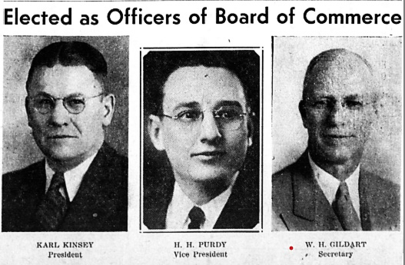
1942 Caro Board of Commerce Directors

Caro Board of Commerce has 130 Members

In May, the record showed the membership to be 130 of whom 104 are Caro businesspersons and professionals and 26 are farmers.
Caro Board of Commerce officers presented clarification of “price control” regulations to retailers. Under the sponsorship of the Caro Board of Commerce and the Caro Exchange and Rotary Clubs another scrap metal collection was made.

In December, two beet growers near Caro were aided by Caro businessmen during the harvest. They received the going rate for the labor, and the recipients have turned the amount over to Caro Board of Commerce.

Christmas carols were heard in the business section during the holiday season.
They are being presented over the Board of Commerce using the broadcasting apparatus from the courthouse.

1943

Directors of Caro Board of Commerce Named

In January, over ninety ballots were cast by Caro Board of Commerce members for the election of four directors. It took place the annual meeting at the Hotel Montague.

O. H. Dibble Elected President

In February, the directors of Caro Board of Commerce elected H. O. Dibble president for the ensuing year. He succeeded Karl Kinsey.
Mr. Dibble operated the 10-cent store which he bought from of F. A. Ellis. He was the owner of the Dibble Stores in Caro, Bad Axe and Big Rapids. He was a Caro businessperson for nearly 22 years.

Amazing World is Coming After War

In October, at the Caro Board of Commerce meeting at the Montague Hotel, about 70 were in attendance including five officers in Charge of Military Police Guards and German Prisoners. After community singing, led by Carl F. Mantey and Karl Kinsey, with J. A. Gallery at the piano, the speaker was introduced by Andrew Larsen who paid high tribute to Mr. Daschner's abilities as manager of the Michigan Hardware Association. Mr. Daschner brought with him an assortment of articles formerly manufactured from steel now made from substitute materials such as plastics, wood fiber, synthetic rubber, ceramics, and glass because of the war.

1944

President of the Caro Board of Commerce - 1944

In February, directors unanimously selected John E. Sheridan as the year’s President.

Caro Board of Commerce Suggest V-Day Procedure

In September, the directors publicize the hope that no wild celebrations will occur until Japan is “whipped.” The war with Germany was nearing its end.

1945

Peoples State Bank Cashier is President

In February, M. Roy H Smith becomes president of the Caro Board of Commerce: Judge Almond C. Peirce, Vice-President, and W. H. Gildart Secretary & Treasurer.
Other members of the board of directors were J. W. MacLachlan, W. R. Kirk, E. J. Riley, George J. Beith, and A. J. Geib. Assistance to Caro industries in locating manufacturing land was discussed.

1946

Almon C. Peirce President

In April, Caro Board of Commerce meeting is held Friday at Hotel Montague with dinner.
Dr. John H. Muyskens, associate professor of phonetics of the speech at the University of Michigan gavel. It is a matter of pride to those who have had charge of the program that the debt to the village and to Caro Board of Commerce has been paid, and the debt to the school district will be paid in eight years. The address “Prepared Positions.''
Almon C. Pierce was the new President.

Lighted Field at Fairgrounds Hailed a Success

In July, the Caro High School Athletic Association has paid its debt to the Village of Caro and the Caro Board of Commerce.

1947

Caro Board of Commerce Sends Questionnaire

In August, the Caro Board of Commerce mailed out questions concerning whether a retail merchants division of Caro Board of Commerce should be organized.

New Retail Merchants Division Charge with Meeting

In October, the Caro Board of Commerce had its fall meeting at the Hotel Montague.
Otis Cook, secretary of the Michigan Retailers Association of Lansing was the guest speaker. The Merchants Retail Division of the Caro Board of Commerce was charged with the meeting. President R. Sarchet of the Retailers said that their committee would make sure every retail businessperson in Caro will be invited to and be present at the meeting.

1948

Board Meetings Open to Members

In March, 160 individuals, businesses, and famers were members of the Caro Board of Commerce. President William R. Sarchet delayed the plans for 1948 until the members were polled. The meetings were open to all members who were free to express their themselves anytime and, on any matter, affecting community welfare.

4-H Dormitory

In September, the Caro Board of Commerce is asked to be part of the program that will fund the purchase the 4-H Club building and for the improvements to the building.
The former boarding house of the Caro Sugar Plant was purchase by the county 4-H Club Council, a non-profit, and put to good use as a dormitory for 4-H Club members exhibiting at the county fair. At the general meeting of the Caro Board of Commerce members at Hotel Montague, a $1,000 solicitation was reviewed.

Caro Football Team to Get Big Banquet

In October, the Caro High School football team were leaders in the Upper Thumb High School Association.
The directors of the Caro Board of Commerce understand that they had been out night after night for practice as well as their coach and that they should receive a reward.
A banquet was held at the Caro High School Auditorium. The ladies of the Sutton Methodist Church served one of their renowned beef dinners.

Tuscola County 4-H Council Fund

In November, it was noted that when the 4-H Club Council agreed to purchase the building, the former boarding bouse of Michigan Sugar Company several Caro businessmen and others in the county loaned the council $2,000.00
From first collections including more than $800 turned over by Caro Board of Commerce, this note was paid. The building cost $7,500, and necessary improvements to make it the 4-H club headquarters cost another $,2,500.
Hence the drive to get $10,000. The terms of the purchase from the Michigan Sugar Company called for the payments of $3,500 a year until the $7,500 was paid.

1949

Frank J. Rolka is President

In January, the Caro Board of Commerce names Frank J. Rolka as President.
Mr. Rolka was a Caro resident for 12 years coming from Saginaw.
He purchased the Retail Credit Bureau that he managed except for a period when he was in the Armed Forces during World War II. A committee was proposed to for the study of the by-laws on model of the Michigan Board of Commerce, other boards of commerce in Michigan and elsewhere.

New Swimming Pool Discussed

In February, at the meeting of the Caro Board of Commerce, Mr. Boyd. Secretary of the Saginaw Board of Commerce was the speaker. Reports were made from the by-laws, Industrial, and swimming pool committees. An important and large meeting, the Board charged five cents for tickets.

Caro Retailers Show

In March & April, the Caro Retailers Show took place at the Fairgrounds:
More than forty merchants had booths for the display of merchandise, with electrical appliances predominating.
Whole-hearted cooperation was given the to the show by the Detroit Edison Company and the Moore Telephone System who connected to two phones for the convenience of the patrons at the show.
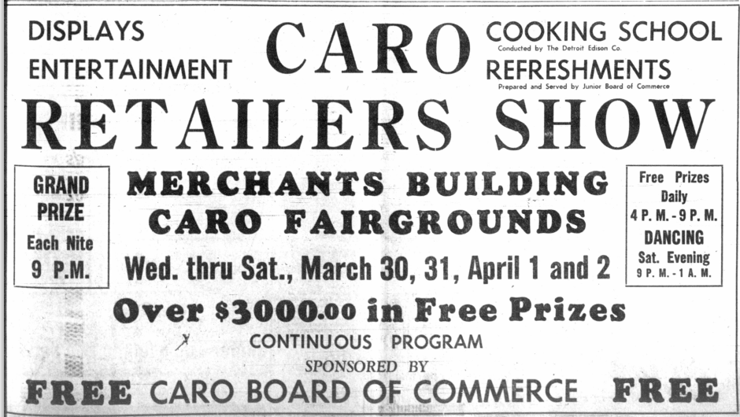

The estimated total attendance for the four days was about 25,000.

Shetland Pony Given Away at Fair

In August [July news,] the Caro Board of Commerce cooperated again this year with the Fair Association and provided a Shetland pony to be given away on “Kid’s Day."

Pool Pledges Above $11,000

J. C. Penny Company topped the weeks pledges with $300.00. The Lions Club would pay for excavation. Timothy C. Quinn was the chairperson of the Caro Board of Commerce committee directing the campaign.

Second Annual Harvest Festival

In September, it announced that forty gifts for October 6, 7, and 8 were shown in the window of the Coffee Cup Café of the Second Annual Harvest Festival.
The homecoming football game would be on Friday, and the free pavement dance on Saturday.

1950

Second Annual Merchants Show

In April, entertainment was provided daily.
Refreshments also were served, and prizes conservatively estimated to have a total value of $3,000.00 were given away. Each night a giant searchlight furnished by the U. S. Army Recruitment Service lit up the skies. Thirty-two businesses took part in the Merchants Show at the Fairgrounds.

Mr. Scott Speaks at Meeting

In September, the directors of Caro Board of Commerce report a brisk advance sale
of tickets for their meeting at a Hotel Montague Dinner. President William Janks invited W. Emerson Scott to attend and relate his experiences from this canoe trip to the artic from which he returned a week before.

1951

Merchants Schedule Third Annual Merchants Show

In April, the Merchants show sponsored by the Caro Board of Commerce featured thousands of dollars’ worth of free prizes, free refreshments daily, free admission, a cooking school and displays by 30 Caro merchants at the Merchants Building at the Fairgrounds.

Getting M-24 Paved

In December, thirty Caro Board of Commerce directors sent letters to Mr. Zeiger the commissioner of the State of Michigan highways. Their goal was to get the M-24, the highway between Caro and Mayville, paved. D. L. Stiffler was the Chairperson of the board. Two petitions and one hundred more letters were promised.
The state said the southern portion of the gravel road would be paved in the spring, but the board and residents said they want the entire stretch paved.

1952

No information.

1953

Coach Don Stamats’ Silver Anniversary

In December, the Caro Board of Commerce and four Caro service clubs, the Jaycees, Exchange Club, Lions Club , and Rotary Club joined forces to put on a truly fine party for Coach Don Stamats on the occasion that he had his silver anniversary of coaching in Caro.

1954

No information.

1955

No information.

1956

No information.

1957

Caro JC’s Elect Officers

In April, the Junior Chamber of Commerce elected it officers: President, Dick Bolton; First Vice- President, Tom Cockerill; Second Vice President. Glenn Burkel; Secretary, Dick Kern; Corresponding Secretary, David Pell; and Treasurer, Gene Skidmore.

1958

No information.

1959

Caro Board of Commerce Involved with livestock Sale

By September 1959, it appears that the Caro Board of Commerce was mostly involved with 4-H sales of livestock:

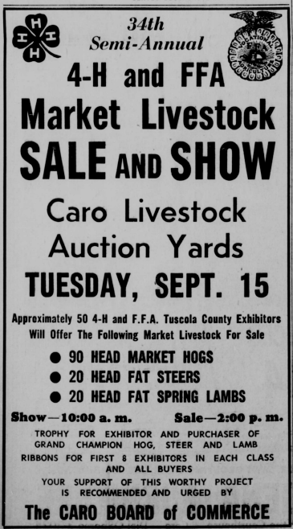

1960

No information.

1961

Caro JC’s

In June, the Caro Junior Chamber of Commerce is presenting outstanding programs for the youth.

1962

No Information.

1963

Caro Board of Commerce has Large Meeting

In January, 250 persons were on hand for the annual Caro Board of Commence dinner at Caro High School’s cafeteria. A delicious beef dinner was served on tablecloth-covered tables decorated with flowers and green programs.
New directors were Harry Ramsower of Gambles, Harry Richards of Detroit Edison, and Bob Kettles, of Kettles "Ford Sales.
Featured speaker of the evening was John Spence, Assistant Secretary of Pure Oil Company. Carl F. Mantey, Secretary of the Executive Committee of the new Caro Community Hospital, spoke at some length on the institution up to the present.
He paid high tribute to committee members, solicitors, and those who pledged to the project to the number of more than 900 during the 1960 19-week campaign

Area Chamber of Commerce Collaborate

In March:

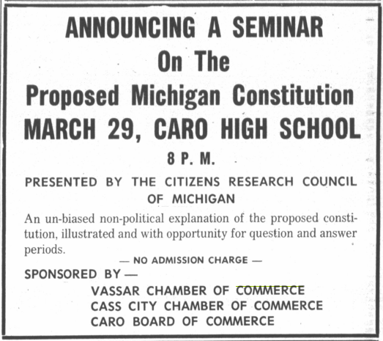

Dollar Days

In July, Tuscola County shoppers flocked to Caro for the annual “Dollar Days” promotion.The Retail Division of the Caro Board of Commerce sponsored it.
In recent years, the special sale event was expected to be one of the largest.
Ed Terrell of the Retail Division Chairman indicated that he had never seen such merchant participation for any “Dollar Days." Tremendous bargains were everywhere.
The Tuscola Advertiser wrote “there were plenty of bargains for the housewife, sportsmen, farmer, handyman, young, and old.” Caro businesses that participated include those selling clothing and hardware stores, restaurants, picture shows, jewelers, furniture stores, and drug stores were just a few among those who were on the program. Advertised was the mood for a high-classed summer sale with low, low prices.
For “Dollar Days" bargains, people shopped the stores listed below:
Gambles, Rainbow Restaurant, Woolworth’s, Terrell’s Men’s Wear, Dyer’s Jewelers, Caro Pharmacy, Gunsell’s, Inc., Sheridan's, Wm. Manasse Jewelers, Preston's, Janks, Caro Wallpaper, Riley’s Shoe Store, Kauffman's Food Market, Moore Drugs, Caro Shoe Service, Larry’s TV, Western Auto, Collins Shoe Store, Grady’s Hardware, J. C. Penney Co., Ben Franklin, Fred's Men’s Shop, State Furniture and Appliance, Dibble’s, Fitzgerald’s, Kay’s, Bee-Hive Restaurant and Caro Floor Covering.
It was a good time for Caro!

Holiday Decorations

In November 1963, the Caro Board of Commerce provided street decorations and tinsel for the streetlights that brightened the year’s expositions as in years passed to help make shopping in Caro a pleasant experience.

The Caro Board of Commerce & Caro Chamber of Commerce Coexist

1964

Caro Chamber of Commerce Brochure

In May, a special committee of the Caro Chamber of Commerce worked on a two-color brochure extolling the virtues of the Caro Community. Bob Kettles was the chairperson of the project, which will produce folders for free distribution to visitor and potential residents and manufacturing concerns. The brochure included pictures of the various attributes of the Caro Community. It gave useful and helpful information about the town. The Detroit Edison public relations department helped develop the brochure.
The brochure took the place of the one produced several years previously.

1965

No Information.

1966

No Information.

1967

No Information.

1968

No Information.

1969

Caro Chamber of Commerce Officers Elected

In December, Tuscola Advertiser printed the following:

The Caro Chamber of Commerce
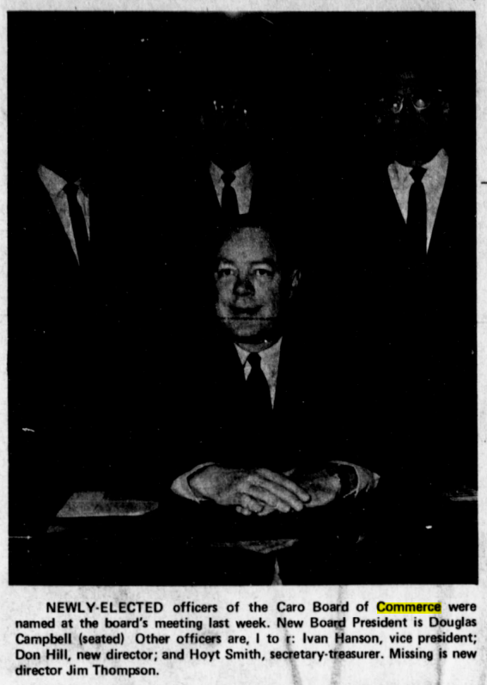

1970

Caro Board of Commerce Meets at Caro High School Cafeteria

In January, this advertisement was printed in The Advertiser about the Caro Chamber of Commerce:

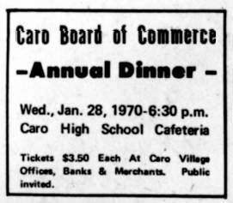

Caro Board of Commerce Presents the First “Citizen of the Year” Award

In February 1970, the Caro Board of Commerce presented the first “Citizen of the Year” award to Reid Thurston, 61, superintendent of parks and recreation for the Village of Caro. This was for the year just passed or 1969.

Community Calendar

In March 1970, the Caro Chamber of Commerce issued an appeal.
It asked all Caro civil clubs and organizations to submit their calendar of events for the year to Village Clerk Hoyt Smith. The Caro Chamber Commerce president then was Ivan Hanson. The Chamber in cooperation with The Advertiser listed a calendar of events

April 2, Caro Chamber of Commerce president, Ivan Hanson, said that local civic groups, clubs, and other organizations had until April 10 to submit a complete calendar of events for the 1970 year.

Caro Chamber of Commerce Reorganized

The Caro Chamber of Commerce hoped to publish at least once a month a list of organizational meetings and community events.
If it warranted interest, a column spot lighting a merchant of the week was projected.
Mr. Hanson the President of the Caro Chamber of Commerce said that the Chambers was recently “reorganized.” It was voluntary organization.
Composed of business and professional men and women and other citizens, they believed that through united action the progress of the community can be materially enhanced and that living conditions can be continuously improved.
“The Chamber of Commerce is operated as an independent, nonprofit organization for the overall betterment of the community for which they serve,” Hanson said.
“We are run by the membership through an elected board of directors.
Elections are held annually and retiring members are replaced by newly elected directors. It is our practice to replace only a portion of these individuals each year to provide for continuity of action.”
Hanson said that support of the Caro Chamber of Commerce is important to all business and professional people and other citizens because “it pays real dividends in the form of more business, better living conditions, and a more attractive and desirable community. Since the service rendered must be adequately financed to be effective, support is highly Important as most of the funds available are strictly from membership dues,” Hanson said.
The following were the 1970 members of the board: President, Ivan Hanson; Vice President, Ron Hebner; Secretary/Treasurer, R. Hoyt Smith; directors Ron Wooster, Elton Gingrich, Donald Hill, Jim Thompson, Douglas Campbell, Frank Chamberlain, and Jack Stevenson.
Mr. Hanson was chairman of the community calendar and the welcome wagon projects; Stevenson chairs the annual dinner; and Smith oversees publicity.
Chairman of the membership subcommittees were the following: Gingrich, industrial; Thompson, real estate; Chamberlain, retail; Wooster and Hill, service clubs; and Campbell, professional.

Caro Board of Commerce—Involved with 4H

In July, the Caro Board of Commerce helped support the Jr. Market Animal Sale during fair week.

Advertisement

In July, the Caro Chamber of Commerce had the following ad in the Tuscola Advertiser:

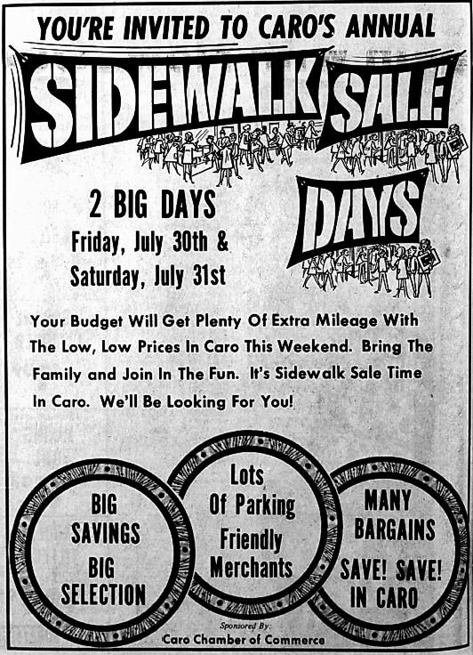

In August, the list of members of the Caro Chamber of Commerce included those the follow:

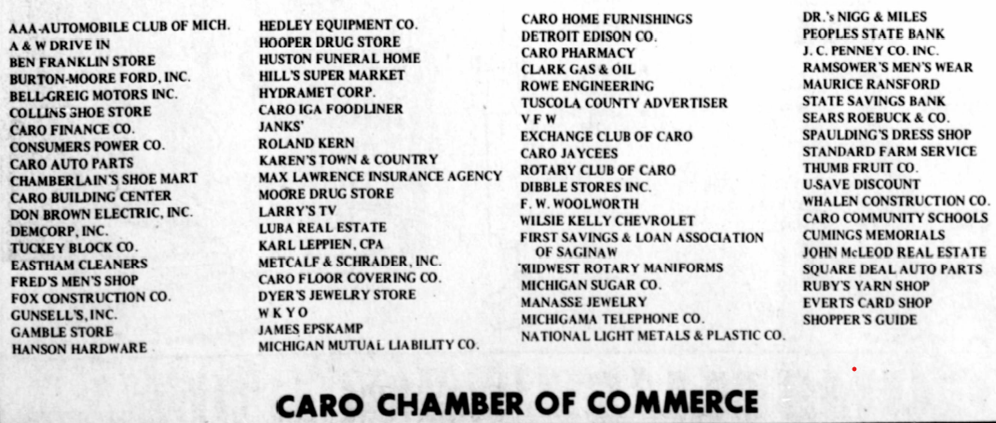

1971

Citizen of the Year

In February, The Caro Chamber of Commerce named Coach Donald Stamats Caro’s 1970 Citizen of the Year at the annual dinner meeting.

1972

Citizen of the Year

The Caro Chambers of Commerce celebrates Lucille Ashmun as the 1971 Caro Citizen of the Year.

First Annual “Caro 150”

In January of 1972, Caro’s first annual “Caro 150” snowmobile racing classic was planned. It was one of the top five in the state with purses of from $7,000 - $10,000.
The 150-mile racing classic (300 laps) was planned to be held January 30 at the half-mile, high banked, oval track at the Caro Fairgrounds. The Caro Chamber of Commerce in cooperation with the Cass River Sno-Drifters Snowmobile Club and various Caro civic groups sponsored the event.

In October, an organizational meeting took place to plan the February “Caro 150” snowmobile racing. The meeting was held at the Cock & Bull Restaurant in Caro.
The Caro Chamber of Commerce president this year was Ronald Hebner.
The meeting was open to anyone interested in helping plan and working work with this next year’s second annual event.

Harvest Festival

In October 1972, “the business district of Caro came to life in an extra special way.
The three-day Harvest Festival sale had started that ran through Friday and Saturday.
Many Caro merchants kept their businesses open until 9 p.m. They offered values that were exceptional. Highlighting the Harvest Festival, the biggest ever, were low prices and entertainment. One special feature for the children was the balloon clown who walked the streets handing out free balloons to children. Strolling musicians walked the streets and entertained the shoppers. Lincoln Street, on both sides of State to the alleys, was blocked off and a platform erected on which the Caro High School Band played. A gala parade was also scheduled. The band led the procession.
The Caro Chamber of Commerce went all out on this promotion.
The Chamber purchased over $300.00 worth of merchandise that it gave away in a free drawing. Tickets were available at all local businesses.
The Caro Jaycees operated a sandwich wagon so that shoppers can purchase lunch while they shopped.

1973

Citizen of the Year

James Sutherland was the 1972 Caro Citizen of the Year.

Second Annual “Caro 150”

In February, rain or shine the Second Annual “Caro 150” Snowmobile Race would take place. The Caro Chamber of Commerce sponsored event was offering $7,000 in prize money. Racing chairman was Ronald Hebner.

Welcome to Caro Sign

In February, the Caro Chamber of Commerce announced that any service club or civic organization interested in helping to defray the cost of the “Welcome to Caro” signs that would include the name, seal, and meeting dates of each participating organizations should contact the Chamber. The Chamber of Commerce required at least eight commitments before the Chamber purchases and erects the signs.

Caro 150

In February, racers from the local area dominated the “Caro 150.” A total of 2,000 avid racing fans braved the 10-degree temperatures at the grandstands. The cold weather kept the crowd to a minimum.

Egg Extravaganza

In March, a committee composed of members of the Caro Chamber of Commerce to host a pre-Easter extravaganza in downtown Caro. The promotional idea was first introduced to the Chamber. Fred McMullen, Glenn Tryon, Bob Paul, and Bob Trudeau were members of the committee. The event ran in conjunction with the Annual Jaycee Easter Egg Hunt at the Fairgrounds in Caro.

1974

Citizen of the Year

Beatrice Berry was the 1974 Caro Citizen of the Year.

Caro Board of Commerce Advertising

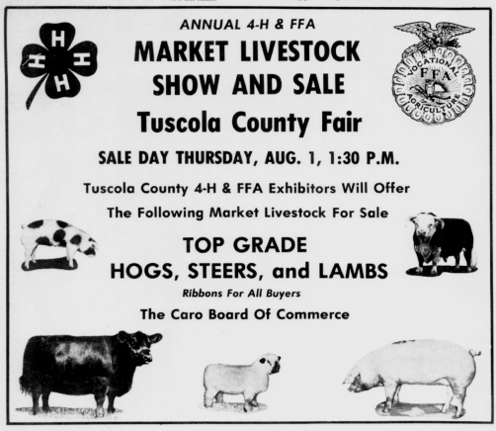

1975

Citizen of the Year

The Caro Chamber of Commerce named Advertiser publisher Rudy Petzold the 1974 Citizen of the Year.

1976

Citizen of the Year

Dorr Wiltse was the 1975 Citizen of the Year.

1977

Citizen of the Year

Don Kanicki was the 1976 Citizen of the Year.

1978

Citizen of the Year

Gladys Galloway was the 1977 Citizen of the Year.

Caro Board of Commerce Award 4-H & FFA Livestock Ribbons

In July, at the Fair, the Caro Board of Commerce gives recognition to the 4-H and FFA groups.

1979

Citizen of the Year

Percy Gram was the 1978 Citizen of the Year.

Ribbons for 4-H & FFA

In August, the Caro Chamber of Commerce sponsored ribbons for at the Tuscola County Fair for the 4-H & FFA groups.

Christmas Store Hours

In December, the Caro Chamber of Commerce published the store hours in the Tuscola County Advertiser.

1980

Citizen of the Year

William Graham was the 1979 Citizen of the Year.

64 exhibits & Dancing highlighted Caro Art Fair

In June, sixty-four exhibitors, a Polish song and dance ensemble and live street dancing were part of the fun in store in Caro. The annual Caro Art Fair was held on a Friday and Saturday along the busy business district. The event was sponsored by the Caro Chamber of Commerce. The coordinator was Tom Thompson.
On display for viewing or purchase was home-crafted sewing, toys, wood-burnings, wall hangings, watercolors, oils and acrylic paintings, costume jewelry, ceramics, metal and fabric items, sculptures, and many, many more items. Another high point of the art festival was the German music and dancing on Friday from 8:00 am - 9 pm to the sounds of Denny and the Music Makers consisting of Denny, Clarence and Stephen Ewald and Dick Dievendorf.

Big Crowd Moves Dinner

In September, because nearly 300 tickets were sold for the Caro Chamber of Commerce Fun Day Dinner, it was moved from the Caro Gun Club to the Caro Knights of Columbus Hall. The move required the elimination of the BYOB by ticket holders due to K of C license restrictions. Beer and mix drinks were served as part of the ticket price.
Dale Hunt, popular Caro organist along with Vassar's accordion-playing butcher, Willi Becker, led a sing-along.

1981

Citizen of the Year

Ruby Reid was the 1980 Citizen of the Year.

The First Annual Pumpkin Festival was Compete with a Flag

In October, during the first annual Tuscola County Pumpkin Festival, an orange and black flag honoring the event flew at the Caro Triangle. The Pumpkin Festival Committee Chairman was Gary Fulgham.
The flag was made by Ruby Reid from a design by Dale Perz with the trim and grommets by T. Hall. The large pumpkin contest was sponsored by the Caro Chamber of Commerce and had been promoted since the spring with the dissemination of pumpkin seeds to over 200 young growers between the ages of 6-9. The Chambers also created list of clues issued in conjunction with the Mystery Pumpkin Contest.
The prize was a $100 shopping spree in Caro.
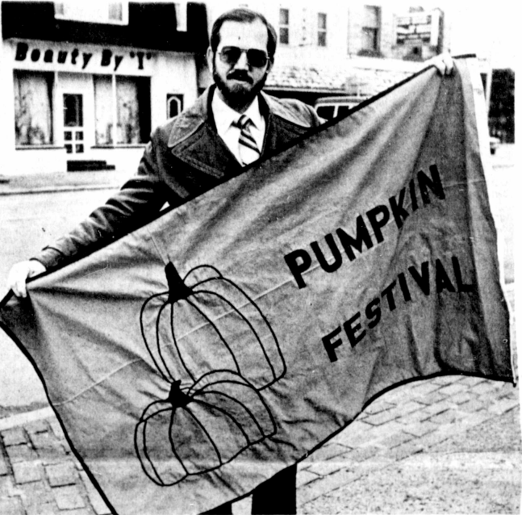

Santa Clause & his Wife Come to Caro

In December, Santa brought his wife with him this year. He was sponsored by the Chamber of Commerce. Santa and Mrs. Claus were located indoors this winter in the old Creative Office Systems building at 177 N State Street in Caro.

1982

Citizen of the Year

Ronald Leader was the 1981 Citizen of the Year.

Pumpkin Clues Announced for Pumpkin Festival

In September, clues in the Mystery Pumpkin Contest that the Caro Chamber of Commerce sponsored were announced.

1983

Citizen of the Year

Frank Chamberlain was the 1982 Citizen of the Year.

1984

Citizen of the Year

Dorothy Mantey was the 1983 Citizen of the Year.

Dollars Days

In March, Dollar Days sponsored by the Caro Chamber of Commerce had many coupons from different Caro stores in the Tuscola County Advertiser.

Dignitaries to Visit Caro During Pumpkin Festival

In October, a host of dignitaries, many of whom were politicians, were to be in Sunday's Pumpkin Festival Parade. Also on hand, as will were Caro Citizen of the Year Dorothy Mantey and Chamber of Commerce President Sheila Everts. The Tuscola County Commissioners rode in horse drawn carriages in the parade. Don Stamats was Parade Marshall.

1985

Citizen of the Year

In January, Caro area farmer and church and civic leader Paul Findlay was honored as Citizen of the Year 1984. Ceremonies were at the annual Chamber of Commerce dinner and dance at the Knights of Columbus Hall. A sellout crowd of 250 people was on hand. Mr. Findlay was characterized as a kind, generous, dependable man who loved life and people.

Bringing Community Together is New Director’s Aim

In January, William Thomas Molby became the first full time director for the Caro Chamber of Commerce. He was hired for his personality and his ability to get along with people. He also served as pastor of the Caro Free Methodist Church.
A big and tough task was to organize the small office the chamber whichi opened at 429 N State. His long-range goal was to build more cooperation among Caro merchants and to attract more people to the business area.
His goal was to help people realize the true potential of Caro and to realize from a retail standpoint how good everyone had it in Caro.

1986 Citizen of the Year

Advertisement for the Citizen of the Year Award

In January:

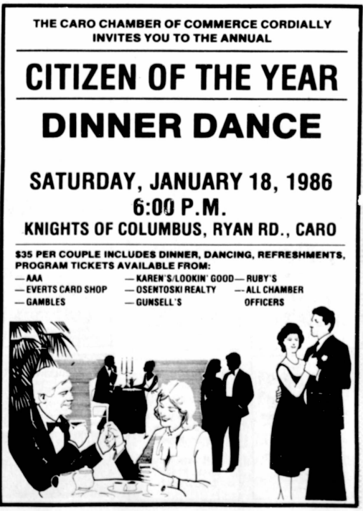

Citizen of the Year

A woman with a lifetime of service to others and her community was named 1985 Citizen of the Year by the Caro Chamber of Commerce.
She was Terese Hunter a veteran bloodmobile organizer, Sunday School teacher, and friend to countless people. She was honored by nearly 300 people who attended the annual dinner and dance at the Caro Knights of Columbus Hall.

The Helm of the Caro Chamber of Commerce

In January, the directors of the of the Caro Chamber of Commerce were Wayne Robinson, Ray Horan, Clark Searle, Dale Perz and Darlene Hood with President George Holmes, Vice President Michael Sinchak, Treasurer Ann McDurmon, Barb Osentoski, Secretary, and Executive Director Margie White.

Community Calendar & Chamber Quarter Event

In April & May, the Community Calendar note in the Tuscola County Advertiser is active and would continue. The Caro Chamber of Commerce was having its quarterly event for $2.00 at the Arrowhead Country Club.

Arts, Crafts, &Fair

In June:

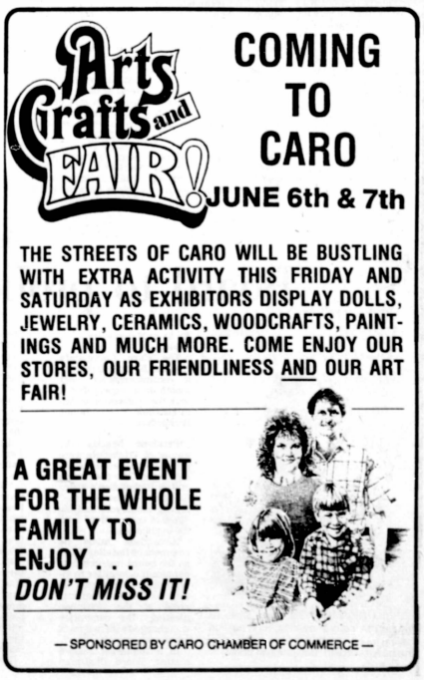

Sidewalk Sale

In July:

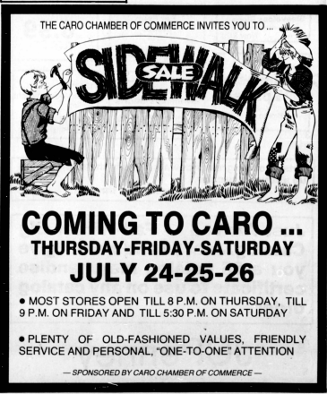

Citizen of the Year

James McLoskey was the 1986 Caro Citizen of the Year.

1988

Citizen of the Year

Dr. Herbert Nigg was the 1987 Caro Chamber of Commerce Citizen of the Year.

1989

Citizen of the Year

Civic leader and attorney Maurice Ransford was honored as Caro's 1988 Citizen of the Year. The honor was presented by 1987 Citizen Dr Herbert Nigg before a sold-out crowd attending the annual Caro Chamber of Commerce Citizen of the Year event.

1990

Citizen of the Year

W. Donald Duggar was the 1989 Citizen of the Year.

1991 Citizen of the Year

Citizen of the Year

Carol Ellsworth was named the 1990 Caro Citizen of the Year.

1992

Citizen of the year

In January, the Caro Chamber of Commerce named Pat Boylan Caro's Citizen of the Year for 1991.

70th Anniversary Celebration

In February of 1992, the Caro Chamber of Commerce celebrated its 70th Anniversary.
It was incorporated on January 22, 1922, as the Caro Board of Commerce.
They changed its name to Caro Chamber of Commerce in March 1970. It has continued operation to the present without interruption.
The Caro Chamber was also distinguished as a charter member of the Michigan Slate Chamber of Commerce. The Caro Board was instrumental in getting the Michigan Chamber of Commerce started.
The officers in 1970 of the Caro Chamber of Commerce were President Ernest Teller, Vice-president Robert Daniels, Treasurer William Jackson, Secretary April Goulet, Executive director Lois Sutton.
Directors were Sally Dittman, Dale Perez, Louise Nast, Karen Peruski, Linda Langley, Karen Raymond, Tom Kain and David Brenneman.
The Caro Chamber of Commerce provided prospective residents with information about Caro and the surrounding area. This includes area opportunities such as education, sports, and recreational programs. It also included music and arts locations and health care facilities. Local shopping and business services were highlighted.
The chamber also answered questions about real estate and housing opportunities.
It provided maps of the town and county. It also supplied information about the local newspaper and radio. The chamber spends money to support local events and organizations and supported itself through retail promotions and community festivities.
One objective of the Chamber was to keep the local dollars around Caro.
The Chamber Board of Directors met once a month in the Caro Chamber of Commerce office. Anyone who wanted to make a special presentation or appear on the agenda could call the office.

1993

Citizen of the Year

Congratulations was for Glenn Eastham 1992 Caro Citizen of the Year.

1994

Citizen of the Year

Weston Raven was named 1993 Caro's Citizen of the Year. Betty Colling received the Caro Chamber of Commerce Award of Merit. This was the 25th anniversary Citizen of the Year dinner/dance. 220 attended at the Knights of Columbus Hall.

1995

Citizen of the Year

The 1994 Citizen of the Year was Mary Ann Vandemark.

1996

Citizen of the Year

Caro’s 1995 Citizen of the Year was a person whose value to the community was without bounds. Rose Putnam was the 1995 Caro Citizen of the Year.
Over 200 people cheered as the long-time Pumpkin Festival volunteer and chair of the group that saved the Octagon Barn was named recipient of the award.

Early Celebration of 75th Anniversary of the Caro Chamber of Commerce

In May of 1996, the Tuscola Advertiser published the following information:
The Caro Chamber of Commerce was originally the Caro Businessmen's Association.
In 1922, it was incorporated as the Caro Board of Commerce.
In 1970 the name was changed to the Caro Chamber of Commerce.
In celebration of Michigan Week and the 75th Anniversary of the Caro Chamber of Commerce took place at the campus of the Great Lakes Junior College in Caro.
Present and past chamber members, government dignitaries. and area residents attended a special ceremony to bury a time capsule at the college that is to be opened in 75 years. In 1970, the Caro Chamber of Commerce had 170 members.
The 75th Anniversary was in 1997.]

1997

Citizen of the Year

Brent McLaughlin was the 1996 Citizen of the Year.

1998

Citizen of the Year

Betty Colling was the 1997 Citizen of the Year.

1999

Citizen of the Year

Betty Pattullo was the 1998 Citizen of the Year.

2000

Citizen of the Year

Jim Sparling named the 1999 Caro Citizen of the Year.

2001

Citizen of the Year

Richard Ransford was named 2000 Caro Citizen of the Year.
Dick Ransford was a former Caro Village President. He also served on many civic organizations. He and his wife Sue were successful owners of Ransford Funeral Home where Dick worked for 28 years.

Glen Roth earned the Caro Chamber of Commerce Merit Award.

2002

Citizen of the Year

Gary Avery played an active role in the lives of scores of young men, introducing and reinforcing the scouting ideals with the common thread of making them better citizens of Caro and of the world. He was the 2001 Caro Citizen of the Year.

Mike Bauerschmidt was the winner of the Merit Award.

2003

Sarah Dost was the 2002 Citizen of the Year.

2004

Ken Beachy was the 2003 Citizen of the Year.

2005

Citizen of the Year

Pat Curtis was the 2004 Citizen of the Year.

2006

Citizen of the Year

In January, Kathy Neuman became the 2005 Citizen of the Year at the Caro Chamber of Commerce Annual Dinner.

Ginger-bread Village

In December, during the early Christmas season, Caro’s newest festival in 2006 was the Gingerbread Festival. The festival hosted a variety of events throughout the town.
A Gingerbread Village was created not just the downtown but in the whole town.
Gingerbread Village is a joint project between the Caro Chamber of Commerce and volunteers in the community.
The idea started as a simple fundraising effort for Thumb Area Big Brothers/Big Sisters, Inc., and Thumb Area Center for the Arts. Mascots of the festival were Fred and Gingerbread who were featured around town.
There also was entertainment downtown. Carolers walked the streets and there was other entertainment as well. Elementary students and parents were encouraged to create a graham cracker house. Prizes were awarded to the best house in three age groups. Gingerbread Village Central was located at 160 N. State St. the formerly Thumb Office Supply store. It was 10 days of fun in downtown Caro.

2007

Citizen of the Year

In January, Sandy Gaudreau the Executive Director of Thumb Area Big Brothers/Big Sisters Inc. received the top honors as the 2006 Caro Chamber of Commerce Citizen of the Year at the Caro Knights of Columbus Hall.

Susan Holder was named Merit Award winter at the 2006 Caro Chamber of Commerce Citizen of the Year event.

Second Annual Gingerbread Festival

The Thumb Area Big Brothers Big Sisters invited to go on a home tour which will begin at Gingerbread Central and tour five homes in the Caro area. The tour started at Gingerbread Central where you picked up a map.
There were also carriage rides, gingerbread house making contests, art walk at downtown businesses.

2008

Citizen of the Year

Robert DeBoer was the 2007 Citizen of the Year.

2009

Citizen of the Year

Tom Striffler was the 2008 Citizen of the Year.

2010

Citizen of the Year

Richard Fullmer was the 2009 Citizen of the Year.

2011

Citizen of the Year

Mike Henry was the 2010 Citizen of the Year.

The Merit Award recipient was Margie Sylvester.

2012

Citizen of the Year

Norm Daniels was the 2011 Citizen of the Year.

2013

Citizen of the Year

The 44th annual Caro Chamber of Commerce Community Honors Dinner awarded the 2012 Chamber Citizen of the Year recognition to Jim Will.

The Merit Award went to Leianne Nichols.

The Service Award went to Louise Hodges, and the Junior Citizen Award went to her daughter, Nicole Hodges.

2014

Citizen of the Year

Brenda Caruthers was the 2013 Citizen of the Year.

2015

Citizen of the Year

Jim Rolka was the 2014 Citizen of the Year.

2016

Citizen of the Year

James Tussey was the 2015 Citizen of the Year.

2017

Citizen of the Year

In February, the Caro Chamber of Commerce named a man behind decades of real estate deals throughout Michigan's Thumb region, David Osentoski as the “Caro 2016 Citizen of the Year. This was the 48th annual Community Dinner for the award, which was held at the Knights of Columbus Hall.

Wrestling Coaches Steve Ley and Bob Suranye were presented with the Caro Chamber of Commerce Merit Award.

2018

Citizen of the Year

Dale Perz was the 2017 Citizen of the Year.

2019

Citizen of the Year

Joe Greene was the 2018 Citizen of the Year.

2020

Citizen of the Year

Mark Ransford was the 2019 Citizen of the Year.

Wendy Jacot was presented with the Merit Award.

2021

Due to COVID-19, no event was held for the Citizen of the Year.

Junior Citizen of the Year was awarded to Sara Weingartz

2022

The Caro Chamber of Commerce Celebrates its Centennial 100th Anniversary.
Kim Wasik was the 2021 Citizen of the Year.
Mandy Knox received the Merit Award.

Postlog

